Exp No: 1
FLASHING OF LED USING AT89C51 MICROCONTROLLER USING PROTEUS
AIM:
To Write an assembly language program to flash the LED using AT89C51
SOFTWARES REQUIRED:
Proteus software
PROGRAM:
ORG 0000H
UP: SETB P2.0
ACALL DELAY
CLR P2.0
ACALL DELAY
SJMP UP
DELAY: MOV R4,#35
H1:MOV R3,#255
H2:DJNZ R3,H2
DJNZ R4,H1
RET
END
OUTPUT:
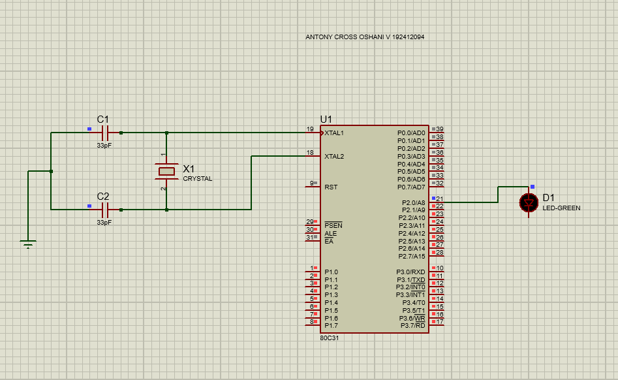
RESULT:
Thus the program has been successfully verified and executed.

