EXP NO: 14
EMBEDDED C PROGRAM TO DISPLAY “HELLO WORLD” MESSAGE
AIM:
To write an Embedded C program to display “HELLO WORLD” message using Keil
software.
SOFTWARE REQUIRED:
Keil
PROGRAM
#include <reg51.h> #include <stdio.h>
void main (void){
SCON = 0x50; /* SCON: mode 1, 8-bit UART, enable rcvr */ TMOD = 0x20;
/* TMOD: timer 1, mode 2, 8-bit reload */ TH1 = 0xFD; /* TH1: reload
value for 9600 baudrate */
TR1 = 1; /* TR1: timer 1 run */
TI = 1; /* TI: set TI to send first char of UART */ while (1)
{
printf ("Hello World ! \n ");
}
}

OUTPUT:
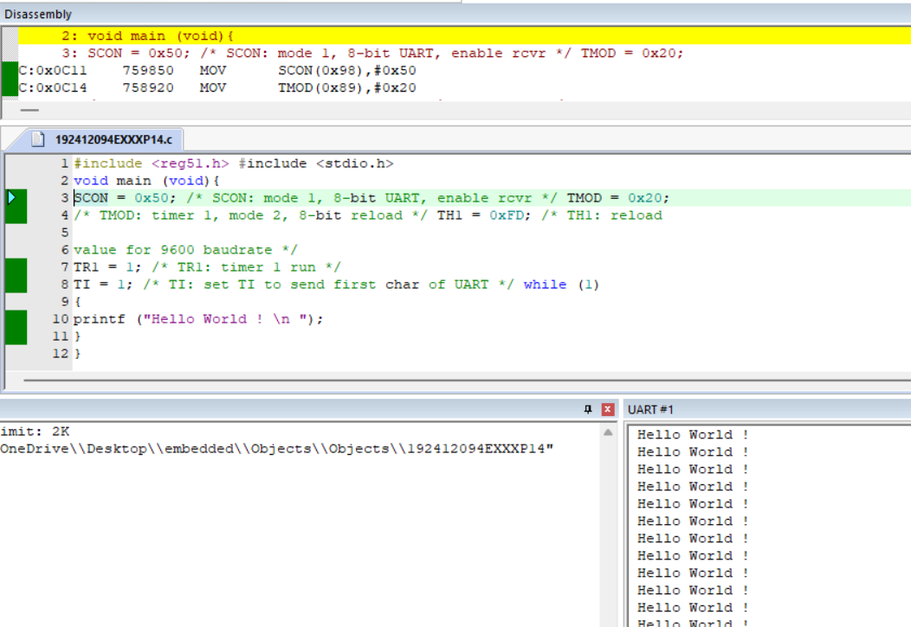
RESULT:
Thus the program has been successfully verified and executed.

