EXP NO: 12
EMBEDDED C PROGRAM TO MULTIPLY TWO 16-BIT BINARY NUMBERS
AIM:
To write an Embedded C program to multiply two 16-bit numbers using Keil software
SOFTWARE REQUIRED:
Keil
PROGRAM
#include <reg51.h> void main()
{
while (1)
{
unsigned int num1, num2; unsigned long int product; num1 = 0x2222;
num2 = 0xBBBB;
product = (unsigned long int)num1 * num2; P0= product &0xff;
P1= (product & 0xff00)>>8;
P2 =(product & 0xff0000)>>16; P3 =(product & 0xff000000)>>24;
}
}
OUTPUT:
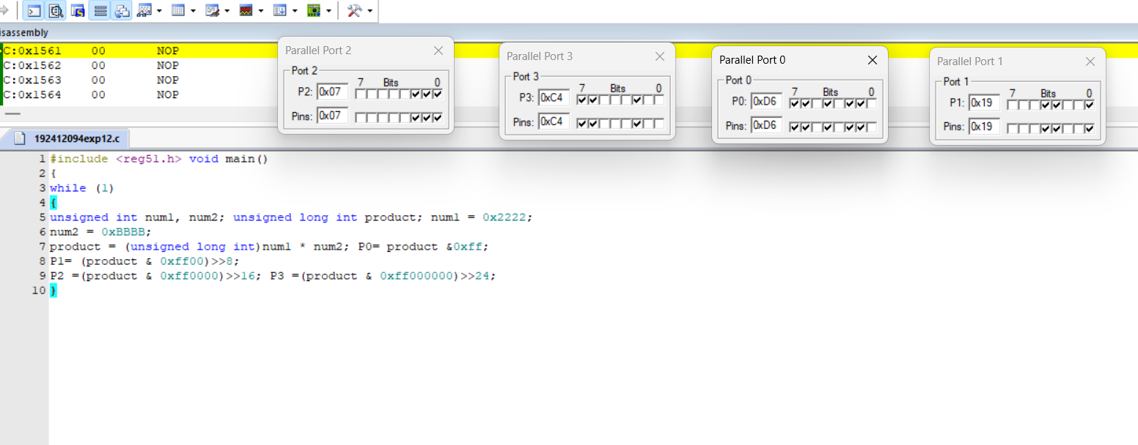
RESULT:
Thus the program has been successfully verified and executed.

