EXP NO: 6
ARDUINO TO 16X2 LCD DISPLAY USING PROTEUS
AIM:
To write an Embedded C program to interface Arduino Uno and 16 x 2 LCD display using
Arduino Uno and Proteus
SOFTWARE REQUIRED:
• Proteus 8 software.
• Arduino IDE software
PROGRAM
#include <LiquidCrystal.h>
LiquidCrystal lcd (7, 8, 9, 10, 11, 12);
// your PWM numbers may be different
void setup() {
lcd.begin(16, 2);
lcd.print("put your message here");
}
void loop () {
for (int i=0; 1<13; i++)
}
lcd.scrollDisplayLeft();
delay(700);
}
}
OUTPUT:
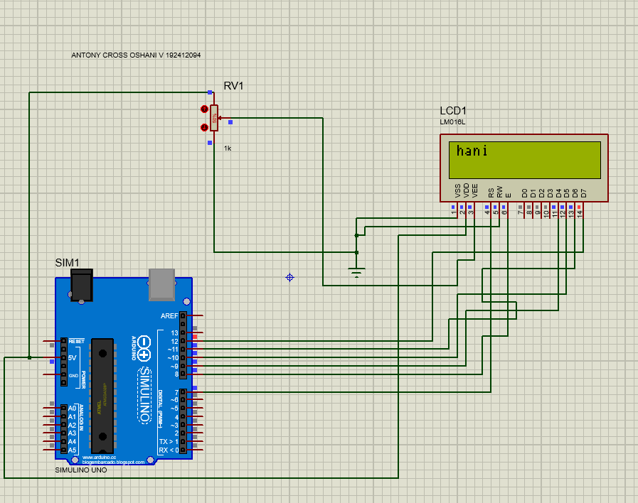
RESULT:
Thus the program has been successfully verified and executed.

