QueryMed: An Intuitive Federated SPARQL Query Builder for Biomedical RDF Data

Oshani Seneviratne and Rachel Sealfon
MIT - CSAIL

ABSTRACT

We have developed an open-source SPARQL query builder and result set visualizer for biomedical data, QueryMed, that allows end users to easily construct and run translational medicine queries across multiple data sources. Querymed is flexible enough to allow queries relevant to a wide range of biomedical topics, runs federated queries across multiple SPARQL endpoints, and is designed to be accessible to users who do not know the structure of the underlying ontologies or the SPARQL query language. The system allows the users to select the data sources that they wish to use, drawing on their specialized domain knowledge to determine what data sources they trust. Users can add additional data sources if they are interested in seeing results from sources that are not in the default list. The system also allows the user to exploit the structure of the data available at each of the data sources by exposing the available properties and concepts. Upon retrieval of the result set from the various data sources, it is possible to filter and improve the query based on some user-defined criteria and categories.

Keywords
Biomedical Ontologies, SPARQL, Query Federation, Query Building, Semantic Web, User Interfaces

1. INTRODUCTION

RDF data in the semantic web, like the data in relational databases, is modeled in a structured format that can be queried using a standardized query language. The biomedical domain is among the early successes of the semantic web, due to the rapidity with which the biomedical community has made its data available in RDF triple stores and made the data available via SPARQL endpoints. However, although a plethora of useful biomedical data is currently available in semantic web formats, there is currently a need for easy-to use systems that do not require the end user to have knowledge of the structure of the underlying data, and that also allow users to run federated queries on multiple SPARQL endpoints. For example, physicians and patients may be interested in running queries on disease properties, clinical trials, and drugs, but not know the SPARQL query syntax or the structure of the ontologies in which this information is stored. Therefore, because of the complexity of the underlying structure of the data available at various semantic web data sources, and the rapidly increasing number of available semantic web resources, developing intuitive ways to query and display query results is both an important and a challenging problem.

This paper is organized as follows: Section 2 gives the background with an overview of the biomedical ontologies used and the technologies used in building the system. Section 3 outlines a use case that motivates the need for a system such as the one we have developed and outlines SPARQL endpoints that are queried. Section 4 gives the architecture of the QueryMed system, a scenario of how a user may use the system and a performance analysis. Section 5 discusses the related work and illustrates how QueryMed differs from those. Finally, we conclude the paper in Section 6 with a summary of the contributions and future work we can do to improve QueryMed.

2. BACKGROUND

2.1. Biomedical Ontologies and Semantic Web

The vision of the Semantic Web is the transformation of the World Wide Web into a database in which data is modeled by structured languages (RDF, OWL) and can be queried by a standardized query language, SPARQL [Cheung, 2009]. The addition of structure to web data is intended allow inferences to be automatically made by intelligent agents drawing on web data from multiple sources. There are several parallel concepts in the two domains as shown in Table 1 [Berners-Lee, 1998].

Relational Databases | Semantic Web
Record | RDF Node
Field (Column Name) | RDF Property
Record Field | Value
SQL | SPARQL

Table 1: Comparison of Relational Databases and the Semantic Web

Semantic web data is generally represented as RDF triples. RDF data is described by a directed, labeled graph, with relationships among data items represented as a series of subject, object, predicate triples. For example, we might want to express the concept, "Sam is a professor for 6.830." This triple expresses the relationship between two entities, Sam and 6.830. The relationship between "Sam" and "6.830," which is "professor," is known as the predicate of the triple; "Sam" is the subject while "6.830" is the object. In order for this statement to be machine readable, each of the entities in the statement ("Sam," "professor," and "6.830") will be described by a Uniform Resource Identifier (URI) (RDF Primer). The Web Ontology Language (OWL) is a language that permits the definition of web ontologies, allowing additional properties and constraints on relationships among data to be represented (OWL primer).

Although most web data is not currently available in semantic web formats, biological knowledge domains have been an early success of the semantic web (Yip, 2009). Integrating biomedical data across multiple databases and automatically extracting specific biological knowledge from web resources are crucial tasks for physicians and biologists, and much biological data on the web is available in structured ontologies that define relationships between entities. Life scientists have been proactive in recognizing the promise of the semantic web for their fields and in moving large biological databases into semantic web formats. Many major biological and biomedical data resources, including Gene Ontology, DailyMed, LinkedCt, and Diseasome, are currently available as RDF triplestores. These resources represent valuable standardized repositories of information that can be automatically mined for biological knowledge. The Semantic Web Health Care and Life Sciences Interest Group (HCLSIG) has been formed with the purpose of exploring the applications of the semantic web to the biological domain.

However, although many valuable resources in the biological domain are available in semantic web format, there are a number of challenges that must be addressed in order to make semantic web resources of maximal use to life scientists. One challenge is constructing systems that allow end users to run intuitive queries on biological data. Since users of biomedical resources are likely to have extensive domain knowledge, but unlikely to be familiar with the SPARQL query language syntax or with the structure of many of the specific resources of interest, it is important to design systems that are intuitive to use and allow physicians and biologists to take advantage of the wealth of structured biological knowledge available on the semantic web. Another central challenge is designing systems that allow users to query multiple data sources simultaneously, since relevant biological data is often distributed among many sites (Pasquier, 2008).

2.2 SPARQL Query Language

A SPARQL query performs a pattern-matching search on the underlying RDF graph of the desired resource. The majority of SPARQL queries are constructed from basic graph patterns. Like RDF triples, a basic graph pattern contains a subject, an object, and a predicate; however, in the basic graph pattern, the subject, object, or predicate may be replaced by variables. The query result is the set of tuples matching the query pattern (SPARQL primer).

The SPARQL query language is designed to query semantic web data, just as SQL is designed to query relational data. However unlike SQL, SPARQL supports query forms other than "SELECT" result set retrieval. This makes the semantics of the SPAQRL query language much more flexible and easier to use. In SPARQL, the following types of queries are possible:
1. "ASK" query to test whether a graph contains some data of interest.
2. "DESCRIBE" to generate an RDF description of a resource(s).
3. "CONSTRUCT" to create a custom RDF graph based on query criteria. This can also be used to transform RDF data.

3 MOTIVATION

In the relational database world, data is contained within "data silos". The schema in one database is different from the schema in another database, although the data may describe the same thing. Data in relational databases is also not formed in a way that can be easily integrated with other relational databases without writing extensive application logic. In contrast, RDF data is represented in a form that is amenable for URI based data integration that can span multiple data sources.

However, because of the scale free nature of the web, locating the appropriate data endpoint to execute a specific query is a challenging problem. While the SPARQL query language has some support for expressing queries that span multiple data sources, there are currently no well known tools and techniques to issue queries that can combine data from multiple sources and present to the user in an intuitive manner. The user will need to go to a particular SPARQL endpoint, learn what properties and concepts are available and then issue a query. After getting the results from that data source, the user will have to use the results in constructing another SPARQL query that can be used to issue another query at another SPARQL endpoint.

Consider the following scenario: a physician may know her patient's personal information, symptoms, current medications, and genotype. She may wish to figure out the patient's diagnosis and treatment plan, find any relevant papers in PubMed that relate to the prevailing condition, view the function of genes that the patient has a mutation in, or identify clinical trials that the patient can be referred to. The information required for the execution of this query needs to be gathered from various data sources such as DailyMed, Drugbank, LinkedCT, Dieseasome, GO and other such relevant data sets that are publicly available. However, the query needs to be written and executed one data source at a time. For example, the physician will have to first find the URIs of diseases that mention the word “coronary artery disease” (which she thinks is the cause of the symptoms the patient showed) from Diseasome. She can then use those URIs of diseases to find drugs that will not have an adverse reaction with the drugs that the patient is already taking that treat the disease in Dailymed or Drugbank. The physician can also query data sources such as LinkedCT to find out what clinical trials have been successful in treating this disease, and follow the course of treatment recommended for that disease.

4 QUERYMED

4.1 Architecture overview

QueryMed architecture at 10,000 feet is given in Figure 1. The user interface accepts query terms from the user, allows management of additional data sources and executes the SPARQL queries at the SPARQL endpoints available at various biomedical data sources via a proxy server.
Figure 1: QueryMed Architecture Overview

QueryMed is implemented in Java in the backend and JavaScript in the frontend. The JQuery library is extensively used for the user interface, while the Jena library is used to run SPARQL queries. QueryMed relies on the following remote resources:
- SPARQL Endpoints: QueryMed runs queries on multiple remote SPARQL endpoints that expose biomedical data.
- Sources List: The default list of endpoints available to the user is stored in a source list on the proxy server.

The components of the user interface and the proxy server are illustrated in Figure 2.

Figure 2: QueryMed Architecture details

4.1.1 Proxy Server

The user submits a query across the proxy server. The query is translated into a SPARQL query for each individual endpoint, and the results are returned to the user. The specific components implemented in the proxy server are as follows.
- Source Manager: The source manager reads the source list and populates the default query list on the user interface. It also keeps track of the default endpoints, the currently selected endpoints, and the endpoints that have been dynamically added.
- Translator: This is responsible for translating the user query into valid SPARQL syntax.
- Run Query: The purpose of this service is to run SPARQL queries. It takes input on source and keyword from the client, and returns the query results as a JSON object. The structure of the JSON object is given in listing 2.
- Get Properties: This service takes as input an individual source. Returns an array of all properties for that source.
- Get Property Values: This service takes as input an individual source and a specific property. It returns a list of the possible values that this property can take.
- Advanced Queries: This service takes as input list of sources, properties, query terms, and logical operators as a JSON object. The structure of this JSON object is given in listing 3. After constructing and executing the SPARQL query it returns a set of query results as a JSON object in the format given in listing 2.

4.1.2 User Interface

The query interface is implemented in JavaScript (using the JQuery library), HTML and CSS. The noteworthy components of the user interface are as follows:
- Query Interface: The user inputs their query terms into the text box provided in the query interface.
- Result Browser: The user can view their query results, organized by the source of the results. The results are presented in a tabular manner with pagination and with the capability to change the number of results viewed at a time, search the columns based on some text value and also to sort the columns.
- Dynamic Facet Creator/Filter: This allows the user to select a particular data source, load the properties available at that source, and issue the query to obtain the results.
- Add New Source: Allows the user to add a new data source to extend the query.

4.2 System Functionality and Design Decisions

4.2.1 Source list

Because the set of default endpoints is stored on the proxy server, the set of resources available by default to the user can easily be updated. Since useful biomedical resources are rapidly being developed and made available to RDF triple stores, the ease of updating the resource list ensures that the system can easily be brought up to date. In fact, the QueryMed system could be easily adapted to perform queries outside the biomedical domain by modifying the list of input datas ources.

4.2.2 Proxy Server

While an entirely client side application is possible, we chose to have a proxy server do the SPARQL query execution and caching. There are several reasons for this decision:
1. Efficient cache management: The result set from running an unrestricted query can result in returning millions of results to the client. When we are refining the query, it may reach a point that it becomes infeasible to keep it all in the browser's javascript memory. A typical memory footprint for a browser (for e.g. Firefox) is usually between 20MB and 100MB. A poorly constructed query can result in Gigabytes worth of triples returned, resulting the browser to crash.
2. The proxy server enables us to avoid cross domain XML-HTTP-Request errors.

4.2.3 Data Structures

The parameters required for constructing the SPARQL queries are sent from the user interface to the proxy server. In the general “Query All” case, the system will only take the query term specified by the user in the text box, perform a regular expression filter on all the properties available at the SPARQL endpoint and compose the results. The generated SPARQL query will be of the form given in listing 1. The “input” in the query contains the user’s keyword.

SELECT ?projection_1 ? projection_2 ... ? projection_n
WHERE {?x source:property ? projection
FILTER regex(? projection, '" + input +"', 'i)
}
... //Other property filers are to follow

Listing 1: Minimal SPARQL query structure in the “Query All” case

When the results are returned, each result set is structured in the JSON object given in listing 2. This identifies the source the query was executed at, the URI, the variables (or projections) of the query and the result set.

{
"bindings":
[
{"source" : "source_label",
"uri" : "http://source.com/sparql.",
"vars" : ["variable1","variable2"],
"count":2,
"results" :
[
{"variable1": "Value 1", "variable1": "Value 2"},
{"variable1": "Another Value 1", "variable1": "Another Value 2"},

]
}
,
{ //Another Source and Result Description
...
},
...
]
}

Listing 2: JSON returned from the RunQuery service

When the user wants to construct an “advanced query”, the payload to be sent to the proxy server to do the SPARQL query construction and query execution orchestration is much different than in the “query all” case. There the system needs to specify what data sources are to be queried, what properties are queried, the values for each of the selected properties, and how these property value pairs relates to the original query term the user has specified. The structure of this payload is given in listing 3.

{
"http://some-source/sparql": {
"property1": {"value1": "AND"},
"property2": {"value 2": "OR"},
"property2": {"value 3": "FILTER"}
}
}
//Other sources ...
}

Listing 3: JSON constructed to send the structure of a SPARQL query for an advance query with logical operators

4.2.4 Query Interface

In order to make QueryMed easy to use, but still provide a flexible tool that is able to perform a range of queries, we provide an uncluttered interface with only blank search box and two buttons. The “Query All” button will issue a SPARQL query based on the keyword specified over pre-selected data sources. The advanced search option “Refine Query” allows the user to take advantage of the structure in the underlying semantic web data. The initial query interface is given in Figure 3.

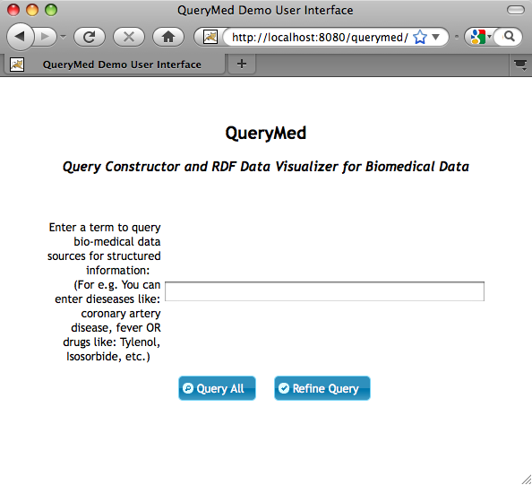
Figure 3: Initial search interface seen by the user

We believe that the unstructured keyword search is likely to encourage users without previous experience of running queries on semantic web data to explore the additional features of our system that allow more flexible and advanced queries. For example, physicians who are not used to running queries on semantic web data may be more willing to invest time into learning how to find better search results once they see that the system can easily provide them with some initial useful query results using the basic keyword search option. However, the execution of queries using QueryMed will be very much different from a user issuing a web search on a search engine such as Google, because it exploits the underlying structure of the data as exposed in the data sources they are coming from.

The advanced query interface provides the user with the option of selecting specific data sources to query as shown in figure 4. The user can also dynamically add additional data sources as shown in figure 5. This feature allows the user to perform their query only over relevant or trusted data sources. The ability to dynamically add additional sources increases the flexibility of the QueryMed system.
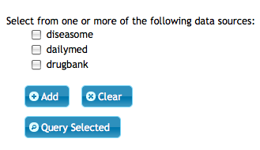
Figure 4: The user has the option of selecting specific trusted or relevant data sources, or of adding additional data sources to query.

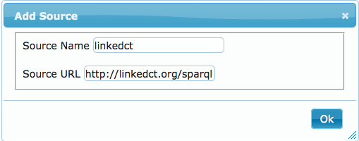
Figure 5: The user can also dynamically add new data sources

When a data source is selected, the properties list is automatically populated with the properties available at the selected endpoint so that the user can run queries specific to the underlying structure of the RDF data in order to return more relevant query results. The properties list is generated by running a SPARQL query of the form given in listing 4 at the specified data source. This allows users to improve their searches using the structured data without prior knowledge of this structure.

SELECT DISTINCT ?property
WHERE { [] ?property [] }
ORDER BY ?property

Listing 4: SPARQL to obtain all the properties available at a given endpoint

Once the properties are returned it will be displayed in the user interface as shown in figure 5. The user can choose to perform exact queries, or filter results on specific keywords. If such specific keywords are used (and not the exact property value), the users have the specify the “FILTER” option in the user interface. They also can choose logical operators to connect the various parts of their query. When “AND” is used it will be used as a basic triple pattern in the SPARQL query, i.e. as a conjunction. When “OR” is used the triple is made to disjunct with the rest of the query with the SPARQL UNION operator. If none of the options are specified, the default will be taken as an “AND”.

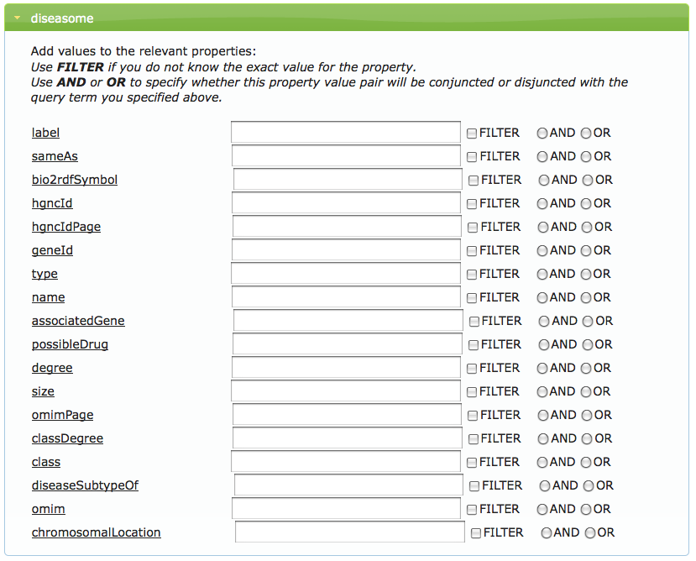
Figure 5: The Advanced Search feature allows the user to perform exact or pattern-matching queries connected by user-specified logical operators over specific properties in given resources, taking advantage of the structure in the RDF data.

Clicking an individual property displays a description of the property, allowing the user to understand keywords that will be most useful to search on each the specific property. The sample description for a the property rdfs:label is given in figure 6.

Figure 6: Clicking on a property opens a window containing a description of that property.

Query results are displayed to the user as a table, which can be filtered and searched to refine the query result, or printed as shown in in figure 7.

In this case, suppose a physician is interested in searching for information about drugs used to treat coronary artery disease. She goes to the query interface, and initially types in “coronary artery disease” in the query box. This action searches for coronary artery disease over all fields of all properties, and displays selected query results to the user in a table. Selected columns from the default resource set are automatically displayed. She can then filter by searching over individual columns—for example, she might be interested in querying for all of the drugs used to treat coronary artery disease whose route of administration is “injection.” She can also choose to print the returned result set.

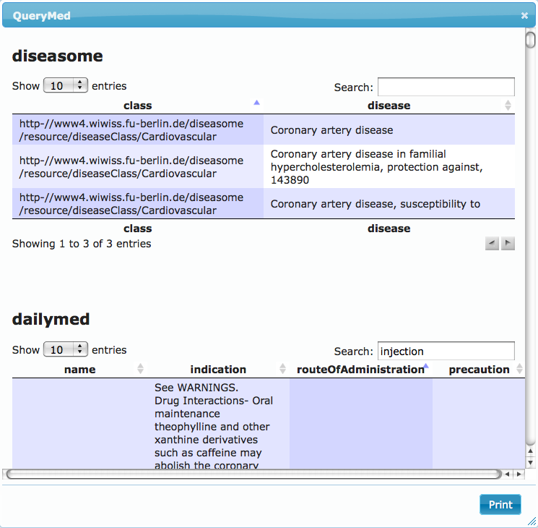Figure 7: A sample result table

4.3 Performance

The slowest step in running queries over the QueryMed system is populating the property values for each selected endpoint. We have analyzed several biomedical data sources and the times taken to load the user interface is given in table 2.

Time (sec) | Diseasome | Dailymed | Drugbank
1st Trial | 3.45 | 1.77 | 9.51
2nd Trial | 1.61 | 1.57 | 9.34
3rd Trial | 1.71 | 1.66 | 9.06

Table 2: Running times to retrieve all the properties from selected endpoints

For all selected endpoints, the property values take longer to load on the initial query than in subsequent iterations, probably due to browser caching. The running time to acquire the list of property values for the Drugbank endpoint is much larger than the time for the other two endpoints, probably due to the greater number of triples stored in Drugbank. (As of 12/10/09, Diseasome contains 91182 triples, DailyMed contains 164,276 triples, and DrugBank contains 765936 triples.)

4.4 Resources

The source code of the implementation of the Querymed system is available at the QueryMed Google Code project:
http://code.google.com/p/querymed/

A video outlining how a user can run the system can be found at:
http://www.youtube.com/watch?v=JCr7vryS9Vg

5 RELATED WORK

A number of existing tools to provide a user-friendly interface for browsing Semantic web data, or to allow users to perform federated queries. Several of these are described below.

There are several previous systems that have been specifically designed to run semantic web queries on biological data. The SMART query tool is a web-based application designed to allow biologists to run SPARQL queries over multiple endpoints. Queries to the SMART system are constructed using a descriptive logic query written in the natural-language like Manchester OWL syntax. GoWeb is a system designed for answering queries on biomedical data which allows users to run queries using both semantic web and keyword-based search.

The Twinkle project [twinkle] offers a stand-alone graphical user interface to load and edit SPARQL queries that can be used to query online SPARQL endpoints. Our system differs from the Twinkle system in several aspects. First of all, in their system, the user is expected to know what is already available at the SPARQL endpoints to write the query. But in Querymed, we only ask for specific keywords of interest, and give the option of restricting the query, should they wish to run a more precise query. Second, although Twinkle was designed to be a more general purpose system, it only supports few SPARQL endpoints, while Querymed allows the user to dynamically add SPARQL endpoints.

While SPARQL queries are designed to be run against individual sites, it is often useful to draw on multiple web resources in answering a query. There are a number of systems, including the DARQ and CALO systems, designed to allow the user to run integrated queries against multiple SPARQL endpoints.

Table 3 compares selected features of the QueryMed system with other related systems. The QueryMed system was unique among the systems that we found in that it allows endpoints to be dynamically added by the user. Other features of the QueryMed system that distinguished it from similar systems included the ability both to perform keyword queries and to construct more advanced queries taking advantage of the structure of the semantic web data. This feature increases the ease of use of our system relative to other, similar systems. Furthermore, the Javascript based user interface of the QueryMed system, implemented using the JQuery library, makes our user interface particularly attractive, easy to interact with, and able to handle a variety of user input events. Another unique feature of our system is the property-based query interface, which enables users to take advantage of the structure of the underlying ontologies used to represent the data without prior knowledge of the ontology structures.

 | Query multiple sources? | Dynamic addition of sources? | Allows keyword queries? | Open-source | GUI
Query  Med | Yes | Yes | Yes | Yes | Yes
SMART | No | No | No | Yes | Yes
DARQ | Yes | n/a | No | Yes | No
GoWeb | Yes | No | Yes | No | Yes
BioGateway | Yes | No | No | No | Yes

Table 3: Comparison of selected features of the QueryMed system with other related systems.

6. FUTURE WORK & CONCLUSIONS

The bottleneck in the running time of our system is running queries that must retrieve many triples from slow remote SPARQL endpoints. By caching relevant data locally, running time could be significantly improved. We observed that the QueryMed system performs significantly faster the second time that a query is run on a given resource, due to browser caching; by managing our own cache to contain the data most likely to be needed, we could reduce running time still further. Another approach that could reduce running time still farther would be to create a complementary standalone application that gives the user the option at startup time of reading the RDF data over the web or of reading data stored locally on the user's machine. If the user chooses to read data over the web, it will then be stored locally so that subsequent queries on this data would be rapid. This approach might be too memory-intensive if the user wishes to run queries over a large number of enormous databases, but might work best in the situation where there is a small or moderate amount of data in the repositories of interest to the user. Our system currently allows only a restricted set of SPARQL queries; allowing additional types of queries and including query optimization functionality could increase both the flexibility and speed of the QueryMed system. By drawing on the flexibility of the SPARQL language and the information contained in the ontologies used to represent the data, it would be possible to extend our system into an intelligent reasoning system on biomedical data which allows physicians to enter sophisticated, complex queries and find relevant biological results.

We also believe that it would be useful to allow users to explore the interconnections among similar resources across multiple databases. One challenge in integrating biological data stored in RDF across multiple data sources is that individual data items (ie, a specific protein or a specific drug) may be represented by multiple distinct URIs across multiple databases. The diversity of representations of identical data items across different biological databases makes it difficult to automatically combine these items. However, there is some cross-referencing between the biomedical databases that we examined (for example, DailyMed drugs sometimes refer to diseases in the Diseasome database by their URI). It might be useful to provide a representation of the relationships among search results from different sources with the query results. Additionally, the system could automatically detect similar data items even if they are identified by distinct URIs, and group similar items from distinct data sources together in the query results. Another useful feature might be to allow the user to view the relationship among distinct URIs (as in the relfinder system , which displays possible paths through the RDF graph between distinct resources).

REFERENCES

Berners-Lee, Relational Databases on the Semantic Web, Design Issues, http://www.w3.org/DesignIssues/RDB-RDF.html, September 1998.

Ambite, JL., et al. Design and Implementation of the CALO Query Manager. In Proceedings of the 18th Innovative Applications of Artificial Intelligence Conference, Boston, MA, 2006.

Battista, A., et al. SMART: A Web-based, Ontology-Driven, Semantic Web- Query Answering Application Semantic web challenge at the ISWC, 2007.

Cheung, K., et al. A journey to Semantic Web query federation in the life sciences. BMC Bioinformatics, October 2009.

Dietze H, Schroeder M: GoWeb: a semantic search engine for the life science web.
In Proceedings of the Intl. Workshop on Semantic Web Applications and Tools for the Life Sciences SWAT4LS Edited by: Burger A, Paschke A, Romano P, Splendiani A. 2008. OpenURL

Dodds, L. Twinkle: a graphical user interface SPARQL query building. twinklehttp://www.ldodds.com/projects/twinkle/

Heim, P. et al. RelFinder: Revealing Relationships in RDF Knowledge Bases. Proceedings of the 4th International Conference on Semantic and Digital Media Technologies (SAMT 2009), Springer.

Langegger, A., et al. Sharing data on the grid using ontologies and distributed SPARQL queries. In: Wagner, R., Revell, N., Pernul, G. (eds.) DEXA 2007. LNCS,
vol. 4653, pp. 450–454. Springer, Heidelberg (2007)

Manola, F., and Miller, E. RDF Primer, W3C Recommendation,, February 2004. http://www.w3.org/TR/rdf-primer.

McLeod, D., and Heimbigner, D. A federated architecture for database systems. In
Proceedings of the AFIPS National Computer Conference, vol. 39. AFIPS Press, Arlington, Va., 1980.

Pasquier, C. Biological data integration using Semantic Web technologies. Biochimie. Vol. 90, Issue 4, p.584-594, 2008.

Prud'hommeaux, E. and Seaborne, A.. SPARQL Query Language for RDF. W3C Recommendation, January 2008. http://www.w3.org/TR/rdf-sparql-query/.

Quilitz, B. and Leser, U. Querying distributed RDF data sources with SPARQL. Proceedings of the 5th European Semantic Web Conference 2008), p. 524–538. Springer, 2008.

Smith, MK. et al. OWL Web Ontology Language. W3C Recommendation, February 2004. http://www.w3.org/TR/owl-guide/

Wei, W, et al. A. Search with Meanings: An Overview of Semantic Search Systems. International Journal of Communications of SIWN, 3, 2008; S. 76-82.

Yip, YL. Accelerating Knowledge Discovery through Community Data Sharing and Integration. Yearb. Med Inform. 2009:117-20.

Health Care and Life Sciences Interest Group: http://esw.w3.org/topic/HCLSIG
Pubmed is a repository of biomedical research papers available at http://pubmed.bio2rdf.org/sparql/ ,
DailyMed has information about marketed drugs published by the National Library of Medicine: http://dailymed.nlm.nih.gov/dailymed/about.cfm. The SPARQL endpoint is available at http://www4.wiwiss.fu-berlin.de/dailymed/
Drugbank has chemical, pharmacological and pharmaceutical properties of drug data with comprehensive drug target information: http://www.drugbank.ca. The SPARQL endpoint is available at http://www4.wiwiss.fu-berlin.de/drugbank
LinkedCT has clinical trial information available at http://linkedct.org/sparql .
Diseasome has disease information available at http://www4.wiwiss.fu-berlin.de/diseasome/
GO has data expressed using the Gene Ontology: http://www.geneontology.org. The SPARQL endpoint is available at http://go.bio2rdf.org/sparql

