QueryMed :: Intelligent Query Translator and RDF Data Visualizer for Biological Data

Rachel Sealfon (sealfon@csail.mit.edu)
Oshani Seneviratne (oshani@csail.mit.edu)

Significant amount of medical data has been organized into ontologies, including SO-Pharm (Suggested Ontology for Pharmacogenomics), the Human Disease Ontology, and the Drug Ontology. There is a need for systems that allow end users (physicians and patients) who have no knowledge of SPARQL or the underlying structure of the data to effectively query, search, and utilize this enormous amount of information that are freely available on the web as linked open data. We propose to develop a query translation system, QueryMed, that allows end users to easily build and run translational medicine queries.

The proposed system architecture for QueryMed is as follows:

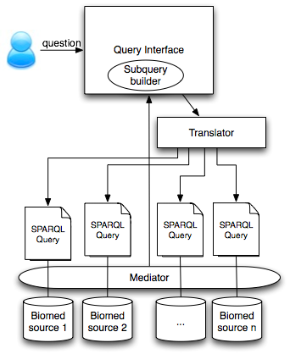

QueryMed will include the following features:

- Sub-query builder will provide SPARQL query flattening. This is similar to how view flattening is done with most SQL implementations. However, we propose to provide a faceted browsing interface to filter the terms of interest.
- Query translator will provide a mapping between user questions and SPARQL. The translator will not be limited to pre-defined template structure.
- Query mediator to abstract the data sources and provide a system that is preloaded with the ontologies used to describe biomedical data.
- Dynamic visual interfaces that provide the user with the means to create and refine a query without requiring prerequisite knowledge of the data or query language.
- Provide information as to where the data is coming from to explain the query results to the user and also to provide assurance of the trustworthiness of the data.
- Provide the option of caching data for performance, or have it queried from remote endpoints.
- Present the answers to the queries, and allow the user to modify the query: for e.g. "what-if" scenarios.

