R-Store

Seneviratne, Oshani
CSAIL
M.I.T.
oshani@mit.edu
Moscicki, Angelique
CSAIL
M.I.T
moscicki@mit.edu
Herrero-Lopez,Sergio
CEE
M.I.T
sherrero@mit.edu

ABSTRACT
The Resource Description Framework is the foundation of the Semantic Web. This new file format has been accepted worldwide and both the research community and the industry are continuously generating RDF data. In order to make use of the full potential of the web, tools that exploit this data are necessary. This paper describes a system for representing RDF data in a relational database. Instead of using the conventional triples table, it analyzes the RDF to produce wide representations that enhance query performance. At the same time, it reduces space overhead by generating schemas that minimize the number of nulls.
General Terms
Algorithms, Performance, Design, Languages, System.
Keywords
Resource Description Framework, Relational model, triple, subject, predicate, object.

INTRODUCTION
Resource Description Framework (RDF) is a standard developed by the World Wide Web Consortium for Web Based Meta data. The primary purpose of expressing information in RDF is to provide semantics to the data that is represented. It defines statements about resources in the form of Subject-Predicate-Object expressions, called triples in the RDF terminology. The RDF schema describes the basic elements for the description of ontologies and intends to structure RDF.
The simplest solution to persist RDF data triples is to create a single flat table with three columns, one for each element of the triple. Unfortunately, this representation leads to serious performance issues because queries involve many self-join over the same table.

Permission to make digital or hard copies of all or part of this work for personal or classroom use is granted. This paper is a deliverable of the MIT 6.830 Database Systems Course.
This research describes the design and implementation of R-Store, a tool that given a RDF data set, generates the corresponding relational schema. This allows getting the benefits of the query performance of relational databases (RDB) and avoiding the problems created by self-joining a single table.
Section II, explains briefly previous attempts to solve this problem. The data set considered for this paper is introduced in Section III. Section IV defines the some of the terms used in the paper and gathers the limitations of R-Store. Section V describes the details of the design of the R-Store, giving details of the implementation of each of the modules that contains. The RDF Schema- Based (RDFSB) schema generation algorithm is explained in Section VI, while Section VII introduces he Statistics-Based (SB) schema generation algorithm. Section VIII, compares side-by-side both algorithms and the generated schemas. The conclusion of this study is shown in Section IX.

PREVIOUS WORK
There are many RDF stores implemented which store the RDF data, but there is no known free and open source implementation for conversion of data represented in RDF to a relational database schema.
Oracle has also produced a solution to this problem [cite]. The Oracle solution stores the triples in a triples table, but allows the user to create materialized views on self-joins of the triples table via the Oracle TABLE function. It also creates Property Tables similar to the solution proposed in this paper, but does not attempt to eliminate null values.
The popular RDF Stores such as Sesame [cite - 1] could be deployed on top of a variety of storage systems including relational databases, but all these known system store the RDF data in the triple format (i.e. Subject, Predicate, Object) and does not attempt to create an actual relational database schema out of the RDF data.

SAMPLE DATA SET

A complete RDF data set and the corresponding RDF schema have been generated for this research.
The generated RDF schema contains the following elements:
- RDF classes: Person, Course, Student, Teacher, Location, Department
- RDF properties: office, department, teachers, students, name, year
For this research we considered that students are only allowed to take one course. Next, the relations between classes were analyzed:

- Many To Many: Courses are taught by one or many teachers. One teacher can teach on one or many courses.
- One To Many: A course has one or many students.
- Many To One: Many students belong to one department.
- One To One: Office numbers are associated to a unique address.
Examples of the RDF classes and relations are shown in Figure 1.

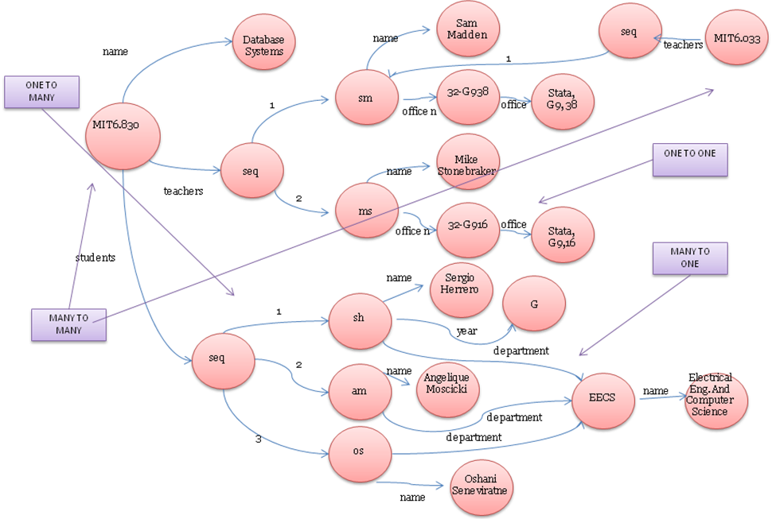
Figure 1: RDF graph of the data set used

TERMS AND CONSTRAINTS

Terms

Property Tables:
A Property Table, as used in this paper, is a relational database schema keyed on a single Class. The other columns are attributes related to the primary key via a single arc in the RDF graph. Additionally, there is a type of Property Table which represents a many-to-many relation. It is keyed on two Classes, and has no additional columns. As before, the two columns are related via an arc in the RDF graph.

Predicate Rules:
Because an RDF Property can have multiple Subject and Object Classes, it became necessary to identify arcs in RDF by the triplet Subject Class, RDF Property, and Object Class. This structure will be referred to as a Predicate Rule. Alternatively, a Predicate Rule can be viewed as a template for an arc in the RDF graph with all Blank Nodes removed.

Blank Nodes:
It is possible in RDF to use Blank Nodes to implicitly specify the existence of an entity not defined in the RDF Schema. Using Blank Nodes results in triples of the form < S, P1, [Blank Node] >, and < [Blank Node], P2, O >, where each Blank Node has a unique identifier. It is not immediately clear from this syntax how to represent this information in a relational database schema, because no name exists for the implicitly defined entity. Without knowing a Class, it is difficult to impossible to assign any meaning to the Blank Node without intervention on the part of the user.
Our system adopts the view that Blank Nodes specify membership in a set associated with the Subjects of statements whose Objects are Blank Nodes. In the example above, the presumed goal is to associate the Object O with the Subject S via Property P1. Statistics-Based algorithm examines the Blank Nodes in the RDF Store, and constructs a set of Predicate Rules which are not defined in the RDF Schema by examining which Object Classes are associated with a given Subject Class and Property by matching the Blank Node identifiers. Properties in triples whose Subject is a Blank Node are discarded because they are assumed to mean nothing more than membership in the set of Objects associated with a given Subject.

Constraints

RDF Syntax subset:
Today, the R-Store accepts a limited subset of the entire RDF syntax. The results and conclusions obtained from research do not contemplate all the details of the RDF recommendation. Nevertheless, we believe that the R-Store could be extended to accept any RDF without modifying the ideas and procedures followed by this paper.

Memory and Scalability:
The performance constraints that we set for ourselves were that we never need to have the entire RDF store in memory at one time, because presumably real RDF stores are too big to put in memory. Since the solution is most likely a one-time cost, time was not a critical factor.

Static Assumption:
The system assumes that the RDF store is static. Given the unconstrained nature of RDF, it is impossible to algorithmically predict future modifications to the structure of the RDF store.

DESIGN
The design architecture of R-Store is shown in Figure 2. The R-Store is composed by three mayor modules:

1.- RDF Store: This module is in charge of parsing RDF files and their corresponding RDFS schema. When the files are processed, the RDF Store generates iterators so that following modules can manipulate this data. Also it constructs a predicate table so that the schema generator can collect statistics.

2.- Schema Generator: This module takes the predicate table as input and executes two different algorithms, RDFSB and SB, in order to determine the relational schema of the RDF model.

3.- DB Populator: When the relational schema is generated, the DB Populator constructs the necessary SQL Data Definition Language (DDL) statements to create the tables in the database. After the relational schema is created in the database, DB Populator gets the triple iterator from the RDF Store and combines SQL Data Manipulation Language (DML) commands to populate the database.

After the database is populated RDF data can be using standard SQL statements.

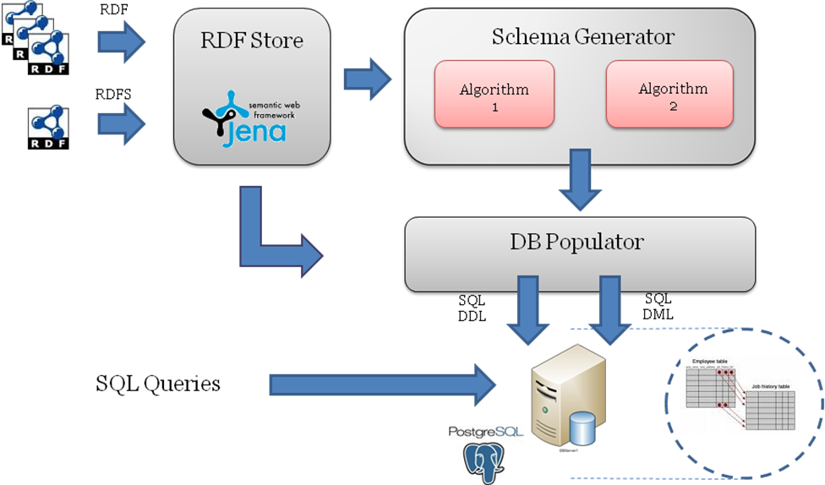
Figure 2: R-Store Design

RDF Store
RDF Store is in charge of parsing RDF files and RDFS schemas. It provides resources to the Schema Generator and the DB Populator to analyze the data.

Jena Semantic Web Framework is extensively used for this task. It provides an Open Source RDF API that allows manipulating triples and schemas. The RDF Store:
- Generates triple iterators.
- Extracts Subject classes from the RDFS schema and classifies triples with the same subject.
  - Maps subjects -> subject classes
  - Given a subject class returns all the subjects of that class.
- Constructs the predicate table.
  - For each predicate generates the map:
(qualified predicate) -> (subject class, object class)
  - This table is sent to the Schema Generator (SG). The SG infers the relational schema by obtaining statistics from the predicate table.

Schema Generator
The Schema Generator offers the user a choice of two algorithms to use to produce relational database schemas. The algorithms will be described in detail in subsequent sections.
Currently, there is no comparison between the outputs of the two algorithms, the decision of which output to use falls on the user. The algorithm to use is specified as a command line argument. In both cases, the output is a representation for a relational database schema, and rules for how to populate them.

Database Populator
Depending on the choice of algorithm, this module will insert the RDF triples into the database either with SPARQL queries over the RDF in the case of the RDFS Schema Based Algorithm, or by using the Predicate Rules produced by the Statistical Algorithm.
In both cases, the RDF data is inserted on a statement by statement basis; it does not construct the actual tuples which will reside in the relational database in memory. This increases the number of UPDATE and INSERT statements necessary to populate the database, but it obeys the memory constraint. Currently, the Database Populator is written to interact with Postgres SQL only.

RDF SCHEMA-BASED ALGORITHM
The main idea behind this algorithm is to discover mappings between the ontology represented by the RDF data and a suitable relational database schema that would represent any data that falls within this ontology. We are making the assumption that usually some approximate correspondences exist between the two, although relational databases are based on closed-world assumption while RDF use open-world semantics.

Schema Generation

This algorithm takes in to account the semantics expressed in the RDF Schema. Based on the sub class relationships, and the property constraints, it will determine the classes which are likely to be represented as a relation in the database and the attributes of each of these relations, as shown in Figure 3.

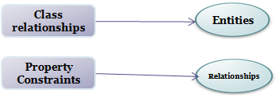
Figure 3: Mapping from RDFS to RDB

First, it considers all the classes in the RDFS and filters the classes which are the leaf classes (i.e the classes which are not subclassed from any other class). The algorithm assumes that these classes are likely to be relations.
Then to determine the cardinality of the relations, this algorithm looks at the RDFS property constraints associated with each of the classes already identified as relations. If a property has a range and a domain (or even multiple ranges and domains), the algorithm deduces that this property could represent a cardinality relationship in the RDB Schema. The distinction as to ONE-TO-ONE, ONE-TO-MANY and MANY-TO-MANY is made based on the following criteria:

[Give examples to what is stated in words]

One To One

Basically, the classes which are not a super class of another class, i.e. all the leaf level classes in the RDF Schema falls in to this category. Also if the range of the property is an RDF literal (or any similar category), the algorithm determines that this property could very well fit as an attribute in the class(es) given in the domain(s).

One To Many

If the range of the property matches an RDF collection attribute such as rdfs:seq, the algorithm assumes that there is a ONE-TO-MANY relationship based on the property considered. Therefore, another relation is added which takes the form of {DOMAIN CLASS}{propertyName} with a foreign key reference to primary key of the relation which represents the domain class.

Many To Many

If both the range and the domain of the property matches to classes which are already identified as a relation in the RDF, create a MANY-TO-MANY relations such as {DOMAIN CLASS}{RANGE CLASS}with foreign key references to both primary keys of the relations which represent the domain and the range classes.

The relations are not created on the fly because it is not possible to create references to relations which do not exist already. Therefore this works in 2 steps where the algorithm identifies which relations need to be created and then first create relations which are members of ONE-TO-ONE relationships, and then move on to other types of relationships.

In order to populate the tables from the data triples, it first iterates over the tables generated, and based on the primary key(s), gets the relevant attributes through SPARQL queries over the RDF Store

Limitations of the Algorithm

In order for this algorithm to work, there should be RDFS describing all the class and property relationships used in the actual data represented by the RDF.

This algorithm fails to make provisions for tables that get created but are not populated

STATISTICS-BASED ALGORITHM

Algorithm Description

The primary optimization method adopted by Statistics-Based algorithm is arc reversal. The key assumption is that for every triple which represents a valid Predicate Rule, the information contained therein should reside either in the Property Table keyed on the Subject Class, or the Property Table keyed on the Object Class. This is a huge simplification to the problem, and the limitations of it will be discussed in a later section.

Statistics-Based algorithm is based on two statistics on each arc in the RDF graph; the cardinality and the frequency. Here an arc is defined to be a Predicate Rule determined from the RDF Schema, or one that was generated by removing Blank Nodes. Both of these statistics are gathered in two iterations over the RDF store, but require that the Predicate Rules already be constructed.

The cardinality of an arc determines whether the arc is a one-to-one, many-to-one, one-to-many, or many-to-many relation. In this case, a one-to-one cardinality does not mean one-to-one in the mathematical sense, but rather the weaker statement that the arc is at most one-to one. It need not exist for every Subject of a given class. The cases where it does not exist are precisely those places where null values could arise from.

The cardinality is determined by two iterations over the RDF store, once over the triples as they have been parsed, and once over the triples with the Subjects and Objects reversed. In both cases, the triples are traversed in sorted order, on the Subject field. That means that in the reversed set, the triples are really sorted on their Object field. Its possible to determine whether a Predicate Rule has cardinality one-to-one or one-to-many by checking the types of arcs (Predicate Rules) coming out of each Subject. Because the triples are sorted on Subject, only those arcs which refer to a given Subject must be stored in memory at once. As soon as a different Subject is encountered, the algorithm is certain that it will never encounter that Subject again, and can make a decision about the cardinality of each arc. The decision is recorded in a two dimensional mask table, indexed on Subject Class and Predicate Rule. In order to find out about the other two cardinalities, the algorithm repeats the same procedure on the reversed set of triples. This is valid because by reversing the Subject and Object, we have reversed the direction of all the arcs. Arcs that were one-to-many have become many-to-one. Arcs that were many-to-many or one-to-one have not changed their cardinality. In light of this, if the algorithm determines that a reversed arc relation is one-to-many, it looks in the mask table to check if the forward iteration also determined it to be one-to-many. If so, the cardinality of this arc is many-to-many. Otherwise, it is many-to-one.

The frequency of an arc is just a count of how many times it occurs in the RDF store. This is recorded straightforwardly in a single pass over the RDF store without reversal. The frequencies are written to a two dimensional frequency table analogous to the mask table. Additionally, the number of times a given Subject Class occurs in the RDF store is logged.

Statistics-Based algorithm considers it unacceptable to have more than one column in a table for a given arc. Consider an example where an RDF store consists of books and authors. A book can have several authors, but each author can have at most one book. Statistics-Based algorithm will never construct a relational schema for the books table which has multiple author columns. The rationale behind this decision is that it is very wasteful of space when the one-to-k cardinality is not known, or variable. For example, if all books but one have a single author, it would be unacceptable to construct a schema for the books table with five author columns just because that one book has five authors. Doing so would result in four columns consisting primarily of nulls in the books table, which is precisely the situation to avoid. Statistics-Based algorithm does not attempt to discover if a non-variable or only slightly variable one-to-k cardinality exists. Instead, it reverses the arc direction so that the Subject Class is referred to in the Property Table keyed on the Object Class. In the books and authors example, it would result in each author keeping track of the book he or she wrote. Statistics-Based algorithm views this as a hard constraint, so reversing the arc is the only possible choice when faced with a one-to-many relation. One technical detail related to RDF syntax is that when the Object Class in such a relation is a Literal, it is impossible to reverse the arc because Literals are always leaf nodes in the RDF graph. The alternative is to treat it as a many-to-many relation.

A many-to-many relation can not be solved by a simple arc reversal because either direction could potentially result in many nulls. The solution adopted by Statistics-Based algorithm is to set up a many-to-many table which is keyed on both the Subject Class and Object Class, and contains no other columns.

Many-to-one relations must be expressed in the forward direction of the arc in order to avoid the problem associated with one-to-many relations. Consequently, Statistics-Based algorithm does not attempt to optimize them in any way.

The only remaining cardinality is one-to-one. There are no constraints on arc direction, so we are free to choose whichever direction will produce fewer nulls in the resulting Property Tables. In order to make the decision about arc direction, Statistics-Based algorithm uses the following cost function:

Cost ( Arc Direction ) = Estimated number of nulls

The first term is the estimated number of nulls that would result from assigning the arc to be a column in the Property Table keyed on the Class of the source of the arc. It is the estimated number of instances of the source Class which do not have an arc of this type. This number is the number of instances of the source Class minus the number of instances of the arc (Predicate Rule) in question. Both of these numbers reside in the frequency table. If the cost of the reverse direction arc is lower than that of the forward direction, the arc will be reversed as shown in Figure 4 . Strictly speaking, the instance counts for the Subject and Object Classes are sufficient to make the decision, because the arc will ultimately go in the direction that has a lower instance count for the source Class.
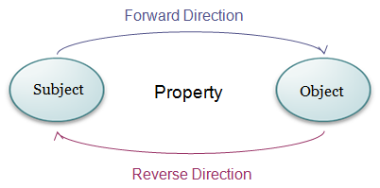
Figure 4: Arc Reversal

Algorithm Limitations

The major limitation of this algorithm arises from the fact that it optimizes using arc reversal alone. It completely disregards chains of one-to-one relations which might otherwise be stored in the same property table, and consequently following a given path in the RDF graph will result in as many joins as there are nodes in the path. Because some of the arcs may have been reversed, it is also likely that these join will not all be on primary keys.

Another limitation is that because it will always reverse the arc which has the smaller count, tables may end up structured differently than the writer of the RDF graph intended. For example, consider what would happen if the RDF store were describing the location of professors’ offices. Suppose that not every professor has an office, but every office contains exactly one professor. Because the relation would be one-to-one and there would be fewer officers than professors, the resulting relational schema would be keyed on offices, not on professors.

A third limitation arises from our assumption about Blank Nodes. In general RDF, a Blank Node does not necessarily have to do with membership in a set; it can have any arbitrary meaning the user can specify for it. The authors of this paper are not aware of a standard concerning the meaning of Blank Nodes. In this implementation, the use of Blank Nodes is restricted to sequences which specify membership in a set.

One final warning or limitation is that the algorithm relies on the RDF being reasonably written. It requires that predicates be used consistently, i.e. do not use two different predicates to express the same information and expect the algorithm to recognize this fact. It requires that predicates are not bidirectional, and at the moment it requires that precisely one subject points to a Blank Node and that Blank Nodes are not chained.

Algorithm Performance

Blank Nodes introduced a violation of the memory constraint mentioned earlier. In order to discover the implicit Predicate Rules and gather statistics on them, we had to load all the statements which contained a Blank Node into memory for further processing. In the worst case, this could require every statement to be loaded into memory. The solution to this problem, which we have not implemented, is to process each Blank Node individually by loading only those statements which contain a particular Blank Node identifier into memory, and calculating the statistics incrementally as opposed to aggregating over the whole set. This solution would greatly increase the time required for the algorithm to execute, but again since time is not a big concern, this solution is feasible. In order to obey the memory constraint, it would be necessary to implement this incremental Blank Node processing in both the Schema Generator and DB Populator modules. With the current implementation, the space complexity for Statistics-Based algorithm is linear in the number of RDF triples and the time complexity is polynomial. With the incremental implementation, the space complexity would be on the order of the number of distinct arc templates, which we assume is much smaller than the number of triples.

Due to the limited range of RDF syntax R-Store can handle, there is no sizable test set to run R-Store on. All functionality works on small examples, but this is a test for correctness rather than a performance benchmark.

ALGORITHM COMPARISON

These 2 algorithms are quite orthogonal in implementation, but they both create and populate a relational database schema. Table 1shows the comparison of both algorithms.

RDF Schema-based | Statistics-Based
Uses only the RDF Schema to generate the schema | Uses RDF schema and statistics collected from the data triples in order to construct the schema
Widens tables based the properties | By default widens the tables and creates a new table only if it is necessary.
Populates the property tables based on customized SPARQL queries, based on the type (i.e. class) of the relationship that each of the tables are members of | Populates the property tables using the predicate rules assigned for each arc in the RDF graph
Uses the RDF semantics to associate a type to the objects | Collapses Blank Nodes and infers Predicate Rules based on the structure of the data.
Table 1: Characteristics of both algorithms

RDF Schema-based | Statistics-Based
Con:  The RDB schema is based on the RDF Schema only, and it does not try to make any optimizations based on the data distribution in the RDF triples. It is rather costly to count the number of nulls in the entire database schema once it is created and populated with the actual data, and to re-create a new database schema based on the possible optimization. | Pro:  Statistics from the data triples are taken in to account when the schema is generated, thus this algorithm provides a good approximation of a RDB schema which would reduce some number of nulls
Pro:  When creating the RDB schema foreign key constraints are also defined. Therefore it is possible to query over multiple tables. | Con:  Foreign Key constraints are not defined.
Con:  Wasted space may result from tables which are created based on the schema from the leaf classes in the RDF schema, but do not have any triples in the actual data from the RDF store | Con:  Although it optimizes some number of nulls, it does not completely eliminate all the nulls and make the optimized schema
Con:  At the moment only works on a small subset of RDFS specification | Pro:  Since RDFS is not explicitly taken into account in the schema creation, this would be scalable than algorithm 1
Table 2: Pros and Cons of both algorithms

The advantages and disadvantages of each of the approaches are classified in .

CONCLUSION AND FUTURE WORK

There are many directions to extend this system in, both in terms of functionality and performance optimization.

The most important extension of this system would be to enable it to handle a larger subset of RDF, including chained Blank Nodes, and other uses for Blank Nodes in RDF than sequences.

In terms of software, the Blank Node handling procedure that does not violate the memory constraint must be implemented, as well as an extension Jena to facilitate creating the reversed triple set mentioned in the discussion on Statistics-Based algorithm. At the present, Jena does not to the authors’ knowledge support reversing the Subject and Object of RDF statements, though enabling it to do so seems to be a small extension of the library.

In terms of theory, given more time it is possible to construct an algorithm which can detect one-to-k cardinalities and to consider relational schemas which make use of them if the cost were sufficiently low. It may be possible to consider schemas which include Subjects and Objects separated by more than a single arc without expanding the solution space such that the problem becomes intractable.

RDF is an unconstrained standard, and a relational database is a constrained representation. In order to get the significant performance benefits associated with using a relational database, constraints must imposed on the problem. Imposing constraints will always incur a cost either in time (on query performance) or in space (wasted space due to nulls), or both. R-Store is a system which attempts to reduce the cost in query performance by reducing the wasted space, and at the same time eliminate the need for many self-joins over a single monolithic triples table. Towards that end, R-Store has succeeded in developing heuristics which solve the problem reasonably well, but can not guarantee an optimal result. Although it works over only a small subset of RDF, it is a working system. It is one of only two tools [Daniel citation] which avoid a triples table. Given the growing popularity of RDF, there will certainly be a need for such tools in the future.

REFERENCES

