R-Store

Seneviratne, Oshani
CSAIL
M.I.T.
oshani@mit.edu
Mosiscki, Angelique
CSAIL
M.I.T
moscicki@mit.edu
Herrero-Lopez,Sergio
CEE
M.I.T
sherrero@mit.edu

ABSTRACT
The Resource Description Framework is the foundation of the Semantic Web. This new file format has been accepted worldwide and both the research community and the industry are continuously generating RDF data. In order to make use of the full potential of the web, tools that exploit this data are necessary. This paper describes a system for representing RDF data in a relational database. Instead of using the conventional triples table, it analyzes the RDF to produce wide representations that enhance query performance. At the same time, it reduces space overhead by generating schemas that minimize the number of nulls.
General Terms
Algorithms, Performance, Design, Languages, System.
Keywords
Resource Description Framework, Relational model, triple

INTRODUCTION
Resource Description Framework (RDF) is a standard developed by the World Wide Web Consortium for Web Based Meta data. It defines statements about resources in the form of Subject-Predicate-Object expressions, called triples. The RDF schema describes the basic elements for the description of ontologies and intends to structure RDF.
The simplest solution to persist RDF data triples is to create a single flat table with three columns, one for each element of the triple. Unfortunately, this representation leads to serious performance issues because queries involve many self-join over the same table.

Section II, explains briefly previous attempts to solve this problem. The data set considered for this paper and the limitations associated to this data set are introduced in Section III. Section IV describes the details of the design of the R-Store, giving details of the implementation of each of the modules that contains. The RDFS- Based (RDFSB) schema generation algorithm is explained in Section V, while Section VI introduces he Statistics-Based (SB) schema generation algorithm. Section VII, compares side-by-side both algorithms and the generated schemas. The conclusion of this study is shown in Section VIII.

PREVIOUS WORK
All material on each page should fit within a rectangle of 18 x 23.5 cm (7" x 9.25"), centered on the page, beginning 2.54 cm (1") from the top of the page and ending with 2.54 cm (1") from the bottom. The right and left margins should be 1.9 cm (.75”).

DATA SET AND CONSTRAINTS

Data Set
A complete RDF data set and the corresponding RDF schema have been generated for this research.
Permission to make digital or hard copies of all or part of this work for personal or classroom use is granted. This paper is a deliverable of the MIT 6.830 Database Systems Course.

The generated RDF schema contains the following elements:
- RDF classes: Person, Course, Student, Teacher, Location, Department
- RDF properties: office, department, teachers, students, name, year
For this research we considered that students are only allowed to take one course. Next, the relations between classes were analyzed:
- Many To Many: Courses are taught by one or many teachers. One teacher can teach on one or many courses.
- One To Many: A course has one or many students.
- Many To One: Many students belong to one department.
- One To One: Office numbers are associated to a unique address.
Examples of the RDF classes and relations are shown in Figure 1.

Constraints
Today, the R-Store accepts a limited subset of the entire RDF syntax. The results and conclusions obtained from research do not contemplate all the details of the RDF recommendation. Nevertheless, we believe that the R-Store could be extended to accept any RDF without modifying the ideas and procedures followed by this paper.

First Page Copyright Notice
Please leave 3.81 cm (1.5") of blank text box at the bottom of the left column of the first page for the copyright notice.

Subsequent Pages
For pages other than the first page, start at the top of the page, and continue in double-column format. The two columns on the last page should be as close to equal length as possible.

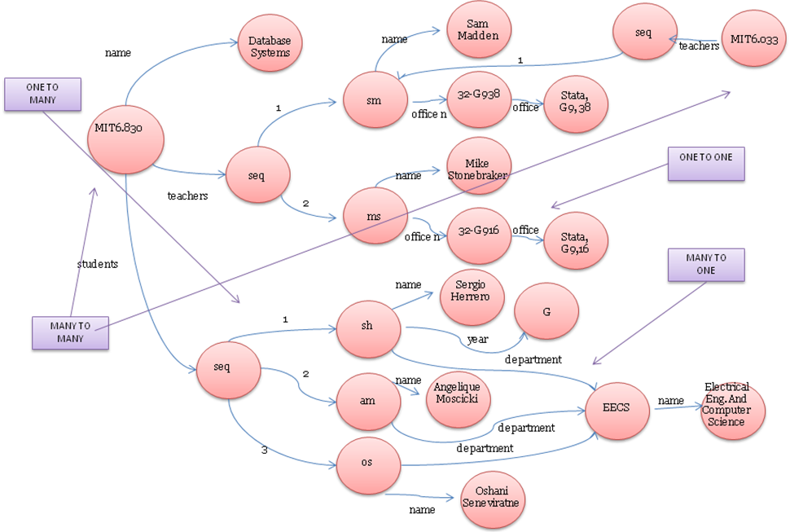
Figure 1: RDF graph of the data set used

Table 1. Table captions should be placed above the table
Graphics | Top | In-between | Bottom
Tables | End | Last | First
Figures | Good | Similar | Very well

References and Citations
Footnotes should be Times New Roman 9-point, and justified to the full width of the column.
Use the standard Communications of the ACM format for references – that is, a numbered list at the end of the article, ordered alphabetically by first author, and referenced by numbers in brackets [1]. See the examples of citations at the end of this document. Within this template file, use the style named references for the text of your citation.
The references are also in 9 pt., but that section (see Section 7) is ragged right. References should be published materials accessible to the public. Internal technical reports may be cited only if they are easily accessible (i.e. you can give the address to obtain the report within your citation) and may be obtained by any reader. Proprietary information may not be cited. Private communications should be acknowledged, not referenced (e.g., “[Robertson, personal communication]”).

Page Numbering, Headers and Footers
Do not include headers, footers or page numbers in your submission. These will be added when the publications are assembled.

FIGURES/CAPTIONS
Place Tables/Figures/Images in text as close to the reference as possible (see Figure 1). It may extend across both columns to a maximum width of 17.78 cm (7”).
Captions should be Times New Roman 9-point bold. They should be numbered (e.g., “Table 1” or “Figure 2”), please note that the word for Table and Figure are spelled out. Figure’s captions should be centered beneath the image or picture, and Table captions should be centered above the table body.

SECTIONS
The heading of a section should be in Times New Roman 12-point bold in all-capitals flush left with an additional 6-points of white space above the section head. Sections and subsequent sub- sections should be numbered and flush left. For a section head and a subsection head together (such as Section 3 and subsection 3.1), use no additional space above the subsection head.

Subsections
The heading of subsections should be in Times New Roman 12-point bold with only the initial letters capitalized. (Note: For subsections and subsubsections, a word like the or a is not capitalized unless it is the first word of the header.)

Subsubsections
The heading for subsubsections should be in Times New Roman 11-point italic with initial letters capitalized and 6-points of white space above the subsubsection head.

Subsubsections
The heading for subsubsections should be in Times New Roman 11-point italic with initial letters capitalized.

Subsubsections
The heading for subsubsections should be in Times New Roman 11-point italic with initial letters capitalized.

ACKNOWLEDGMENTS
Our thanks to ACM SIGCHI for allowing us to modify templates they had developed.

REFERENCES
- Bowman, B., Debray, S. K., and Peterson, L. L. Reasoning about naming systems. ACM Trans. Program. Lang. Syst., 15, 5 (Nov. 1993), 795-825.
- Ding, W., and Marchionini, G. A Study on Video Browsing Strategies. Technical Report UMIACS-TR-97-40, University of Maryland, College Park, MD, 1997.
- Fröhlich, B. and Plate, J. The cubic mouse: a new device for three-dimensional iput. In Proceedings of the SIGCHI conference on Human factors in computing systems
(CHI ’00) (The Hague, The Netherlands, April 1-6, 2000). ACM Press, New York, NY, 2000, 526-531.
- Lamport, L. LaTeX User’s Guide and Document Reference Manual. Addison-Wesley, Reading, MA, 1986.
- Sannella, M. J. Constraint Satisfaction and Debugging for Interactive User Interfaces. Ph.D. Thesis, University of Washington, Seattle, WA, 1994.

Columns on Last Page Should Be Made As Close As Possible to Equal Length

