INTRODUCTION

(brief RDF background…… Oshani)

(problem statement)

(Why are we doing this Oshani?)

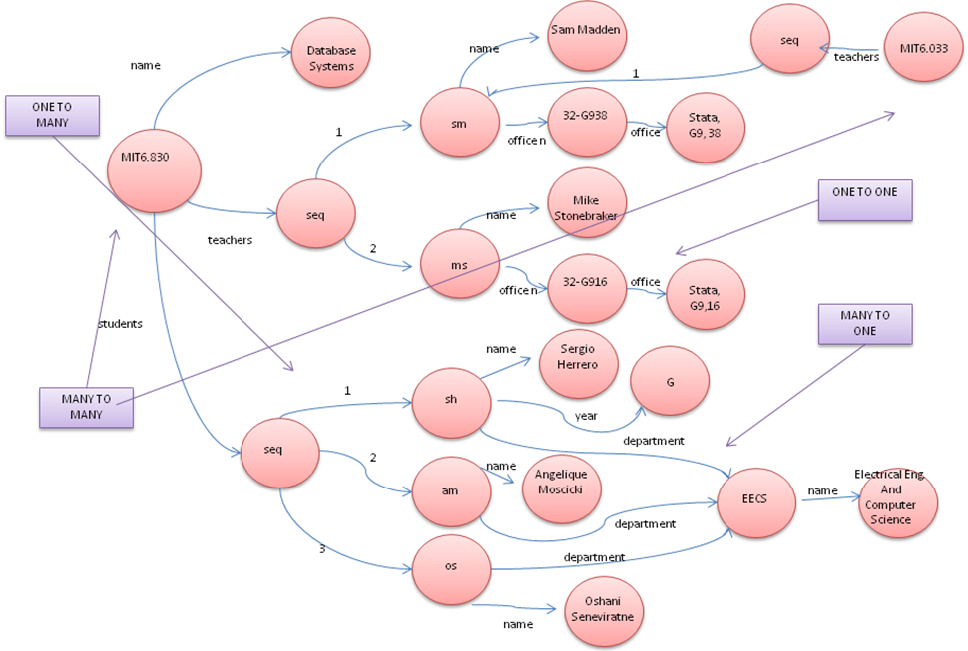

DESIGN:

The design architecture of R-Store is shown in figure X. The R-Store is composed by three mayor modules:

1.- RDF Store: This module is in charge of parsing RDF files and their corresponding RDFS schema. Once that the files are processed, the RDF Store generates iterators so that following modules can manipulate data and constructs a Predicate Table so that the schema generator can collect statistics.

2.- Schema Generator: This module takes the Predicate Table as input and executes two different algorithms to determine the relational schema of the RDF model.

3.- DB Populator: Given a relational schema, the DB Populator generates the necessary SQL DDL statements that will create the tables in the database. After the relational schema is created, DB Populator gets the triple iterator from the RDF Store. Then it SQL DML commands to populate the database.

After the database is populated RDF data can be queried to the database using standard SQL statements.

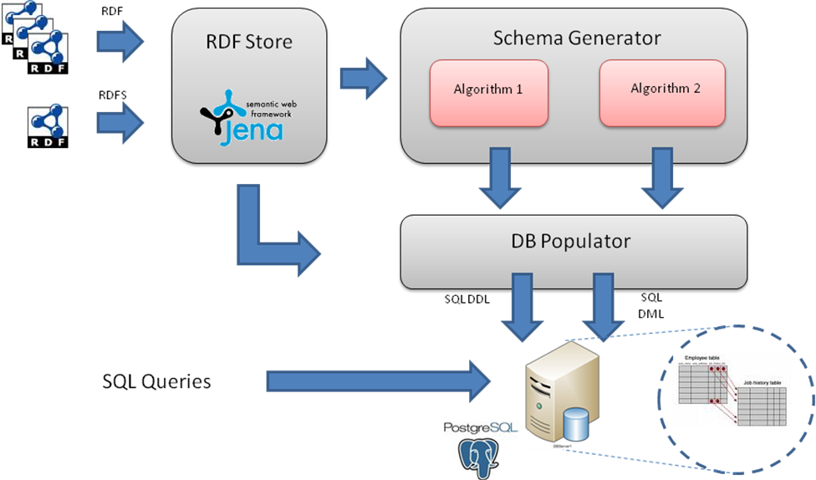

RDF STORE

RDF Store is in charge of parsing RDF files and RDFS schemas. It provides resources to the Schema Generator and the DB Populator to analyze the data.

Jena Semantic Web Framework is extensively used for this task. It provides an Open Source RDF API that allows manipulating triples and schemas.

The RDF Store:

- Generates triple iterators.
- Extracts Subject classes from the RDFS schema and classifies triples with the same subject.
  - Maps subjects -> subject classes
  - Given a subject class returns all the subjects of that class.
- Constructs the predicate table.
  - For each predicate generates the map:
(qualified predicate) -> (subject class, object class)
  - This table is sent to the Schema Generator (SG). The SG infers the relational schema by obtaining statistics from the predicate table.

