Anson’s Individual Document

|  |  |  |  |  |  |  |
| --- | --- | --- | --- | --- | --- | --- |
| Test No. | Description | Input | Expected Output | Actual output | Status | Remarks |
| 1 | Press on PLAY button, go to gameplay scene | Left click | Go to gameplay scene | Go to gameplay scene | PASS | nice |
| 2 | Press on INSTRUCTION button, go to instruction scene | Left click | Go to instruction scene | Go to instruction scene | PASS | nice |
| 3 | When player press on QUIT button, the closes | Left click | Application closed | Game end, application closed | PASS | Nice work buddy |
| 4 | When player press on RESTART button, the game restarts | Left click | Game restarts, go to menu scene | Game restarts and go to menu scene | PASS | Damn ur good |
| 5 | When player press BACK button, player go to menu scene from instruction scene | Left click | Player goes to menu scene | Player goes to menu scene | PASS | Dammit I should’ve used this |
| 6 | Player should be able to restart game in game lose scene | Mouse | Player restarts game | Restart button is working | PASS | nice |
| 7 | When the timer reaches 0 seconds, the player wins the game | NIL | When timer is 0, player win the game | When timer reaches 0, game win | PASS | creative |
| 8 | When the player press F, flash light will turn on | F | When the player press F, the flashlight will be turned on | When the player press F, flashlight is on | PASS | F to pay respects? |
| 9 | When the Game starts, BGM will be played | NIL | When the game starts, BGM will play | When the game starts, BGM plays | PASS | Nice songs |
| 10 | When the player lost the game, an audio sound will be played | NIL | When the player loses the game, sound will be played | When the player lost the game, horror sound played | PASS | Wow funny |

**Test Case**

**Things Anson implemented**

* Enemy A.I
* Spawner (Los Pollos Hermanos Chicken Recipe)
* BGM & Sound Effects
* Backrooms Assets

**Things Josh implemented**

* Movement
* Map design
* Flashlight mechanic
* Bryan.PNG

**Things Qi Hang implemented**

* Timer
* Menu Scene
* Win Scene
* Instruction Scene
* Lose Scene

**Branches and Merges**

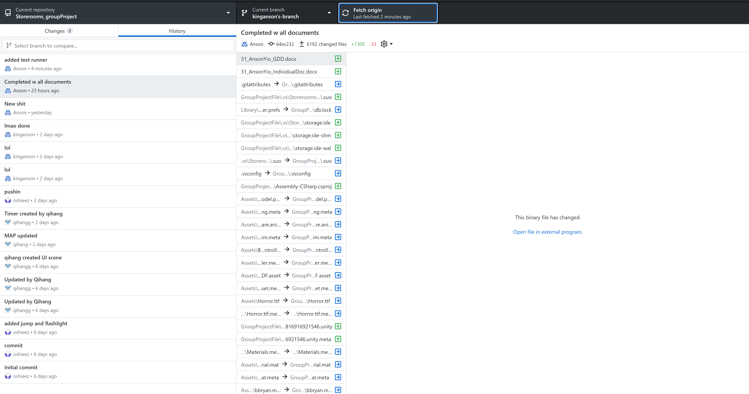

**Test Runner**

