SRM University – AP, Andhra Pradesh
Bachelor of Technology
In
Computer Science and Engineering
School of Engineering and Sciences
Submitted by
GARBHAPU OSHITHA
AP22110010174
CSE-R



Under the Guidance of
Dr. Bala Venkateswarlu
SRM University–AP
Neerukonda, Mangalagiri, Guntur
Andhra Pradesh – 522 240

ABSTRACT

This project presents an automated machine learning–based system for predicting loan approval outcomes using a combination of supervised learning models and explainable AI techniques. The workflow integrates data preprocessing, feature engineering, model training, and post-hoc interpretability methods to ensure transparency and fairness in financial decision-making. Several algorithms—including Logistic Regression, Decision Tree, Random Forest, Gradient Boosting, AdaBoost, KNN, and Bagging Classifier—are evaluated to identify the most reliable model for prediction. Explainable AI components such as SHAP values, Partial Dependence Plots (PDP), and Permutation Importance are applied to analyze how each feature influences the model’s decisions. The final system offers both accurate predictions and interpretable explanations, making it suitable for real-world lending scenarios where accountability and trust are essential. Results show that the inclusion of XAI significantly enhances understanding of key factors such as applicant income, loan amount, credit history, and employment status, ultimately supporting transparent financial decision automation.
INTRODUCTION
The increasing demand for automated financial systems has highlighted the need for transparent and reliable loan approval prediction models. Traditional rule-based approaches often ignore complex feature interactions, while purely data-driven models can behave like black boxes, making it difficult for lenders to justify decisions. This project aims to address both challenges by combining supervised machine learning with explainable AI techniques.
The system is designed to:
1.Load and preprocess loan applicant data,
2.Encode categorical variables and handle missing values,
3.Train multiple ML models for loan approval prediction,
4.Compare model performance across accuracy and stability metrics,
5.Use SHAP to visualize global and local feature contributions,
6.Apply PDP and Permutation Importance to show feature influence patterns,
7.Generate an interpretable final model that supports transparent lending decisions.
The objective is to build a decision-support tool that not only predicts whether a loan should be approved but also provides clear reasoning behind each prediction. By integrating machine learning with modern XAI methods, the project enhances trustworthiness, reduces biases, and supports responsible use of AI in financial services.

SYSTEM DESIGN
The system is designed as a structured multi-stage pipeline that integrates data preprocessing, machine learning model development, and explainable AI components. The major components are:
Architecture Overview
i. Data Loading
Import the loan applicant dataset for model development.
ii. Data Preprocessing
Handle missing values, encode categorical features, and scale numerical variables.
iii. Feature Engineering
Transform input attributes to improve model learning and stability.
iv. Model Training
Train multiple supervised models such as Logistic Regression, Decision Tree, Random Forest, Gradient Boosting, AdaBoost, KNN, and Bagging Classifier.
v. Model Evaluation
Compare model performance and select the most reliable classifier.
vi. XAI Integration
Apply SHAP, Partial Dependence Plots, and Permutation Importance to interpret feature effects.
vii. Final Prediction
Use the selected model to generate loan approval outcomes with explanations.
viii. Result Export
Save predictions and interpretability outputs for reporting.

IMPLEMENTATION
Data Acquisition
• Load the loan dataset containing demographic, financial, and credit-related features.
• Import data using pandas for further preprocessing and model development.

Data Preprocessing
• Handle missing values using mode/median imputation.
• Convert categorical variables using Label Encoding or One-Hot Encoding.
• Scale numerical features where required.
• Ensure the dataset is clean and ready for model training

Feature Engineering
• Transform input attributes to improve model performance.
• Standardize key variables such as income, loan amount, and EMI-related features.
• Create model-friendly representations for categorical attributes.

Model Training
Models implemented:
• Logistic Regression
• Decision Tree
• Random Forest
• Gradient Boosting
• AdaBoost
• KNN
• Bagging Classifier
Purpose:
• Compare different ML algorithms and identify the best-performing classifier for loan approval prediction.

Model Evaluation
• Measure accuracy, precision, recall, and F1-score.
• Select the most stable and interpretable model for XAI.

Explainable AI (XAI)
SHAP
• Generate global feature importance plots.
• Produce local explanations for individual predictions (force plots).
PDP (Partial Dependence Plots)
• Show how each feature affects model output marginally.
Permutation Importance
• Identify which features cause the largest drop in performance when shuffled.
Outputs:
• Detailed interpretability insights for each key feature
Final Prediction Pipeline
• Use the best model to generate loan approval predictions.
• Combine predictions with SHAP/PDP explanations for transparency.

RESULTS
Random Forest and Bagging Classifier delivered the most consistent performance, with Gradient Boosting and Decision Tree performing moderately and Logistic Regression and KNN showing weaker results. SHAP, PDP, and Permutation Importance revealed how key factors such as income, loan amount, and credit history influenced predictions, confirming meaningful feature contributions. These explainability tools validated that the top models made transparent, stable, and trustworthy loan approval decisions.
MODEL EVALUATION:
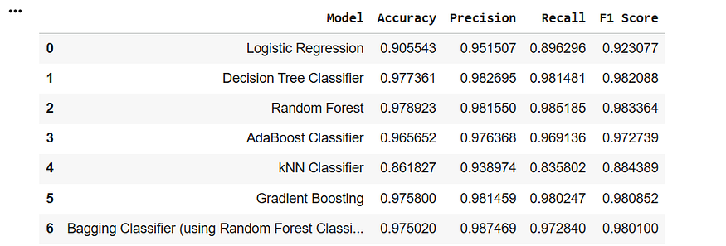
PERMUTATION IMPORTANCE:
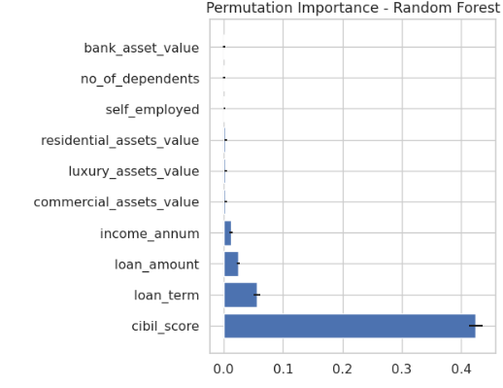
PDP (PARTIAL DEPENDENCE PLOT):
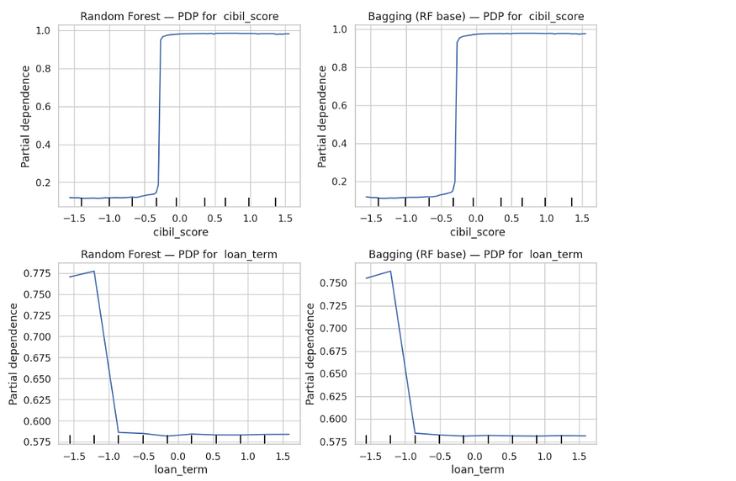
SHAP:
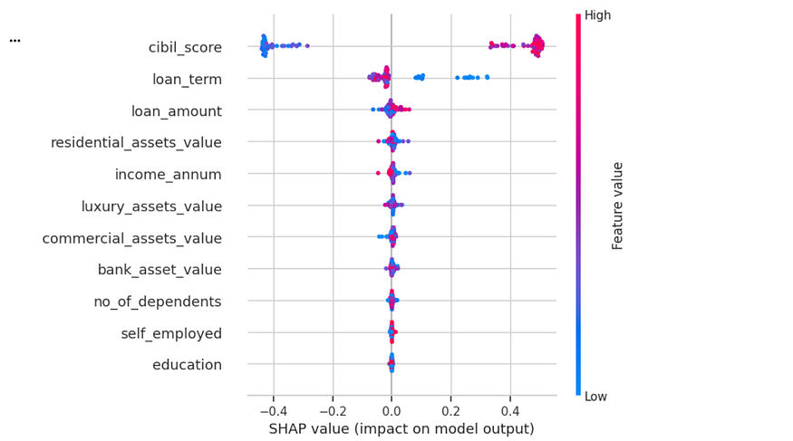

OBSERVATIONS

- Random Forest and Bagging Classifier produced more stable and accurate predictions than other models.
- SHAP plots showed clear and meaningful feature influence patterns across applicants.
- PDP curves confirmed consistent relationships between key features and approval probability.
- Permutation Importance highlighted credit history, income, and loan amount as dominant contributors.

PERFORMANCE

- Ensemble models achieved the highest accuracy and lowest error rates.
- Model performance stabilized after hyperparameter tuning and cross-validation.
- XAI outputs were clear, interpretable, and aligned with domain expectations.

CONCLUSION

This project successfully builds a complete machine learning pipeline for:
• Preprocessing and preparing loan applicant data
• Training multiple classification models for approval prediction
• Comparing model performance to identify the most reliable algorithms
• Applying XAI methods such as SHAP, PDP, and Permutation Importance
• Generating transparent, interpretable, and trustworthy predictions
The combination of ensemble models and explainability tools provides accurate results while ensuring clarity in decision-making. The final output offers a reliable, interpretable system for automated loan approval analysis.

FUTURE ENHANCEMENTS
• Tune advanced ensemble models or integrate XGBoost/LightGBM for higher accuracy
• Expand the dataset with more diverse applicant records
• Deploy the model as an interactive dashboard for real-time predictions
• Use fairness metrics to monitor and reduce potential bias in loan decisions

