Theory of computation

& compiler design PROJECT

(CSE2002)

Prof. Karmel A



WINTER SEMESTER 2016-2017

Analysis Of Research Papers Pertaining To Cellular Automata

* Exploring Cellular Automata
* Various Applications of Cellular Automata

KASHISH MIGLANI(15BCE1003)

OSHO AGYEYA(15BCE1326)

UTSAV RAI(15BCE1352)

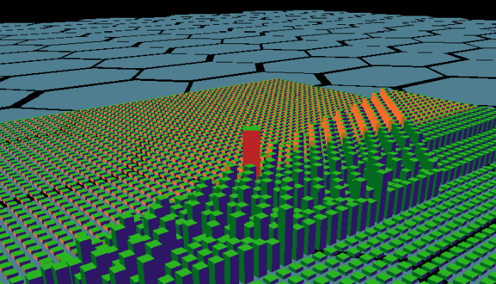

# GENERAL ABSTRACT

1. A cellular automaton is a collection of "coloured" cells on a grid of specified shape that evolves through a number of discrete time steps according to a set of rules based on the states of neighboring cells.



1. Cellular automata have many advantages for geographic modeling. They are capable of supporting very large parameter spaces for simulation.
2. We will be studying various case studies about Cellular Automata and Cellular Automata Models and We will be exploring various common applications related to it.

# FOREST FIRES SPREAD MODELLING USING CELLULAR AUTOMATA APPROACH

## SPECIFIC GROUP MEMBER: Osho Agyeya (15BCE1326)

## MAIL ID: [osho.agyeya2015@vit.ac.in](mailto:osho.agyeya2015@vit.ac.in)

Fire modelling is used to understand and predict possible fire behaviour without getting burned. Fire models are used in different aspects of fire management:

1. Before fire, for risk factor calculation and this would help fire fighters to focus on areas with higher risk and develop better infrastructure.
2. Before fire, for fire fighter training purposes and developing a scenario for training.
3. During fire, for planning fire fighting strategies and this would help fire crews position equipment on the ground so that they can minimize damage and stay safe.

Analysis of research paper will present how we can predict *forest fire spread* using cellular automata. Forest fires are a major loss of animal habitat & human resources. The analysis plays an essential role in designing quick risk management and implementing effective suppression policies. As a preferable modeling approach, the cellular automaton (CA) has been used to understand the complex mechanisms of fire spreading.

REFERENCES

Links:

<http://www.sciencedirect.com/science/article/pii/S0307904X06000916>

<http://www.sciencedirect.com/science/article/pii/S0304380016303064>

<http://www.sciencedirect.com/science/article/pii/S0304380096019424>

<https://en.wikipedia.org/wiki/Cellular_automaton>

<http://www.wolframscience.com/>

<http://natureofcode.com/>

Research Papers:

Forest Fire Modeling Using Cellular Automata and Percolation Threshold, Analysis Sang Il Pak and Tomohisa Hayakawa, Department of Mechanical and Environmental InformaticsTokyo Institute of Technology, Tokyo 152-8552, JAPAN

A simulation software of forest fires based on two-level cellular automata, Giorgio Guariso & Matteo Baracani, Politecnico di Milano, Milan, Italy

Books:

THE NATURE OF CODE: Daniel SHI