MATLAB PROJECT



Fall Semester 2015-2016

Students involved:

1. Osho Agyeya(15BCE1326)-Registered under Uma Maheshwari S.
2. Dhruv Dixit(15BCE1324)-Registered under Mini Ghosh
3. Hargur Partap Singh Bedi(15BCE1257)-Registered under Mini Ghosh

Lab Slot-L19,L20

AIM

The following project is aimed at the demonstration of calculus in economics used by various companies, stock markets and professional institutions for evaluating the functions for monetary parameters such as cost, revenue, profit, loss etc to keep current budget under control while calculating the above mentioned parameters to plan a balanced budget for future.



LIST OF COMMANDS USED

* clc-clearing the screen
* clear all-clearing all pre stored entries in variables
* syms-symbolic calculations
* input-for taking inputs
* subs-for substituting a value in place of a variable in a function
* diff-for differentiating a function
* limit-for findind the limit of a function
* solve-to find the points of a function where it is zero
* figure-to open a new figure window
* hold on-to plot points in same figure window
* hold off- to plot points in new figure window
* fprintf-to print statements
* ezplot-to plot functions
* plot-to plot points
* xlabel-to label x axis
* ylabel-to label y axis
* pause-to plot next graph after pressing enter key
* set-to set the colour of a plot

DESCRIPTION

The program takes the cost function and revenue function as input in terms of x where x is the number of articles. x1 is taken as input which is the number of articles at which the various parameters are supposed to be calculated.

The cost function and revenue function are displayed in the figure window. The cost and revenue at x=x1 are calculated and stored in variables cx1 and rx1.These are also plotted in the same figure window in red colour. The limiting cost and limiting revenue are calculated using limit function and stored in variables lc and lr. These are also plotted in the same figure window in green colour. The expression for tangent at x=x1 is calculated for cost and revenue function and stored in variables tc and tr respectively. These tangents are also plotted in red colour. The expressions for marginal cost and marginal revenue are calculated by differentiating the cost and revenue cost with respect to x, storing them in variables mc and mr respectively. These are plotted in new figure windows. The value of marginal cost and marginal revenue at x=x1 are stored in variables mcv and mrv. These are plotted in the same figure windows in blue colour. The expressions for average cost and average revenue are calculated by dividing c and r by x which are stored in ac and ar respectively. These expressions are plotted in new figure windows. The values of average cost and average revenue are calculated and stored in acv and arv. These are plotted in the same figure windows in yellow colour.

Now, evaluation of extremas of both function is performed. Critical points for cost and revenue and calculated in ccp and rcp variables respectively. For each critical point, the double derivative of the function with respect to x is calculated. On the basis of the double derivative value of the function, maxima, minima and inflexion points are checked and displayed in new figure windows.

The loss or profit obtained on selling x1 articles in stored in res which is displayed in command window. The break even points (points where the cost function is equal to the revenue function) are evaluated and stored in bep variable. These are displayed in new figure window.

The total amount of salary that needs to be given to the employees is taken as an input in the form of a two variable function f(x,y) where x is the total funds of a company while y is the amount of money spent for office maintenance and employee recreation. The local maximas and minimas are calculated for this function by double derivative method and displayed in new figure window on the surface z=f(x,y).

CODE

clc;

syms x y z real;

c=input('Enter the polynomial cost function in terms of x where x is the no. of articles:');

r=input('Enter the polynomial revenue function in terms of x where x is the no. of articles:');

x1=input('Enter the no. of articles:');

cx1=subs(c,x,x1);

rx1=subs(r,x,x1);

res=rx1-cx1;

mc=diff(c,x);

ac=c/x;

mr=diff(r,x);

ar=r/x;

lc=limit(c,x,x1);

lr=limit(r,x,x1);

mcv=subs(mc,x,x1);

mrv=subs(mr,x,x1);

acv=subs(ac,x,x1);

arv=subs(ar,x,x1);

tc=mcv*(x-x1)+cx1;

tr=mrv*(x-x1)+rx1;

bep=real(solve(c-r));

ccp=real(solve(mc));

rcp=real(solve(mr));

mmc=diff(mc,x);

mmr=diff(mr,x);

figure;

hold on;

fprintf('The cost function is given in the figure window.\n');

ezplot(c,[0,x1+25]);

xlabel('No. of articles');

ylabel('Cost');

pause;

fprintf('The cost point corresponding to the no. of articles entered is (%f,%f).\n',double(x1),double(cx1));

plot(double(x1),double(cx1),'r:*');

pause;

fprintf('The limiting cost point corresponding to the no. of articles entered is (%f,%f).\n',double(x1),double(lc));

plot(double(x1),double(lc),'g:*');

pause;

fprintf('The tangent at the cost point is given in the figure window.\n');

t1=ezplot(tc,[0,x1+25]);

set(t1,'color','red');

hold off;

pause;

figure;

hold on;

fprintf('The marginal cost is given in the figure window.\n');

ezplot(mc,[0,x1+25]);

xlabel('No. of articles');

ylabel('Marginal cost');

pause;

fprintf('The marginal cost point corresponding to the no. of articles entered is (%f,%f).\n',double(x1),double(mcv));

plot(double(x1),double(mcv),'b:*');

pause;

hold off;

fprintf('The average cost is given in the figure window.\n');

figure;

hold on;

ezplot(ac,[0,x1+25]);

xlabel('No. of articles');

ylabel('Average cost');

pause;

fprintf('The average cost point corresponding to the no. of articles entered is (%f,%f).\n',double(x1),double(acv));

plot(double(x1),double(acv),'y:*');

pause;

hold off;

figure;

hold on;

fprintf('The revenue function is given in the figure window.\n');

ezplot(r,[0,x1+25]);

xlabel('No. of articles');

ylabel('Revenue');

pause;

fprintf('The revenue point corresponding to the no. of articles entered is (%f,%f).\n',double(x1),double(rx1));

plot(double(x1),double(rx1),'r:*');

pause;

fprintf('The limiting revenue point corresponding to the no. of articles entered is (%f,%f).\n',double(x1),double(lr));

plot(double(x1),double(lr),'g:*');

pause;

fprintf('The tangent at the revenue point is given in the figure window.\n');

t2=ezplot(tr,[0,x1+25]);

set(t2,'color','red');

hold off;

pause;

figure;

hold on;

fprintf('The marginal revenue is given in the figure window.\n');

ezplot(mr,[0,x1+25]);

xlabel('No. of articles');

ylabel('Marginal revenue');

pause;

fprintf('The marginal revenue point corresponding to the no. of articles entered is (%f,%f).\n',double(x1),double(mrv));

plot(double(x1),double(mrv),'b:*');

pause;

hold off;

fprintf('The average revenue is given in the figure window.\n');

figure;

hold on;

ezplot(ar,[0,x1+25]);

xlabel('No. of articles');

ylabel('Average revenue');

pause;

fprintf('The average revenue point corresponding to the no. of articles entered is (%f,%f).\n',double(x1),double(arv));

plot(double(x1),double(arv),'y:*');

pause;

hold off;

figure;

ezplot(c,[0,x1+25]);

xlabel('No. of articles');

ylabel('Cost');

for i=1:1:size(ccp);

d2=subs(mmc,x,ccp(i));

ccpv=subs(c,x,ccp(i));

if(d2==0);

fprintf('The point (%f,%d) is cost inflexion point.\n',double(ccp(i)),double(ccpv));

end;

if(d2<0);

fprintf('The point (%f,%f) is cost point of maxima.\n',double(ccp(i)),double(ccpv));

end;

if(d2>0);

fprintf('The point (%f,%f) is cost point of minima.\n',double(ccp(i)),double(ccpv));

end;

hold on;

plot(double(ccp(i)),double(ccpv),'r:+');

pause;

end;

hold off;

figure;

ezplot(r,[0,x1+25]);

xlabel('No. of articles');

ylabel('Revenue');

for i=1:1:size(rcp);

d2=subs(mmr,x,rcp(i));

rcpv=subs(r,x,rcp(i));

if(d2==0);

fprintf('The point (%d,%d) is revenue inflexion point.\n',double(rcp(i)),double(rcpv));

end

if(d2<0);

fprintf('The point (%d,%d) is revenue point of maxima.\n',double(rcp(i)),double(rcpv));

end

if(d2>0);

fprintf('The point (%d,%d) is revenue point of minima.\n',double(rcp(i)),double(rcpv));

end

hold on;

plot(double(rcp(i)),double(rcpv),'r:+');

pause;

end

hold off;

if(res>0);

fprintf('The profit obtained on selling %d articles is %f.\n',x1,double(res));

elseif(res<0);

fprintf('The loss obtained on selling %d articles is %f.\n',x1,-1*double(res));

else

fprintf('Neither profit nor loss is obtained on selling %d articles.\n',x1);

end;

figure;

xlabel('No. of articles');

g1=ezplot(c,[0,x1+25]);

set(g1,'color','green');

hold on

g2=ezplot(r,[0,x1+25]);

set(g2,'color','blue');

for i=1:1:size(bep);

fprintf('The break even point is (%f,%f).After this point either profit or loss occurs.\n',double(bep(i)),double(subs(c,x,double(bep(i)))));

plot(double(bep(i)),double(subs(c,x,double(bep(i)))),'r:*');

pause;

end

hold off;

f=input('Enter the total amount of salary that needs to be given to the employees in terms of x and y where x represents the total funds of the company and y represents the total money spent for office maintenance and employee facilities:');

fx=diff(f,x);

fy=diff(f,y);

[ax,ay]=solve(fx,fy);

fxx=diff(fx,x);

fxy=diff(fx,y);

fyy=diff(fy,y);

D=fxx*fyy-(fxy)^2;

for i=1:1:size(ax)

T1=subs(subs(D,x,ax(i)),y,ay(i));

T2=subs(subs(fxx,x,ax(i)),y,ay(i));

T3=subs(subs(f,x,ax(i)),y,ay(i));

if(double(T1)>0)

if(double(T2)<0)

fprintf('If the boss is happy,the maximum amount of salary that is to be given to the employees is %f rupees.\n',double(T3));

end

if(double(T2)>0)

fprintf('If the boss is disappointed,the minimum amount of salary that is to be given to the employees is %f rupees.\n',double(T3));

end

if(double(T2)~=0)

figure;

fprintf('The given function is plotted in the figure window.\n');

ezsurf(f,[double(ax(i))-2,double(ax(i))+2,double(ay(i))-2,double(ay(i))+2]);

xlabel('Total funds');

ylabel('Money spent for office maintenance and employee facilities');

zlabel('Total amount of salary that needs to be given to the employees');

hold on;

fprintf('The salary to be given is plotted in the figure window.\n');

plot3(double(ax(i)),double(ay(i)),double(T3),'r*','markersize',15);

end

end

end

OUTPUT

For:

c=(x-1)*(x-2)*(x-3)+6; r=(x-1)*(x-4)*(x-5)+20; f=exp(x^2+y^2-4*x);

output in command window is as follows:

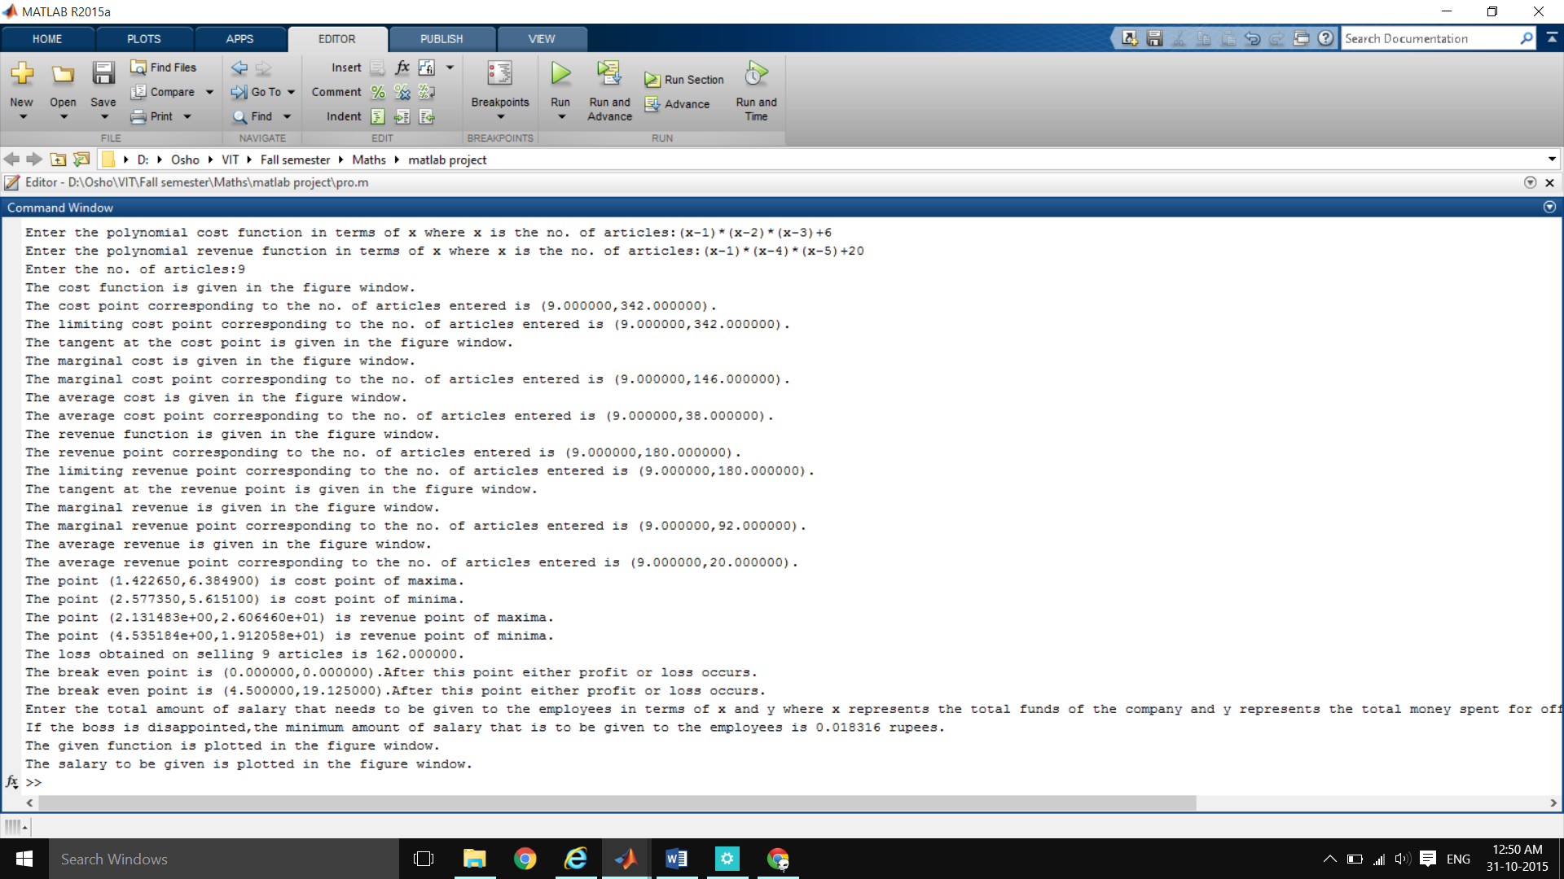

The various figure windows containing plotting in the same order as the above output are given as follows:

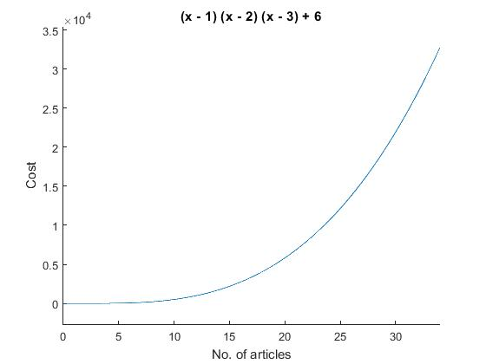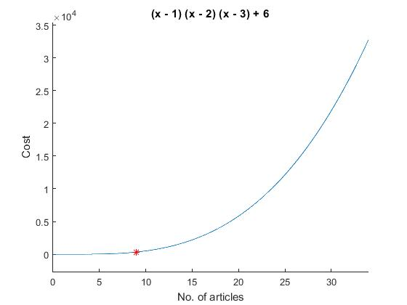

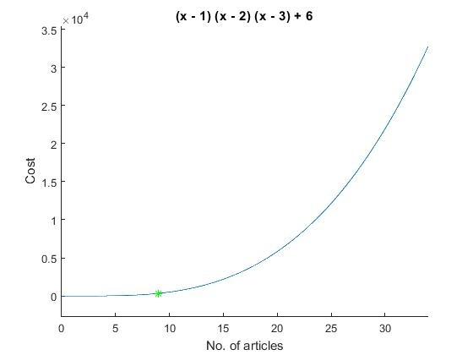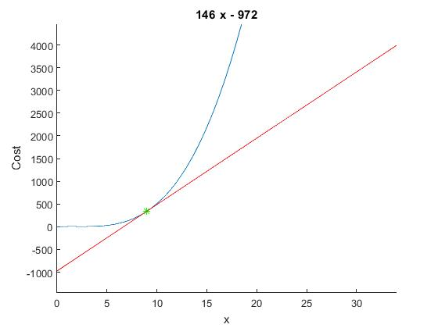

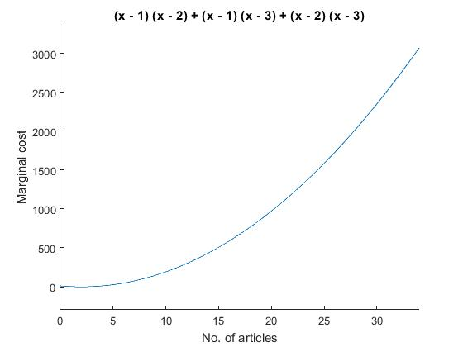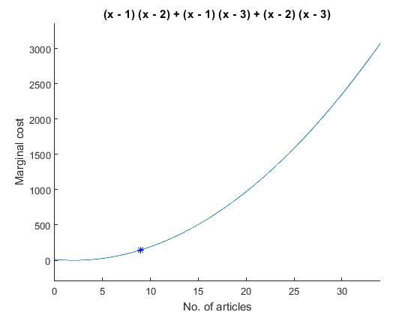

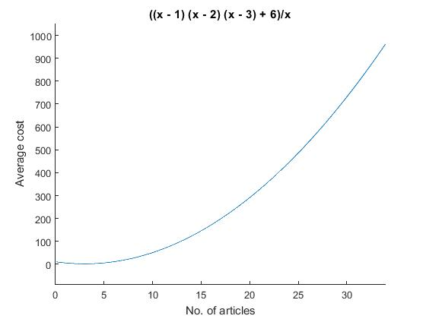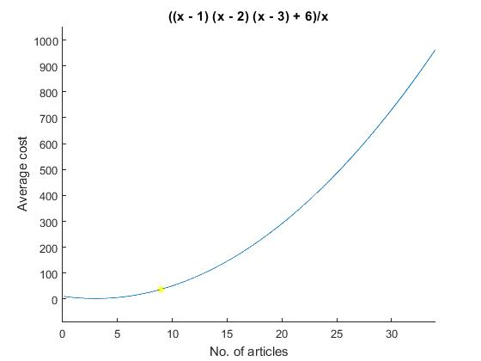

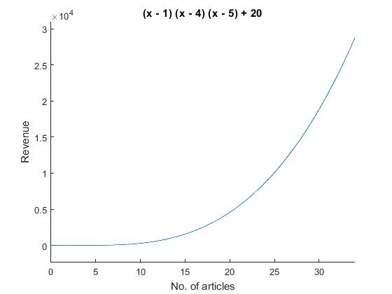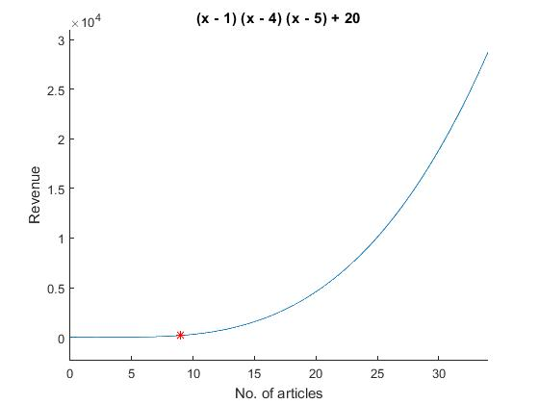

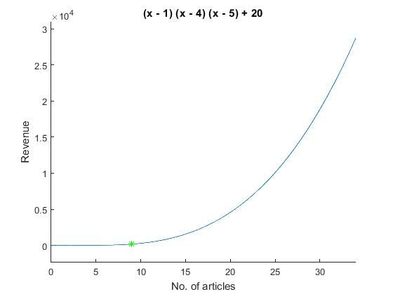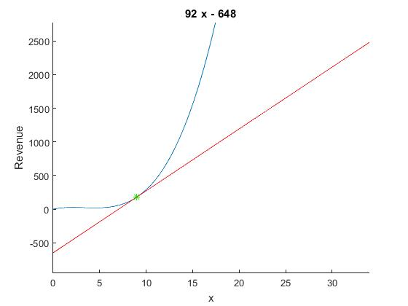

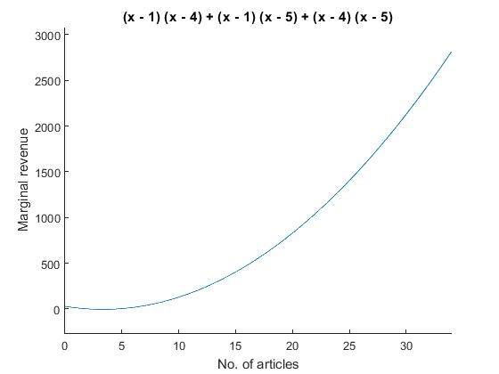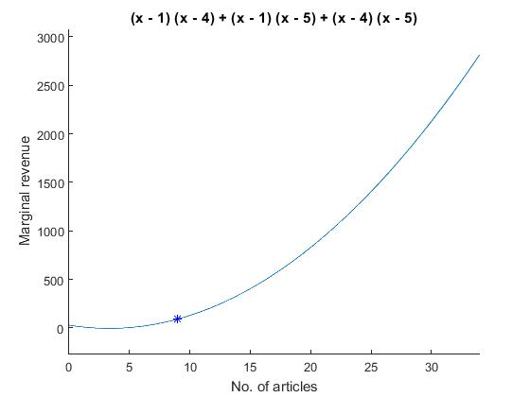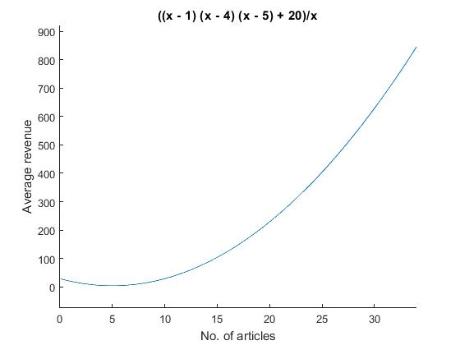 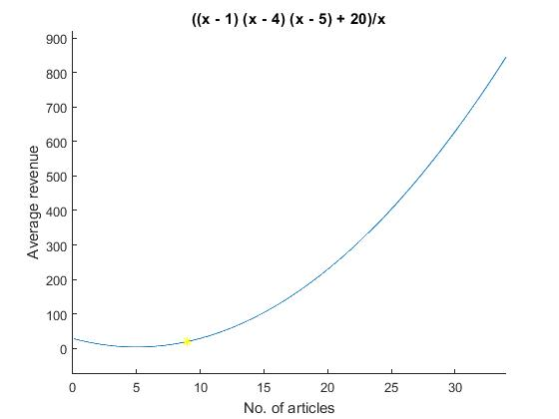

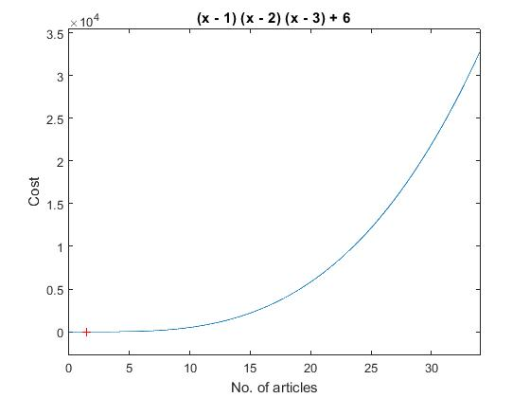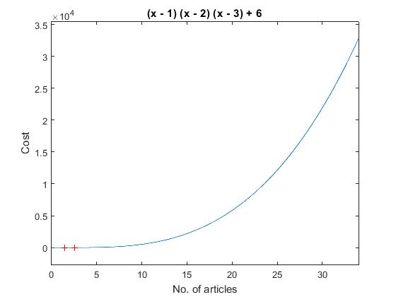

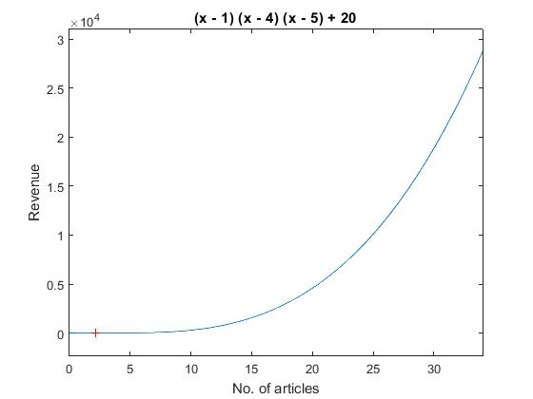 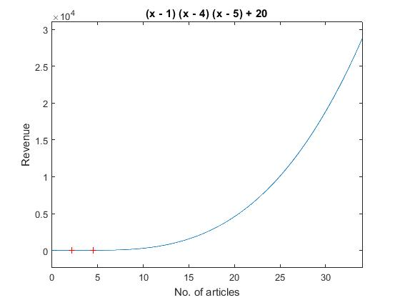

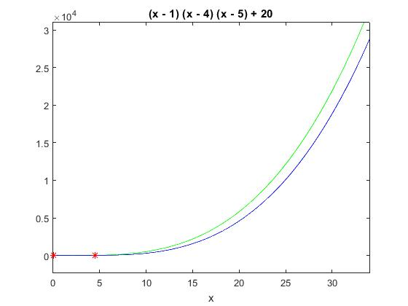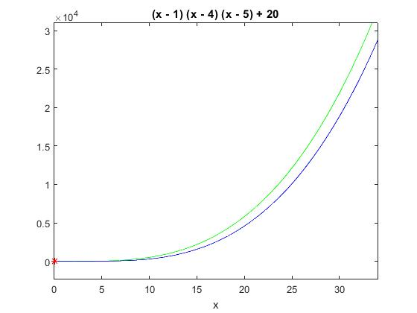

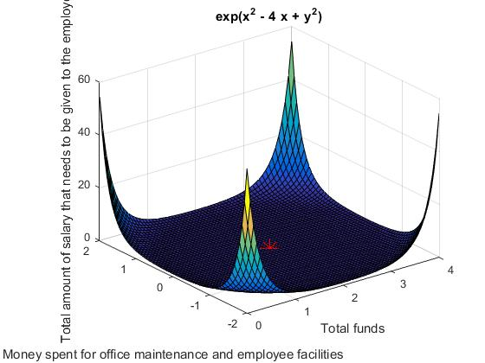

INFERENCE

The cost function **c=(x-1)*(x-2)*(x-3)+6,revenue function=(x-1)*(x-4)*(x-5)+20,no. of articles x1=9 and f=exp(x^2+y^2-4*x)** are given as inputs.

The total cost which is incurred due to buying these items is **Rs 342.** The limit of cost that should be reached while buying x=9 articles is Rs 342 since c is a polynomial function. The tangent at the point (9,342) is plotted whose slope gives us the value of the rate of change of cost function at the point (9,342).**The marginal cost is equal to (x-1)(x-2)+(x-1)(x-3)+(x-2)(x-3).**It is plotted in a new figure window. This gives us the rate of change of cost with respect to the no. of articles at every point. The value of **marginal cost at x=9 is equal to Rs 146 .** Therefore, buying 1 item at x=9 will incur 146 Rs more. The point (9,146) is plotted in the figure window. The **average cost is equal to ((x-1)*(x-2)*(x-3)+6)/x.** It is plotted in a new figure window**. Its value at x=9 is Rs 38.** Therefore, at x=9, each article costs 38 Rs. The point (9,180) is plotted in the same window.

The total revenue which is incurred due to selling these items is **Rs 180.** The limit of revenue that should be reached while selling x=9 articles is Rs 180 since r is a polynomial function. The tangent at the point (9,180) is plotted whose slope gives us the value of the rate of change of revenue function at the point (9,180).**The marginal revenue is equal to (x-1)(x-4)+(x-1)(x-5)+(x-4)(x-5).**It is plotted in a new figure window. This gives us the rate of change of revenue with respect to the no. of articles at every point. **The value of marginal revenue at x=9 is equal to Rs 92.** Therefore, selling 1 item at x=9 will increase revenue by Rs 92 more. The point (9,92) is plotted in the figure window. **The average revenue is equal to ((x-1)*(x-4)*(x-5)+20)/x.** It is plotted in a new figure window**. Its value at x=9 is 20 Rs.** Therefore, at x=9, selling each article fetches 20 Rs. The point (9,20) is plotted in the same window.

To determine the maxima, minima and inflexion point of cost, the 2nd derivative test is used. The results show that a **local maxima is obtained at (1.422650,6.384900) and local minima is obtained at (2.577350,5.615100).**Therefore, attention needs to be paid when x is tending to the abscissa of the above points. Any carelessness might hamper the budget of the company since extremas are crucial.

To determine the maxima, minima and inflexion point of revenue, the 2nd derivative test is used. The results show that a **local maxima is obtained at (2.131483e,2.606460e+1) and local minima is obtained at (40535184e,1.912058e+01).**Therefore, attention needs to be paid when x is tending to the abscissa of the above points. Any carelessness might hamper the revenue of the company since extremas are crucial.

**Loss of Rs 162** is obtained on selling 9 articles. **2 break even points (0,0) and (4.5,19.125)** are obtained. After these points either profit or loss occurs till the curves meet again.

The total amount of salary to be given to the employees is taken as input in f(x,y) depending upon the total funds available to the company and the total amount of money spent for office maintenance(x) and employee recreation(y). **A minima is obtained at z=Rs 0.015316 when f=exp(x^2+y^2-4*x).** Therefore, if the boss is disappointed, this is the salary that shall be given to the employees. The given surface is plotted in the figure window along with the local minima.

Thereby, MATLAB program for Calculus in Economics is exhibited.