INTERNET AND WEB PROGRAMMING



FALL SEMESTER 2016-2017

**DEVELOP A COMPLETE ALTERNATIVE TO A EXISTING WEBSITE:**

**FACEBOOK**   
  
  
  
Shubham Parashar(15BCE1318)

Ayush Sharma(15BCE1126)

Osho Agyeya(15BCE1326)

MOTIVATION/INTRODUCTION:

Social networking has become an integral part of our life. Given this fact, it becomes important to understand the working of websites like Facebook. Therefore, this project is aimed at making a replica of Facebook providing the basic functionalities and important features.

This project is aimed at developing a website having similar functionality to Facebook. The website will have options related to creating a Facebook account,profile management, texting a fellow Facebook mate as well as viewing other Facebook users’ profile.

SCOPE:

The project has the potential to be scaled up so that the network being encompassed by the website can be increased. Also, the functionalities supported can be incremented. This can act as a social network for local university level communication and can be further extended for learning purposes.

METHODOLOGY:

The main objective of this project is to provide the users some services like:

1. To have an attractive and secure login page to access.
2. Make new user account in more user friendly and proper validation of details.
3. Search Friends on entire network.
4. Send friend request to others to make friends and add friends to your friend list to accept request.
5. Easy password recovering process

Like Facebook , our replica uses php for the backend scripting combined with CSS,HTML for layout purposes. Frontend scripting has been done through Javascript where ever required. XAMPP and MySQL have been used for database purposes. Bootstrap and Ajax have been used to make the website more responsive and interactive.

Role of students:

Ayush Sharma: Main page,sign up and login facilities.

Osho Agyeya:Profile management,personal data manipulation and home page after login.

Shubham Parashar:Messaging send/receive/save messages in Inbox

Resources used:

PHP,CSS,HTML,Javascript,MySQL,Ajax

SAMPLE SOURCE CODE:

home.php

<?php

require_once('auth.php');

include 'connection.php';

?>

<!DOCTYPE html>

<html>

<head>

<meta http-equiv="Content-Type" content="text/html; charset=iso-8859-1" />

<title>Facebook</title>

<link rel="icon" href="fb5.png" type="image/png">

<style type="text/css">

.style1 {

font-size: 36px;

font-weight: bold;

}

.stuck {

position: fixed;

top: 10px;

left: 10px;

bottom: 10px;

/*width: 200px; */

width: 100%;

overflow-y: auto;

overflow-x: hidden;

}

</style>

<link rel="stylesheet" type="text/css" href="drop.css">

<link rel="stylesheet" type="text/css" href="post.css">

<meta name="viewport" content="width=device-width, initial-scale=1">

<link rel="stylesheet" href="http://maxcdn.bootstrapcdn.com/bootstrap/3.3.7/css/bootstrap.min.css">

<script src="https://ajax.googleapis.com/ajax/libs/jquery/1.12.4/jquery.min.js"></script>

<script src="http://maxcdn.bootstrapcdn.com/bootstrap/3.3.7/js/bootstrap.min.js"></script>

<!--<body style=" background-color: #e6e6e6;"> -->

<body style=" background-color: #d9d9d9; ">

<?php

$email=$_SESSION['SESS_email'];

$name=$_SESSION['SESS_name'];

if(isset($_POST['submit'])){

$post=$_POST['post'];

$query="INSERT INTO data(name,post,email) VALUES('$name','$post','$email')";

$result = mysqli_query($connection,$query);

if (!$result)

echo "INSERT failed: $query<br>" . $connection->error . "<br><br>";

?>

<script type="text/javascript">

window.location="home.php";

</script>

<?php

}

?>

<div class="stuck">

<a href="m.php">

<button type="button" class="

" >

<h1>

Hello

<?php

echo $name ?>

!

</h1>

</button>

</a>

<div style="position: absolute; width: 100px; top:0; right:5px; ">

<div class="dropdown">

<button class="dropbtn"> <img src="fb3.png" class="image" /> </button>

<div class="dropdown-content">

<a href="home.php">Home</a>

<a href="m.php">Profile</a>

<a href="Rpass.php">Change pass &nbsp; &nbsp; </a>

<a href="login.php">Log out</a>

</div>

</div>

</div>

<div style=" position: absolute; top:-5px; right: 70px; ">

<div class="dropdown">

<button class="dropbtn">

<img src="fb6.png" width="100" height="100" alt=""/>

</button>

<div class="dropdown-content">

<a href="messages.php">Message</a>

</div>

</div>

</div>

</div>

<form method="post" action="home.php">

<div>

<textarea title="What's on your mind?" placeholder="What's on your mind?" rows="4" cols="40" name="post"></textarea>

<div class="post">

<br>

&nbsp; &nbsp;&nbsp; &nbsp;&nbsp; &nbsp;

&nbsp; &nbsp;&nbsp; &nbsp;&nbsp; &nbsp;

&nbsp; &nbsp;&nbsp; &nbsp;&nbsp; &nbsp;

&nbsp; &nbsp;&nbsp; &nbsp; &nbsp;&nbsp;

&nbsp; &nbsp;&nbsp; &nbsp; &nbsp;&nbsp;

&nbsp; &nbsp;&nbsp; &nbsp; &nbsp;&nbsp;

&nbsp; &nbsp;&nbsp; &nbsp; &nbsp;&nbsp;

<input class="btn btn-primary" name="submit" type="Submit" value="Post" >

</form>

</div><!-- Output of post -->

<br>

<br>

<br>

<br>

<br><br><br><br><br><br><br><br>

<?php

$query="SELECT * FROM data ORDER BY data.no DESC";

$result = mysqli_query($connection,$query);

if (!$result) echo "INSERT failed: $query<br>" . $connection->error . "<br><br>";

else

{

while($row=mysqli_fetch_row($result))

{ ?> <br><br>

<center>

&nbsp;&nbsp; &nbsp;&nbsp;&nbsp; &nbsp;

&nbsp;&nbsp; &nbsp;&nbsp;&nbsp; &nbsp;

&nbsp;&nbsp; &nbsp;&nbsp;&nbsp; &nbsp;

&nbsp;&nbsp; &nbsp;&nbsp;&nbsp; &nbsp;

<button type="button" class="btn btn-default" text-align="left" style="height:200px;

width:400px; " ><h2>

<?php

echo $row[1].": ";

?> </h2><hr style="border-width: 3px; "> <h4><?php

echo "";

echo $row[2];

echo "<br><br><br>";

?></h4>

</button>

</center>

<?php

}

}

?>

</body>

</html>

SCREENSHOT:

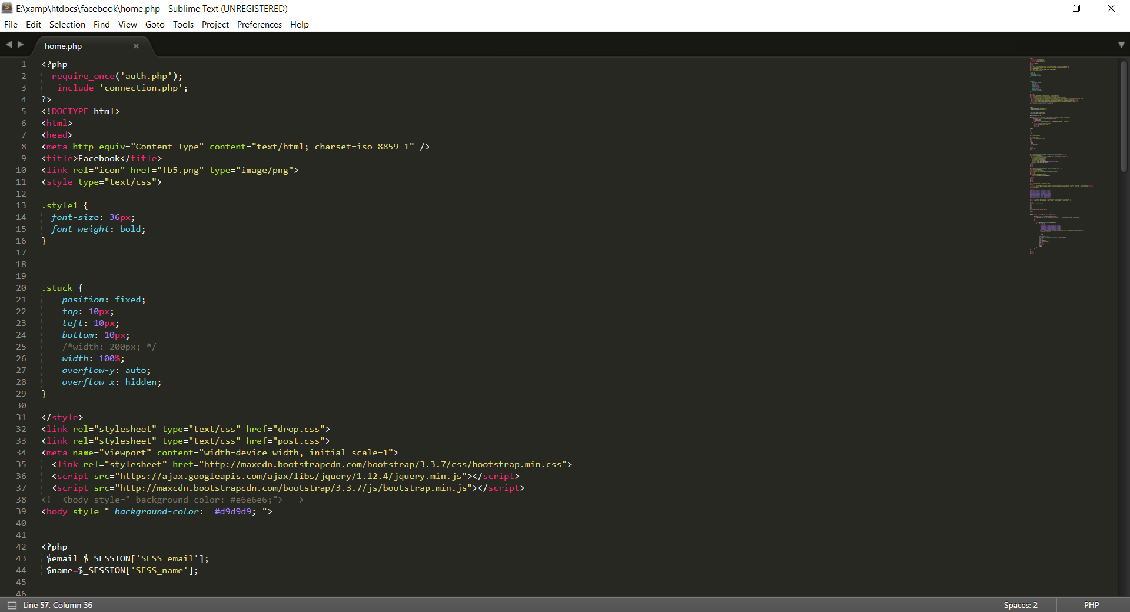

SCREENSHOTS OF OUTPUT:

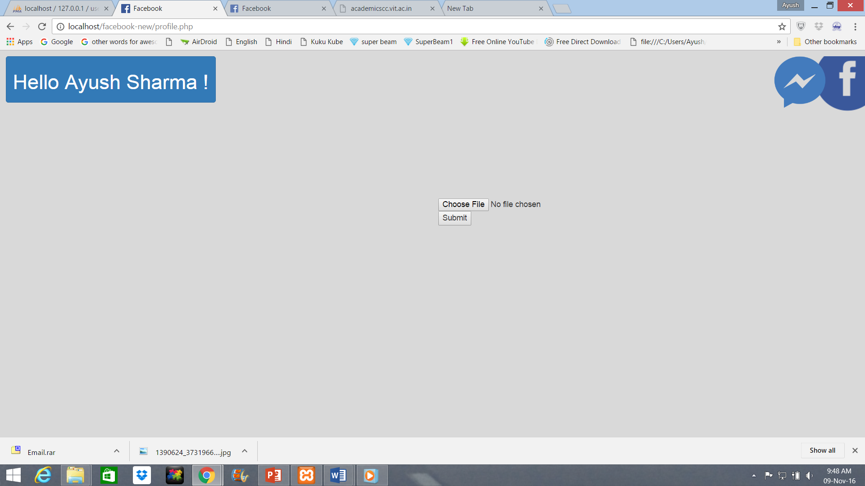

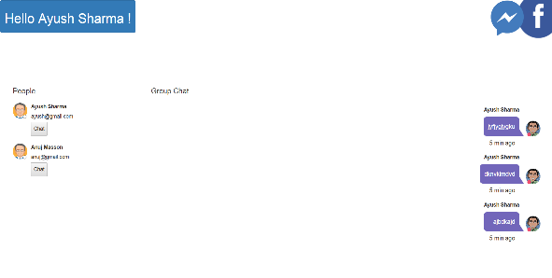

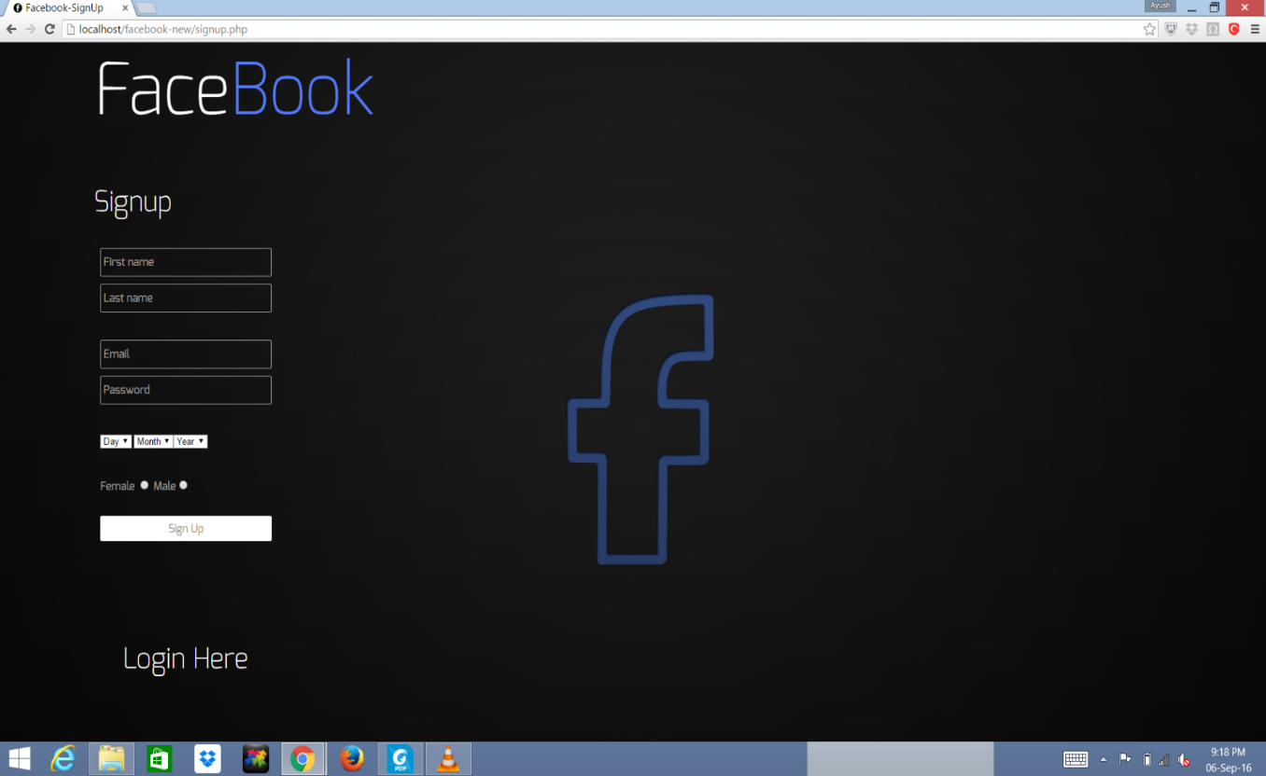

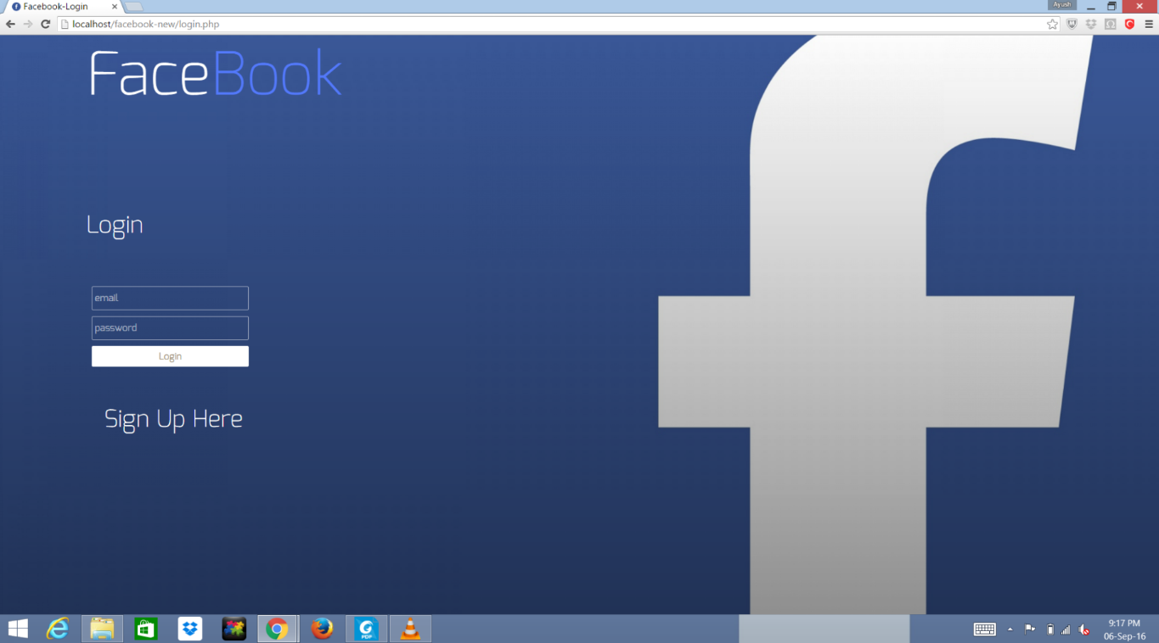

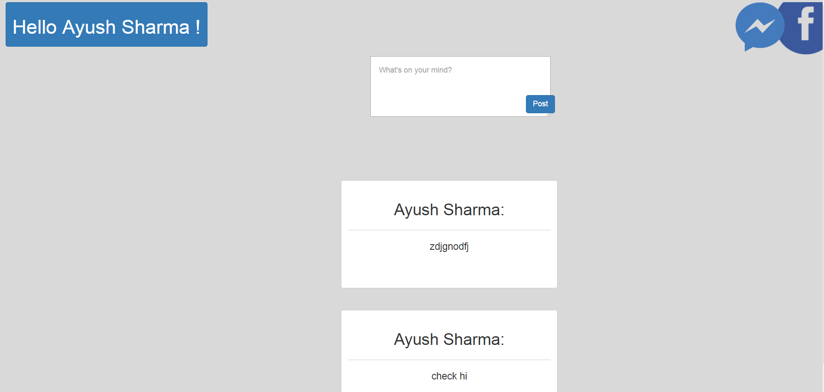

CONCLUSION:

Making the replica of Facebook has been a great learning experience that has helped us gain knowledge about the various paradigms of Web Programming. It is assumed that the application can be scaled to provide even more functionalities in the future. This project has also helped us to gain an understanding of the working of databases and query languages.

POSTER:

