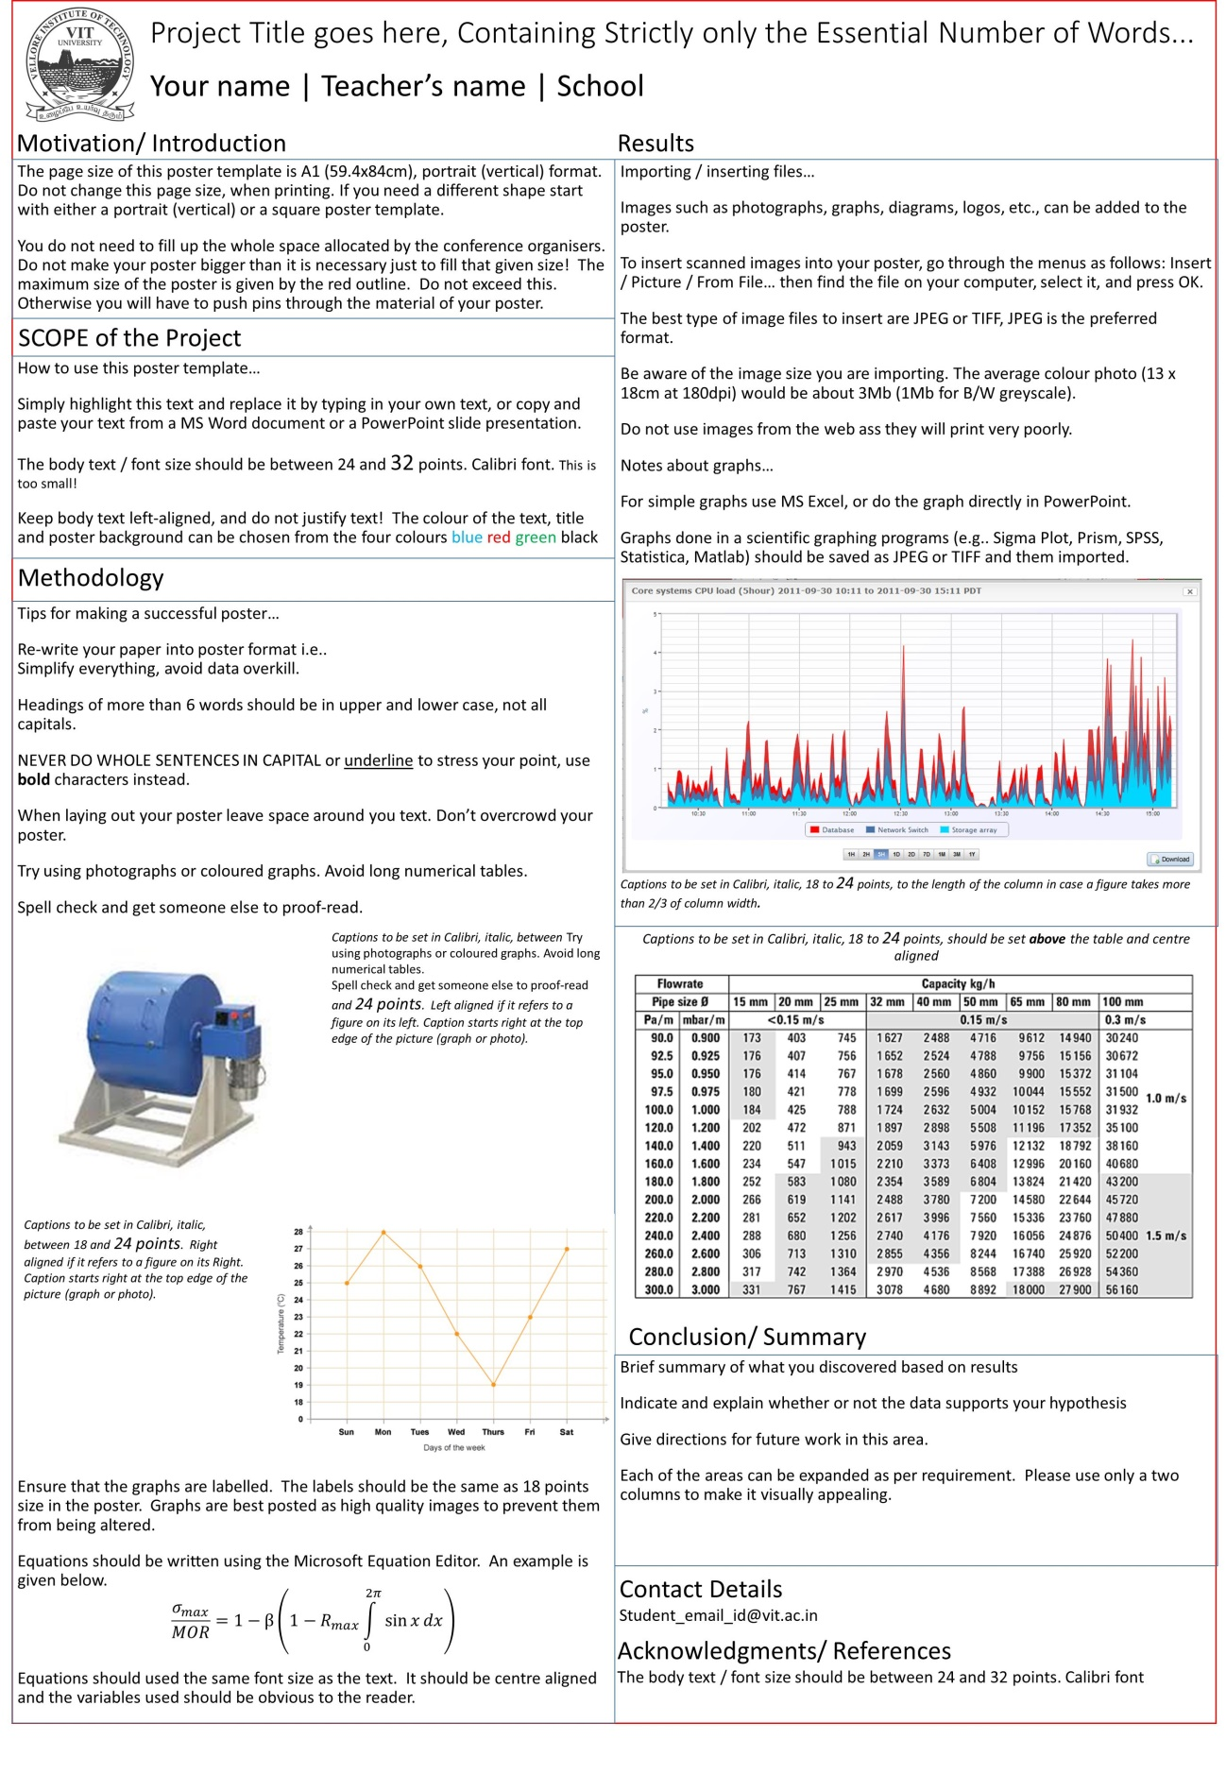

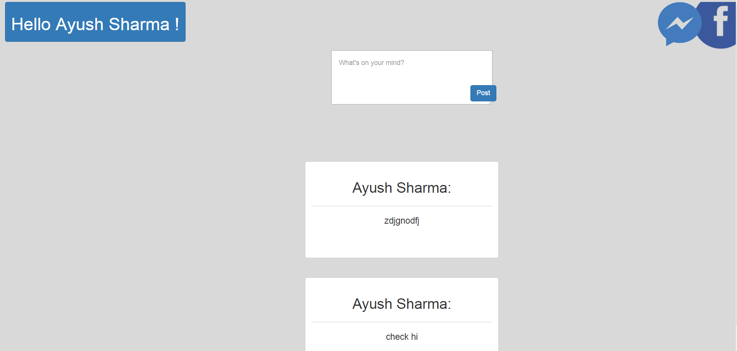 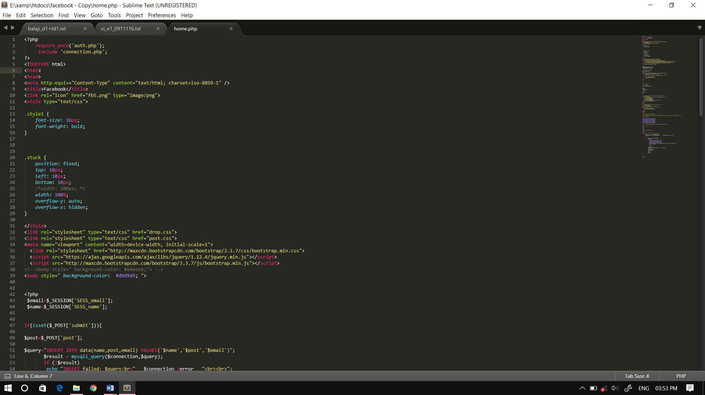

Making the replica of Facebook has been a great learning experience that has helped us gain knowledge about the various paradigms of Web Programming. It is assumed that the application can be scaled to provide even more functionalities in the future. This project has also helped us to gain an understanding of the working of databases and query languages.

Social networking has become an integral part of our life. Given this fact, it becomes important to understand the working of websites like Facebook. Therefore, this project is aimed at making a replica of Facebook providing the basic functionalities and important features.

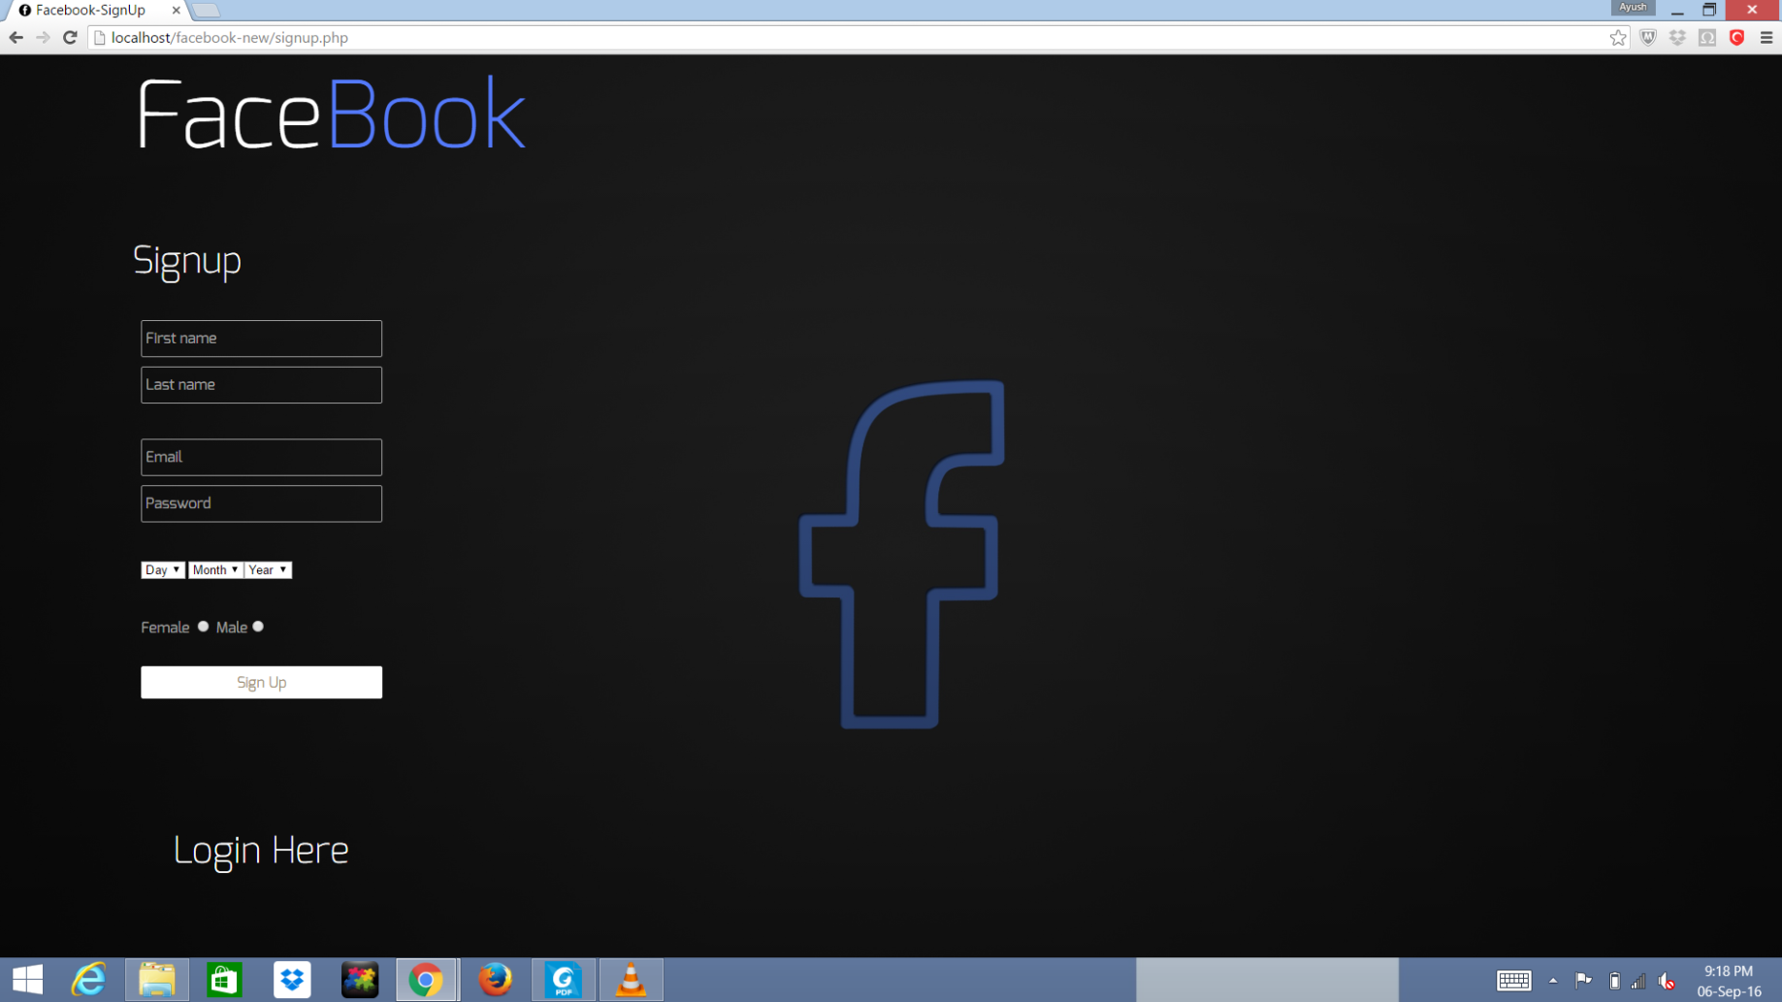

The main objective of this project is to provide the users some services like:

1. To have an attractive and secure login page to access.
2. Make new user account in more user friendly and proper validation of details.
3. Search Friends on entire network.
4. Send friend request to others to make friends and add friends to your friend list to accept request.
5. Easy password recovering process

Like Facebook , our replica uses php for the backend scripting combined with CSS,HTML for layout purposes. Frontend scripting has been done through Javascript where ever required. XAMPP and MySQL have been used for database purposes. Bootstrap and Ajax have been used to make the website more responsive and interactive.

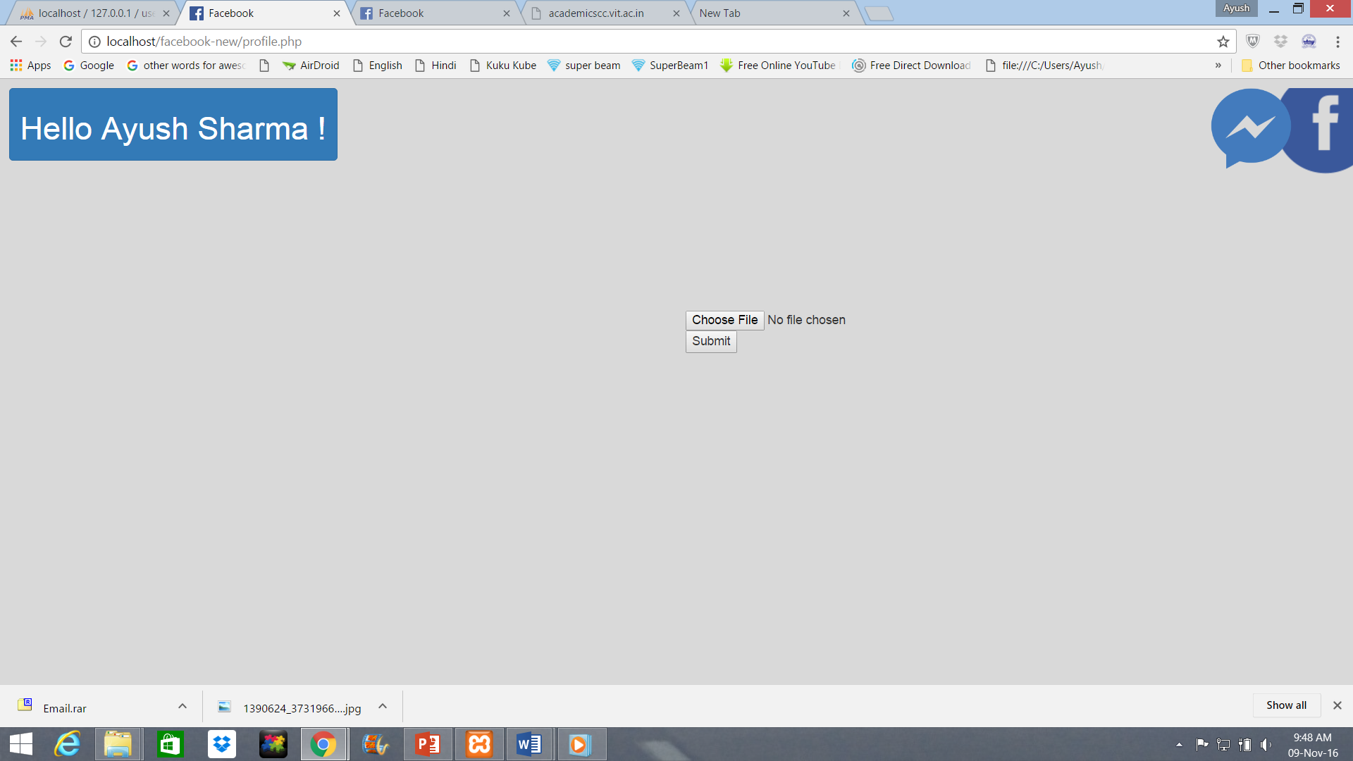

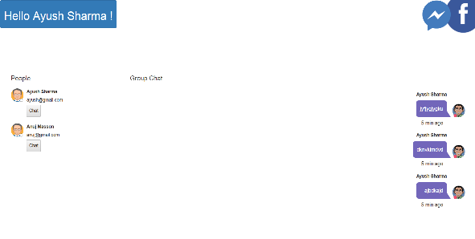

The project has the potential to be scaled up so that the network being encompassed by the website can be increased. Also, the functionalities supported can be incremented. This can act as a social network for local university level communication and can be further extended for learning purposes.

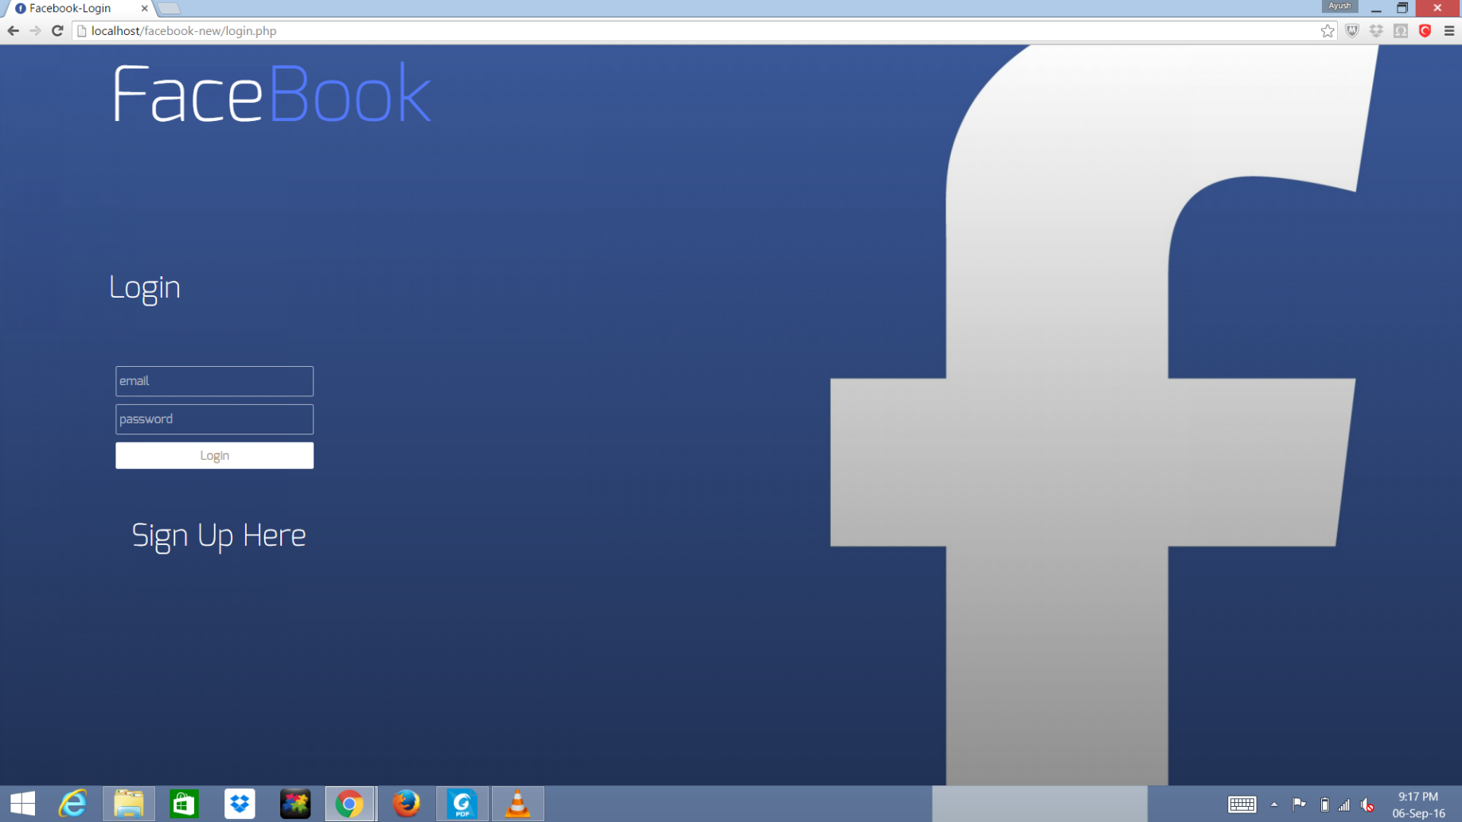

[osho.agyeya2015@vit.ac.in](mailto:osho.agyeya2015@vit.ac.in) [shubham.parashar2015@vit.ac.in](mailto:shubham.parashar2015@vit.ac.in)

[ayush.sharma2015a@vit.ac.in](mailto:ayush.sharma2015a@vit.ac.in)

REPLICA OF FACEBOOK  
AYUSH SHARMA, OSHO AGYEYA, SHUBHAM PARASHAR| Dr. MALATHI G| SCSE