OSHO AGYEYA

PUCHO ROUND 2

New York City Taxi Trip

Duration

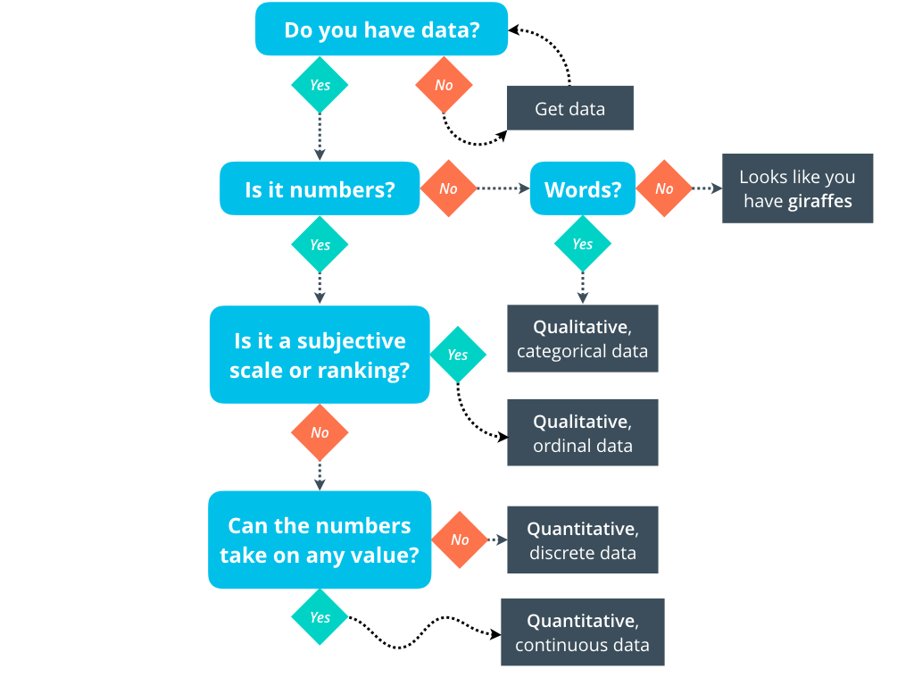

**Osho Agyeya**

**oshoagyeya123@gmail.com**

**+917800191911**

DATASET USED

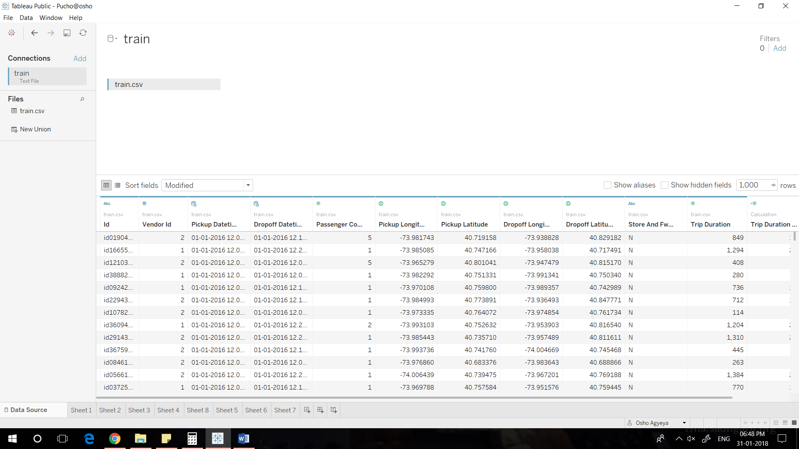

Dataset:train.csv

Source: https://www.kaggle.com/c/nyc-taxi-trip-duration/data

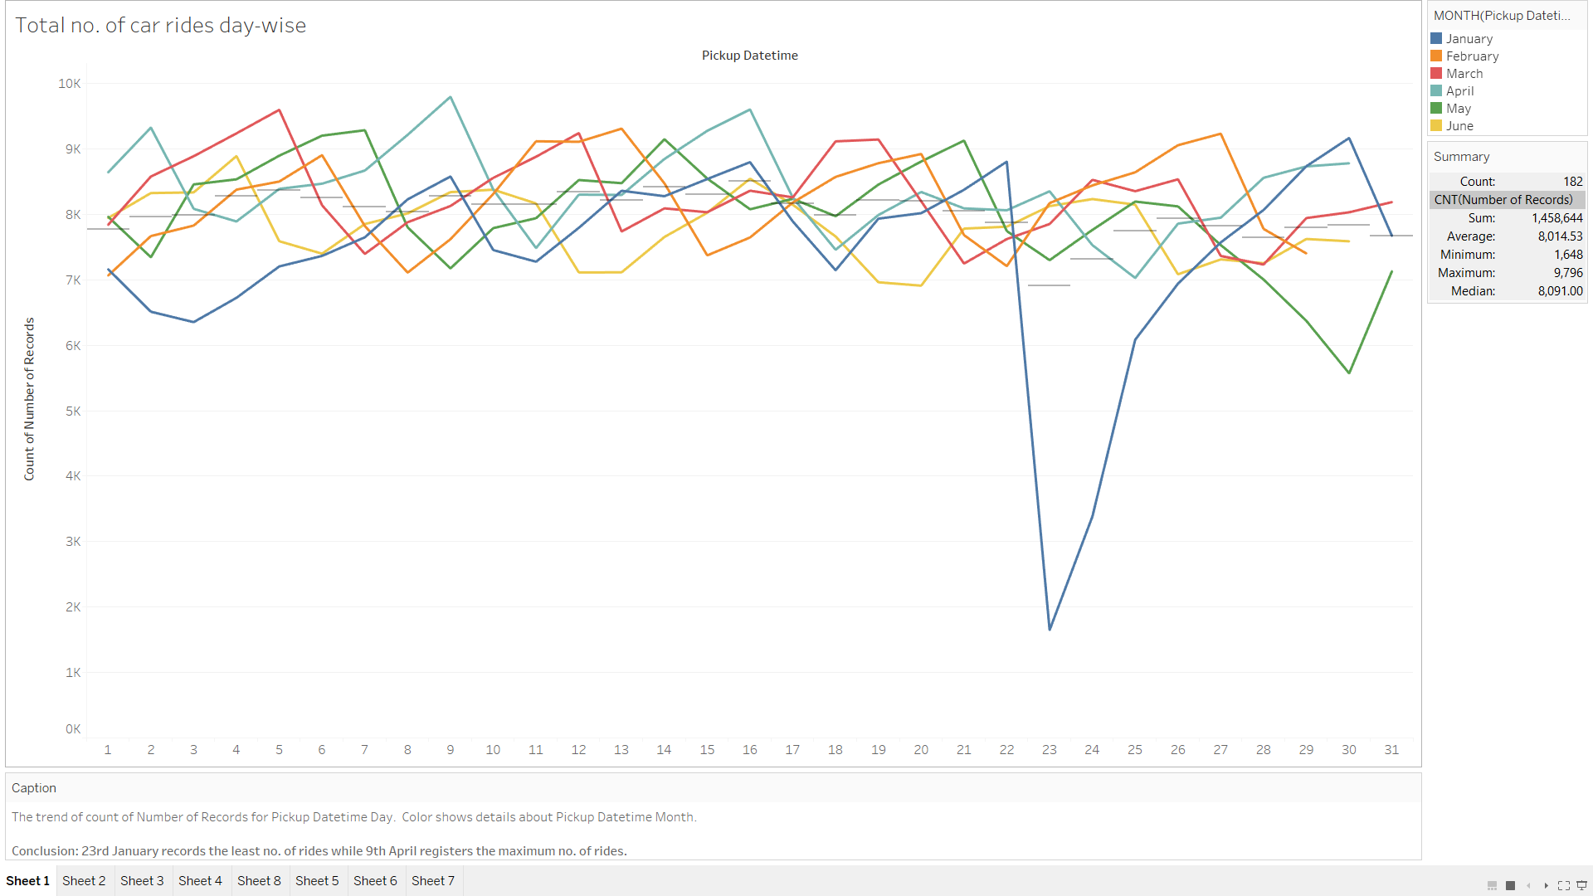

Visualisation 1

Design/Variables

The trend of count of Number of Records for Pickup Datetime Day. Color shows details about Pickup Datetime Month.

Conclusion

23rd January records the least no. of rides while 9th April registers the maximum no. of rides.

Questions:

Q)Why is it that 23rd January registers a sharp decline in no. of rides?

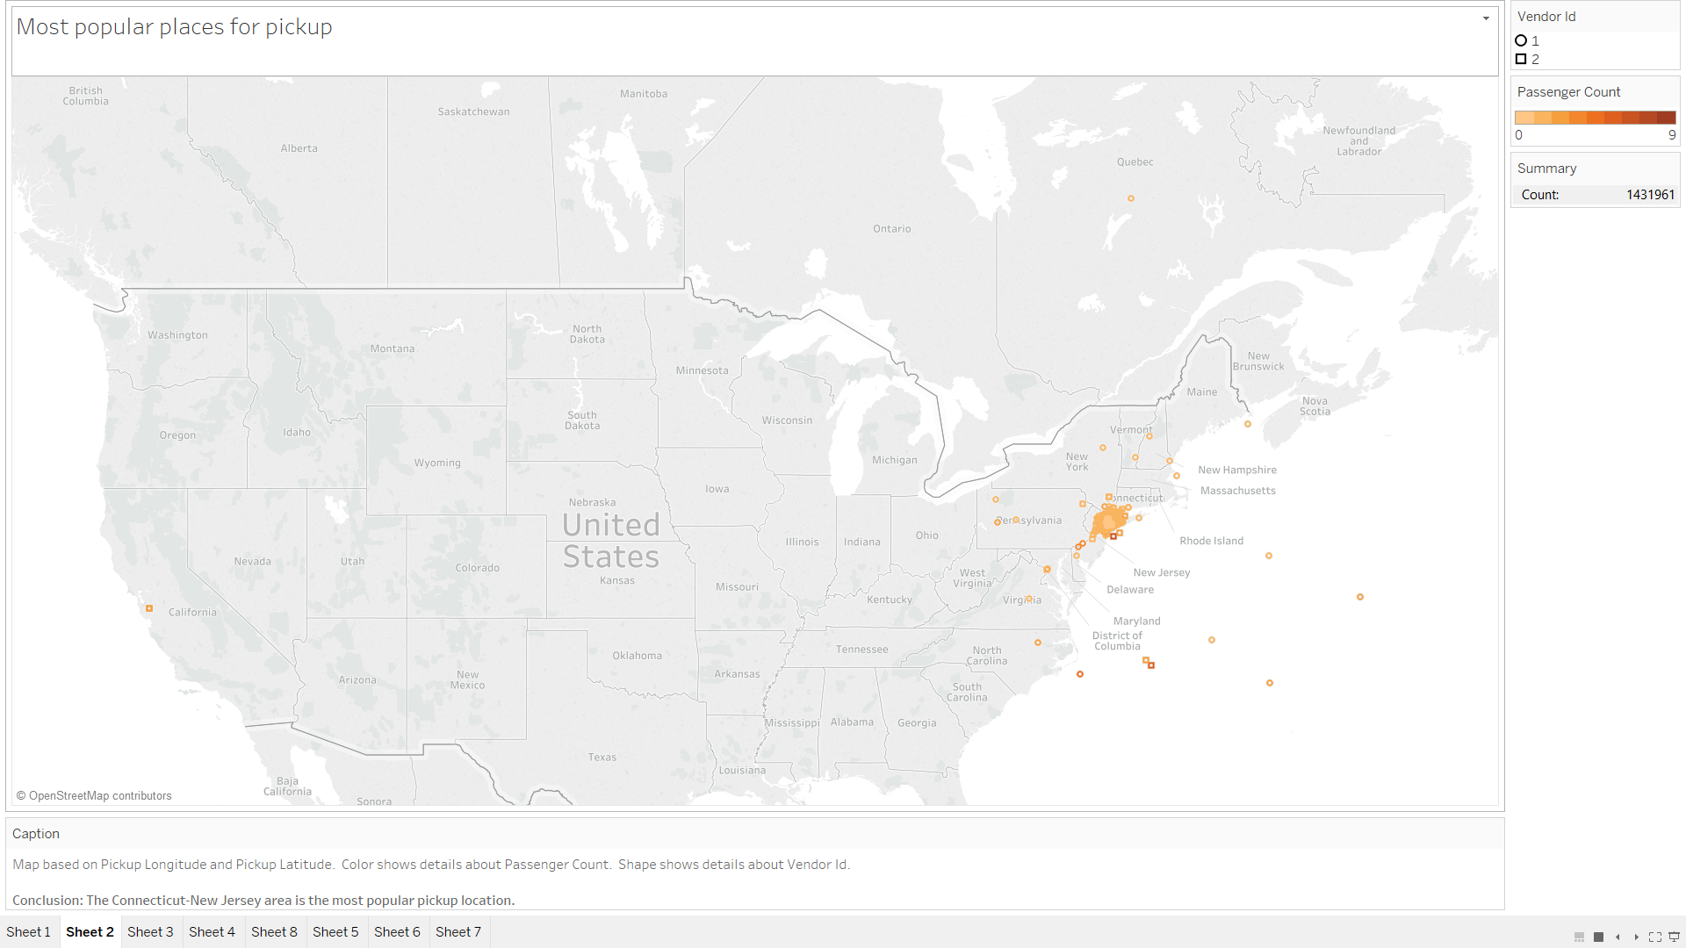

Visualisation 2

Design/Variables

Map based on Pickup Longitude and Pickup Latitude. Color shows details about Passenger Count. Shape shows details about Vendor Id.

Conclusion

The Connecticut-New Jersey area is the most popular pickup location.

Questions:

Q)Why is it that Connecticut, Rhode Island and New Jersey are the places from where maximum rides take off?

Q)Why is it that some rides have zero passengers?

Q)Have the drivers wrongly reported to the vendors regarding certain rides so that they can ride their own journey?

Q)Why is it that some rides have pickup location as sea?

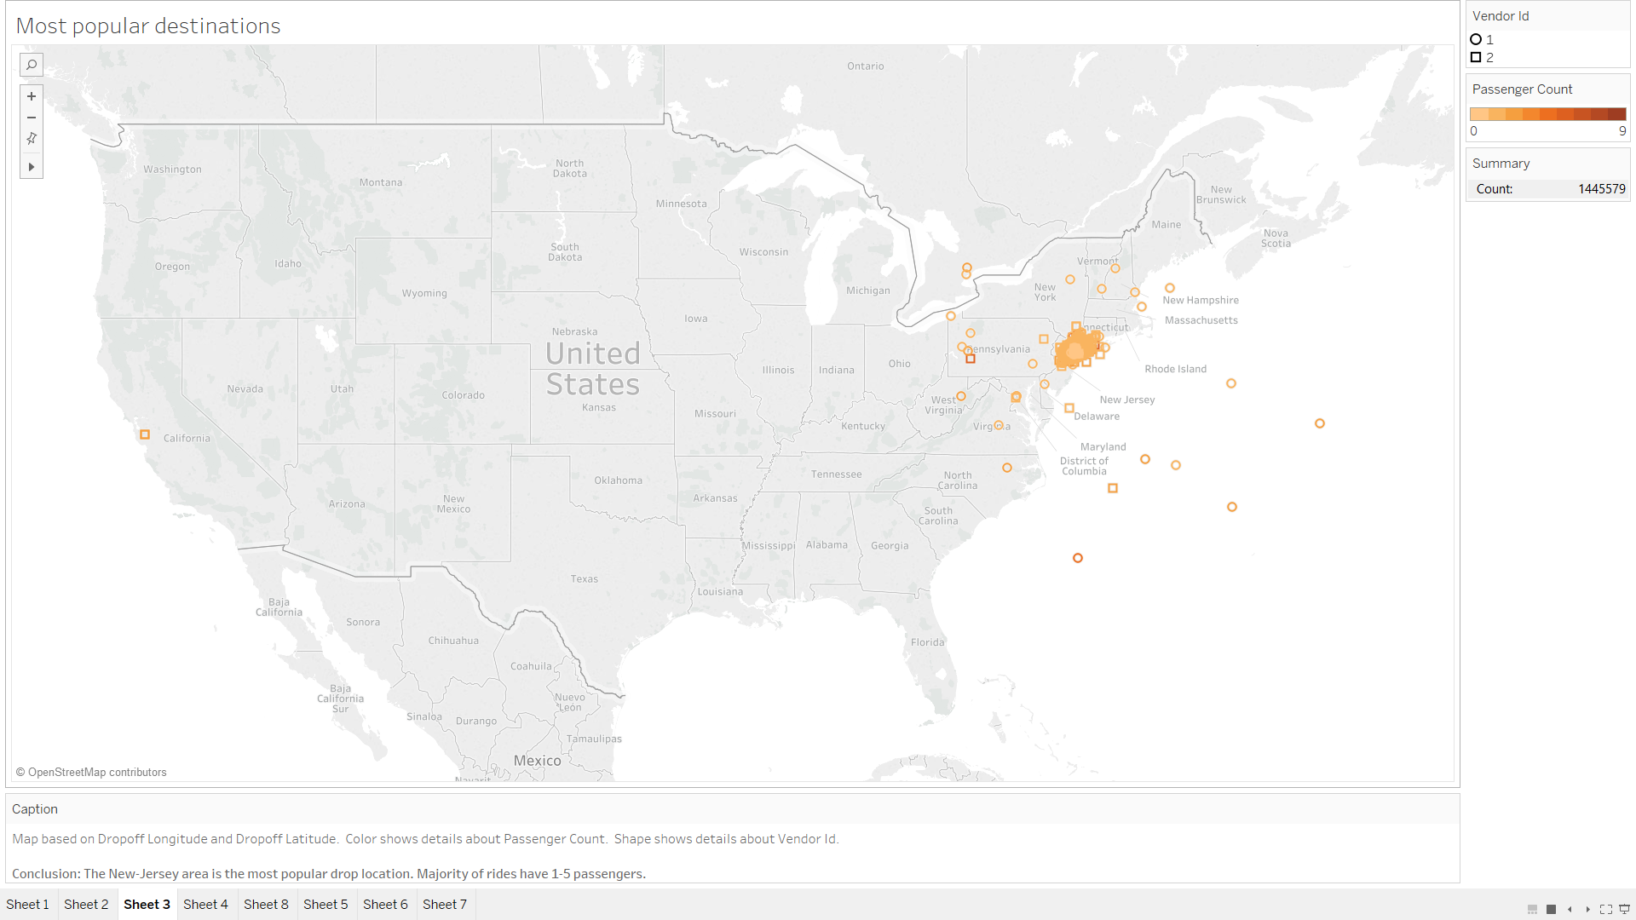

Visualisation 3

Design/Variables

Map based on Dropoff Longitude and Dropoff Latitude. Color shows details about Passenger Count. Shape shows details about Vendor Id.

Conclusion

The New-Jersey area is the most popular drop location. Majority of rides have 1-5 passengers.

Questions:

Q)Why is it that Connecticut, Rhode Island and New Jersey are the places where maximum end?

Q)Why is it that some rides have drop location as sea?

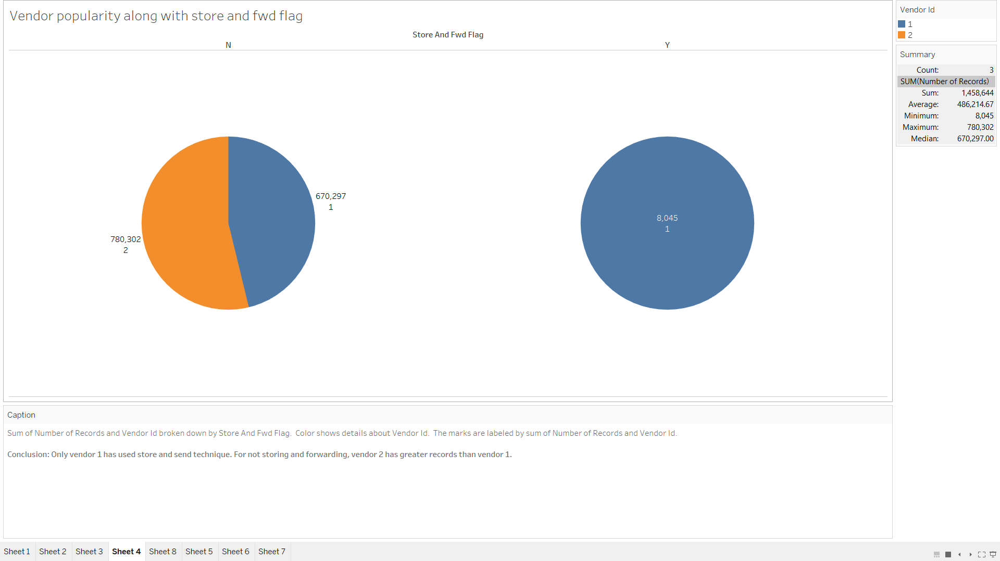

Visualisation 4

Design/Variables

Sum of Number of Records and Vendor Id broken down by Store And Fwd Flag. Color shows details about Vendor Id. The marks are labeled by sum of Number of Records and Vendor Id.

Conclusion

Only vendor 1 has used store and send technique. For not storing and forwarding, vendor 2 has greater records than vendor 1.

Questions:

Q) Why is it that vendor 2 does not have any have records where value of store and fwd flag is 1?

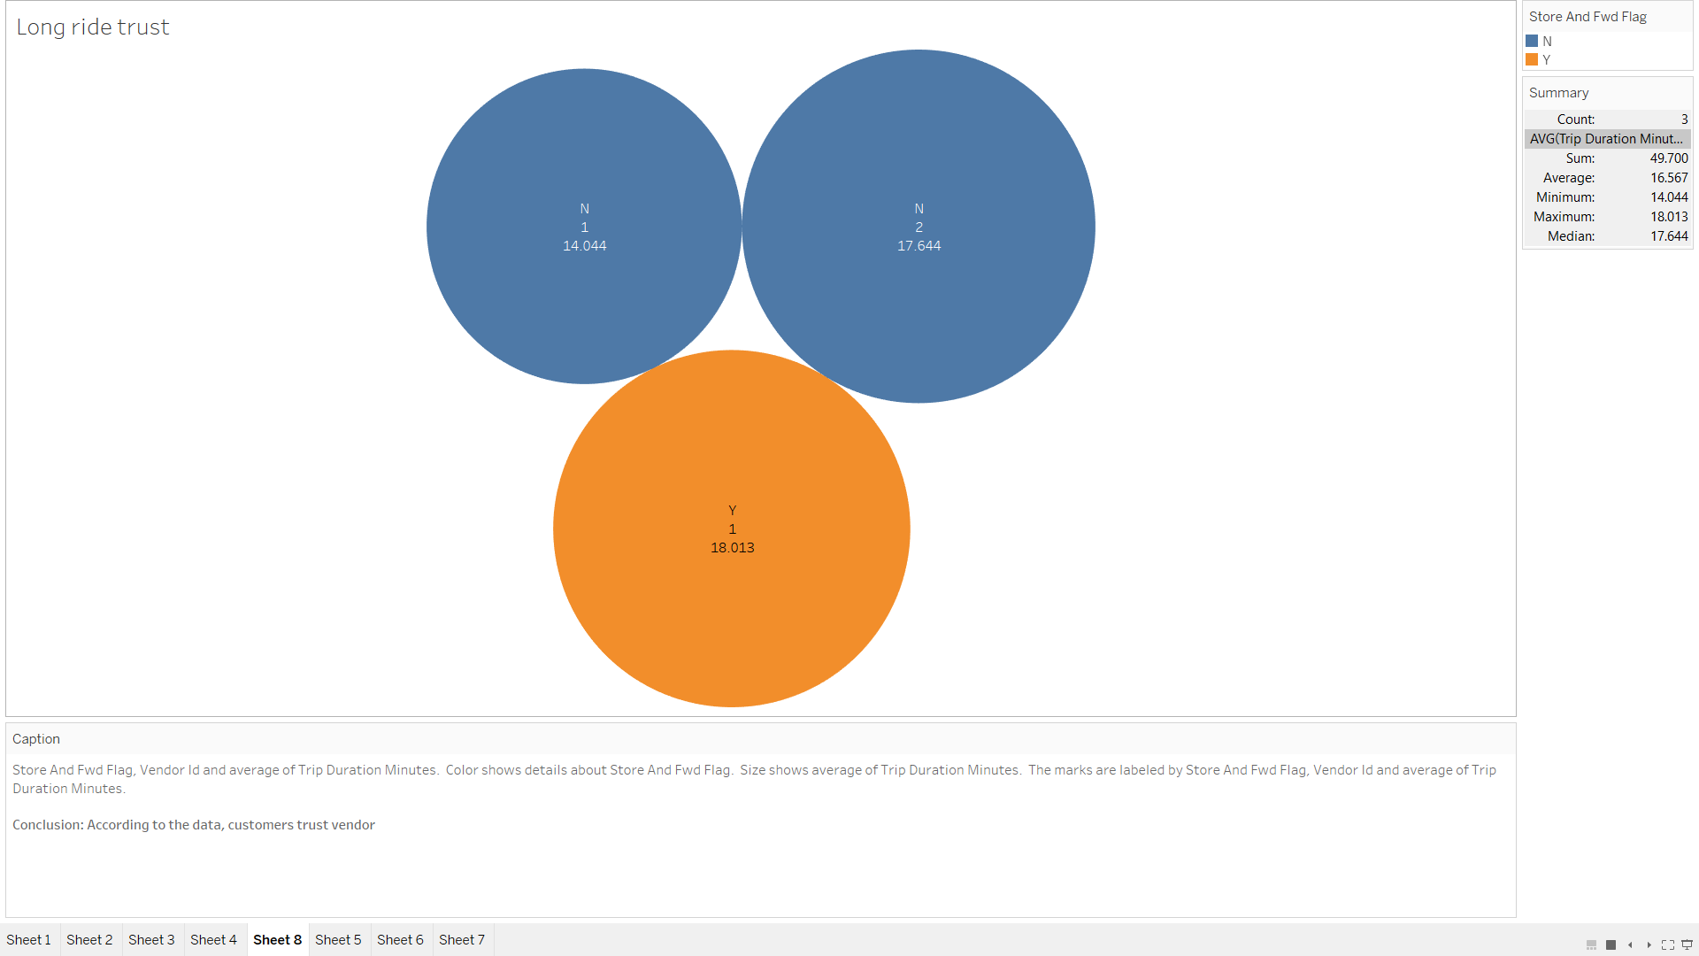

Visualisation 5

Design/Variables

Store And Fwd Flag, Vendor Id and average of Trip Duration Minutes. Color shows details about Store And Fwd Flag. Size shows average of Trip Duration Minutes. The marks are labeled by Store And Fwd Flag, Vendor Id and average of Trip Duration Minutes.

Conclusion

According to the data, customers trust vendor 2 more than vendor 1 in case where Store and Fwd flag id N, while they prefer vendor 1 in the other case.

Questions

Q)Why is it that passengers trust vendor 1 more than vendor 2?

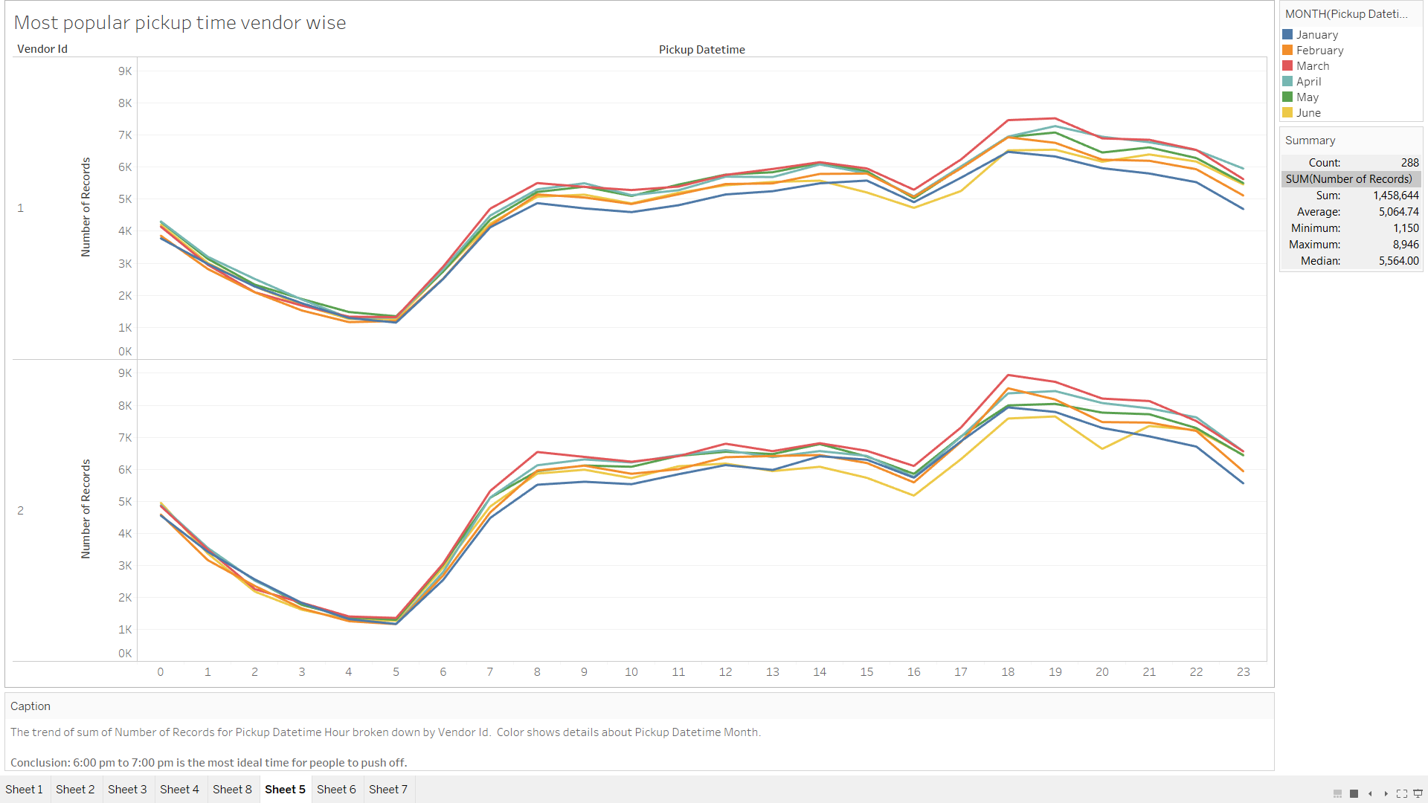

Visualisation 6

Design/Variables

The trend of sum of Number of Records for Pickup Datetime Hour broken down by Vendor Id. Color shows details about Pickup Datetime Month.

Conclusion

6:00 pm to 7:00 pm is the most ideal time for people to push off.

Questions:

Q) Why is it that least no. of people book a ride at 5.00 am?

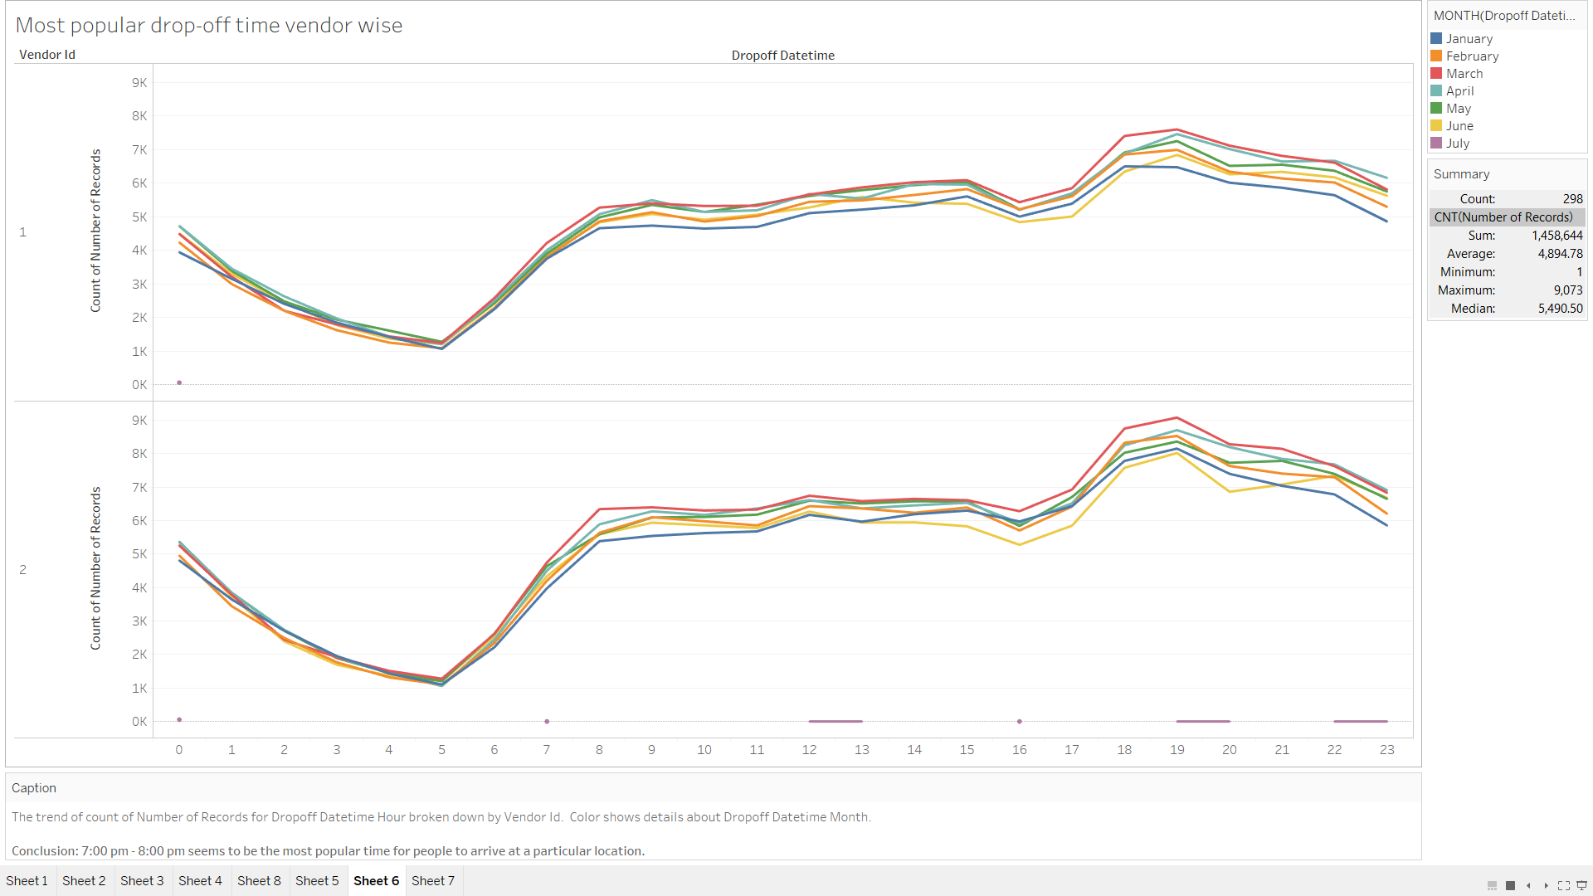

Visualisation 7

Design/Variables

The trend of count of Number of Records for Dropoff Datetime Hour broken down by Vendor Id. Color shows details about Dropoff Datetime Month.

Conclusion

7:00 pm - 8:00 pm seems to be the most popular time for people to arrive at a particular location.

Questions:

Q) Why is it that for the dropoff time graph, July has the least no. of records and that to sparsely distributed?

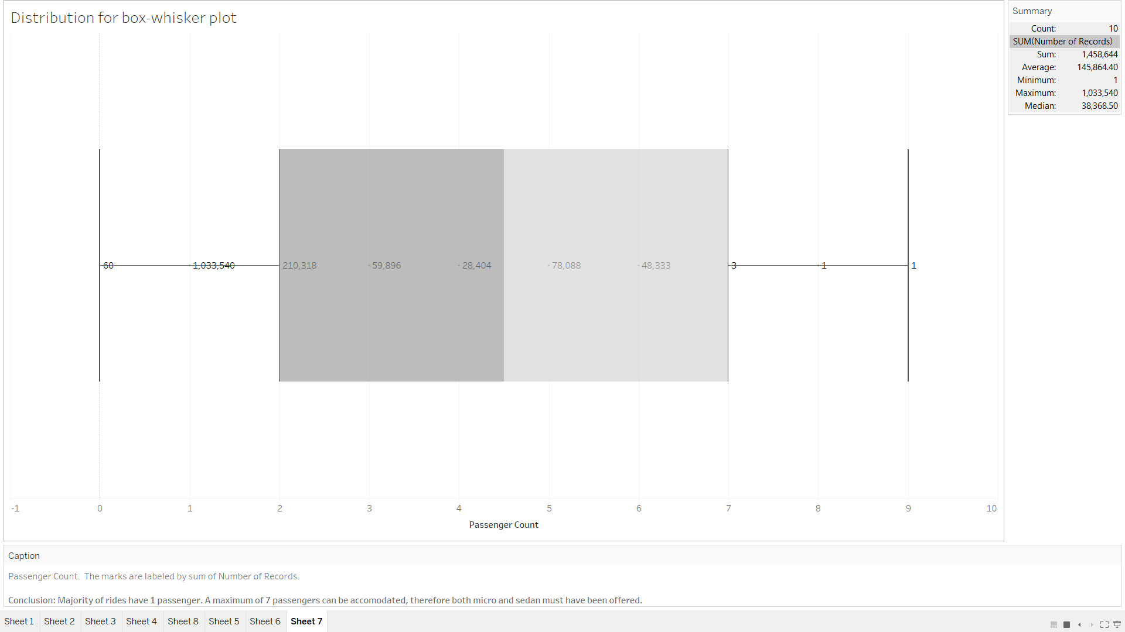

Visualisation 8

Design/Variables

Passenger Count. The marks are labeled by sum of Number of Records.

Conclusion

Majority of rides have 1 passenger. A maximum of 7 passengers can be accomodated, therefore both micro and sedan must have been offered.

Questions:

Q) How have 9 people been accommodated in a taxi car?