OSHO AGYEYA

PUCHO ROUND 1

New York City Taxi Trip

Duration

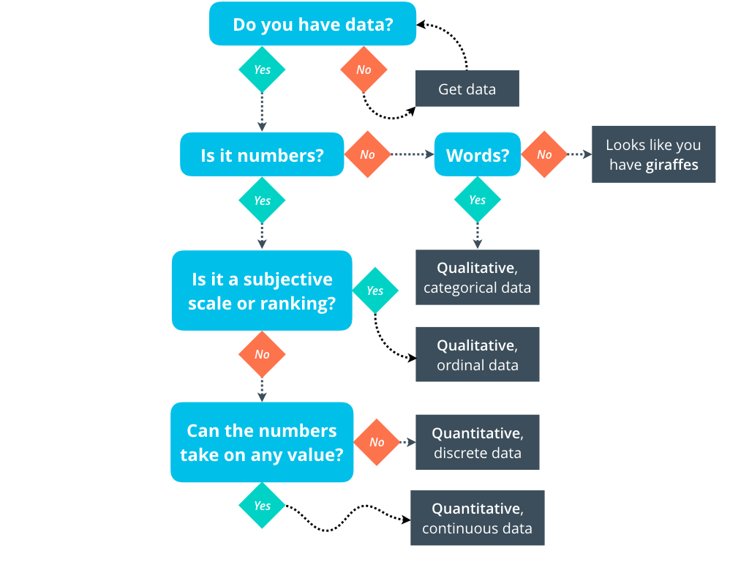

**Osho Agyeya**

**oshoagyeya123@gmail.com**

**+917800191911**

DATASET USED

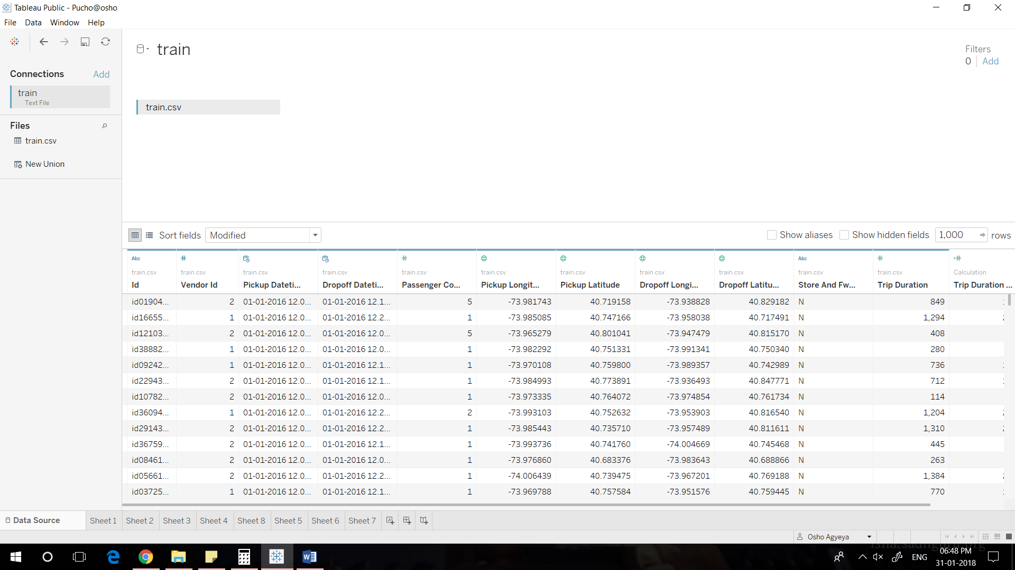

Dataset:train.csv

Source: https://www.kaggle.com/c/nyc-taxi-trip-duration/data

IMAGE 1 ALONG WITH ITS CONCLUSIONS

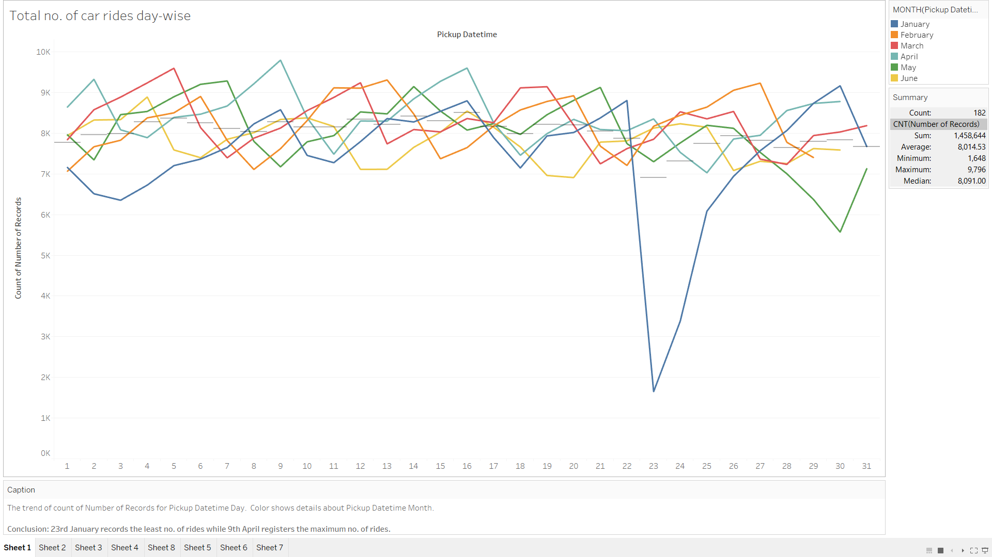

Visualisation 1

Design/Variables

The trend of count of Number of Records for Pickup Datetime Day. Color shows details about Pickup Datetime Month.

Conclusion

23rd January records the least no. of rides while 9th April registers the maximum no. of rides.

IMAGE 2 ALONG WITH ITS CONCLUSIONS

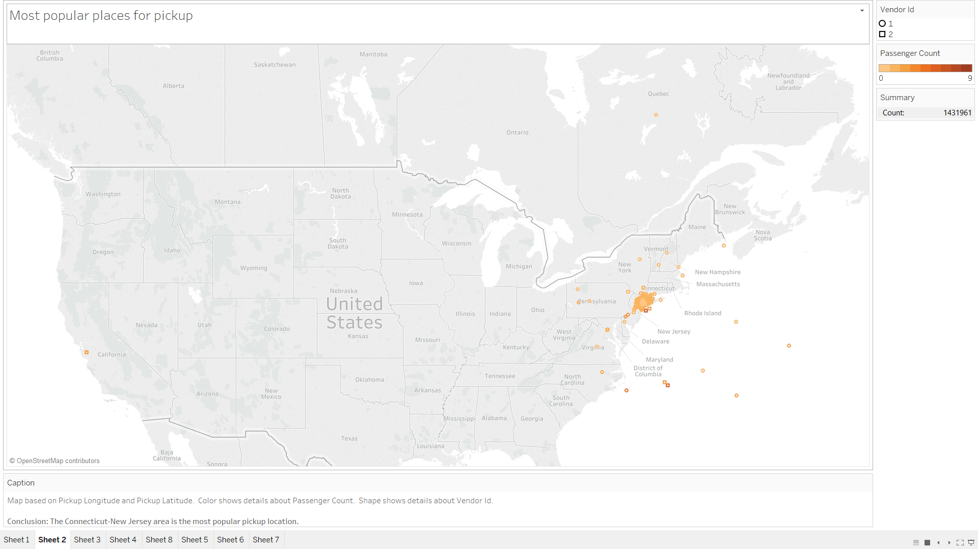

Visualisation 2

Design/Variables

Map based on Pickup Longitude and Pickup Latitude. Color shows details about Passenger Count. Shape shows details about Vendor Id.

Conclusion

The Connecticut-New Jersey area is the most popular pickup location.

IMAGE 3 ALONG WITH ITS CONCLUSIONS

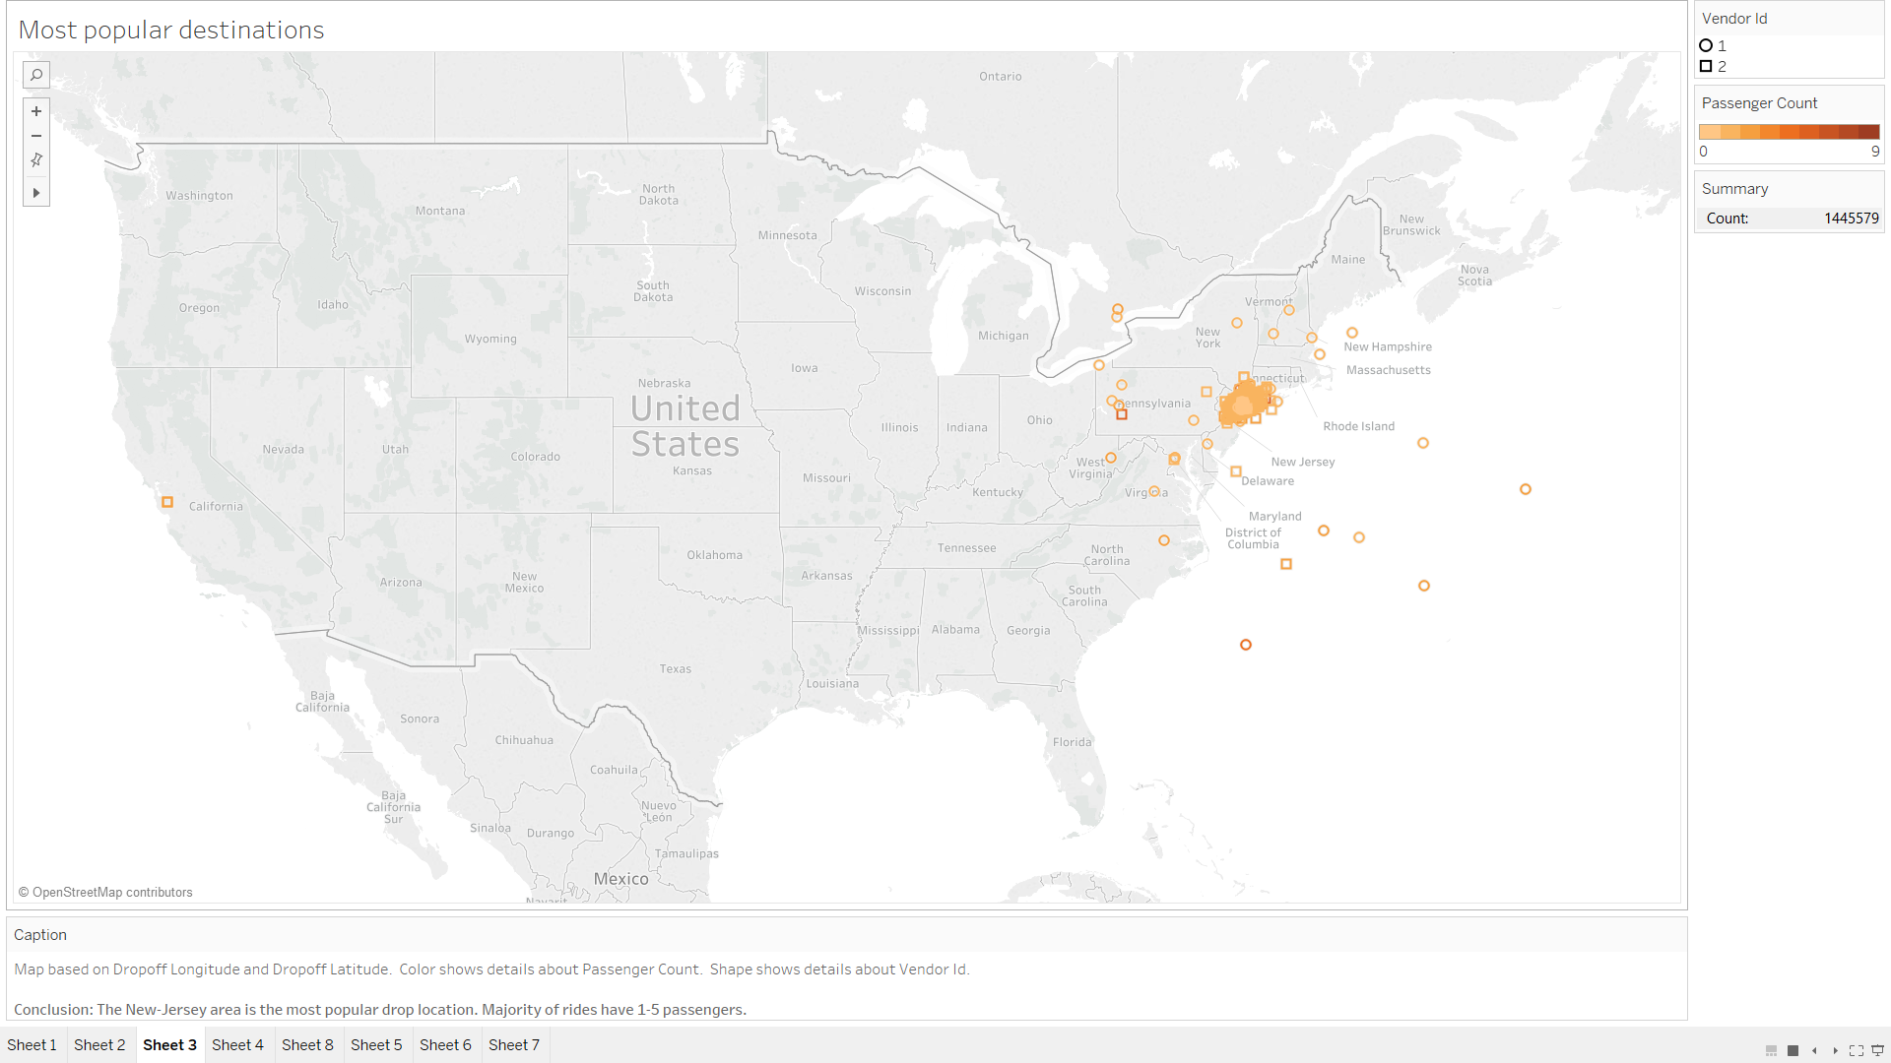

Visualisation 3

Design/Variables

Map based on Dropoff Longitude and Dropoff Latitude. Color shows details about Passenger Count. Shape shows details about Vendor Id.

Conclusion

The New-Jersey area is the most popular drop location. Majority of rides have 1-5 passengers.

IMAGE 4 ALONG WITH ITS CONCLUSIONS

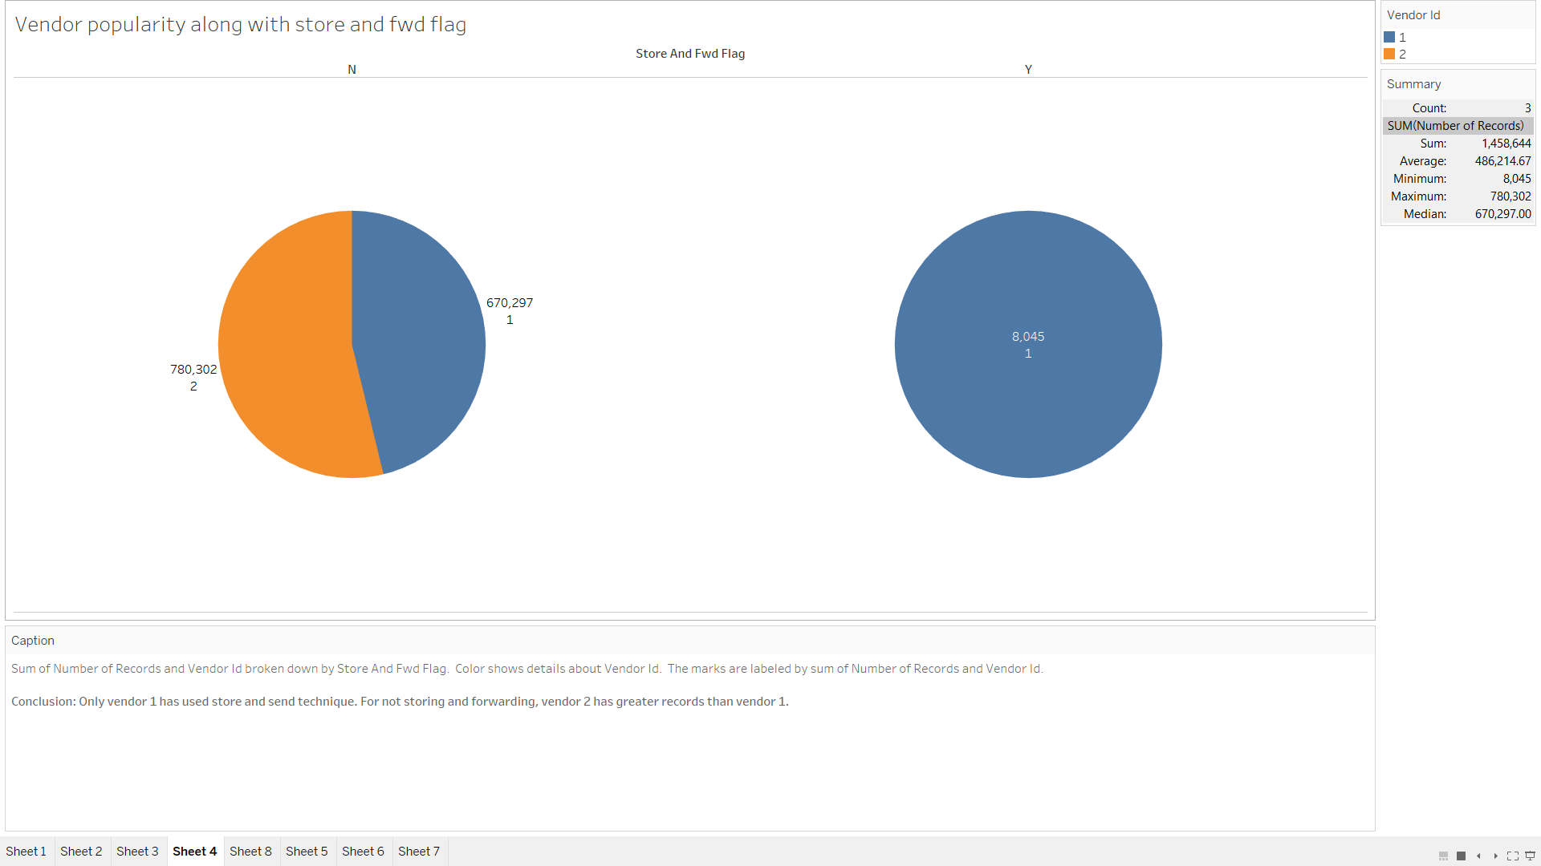

Visualisation 4

Design/Variables

Sum of Number of Records and Vendor Id broken down by Store And Fwd Flag. Color shows details about Vendor Id. The marks are labeled by sum of Number of Records and Vendor Id.

Conclusion

Only vendor 1 has used store and send technique. For not storing and forwarding, vendor 2 has greater records than vendor 1.

IMAGE 5 ALONG WITH ITS CONCLUSIONS

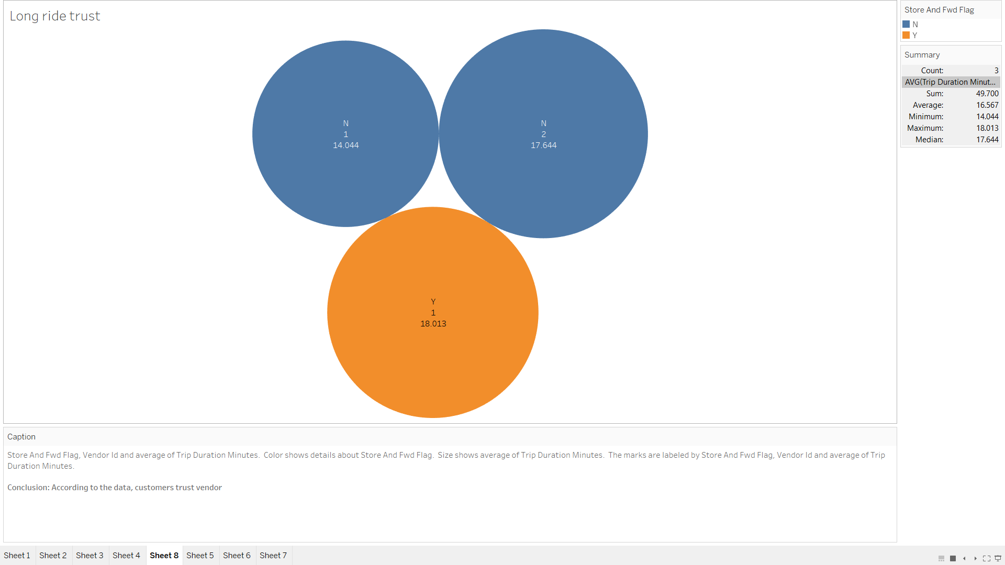

Visualisation 5

Design/Variables

Store And Fwd Flag, Vendor Id and average of Trip Duration Minutes. Color shows details about Store And Fwd Flag. Size shows average of Trip Duration Minutes. The marks are labeled by Store And Fwd Flag, Vendor Id and average of Trip Duration Minutes.

Conclusion

According to the data, customers trust vendor 2 more than vendor 1 in case where Store and Fwd flag id N, while they prefer vendor 1 in the other case.

IMAGE 6 ALONG WITH ITS CONCLUSIONS

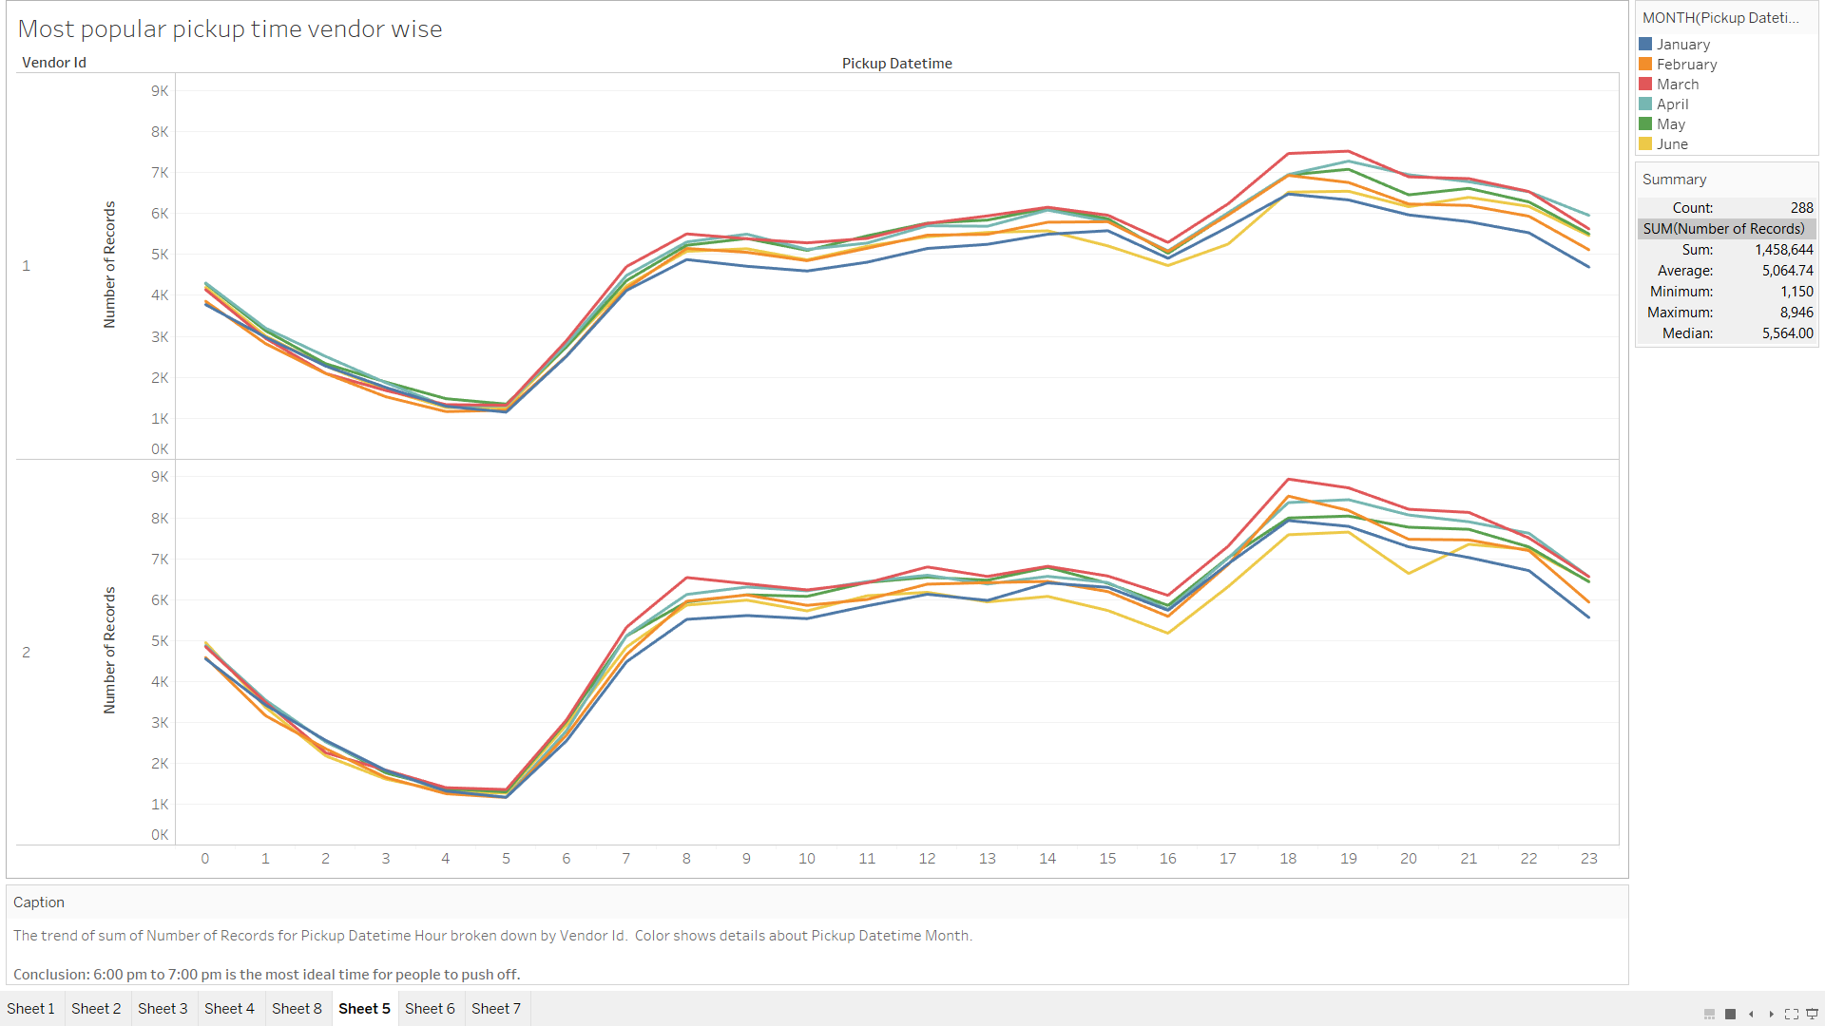

Visualisation 6

Design/Variables

The trend of sum of Number of Records for Pickup Datetime Hour broken down by Vendor Id. Color shows details about Pickup Datetime Month.

Conclusion

6:00 pm to 7:00 pm is the most ideal time for people to push off.

IMAGE 7 ALONG WITH ITS CONCLUSIONS

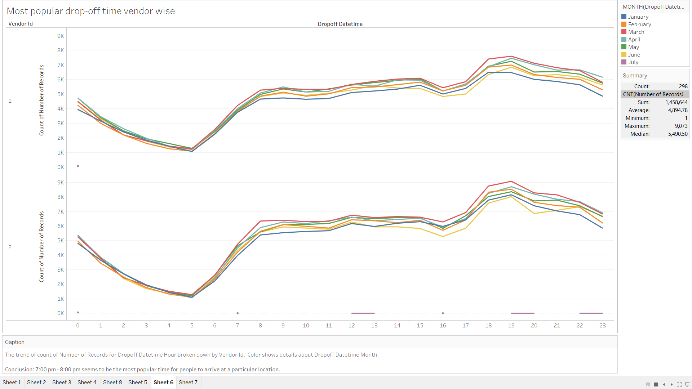

Visualisation 6

Design/Variables

The trend of count of Number of Records for Dropoff Datetime Hour broken down by Vendor Id. Color shows details about Dropoff Datetime Month.

Conclusion

7:00 pm - 8:00 pm seems to be the most popular time for people to arrive at a particular location.

IMAGE 8 ALONG WITH ITS CONCLUSIONS

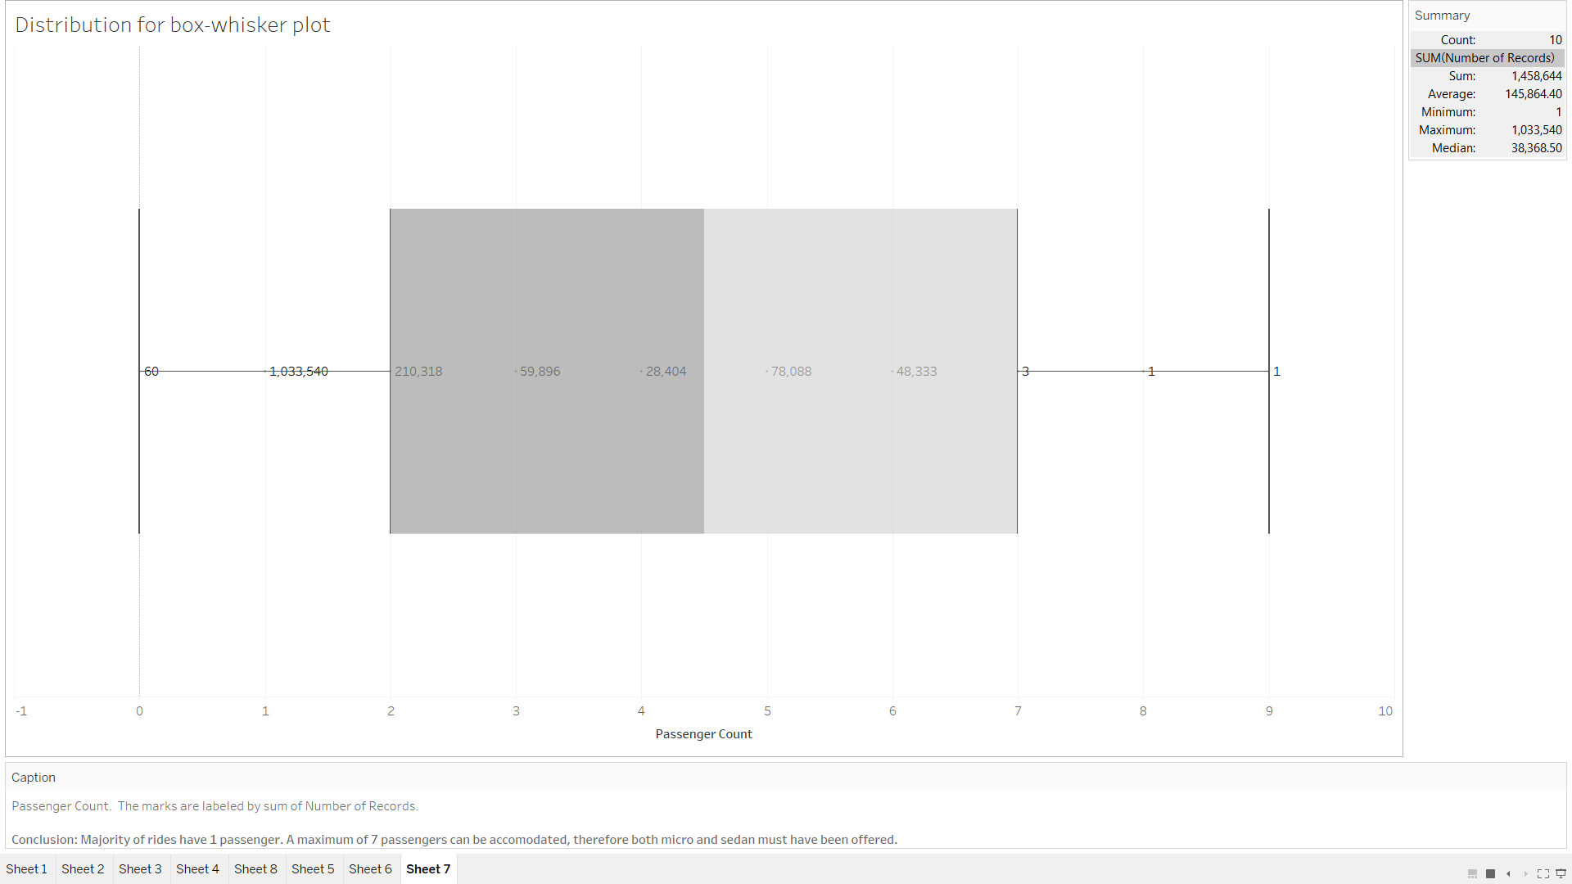

Visualisation 6

Design/Variables

Passenger Count. The marks are labeled by sum of Number of Records.

Conclusion

Majority of rides have 1 passenger. A maximum of 7 passengers can be accomodated, therefore both micro and sedan must have been offered.

Final tableau workbook is available at:

<https://public.tableau.com/profile/osho.agyeya#!/vizhome/Puchoosho/Sheet1>

The tableau file, screenshots and dataset have been included in the folder.