- FALL SEMESTER 2016-2017



MICROPROCESSOR AND INTERFACING

(CSE 2006) PROJECT

PROF KHADAR NAWAS



VOICE CONTROLLED ROBOT BY CELL PHONE WITH ANDROID APP  
1.) Kashish Miglani 15BCE1003

2.) Ketan Atri 15BCE1025

3.) Osho Agyeya 15BCE1326

4.) Utsav Rai 15BCE1352

CIRCUIT DIAGRAM

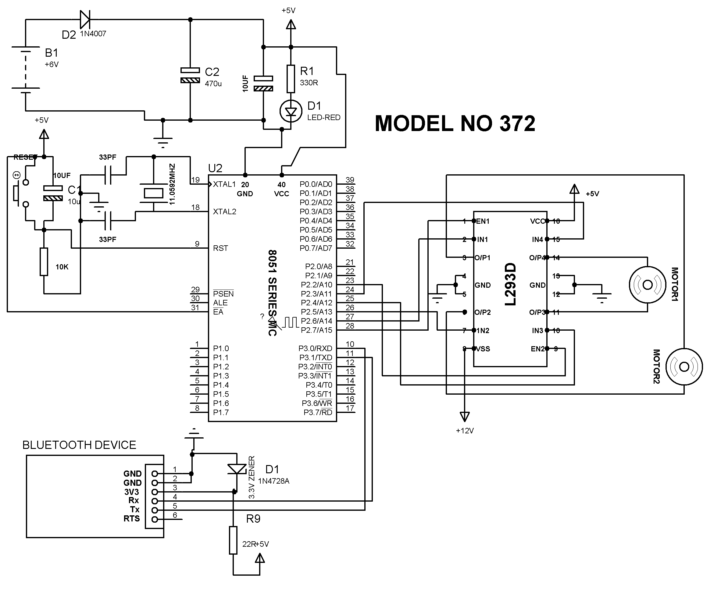

BLOCK DIAGRAM

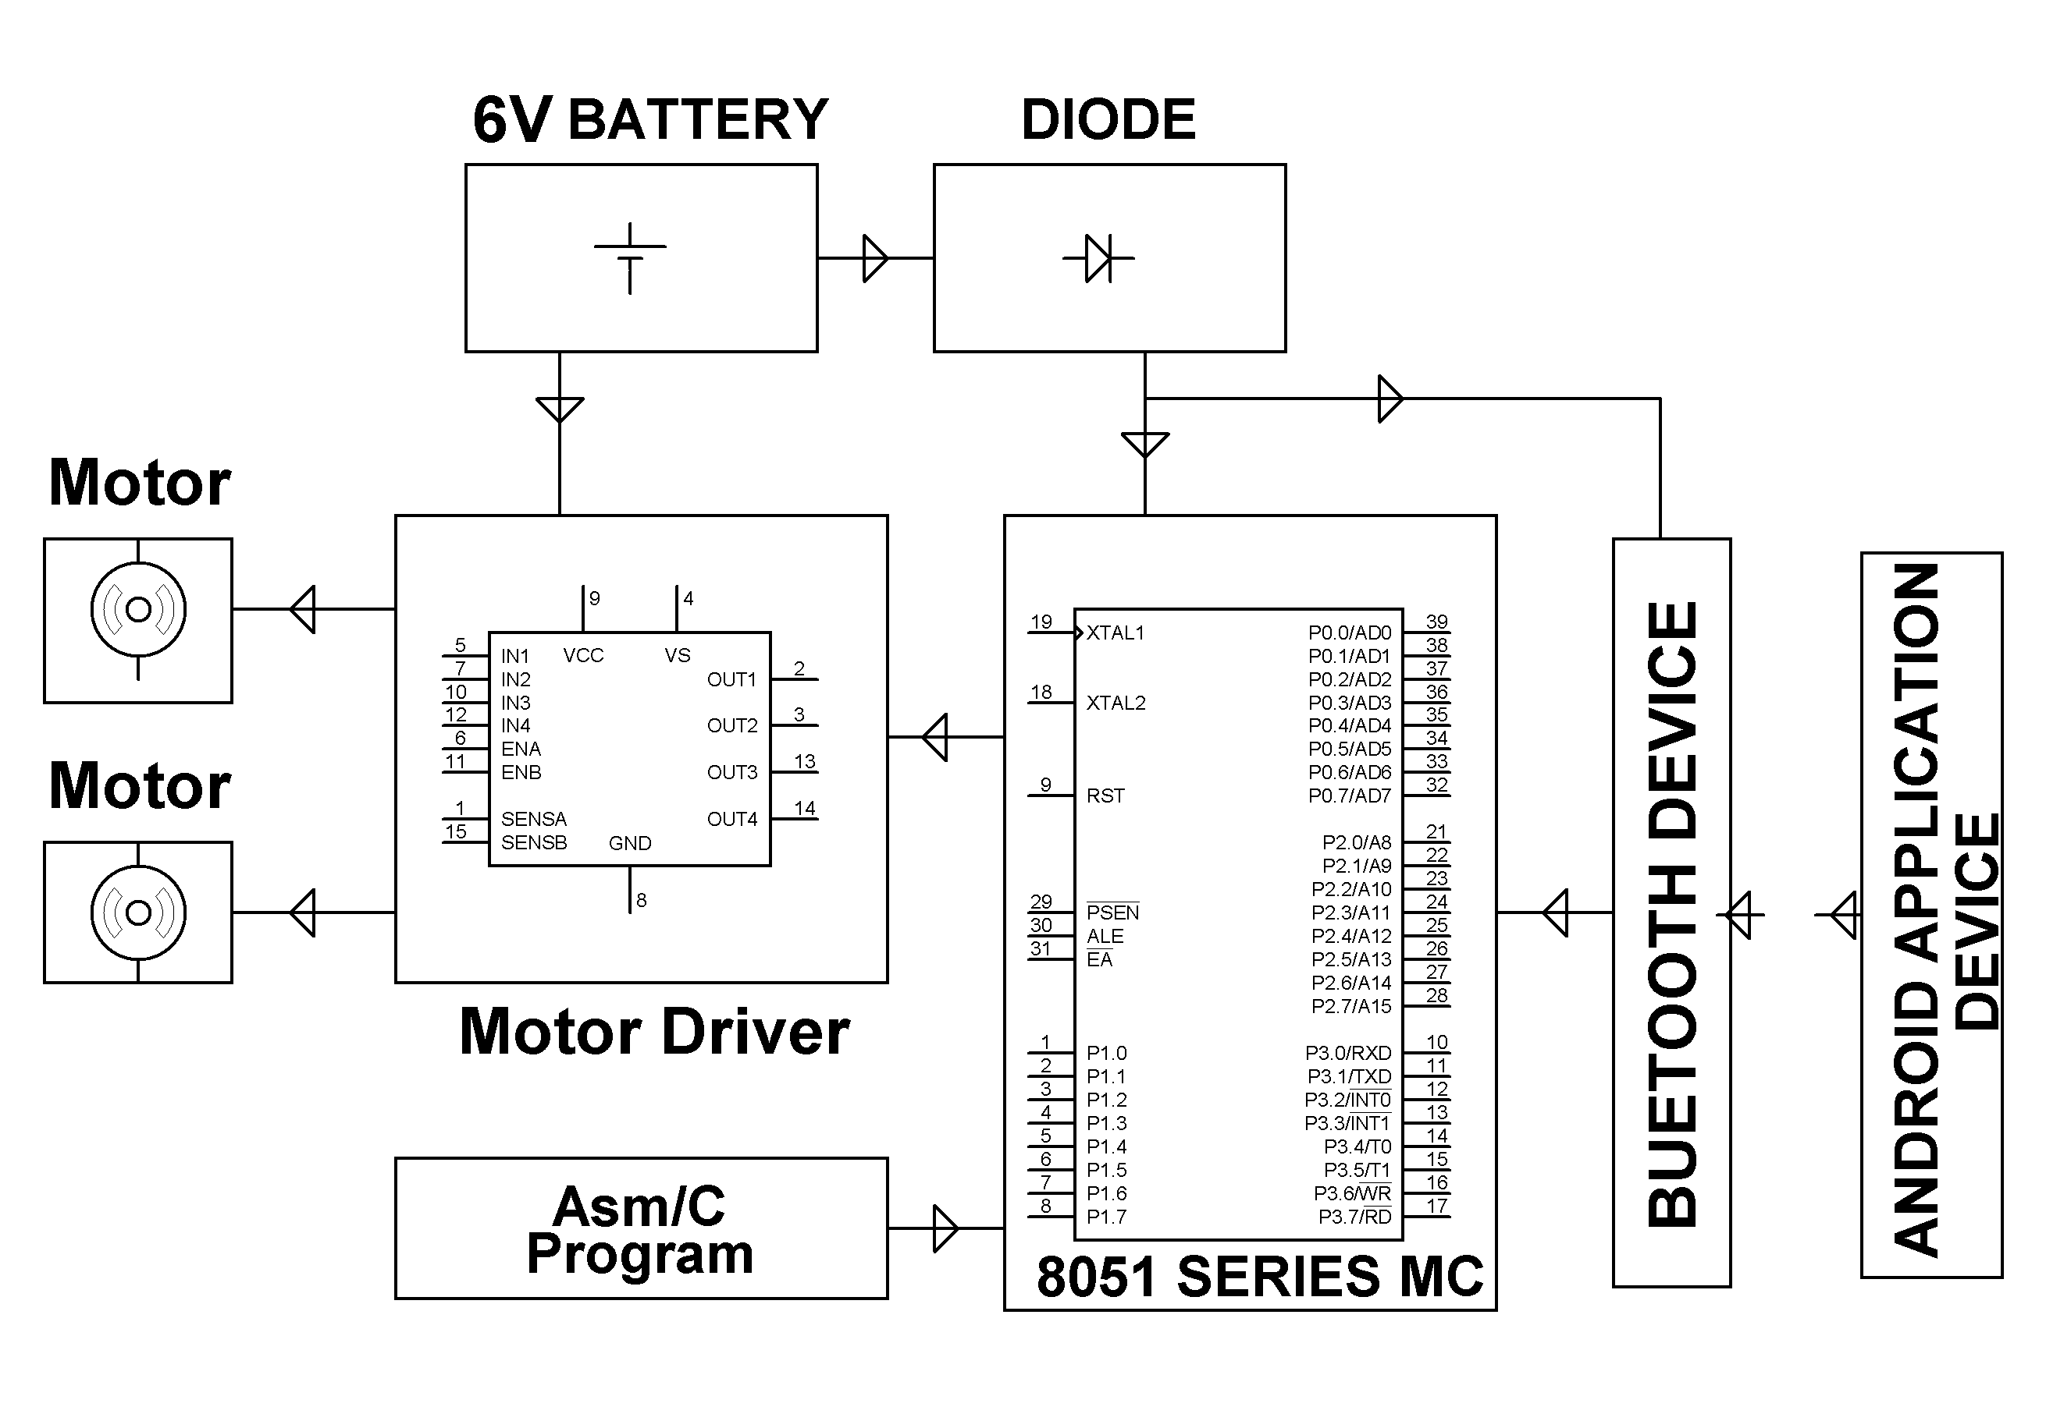

COMPONENTS

8051 series Microcontroller Push Button Bluetooth module Motor driver IC DC motors Resistors

Capacitors Diodes Batteries LED Zener diode Rectifier diode Crystal

PHOTOS

