APPENDIX H – USER MANUAL
SnailShutter Photography Studio Management System (Client Portal)
This user manual provides step-by-step instructions for clients on how to access the SnailShutter online photography portal, log in or register an account, browse photography packages and studio services, schedule appointment dates and time slots, pay the 10% GCash reservation downpayment, track booking statuses, retrieve high-resolution photo deliverables via Google Drive, and manage account profile settings.
________________________________________

1. SYSTEM REQUIREMENTS
Before accessing the SnailShutter Photography Studio System, prepare the following:
• Device: Desktop computer, laptop, tablet, or smartphone (Android or iOS)
• Web Browser: Google Chrome, Microsoft Edge, Mozilla Firefox, or Safari (latest version)
• Internet Connection: Stable Wi-Fi or cellular mobile data connection
• Active Email Address & Mobile Number: Required for 6-digit OTP email verification and booking status updates
• GCash Account: Required for remitting the mandatory 10% booking reservation downpayment
• Google Account / Web Browser: Required for accessing and downloading digital photo deliverables from Google Drive
________________________________________

2. ACCESSING THE SYSTEM AND LOGGING IN
When you open the SnailShutter website, the Public Homepage is displayed.
Step 1: Open your computer or smartphone and launch your web browser (Google Chrome or Microsoft Edge).
Step 2: Type the official web address in the address bar:
o Live Website: https://snailshutter-app.onrender.com
o Local Network or Demo: http://localhost:3000/ or http://localhost/CAPSTONE2/
Step 3: Press Enter. The SnailShutter Studio Homepage will appear and click the login button to redirect to login page.
Step 4: If you already have an existing registered account:
o Enter your registered Email Address.
o Enter your Password (click the Eye icon to verify your entered characters).
o Click Sign In.
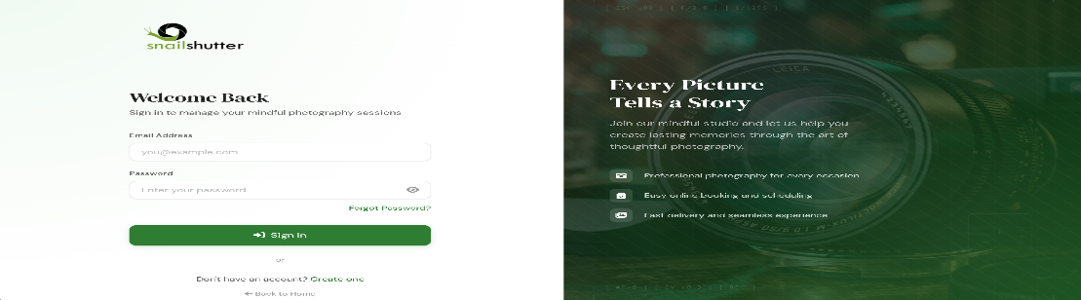
Step 5: Upon successful authentication, the system validates your client role and redirects you directly to your personalized Client Dashboard.

If Login Fails:
• Verify that your email address and password are typed correctly without extra spaces.
• Consecutive failed attempts will trigger a security cooldown timer with a lockout badge.
• If you forgot your password, click Forgot Password? to receive a 6-digit password reset OTP code via email.
• If you do not have an account yet, proceed to Section 3 below.
________________________________________

3. CREATING A NEW ACCOUNT (IF NO ACCOUNT YET)
If you are a new customer and do not have an account yet, follow these steps to register:
Step 1: On the Login screen, click "Don’t have an account? Create one" or click "Sign Up" from the top navigation bar.
Step 2: Fill in the registration form with your information:
o First Name and Last Name
o Active Email Address
o Valid 11-digit Mobile Contact Number (e.g., 09171234567)
Step 3: Enter your chosen password. Observe the interactive Password Requirements Checklist:
o At least 8 characters in length
o At least one uppercase letter (A–Z)
o At least one numeric digit (0–9)
o At least one special character (e.g., !@#$%^&*)
Step 4: Retype your password in the Confirm Password box (a live indicator will confirm that passwords match).
Step 5: Click Send Verification Code.
Step 6: Check your email inbox for the 6-digit One-Time PIN (OTP) verification code. Enter the 6 digits in the verification boxes and click Verify & Complete Registration. (Note: If the email does not appear in your inbox within 60 seconds, check your Spam or Junk folder, or click Resend Code).
Step 7: Once verified, your account is activated. You are automatically signed in to the Client Dashboard.
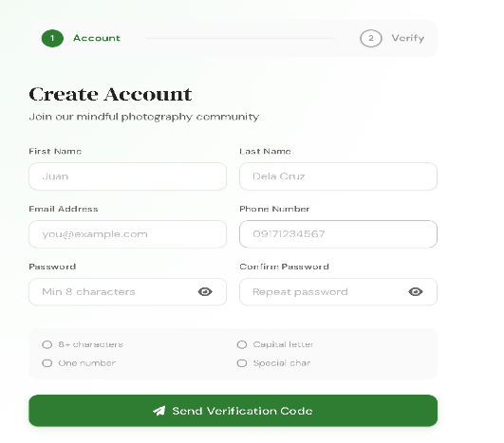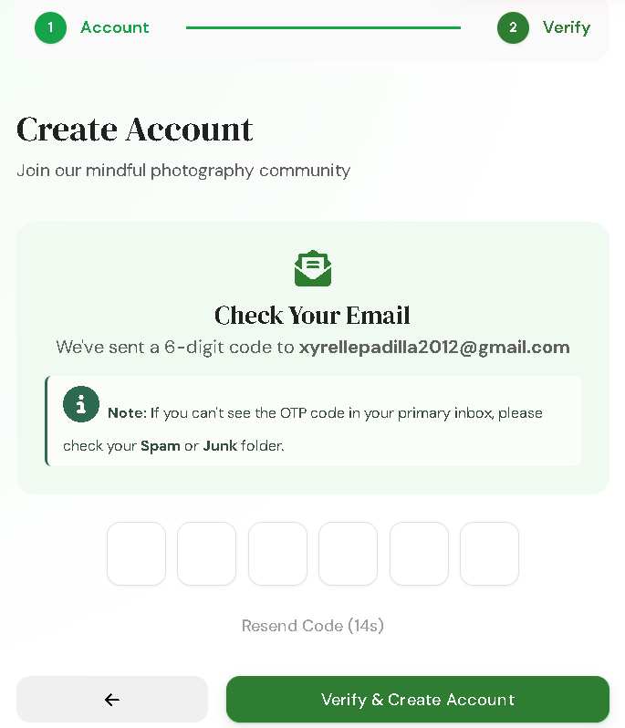
________________________________________

4. EXPLORING THE STOREFRONT & SERVICE CATALOG
After accessing the studio website, browse our curated photography service packages:
Step 1: Navigate to the Services section
Step 2: Filter photography packages by category using the category filter buttons:
o All Packages: Displays the entire studio catalog.
o Portrait: Professional individual, graduation, or couple portrait sessions.
o Events: Creative wedding pre-nuptial shoots,1st Birthday & Christening, 7th Birthday, 18th Birthday(Debut) and full event photography coverage.
Step 3: Browse each product card to review the package title, preview imagery, category badge, session duration, and price in Philippine Peso (₱).
Step 4: Click on any service card to view complete specifications in the package details modal.
__ 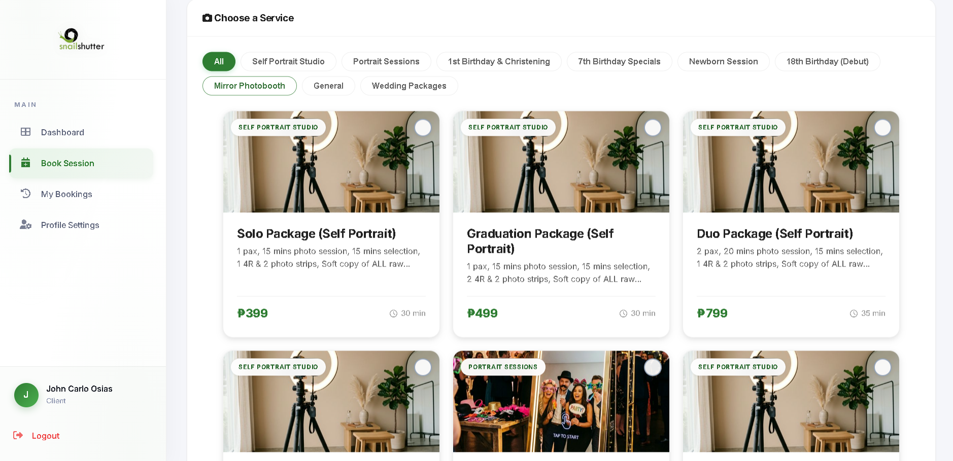 ______________________________________

5. VIEWING PACKAGE DETAILS & SPECIFICATIONS
Step 1: In the service package modal, view all session inclusions and terms:
o Session Duration (e.g., 60 minutes for Portrait, 180 minutes for Wedding Pre-nup)
o Fixed Retail Price (e.g., ₱2,500.00 for Portrait Session, ₱12,000.00 for Wedding Pre-nup)
o Package Description, recommended outfits, creative concepts, and deliverables
Step 2: Click Book This Service or select the card to proceed directly to appointment scheduling.
________________________________________

6. SPECIAL SERVICES & MULTI-PACKAGE SELECTION
Step 1: On the booking screen, click any service card to select it.
Step 2: To select multiple photography packages or add-on sessions, click additional service cards.
Step 3: Observe the Floating Multi-Select Action Bar that slides up at the bottom of the screen:
o Displays the number of selected services (e.g., "2 services selected").
o Computes and displays the running subtotal amount (e.g., "₱6,500"

Step 4: Click Select Date & Time on the floating bar to advance to the scheduling calendar.
________________________________________

7. REQUESTING A CUSTOM TIME RANGE & SPECIAL NOTES
Clients can request custom scheduling or specify bespoke shoot themes:
Step 1: Under Step 2 of the booking calendar, if standard 1-hour increments do not fit your itinerary, click Set Custom Time Range.
Step 2: Input your desired Start Time and End Time within studio operating hours (10:00 AM – 7:00 PM).
Step 3: Click Confirm to apply your custom time window.
Step 4: Under Step 3 (Confirmation), use the Additional Notes (Optional) field to specify:
o Custom creative direction, outfit changes, or props
o Preferred studio backdrop colors
o Special requests or reminders for the photographer

________________________________________

8. MANAGING APPOINTMENT SELECTION & TIME SLOTS
Step 1: On Step 2 of the booking workflow, view the Interactive Monthly Calendar.
Step 2: Select your target photoshoot date. Observe the real-time calendar availability indicators:
o Green: Available shoot date with open time slots.
o Red: Has existing bookings (some slots may still be open).
o Purple: Completed past session dates.
o Black Border: Current calendar day (Today).
Step 3: Check the Real-Time LIVE Sync Badge:
o The blinking green LIVE badge indicates live updates via Server-Sent Events (SSE).
o If another client reserves a time slot while you are viewing, that slot will instantly pulse and disable as "Booked".
Step 4: Select an available time slot from the right-hand panel (between 10:00 AM and 7:00 PM).
Step 5: Studio Lunch Break Notice:
o If your session spans across midday (12:01 PM – 12:59 PM), an alert box will explain that the studio pauses for lunch and resumes automatically at 1:00 PM to give you your full booked shoot time.
________________________________________

9. CHECKOUT & BOOKING CONFIRMATION
Step 1: Review your comprehensive Booking Summary:
o Service Package Name(s)
o Scheduled Appointment Date & Time Window
o Full Package Price (Total Due)
o Required 10% Downpayment Amount (e.g., ₱250.00 for a ₱2,500.00 booking)
Step 2: Proceed to the payment box to complete the reservation deposit.
________________________________________

10. PAYING 10% DOWNPAYMENT & UPLOADING PROOF
To protect reserved slots against abrupt cancellations, a mandatory 10% downpayment is required via GCash:
Step 1: Scan the official SnailShutter Studio GCash QR Code displayed on screen with your GCash app, OR
Step 2: Send payment directly to the studio’s listed GCash number:
o GCash Number: 0912 345 6789 (Click "Copy Number" for quick copying)
o Account Name: SnailShutter Studio
Step 3: Enter the exact 10% downpayment amount and complete the transaction.
Step 4: Save or screenshot your GCash confirmation receipt.
Step 5: Under Upload Receipt / Proof of Payment, click the file input and select your receipt screenshot (accepted: JPG, PNG, WEBP, GIF; maximum size: 2MB).
Step 6: Review the generated image thumbnail preview and file size badge.
Step 7: Click Complete Booking. Studio staff will verify your receipt and confirm your scheduled shoot.
________________________________________

11. TRACKING BOOKING STATUS & GOOGLE DRIVE DELIVERIES
Step 1: Click on the sidebar navigation and select My Bookings.
Step 2: Filter appointments using the status filter tabs (All, Pending, Confirmed, Completed, Cancelled).
Step 3: Locate your booking record and check the real-time status badge:
o Pending: Booking submitted; 10% GCash downpayment receipt awaiting studio verification.
o Confirmed: Downpayment verified studio schedule locked.
o Completed: Photoshoot session conducted; digital images retouched and finalized.
o Cancelled: Booking cancelled or rejected (cancellation reason and timestamp displayed).
Step 4: Click on any booking to open the Full Booking Details Modal.
Step 5: Retrieving Photo Deliveries (When Completed):
o When the photographer uploads your retouched photos, a green banner appears: "📸 Your Photos Are Ready!"
o Click Open Photo Album to be directed to your private Google Drive gallery.
o Preview individual portraits or click "Download all" to save the high-resolution ZIP album to your device.
________________________________________

12. MANAGING PROFILE & ACCOUNT SETTINGS
Step 1: Click Profile Settings (/client/settings.html) in the sidebar.
Step 2: To update your Profile Avatar:
o Hover over your profile photo circle and click the Camera icon.
o Select an image file (JPG, PNG, WEBP up to 2MB).
o The avatar updates immediately across all portal sidebars.
Step 3: To update Personal Information:
o Modify your First Name, Last Name, Email Address, or 11-digit Phone Number.
o Click Save Changes and confirm in the popup modal.
Step 4: To update your Account Password:
o Enter your Current Password (use the eye icon to verify).
o Enter your New Password and Confirm New Password (satisfying all 4 security criteria).
o Click Update Password to apply the new credentials.
________________________________________

13. FREQUENTLY ASKED QUESTIONS & TROUBLESHOOTING
Issue Encountered | Possible Cause | Recommended Action
Cannot log in to my account | Incorrect email or password, or account temporarily locked out due to multiple failed attempts. | Verify credentials; check Caps Lock; if locked out, wait for cooldown timer or click Forgot Password? to reset via email OTP.
Did not receive OTP code | OTP email went to Spam folder or network email delivery delay. | Check your Spam or Junk mail folder. Wait 60 seconds and click Resend Code.
Desired time slot is disabled | Time slot is already booked by another customer. | Select another open time slot or pick an alternative date on the calendar. Slots marked "Booked" cannot be double-booked.
Session spans 12:00 PM – 1:00 PM | Studio observes daily scheduled lunch break (12:01 PM – 12:59 PM). | Standard studio policy. The session pauses at 12:00 PM and resumes smoothly at 1:00 PM to ensure you receive your full shoot duration.
GCash screenshot will not upload | File size exceeds 2MB limit or is in an unsupported format. | Ensure screenshot is in JPG, PNG, or WEBP format and under 2MB. Crop the screenshot in your phone's photo editor to reduce file size.
Google Drive link is missing | Photographer is still retouching and color grading the photos. | Deliverables are uploaded within 24 to 72 hours following the shoot. Once attached by staff, the green "Open Photo Album" button appears.
"Cancel Booking" button missing | The session is already Completed or Cancelled. | Only appointments in "Pending" or "Confirmed" status can be cancelled. Completed sessions represent finished studio services and cannot be retracted.
________________________________________

14. DATA PRIVACY AND SECURITY REMINDERS
SnailShutter values your security and personal data:
• Account Confidentiality: Never share your account password or email OTP verification codes with anyone. SnailShutter staff will never solicit your password.
• Data Protection: Your personal contact details, mobile numbers, and booking records are protected under the Philippine Data Privacy Act of 2012 (R.A. 10173). Client images are hosted in private, secure Google Drive folders accessible only to the booking client.
• Payment Safety: Only remit GCash downpayments to the official studio account displayed in the checkout screen: SnailShutter Studio (0912 345 6789).
• Downpayment Policy: The 10% GCash downpayment covers advance studio scheduling and slot reservations and is non-refundable upon client cancellation.
________________________________________

15. LOGGING OUT OF YOUR ACCOUNT
Always log out after completing your session management, especially when using a shared terminal or public computer:
Step 1: Locate the sidebar footer at the bottom-left of the screen.
Step 2: Click the Logout link (next to the sign-out icon).
Step 3: The system terminates your session, flushes stored credentials from browser memory, and returns you to the Login screen.
Step 4: Close your browser window.

