Appendix H - Sheet 1: Public Website (index.html) & Client Online Booking Flow (client/book.html) (SnailShutter Studio Website)
(Tip: Right-click diagram in Word and select 'Convert to Shape' to edit any text, labels, or boxes)

Appendix H - Sheet 2: Client Portal Dashboard (client/dashboard.html) & Bookings History (client/bookings.html) (SnailShutter Studio Website)
(Tip: Right-click diagram in Word and select 'Convert to Shape' to edit any text, labels, or boxes)

Appendix H - Sheet 3: Staff Portal Daily Schedule (staff/dashboard.html) & Photo Deliveries (staff/gallery.html) (SnailShutter Studio Website)
(Tip: Right-click diagram in Word and select 'Convert to Shape' to edit any text, labels, or boxes)

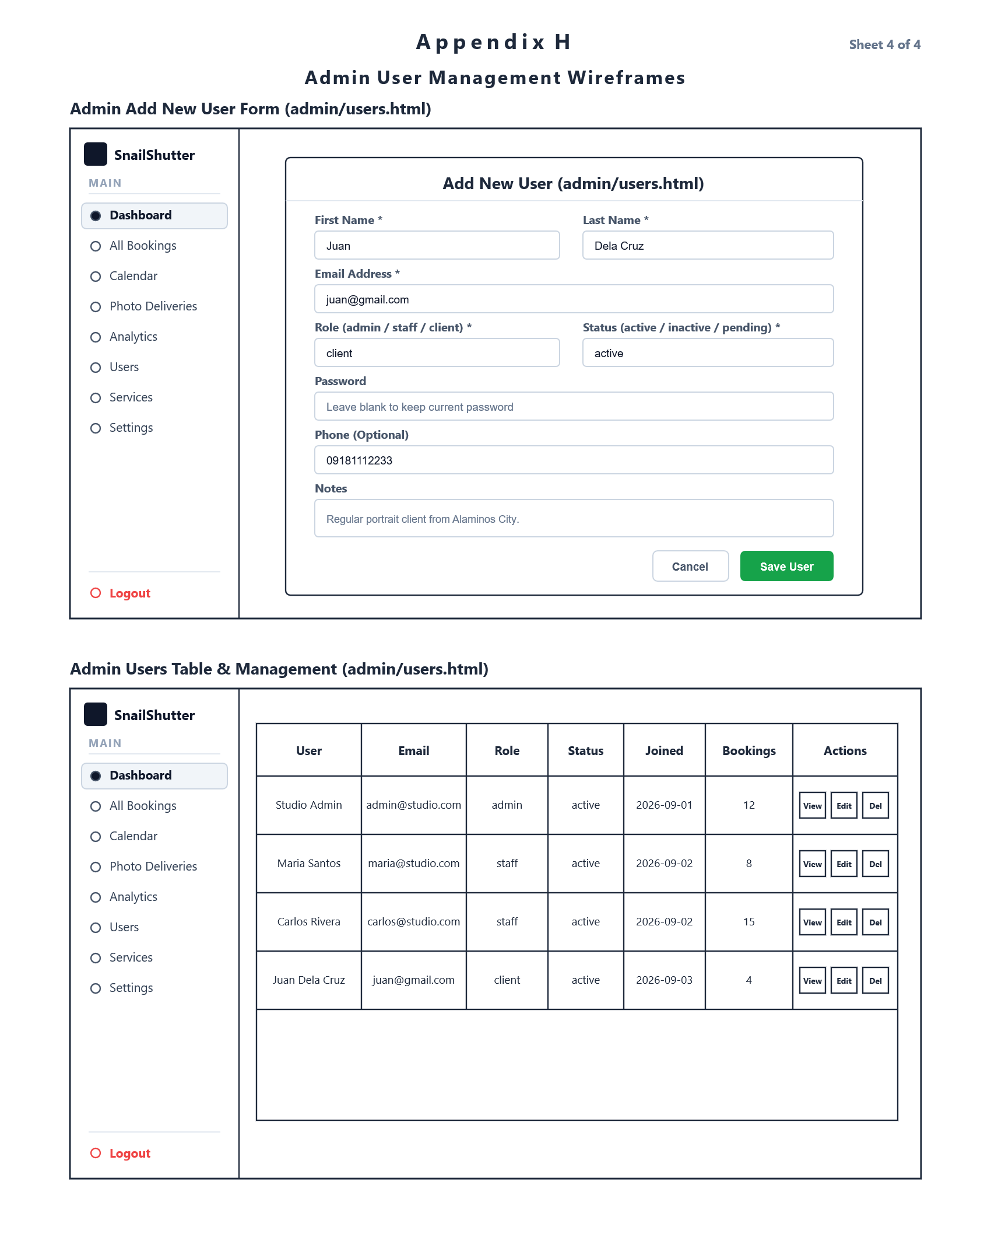
Appendix H - Sheet 4: Admin User Account Creation & Manage Users Table (admin/users.html) (SnailShutter Studio Website)
(Tip: Right-click diagram in Word and select 'Convert to Shape' to edit any text, labels, or boxes)

