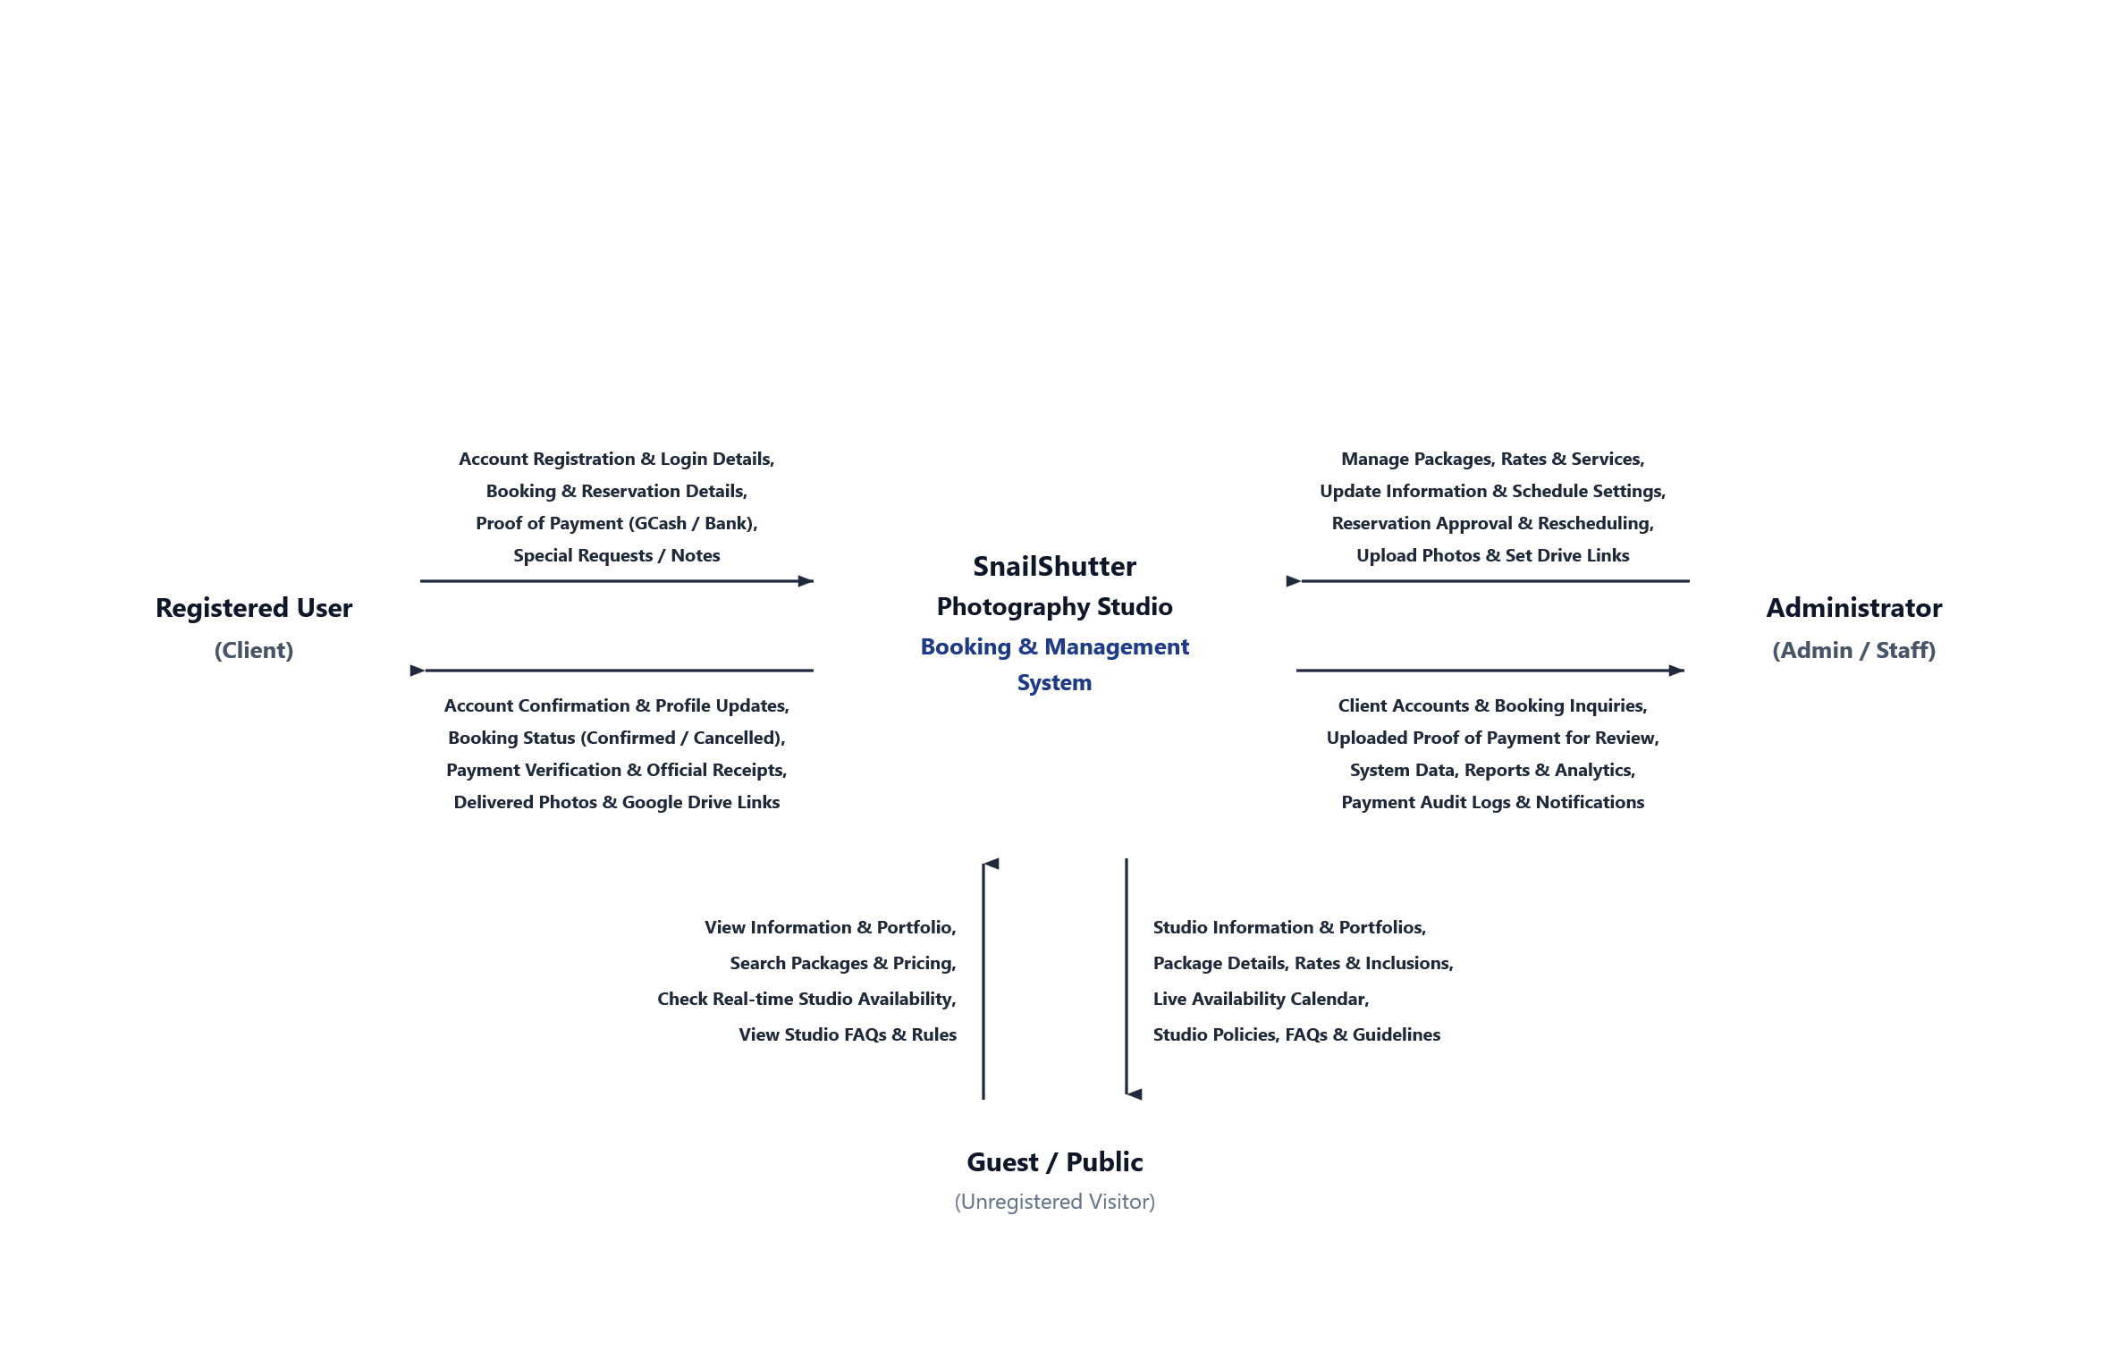Figure 3.2. Context Diagram of SnailShutter Photography Studio Management System with Online Booking

Tip: To edit shapes, arrows, and text, right-click the diagram above and click 'Convert to Shape' (or go to Graphics Format > Convert to Shape).

