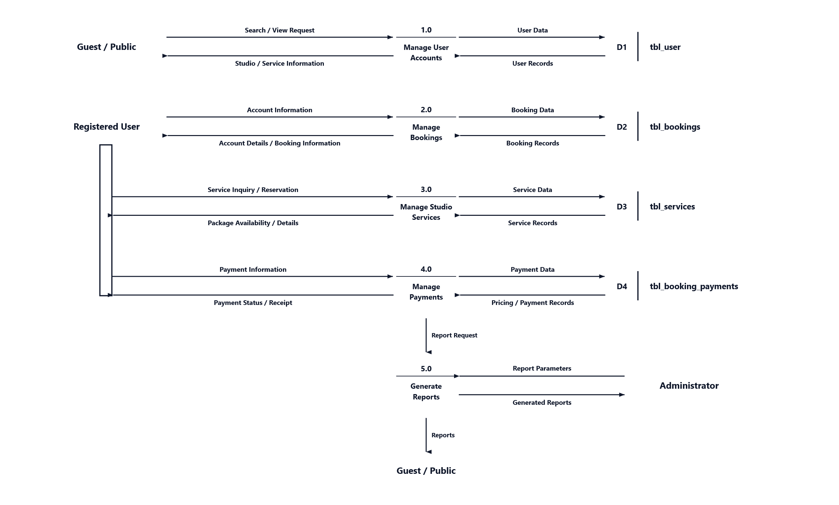Data Flow Diagram (DFD) Level 1. A Data Flow Diagram Level 1 is a visual representation that shows how data moves through the different processes of the system. It illustrates the flow of information between the users, system processes, and database.

The developers will use the DFD Level 1 as a visual representation to understand how data moves through the different processes of the proposed SnailShutter Photography Studio Management System. Figure 3.4 represents the Data Flow Diagram Level 1 of the developers' proposed system.

Tip: To edit processes, data stores, arrows, and text, right-click the diagram and choose 'Convert to Shape' (or go to Graphics Format > Convert to Shape).

