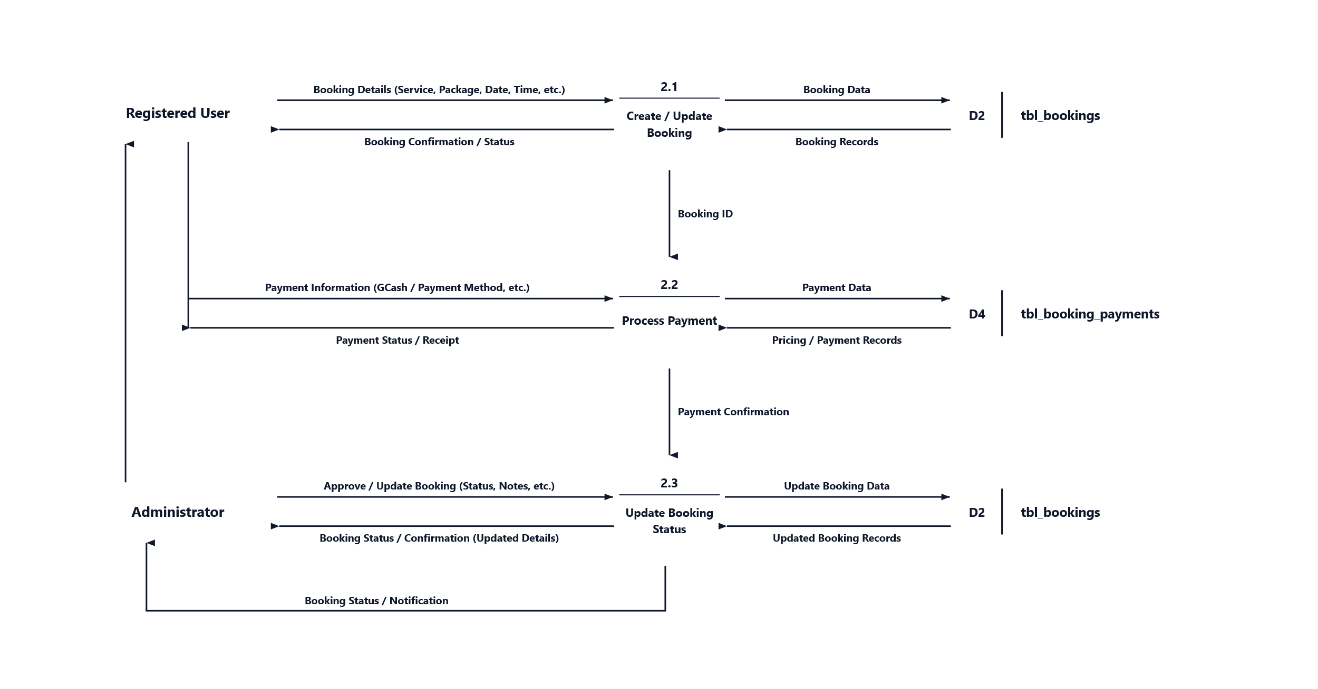Data Flow Diagram (DFD) Level 2. A Data Flow Diagram Level 2 provides a deeper, more detailed breakdown of the functional sub-processes within a primary Level 1 process. In this section, Process 2.0 (Manage Bookings) is decomposed to illustrate the step-by-step transaction lifecycle from initial booking creation, payment processing, to administrative booking status verification and confirmation. Figure 3.5 represents the Data Flow Diagram Level 2 of the developers' proposed system.

Tip: To edit processes, data stores, arrows, and text, right-click the diagram and choose 'Convert to Shape' (or go to Graphics Format > Convert to Shape).

