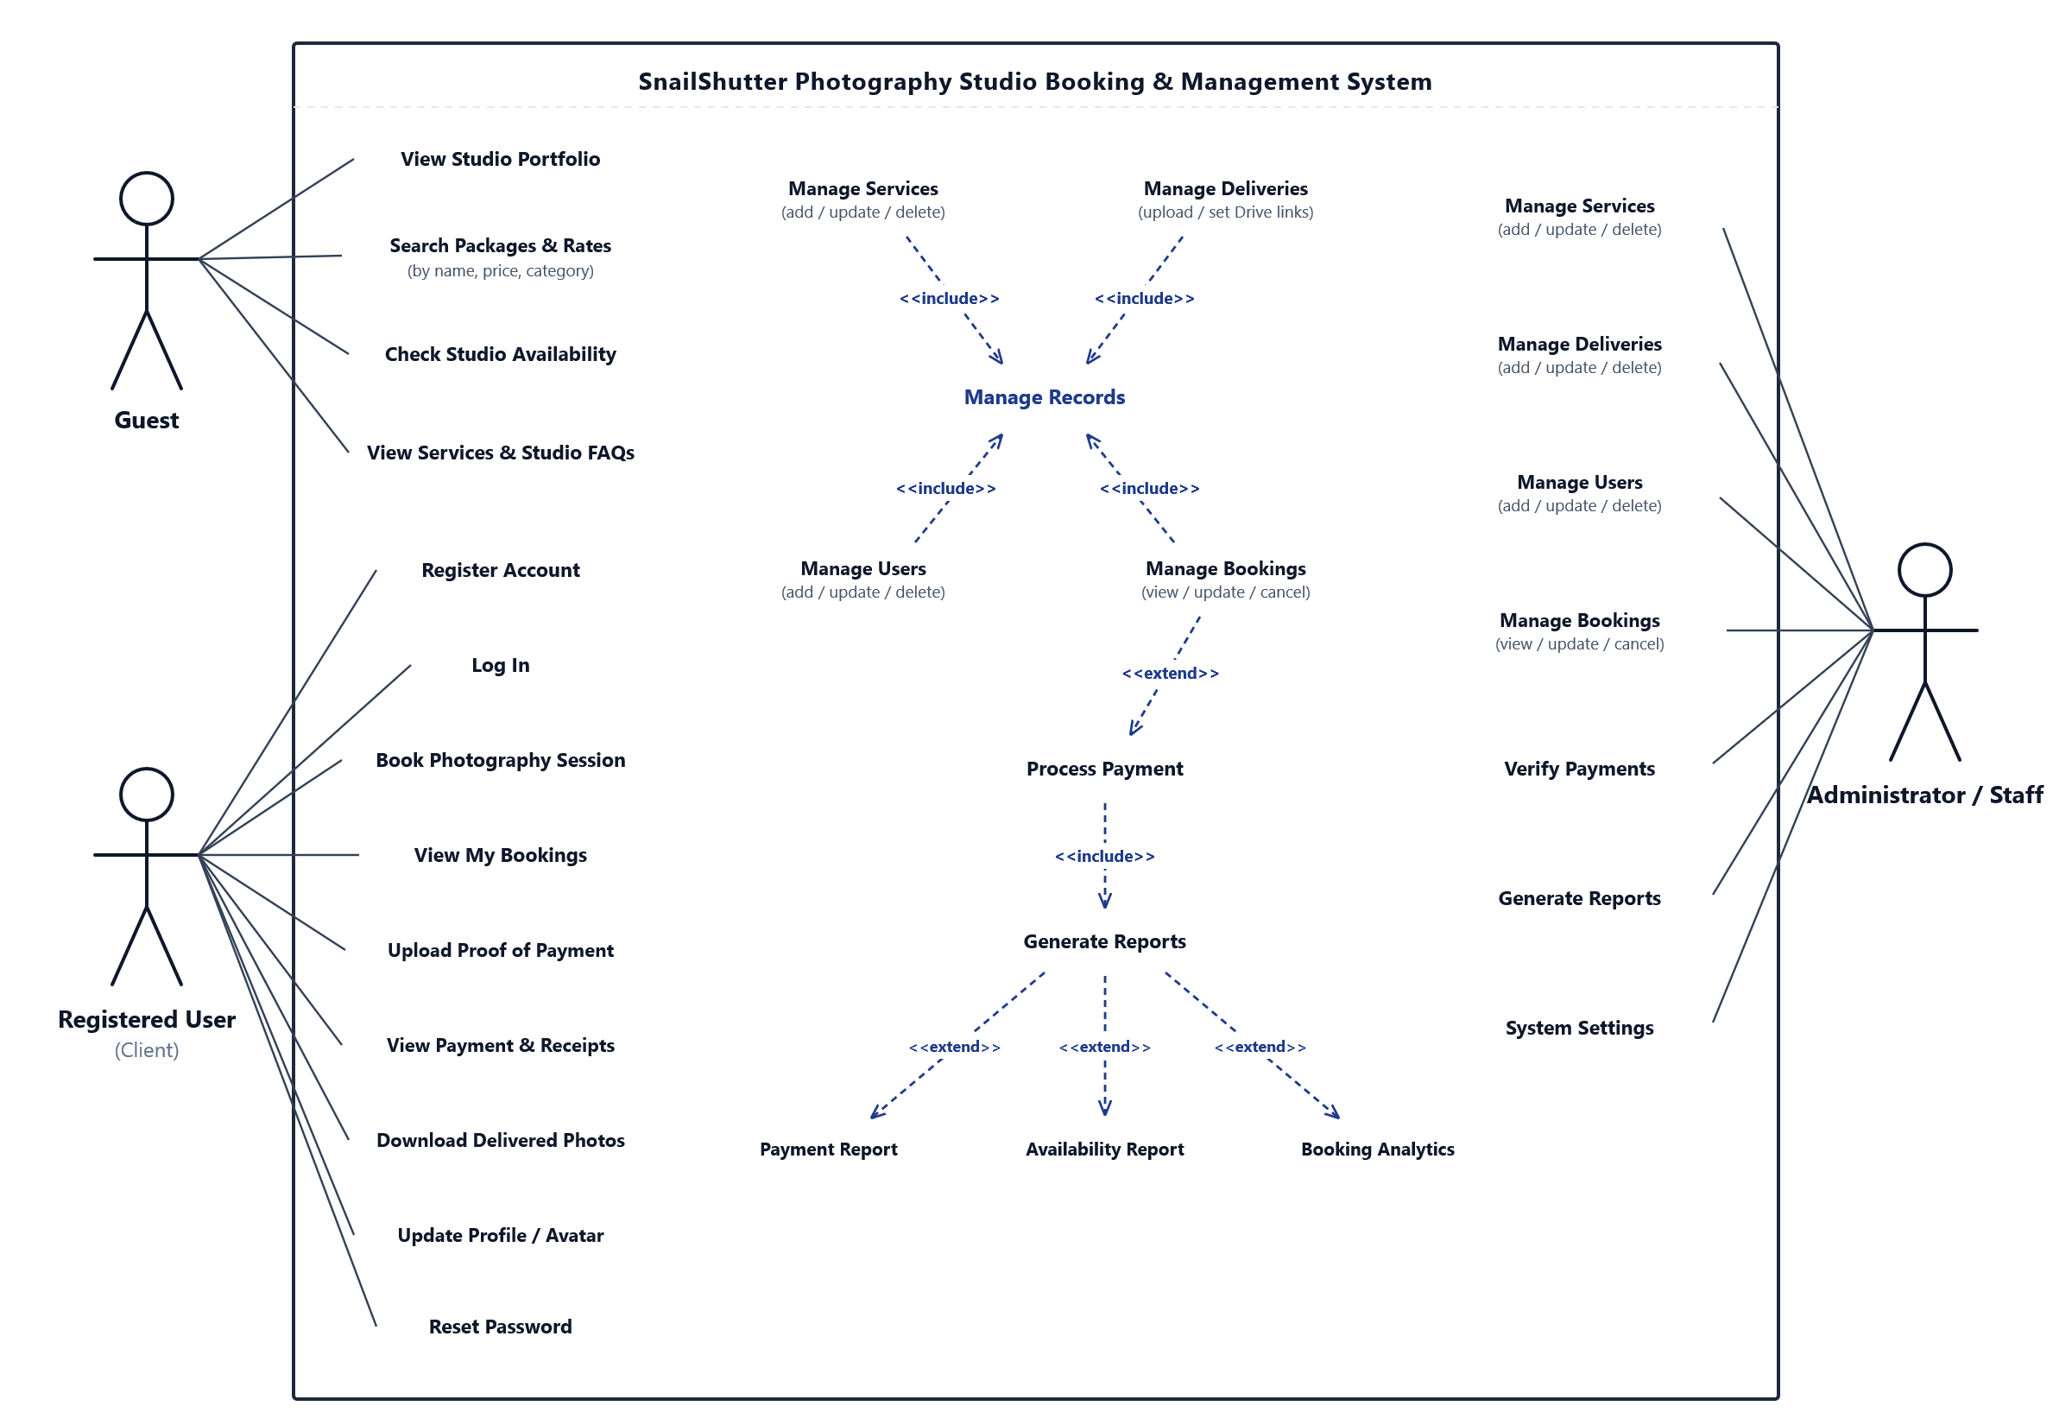Figure 3.1. SnailShutter Use Case Diagram

Tip: To edit shapes and text, right-click the diagram above and click 'Convert to Shape' (or go to Graphics Format > Convert to Shape).

