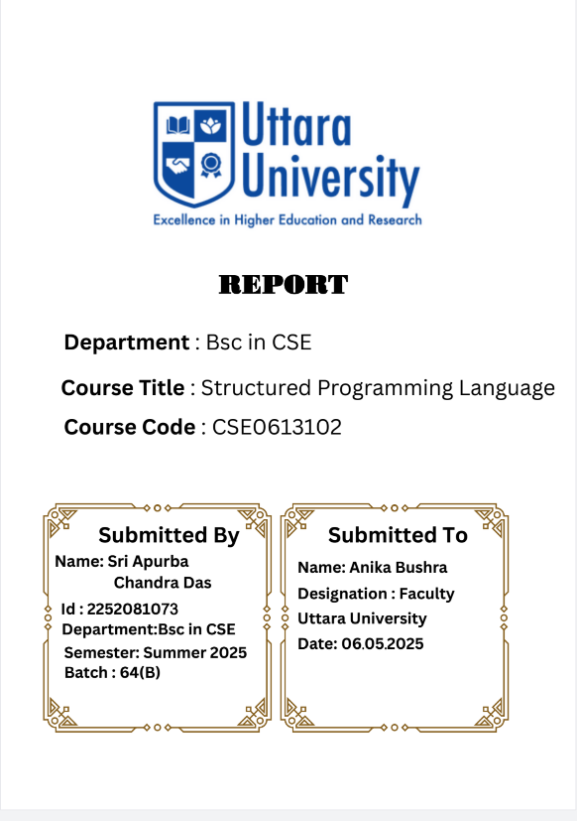

Project Report on Tic Tac Toe Game

# Submitted by

Group Name: Binary Beasts

Batch: 64(B), Department of CSE

Members:

- Sri Apurba Chandra Das (2252081073)

- Ahteshamul Haque Ashik (2252081076)

- Md Rakibul Hasan (2252081074)

- Junayed Islam Shanto (2252081045)

# Abstract

This project presents the development of a simple Tic Tac Toe game using the C programming language. The game allows two players to alternately place the symbols ‘X’ and ‘O’ on a 3×3 grid. After each move, the program checks for winning conditions or a tie. The project primarily demonstrates the use of arrays, loops, conditional statements, and modular programming concepts.  
  
Through this implementation, beginners can better understand fundamental programming logic while enjoying an interactive and engaging game.

# Objectives

* ✔ To design and implement a console-based two-player Tic Tac Toe game.
* ✔ To practice array manipulation and input validation.
* ✔ To apply modular programming by creating functions for displaying the board, handling input, and checking results.
* ✔ To enhance problem-solving and logical thinking skills through practical implementation.

# Discussion

The Tic Tac Toe game runs on a simple yet effective mechanism:  
- The game is played on a 3×3 grid.  
- Player 1 uses symbol X, while Player 2 uses symbol O.  
- Players take turns marking their chosen cell (numbered 1–9).  
- A player wins by placing three identical symbols in a row (horizontally, vertically, or diagonally).  
- If all cells are filled without any winner, the game ends in a tie.

## Gameplay Interface

* • Initial Board Setup: The game starts with a numbered 3×3 grid, allowing players to select their moves.
* • Player Turns: Players input their choices, which are validated by the program to prevent overwriting already occupied cells.
* • Winning Condition: When a player successfully aligns three symbols, the program declares the winner and prompts whether to restart.
* • Tie Condition: If the grid is filled and no winner is found, the game is declared a tie. The player can choose to play again by pressing ‘y’.

# Conclusion

The Tic Tac Toe project has been successfully designed and executed using the C programming language. With the collaboration of all team members, the program ran smoothly without any errors during testing.  
  
This project has not only enhanced our programming skills but also strengthened our ability to implement logical problem-solving strategies. It reflects how a simple concept like Tic Tac Toe can be effectively transformed into a functional program using basic programming constructs.

# Future Enhancements

* ✔ Adding a single-player mode with AI (computer as opponent).
* ✔ Implementing a graphical user interface (GUI) for better visuals.
* ✔ Extending the game to dynamic grid sizes (e.g., 4×4 or 5×5).
* ✔ Adding a scoreboard system to track multiple rounds.