Data Visualisation 2 Report

Author: Oliver Sirota

Student ID: 31464645

Word count: 821

URL: <https://osir0002.github.io/3179/>

# Domain

The domain of my data visualisation is global military power.

# Why?

The primary purpose of my visualisation is to compare nations across the world in terms of military strength and firepower.

# Who?

The intended audience is anyone with an interest in facets of the military and how nations compare.

# What?

My visualisation primarily uses the table dataset from the Military power by country 2022 dataset (Kanawattanachai, 2022). It lists 40+ metrics of military power by country in 2022. The chart relating to nuclear warheads uses the table dataset from the Nuclear_warheads countrywise 1945-2022 dataset (Chopra, 2022). The rankings used in the bump chart was sourced from (GlobalFirepower, 2021). All the data was downloaded as spreadsheets, cleaned, and imported into the repository.

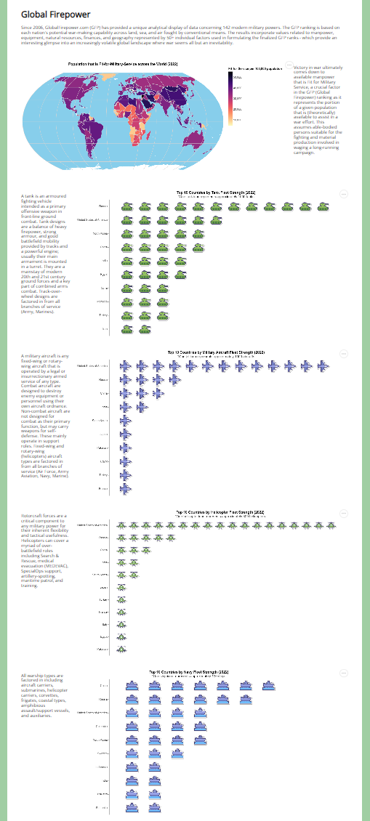

Figure 1. A screenshot of the data visualisation

# How?

## Special Features

In my visualisation, as illustrated in figure 1, I use many icons as marks for my charts sourced from (<https://icons8.com/icons>). They provide immediate context to viewers of the data. In my bump chart, clicking on a country reduces the opacity of all the other countries to highlight the clicked-on country. This makes it easier for viewers to read the data and see the trends for a particular country. In my bar chart, I have included a year slider so that viewers can easily see how the data changes over time.

## Idiom Choice Rationale

A choropleth map was chosen to present the proportion of populations that are fit for military service across the countries of the world to be able to easily identify trends and correlations between countries as well as any outliers. The fit-for-service attribute is normalised to a proportion of 100,000 residents of a country. This attribute is encoded by the colour luminance channel between two hues. Countries are encoded as geographic regions on the area-preserving equal Earth map projection. Isotype charts were chosen to compare countries across various quantitative attributes including number of tanks, aircrafts, helicopters, ships, and defence spending to be able to easily compare countries, determine the country with the largest quantity and look up values. The icons also make it also very easy to determine the domain of each chart at a glance. A bar chart was chosen to compare countries by nuclear warhead amount over time to be able to easily compare countries and identify the country with the largest cache of nuclear weapons, as well as clearly view the changes over time. A bump chart was chosen to present the top countries ranked by military power over time as it clearly encodes ordinal attributes with position and easily allows the audience to compare countries and identify trends.

# Design

## Layout

My visualisation is structured in rows, with each row split into two columns (a chart on one side and text on the other), save for the introductory paragraph and bump chart. The text and charts alternate sides to make distinctions between sections of my visualisation. The charts take more space than the text and create asymmetry in my visualisation, evoking an air of modernity. The text containers are made thin in order to increase readability by reducing the length of the lines. The elements of the visualisation are positioned to create balance through evenly distributing white space as well as adhere to the gestalt principle of proximity to group related elements.

## Colour

In my visualisation, I use black text against a white background for high readability. I use the “magma” colour scheme for my choropleth map so as to not clash with the blue ocean background, as it uses yellow and red/purple hues. This also accounts for those with colour blindness by avoiding green and red together. I use green as the outer background colour as it adds a pleasant aesthetic to the visualisation and is the hue most closely associated with the military. I use orange for the bar chart as it contrasts with the other colours in my visualisation pleasantly.

## Figure-Ground

I varied font size and weight to create a hierarchy with the text, from the title being the largest and thickest to the footnotes being the thinnest and smallest. The chart titles are made thicker to stand out, whereas the paragraph text is made slightly larger for readability. Clicking on a country in the bump chart reduces the opacity of the other countries for the selected country to stand out.

## Typography

I used the Open Sans typeface for all text in my visualisation as it is an open-shape, sans-serif typeface that is modern and highly legible at small sizes.

## Storytelling

My visualisation is of a comic strip storytelling genre. The title at the top is read by viewers first, followed by the introductory paragraph of text beneath it from left to right. The viewer then is invited to examine the choropleth map along with its accompanying text, followed by the isotype charts which go over specific data, and then the bump chart at the bottom which summarises the data.

**References**

Chopra, V. (2022). *Nuclear warheads countrywise 1945-2022* [Data file]. Retrieved

from <https://www.kaggle.com/datasets/vaibhavchopra2/nuclear-warheads-countrywise-19452022>

GlobalFirepower. (2021). Military powers ranked since 2005 according to Global

Firepower. Retrieved from <https://www.globalfirepower.com/global-ranks-previous.php>

Kanawattanachai, P. (2022). *Military power by country 2022* [Data file]. Retrieved from

<https://www.kaggle.com/datasets/prasertk/military-power-by-country-2022>

**Appendix**



