Data Visualisation 2 Report

Author: Oliver Sirota

Student ID: 31464645

Word count:

URL: <https://osir0002.github.io/3179/>

# Domain

The domain of my data visualisation is global military power.

# Why?

The primary purpose of my visualisation is to compare the performance of freedivers over time across various disciplines and present the physiological factors of the sport.

# Who?

The intended audience is anyone with an interest in water sports or ocean diving.

# What?

My visualisation primarily uses the table dataset from the Freediving World Records Dataset (Bronshtein & Gupta, 2021). It lists freediving world records recognised by AIDA and information regarding the world record attempts. Physiological data such as heart rate (HealthDirect, 2020; Saplakoglu, 2021) and lung capacity (American Lung Association, 2021; OpenWaterHQ, 2022; Schagatay, Richardson & Lodin-Sundstrom, 2012) was also sourced from various websites. All the data was imported into spreadsheets, cleaned, and uploaded to Tableau.

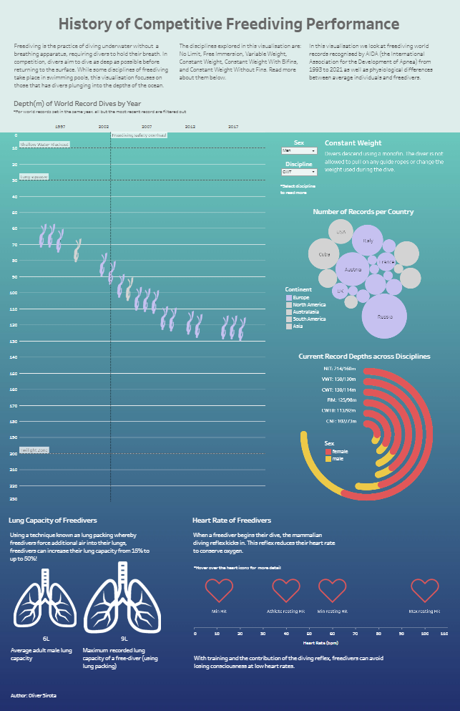

Figure 1. A screenshot of the data visualisation

# How?

## Special Features

In my visualisation, as illustrated in figure 1, the dot plot features labels indicating interesting depths and years that could have impacted the data as well as providing viewers more insight into the world of freediving. Clicking on the bubbles in the bubble plot will also filter the diver marks in the dot plot to only show divers from that country. I have also included a description of each freediving discipline that changes to match the discipline filter. I have also included three different icons to use as marks for my charts: divers (<https://www.abyss.com.au/en/dive-gear>), hearts (<https://www.iconpacks.net/free-icon/heart-3510.html>), and lungs (<https://iconarchive.com/show/ios7-icons-by-icons8/Healthcare-Lungs-icon.html>). They provide immediate context to viewers of the data.

## Idiom Choice Rationale

A dot plot was chosen to present the progression of freediving records over time for viewers to be able to easily identify trends in the data by examining the position of the data points and the curves made by them. It uses diver icons as marks and the position and colour hue channels. A bubble plot was chosen to compare countries by record count as each country can easily be identified by their label and their relative rankings by the size of their bubbles. It uses circles as marks and the size and colour hue channel; the same hues as in the dot plots as they both encode the same data. A radial bar chart was used to compare record depths between disciplines and sexes for its capacity to display data compactly as well as displaying trends clearly. Lines are used as the marks and the angle, length, and colour hue channels are used. The radial bar chart was also chosen for its uniqueness and aesthetic. A 1D dot plot was chosen to display various heart rates for its simplicity. It uses heart icons as marks and the position channel.

# Design

## Layout

My visualisation is structured into three overall rows. In the top row of my visualisation, the title sits above introductory text split into three columns in order to increase readability by reducing the length of the lines. In the second row I placed two columns of charts presenting the freediving world records data as well as their related filters and legends. The third row of my visualisation presents the physiological data. The column splits for the three overall rows are not aligned with each other to communicate that they are all distinct and to evoke a sense of modernity through the asymmetry. The elements of the visualisation are positioned to create balance through evenly distributing white space as well as adhere to the gestalt principle of proximity to group related elements.

## Colour

For the bottom portion of the visualisation, I used a saturated turquoise-dark blue gradient to resemble the ocean to relate to the domain of freediving. For the top section, I used an unsaturated light green colour to indicate the divide between the sections representing the surface of the ocean, as well as complementing the gradient without being distracting. The text for the top section is in grey whilst the text for the bottom section is in white to contrast against the colour of the background they are positioned over for easy readability.

For the dot plot and bubble plot, the colour hue channel is used to represent continent of origin. Europe is represented by a violet whilst grey is used for the other continents to highlight Europe’s data. These hues also stand out from the background for high readability.

In the radial bar chart, yellow and red are used to represent males and females respectively. These colours are chosen to contrast well with each other and the background, as well as accounting for those with red-green colour blindness as this chart lies over a dark blue area of the background rather than the more green area above. Red and yellow also avoids the stereotype of blue and pink used to represent males and females.

## Figure-Ground

I varied font size and weight to create a hierarchy with the text, from the title being the largest and thickest and the paragraph text and footnotes. The dot plot is the largest chart to indicate it is the primary one. In the bubble and dot plots, grey is used to deemphasise the continents other than Europe.

## Typography

I used the standard Tableau typeface for all text in my visualisation as it is a sans serif typeface that is modern and highly legible at small sizes. It also offers a variety of fonts of different weights for more diverse typographic hierarchy.

## Storytelling

My visualisation is of a comic strip storytelling genre. The title at the top is read by viewers first, followed by the three paragraphs of text beneath it from left to right. The viewer then is invited to examine the world record data displayed in the dot plot, followed by the bubble chart, and then the radial bar chart. The viewer is then guided further down to inspect the physiological data.

**References**

American Lung Association. (2021). Lung Capacity and Aging. Retrieved from

<https://www.lung.org/lung-health-diseases/how-lungs-work/lung-capacity-and-aging>

Bronshtein, I., & Gupta, H. (2021). *Freediving World Records Dataset* [Data file].

Retrieved from <https://www.kaggle.com/datasets/igalbronshtein/freediving-aida-world-records-dataset>

Healthdirect. (2020). Resting Heart Rate. Retrieved from

<https://www.healthdirect.gov.au/resting-heart-rate>

OpenWaterHQ. (2022). Lung Packing For Freediving: Are the Risks Worth It?.

Retrieved from <https://openwaterhq.com/freediving/lung-packing/>

Saplakoglu, Y. (2021). Free Divers’ Heart Rates Can Drop As Low as 11 Beats Per

Minute. Retrieved from <https://www.livescience.com/divers-brain-oxygen-level-lower-seals.html>

 Schagatay, E., Richardson, M. X., & Lodin-Sundström, A. (2012). Size Matters: Spleen

and Lung Volumes Predict Performance in Human Apneic Divers. *Frontiers In Physiology*, *3*. doi: 10.3389/fphys.2012.00173

**Appendix**



