AIMS
User Manual
Asset & Inventory Management System

1. Documents
AIMS sales documents — Quotations, Sales Orders, Delivery Orders, Invoices, and Credit/Debit Notes — are all created in the same editor and follow the same steps; only the starting point and a few fields differ. This section walks through creating each type, starting with a Quotation.

1.1 The document toolbar
Every document opens in the same editor. The toolbar across the top provides the main actions (shown here on a Quotation):
1. Add — start a new blank document of this type.
2. Locate — search for and open another existing document (by number, customer name, P/O or D/O).
3. Duplicate — make a copy of the current document.
4. Stock Card — open the inventory item picker to add items (same as the Add Item button on the line-items table).
5. Print / PDF — download or print the document.
6. Preview — view the finished document on your company letterhead.
7. Confirm Quotation — finalise the document and move it forward in the pipeline. This label changes per document type (e.g. Confirm Order, Confirm Invoice).
Note: Also on the toolbar: the back arrow (←) returns to the list, Previous / Next step through your documents, and the Saved indicator shows changes are stored automatically — there is no separate Save button.

1.2 Creating a Quotation
Step 1 Open the Quotation list and start a new quotation
In the left sidebar, expand Sales and click Quotation. At the top-right of the Quotations List, click Create Quotation. A new draft opens with an auto-generated quotation number.
Tip: the Upload Quotation button beside it lets AIMS read a PDF or image and create the quotation for you automatically. This “extract” button is named differently for each document type (for example, invoices use Import Invoices), and a few document types don't offer it.
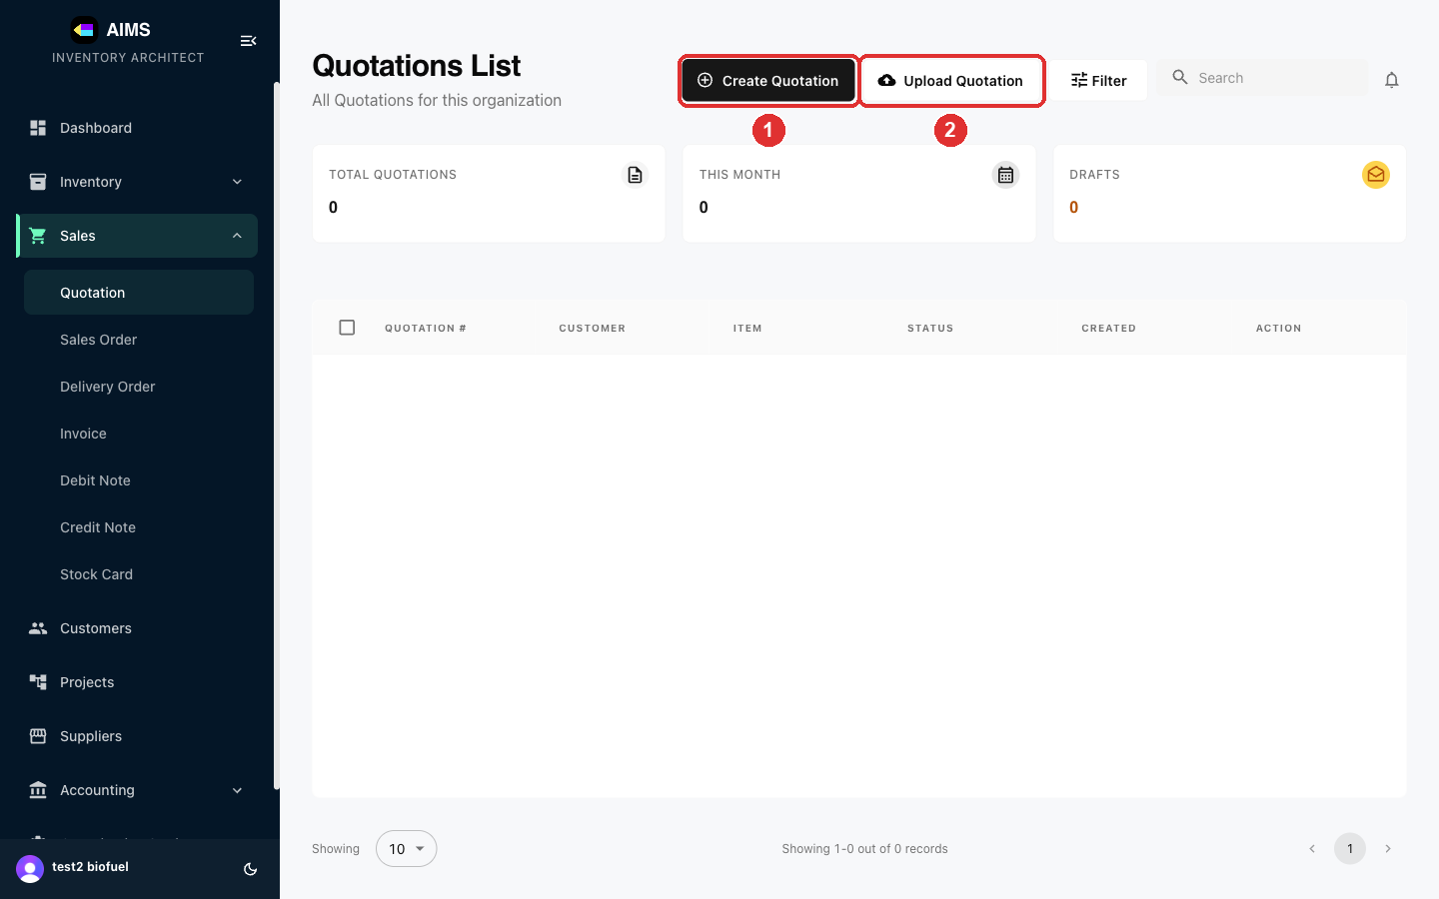

Step 2 Get to know the editor
The quotation editor has three areas: ① the document details (number, date, customer, terms), ② the totals panel (gross, discount, GST, nett total), and ③ the line-items table. Your work auto-saves — watch the “Saved” indicator at the top-right.
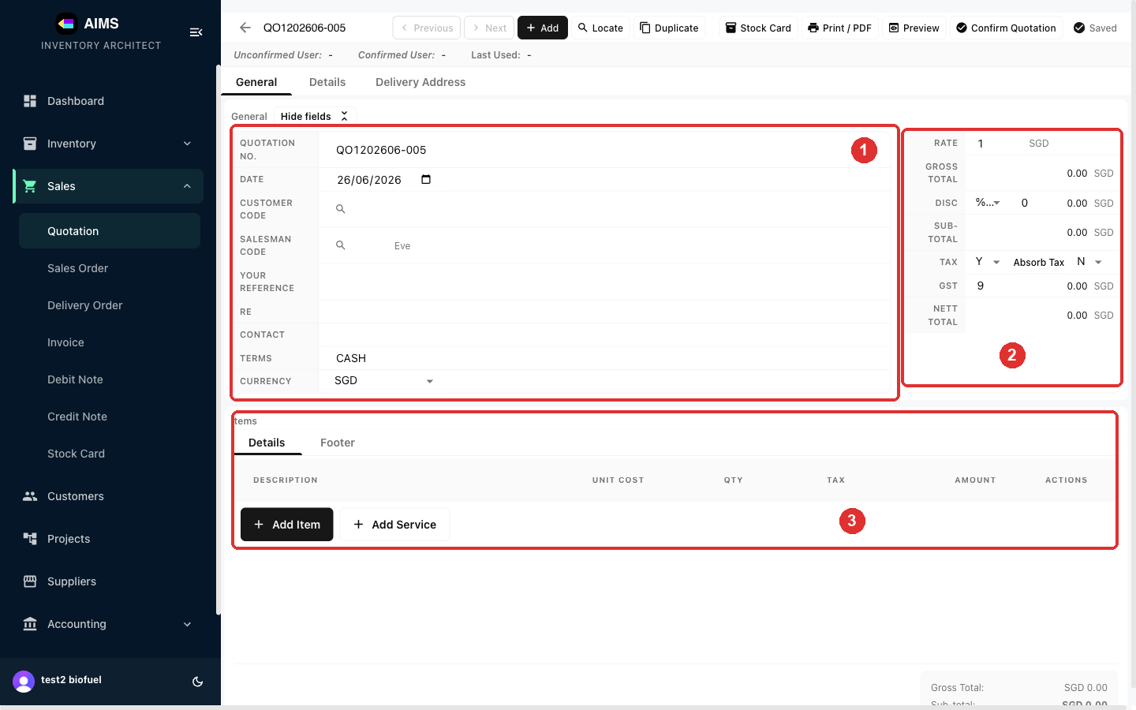

Step 3 Select the customer
Click the Customer Code field, type a few letters of the customer's name, and press the search icon. Pick the customer from the Locate Customer list — their address and contact fill in automatically.
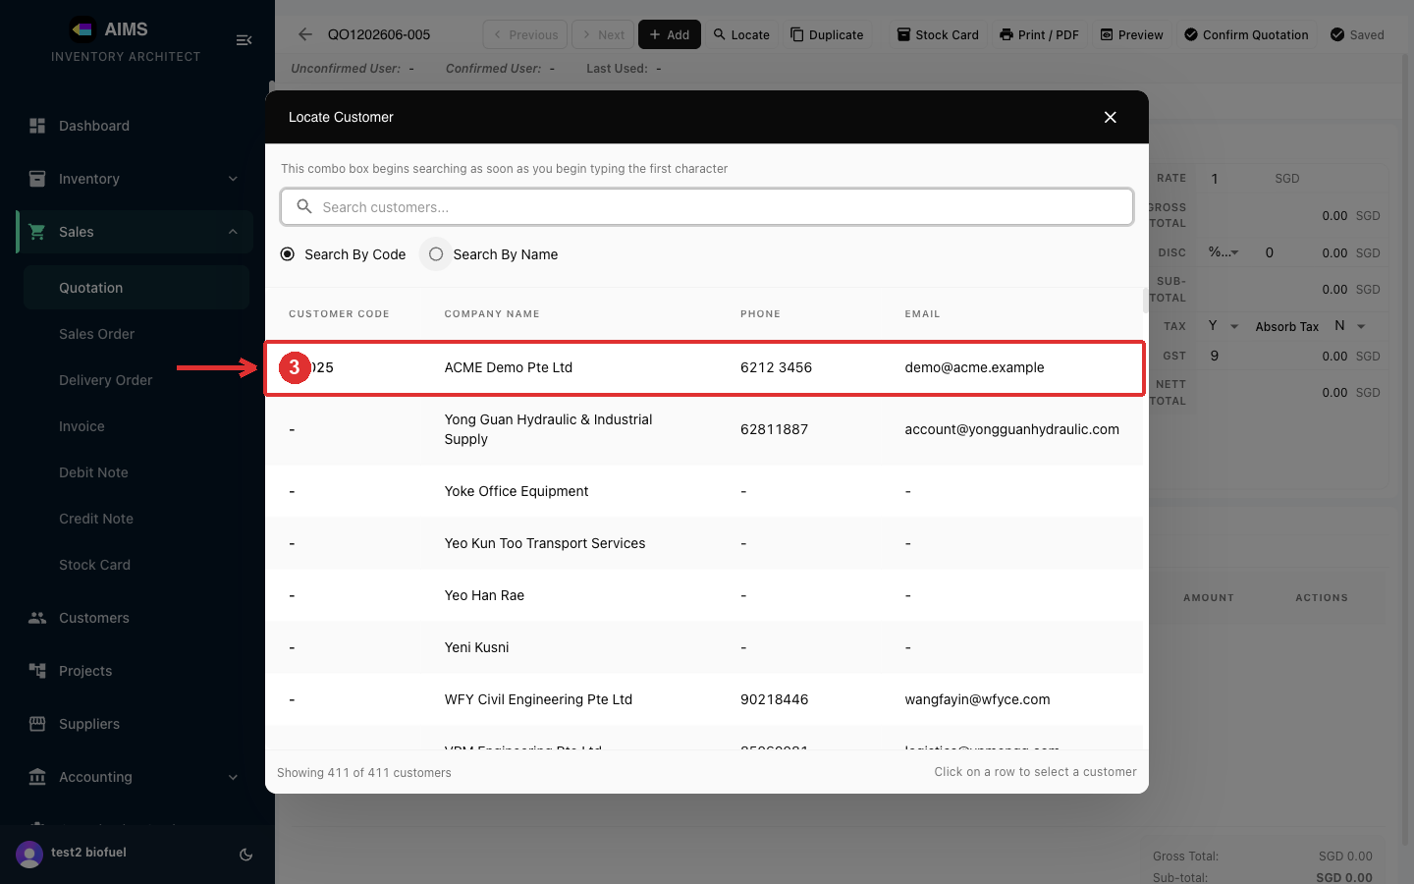

Step 4 Add line items
Click Add Item to open the Stock Card picker. Search by code, description or category, then click an item to add it to the quotation. Use Add Service instead for a non-stock charge (e.g. labour, delivery).
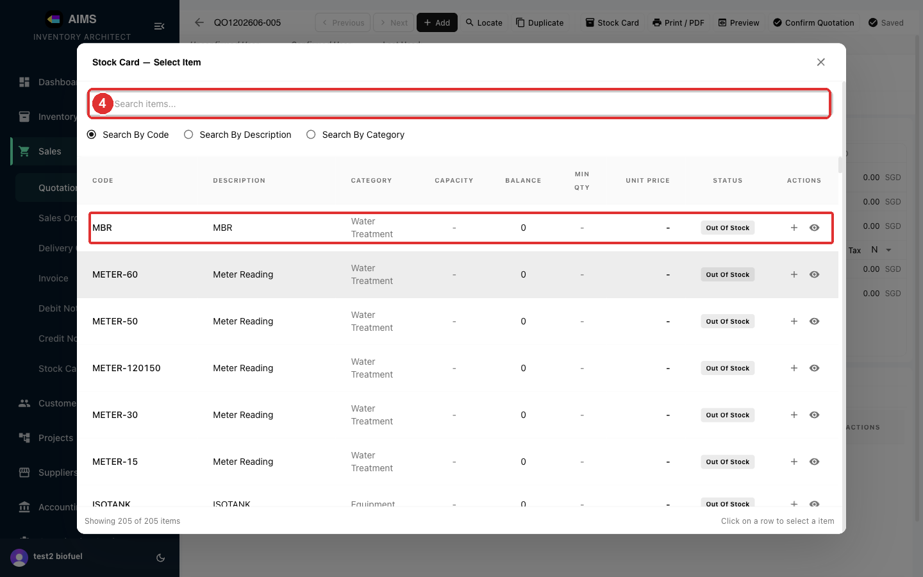

Step 5 Enter quantity and price
In the line item, type the Unit Cost and Qty. The Amount, Sub-Total, GST and Nett Total recalculate automatically. You can apply a discount or change the tax setting in the totals panel on the right.
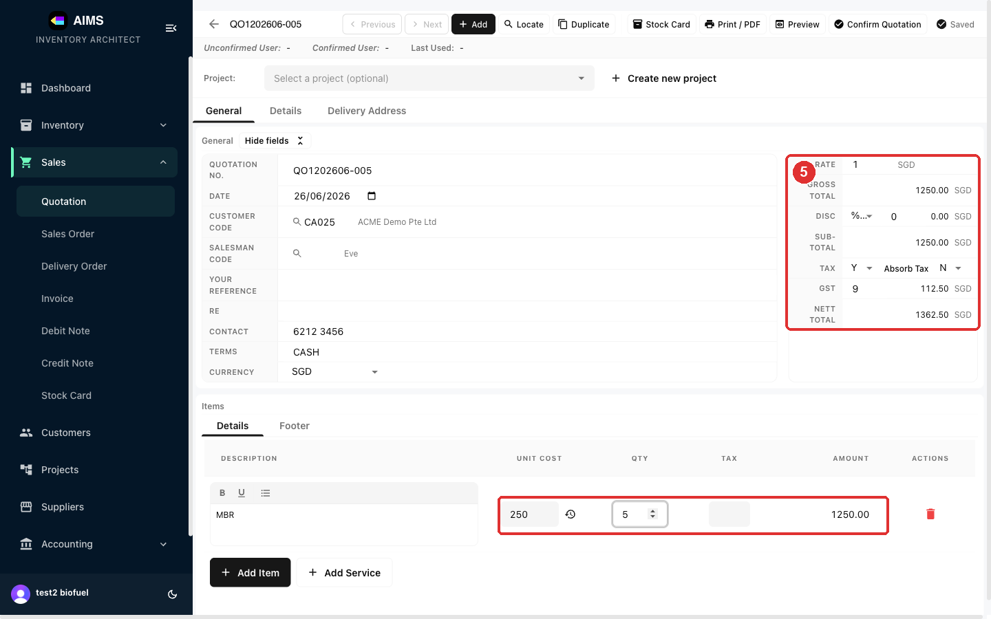

Step 6 Preview, then print or confirm
Click Preview to see the finished quotation on your company letterhead. From here use Print / PDF to download or print it, or Confirm Quotation to finalise it and move it forward in the sales pipeline.
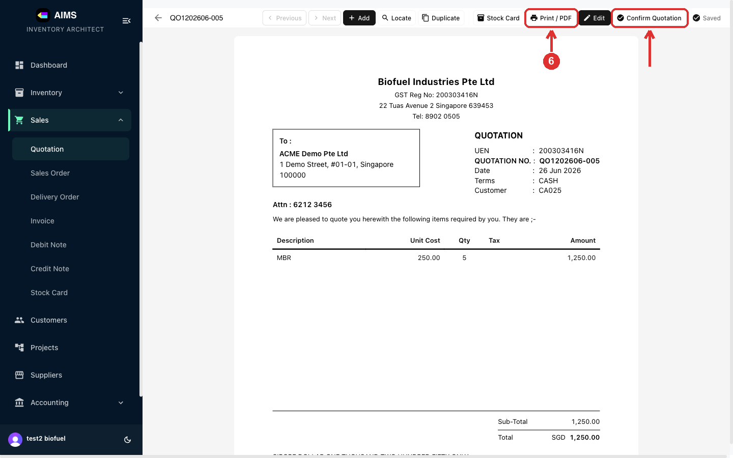

1.3 Creating a Sales Order
Step 1 Open Sales Order and start a new order
A Sales Order confirms a customer's order after they accept your quotation — it's the internal record that drives delivery and invoicing. In the sidebar, open Sales › Sales Order and click Create Sales Order. Fill it in exactly like a Quotation (see 1.2) — select the customer and add line items. Upload Sales Order creates one from a PDF/image.
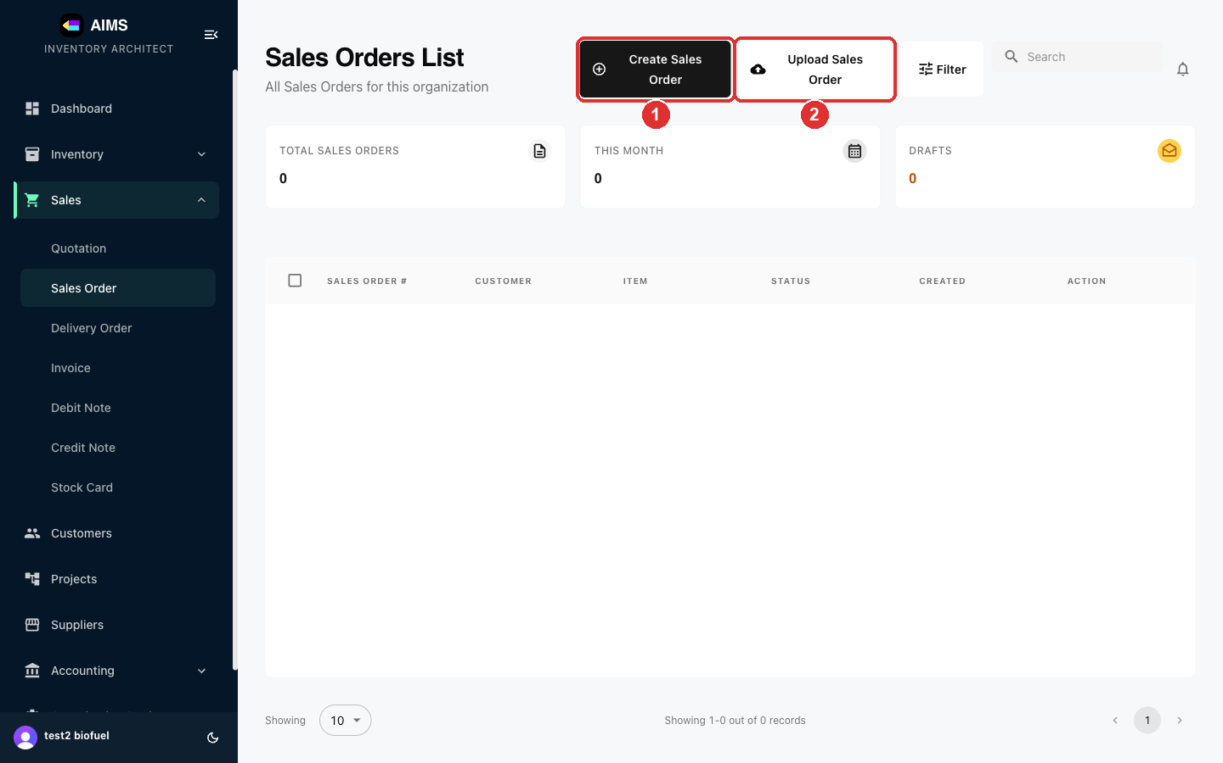

Step 2 Preview and finalise
Click Preview to see the finished Sales Order, then Print / PDF or Confirm Document to finalise it.
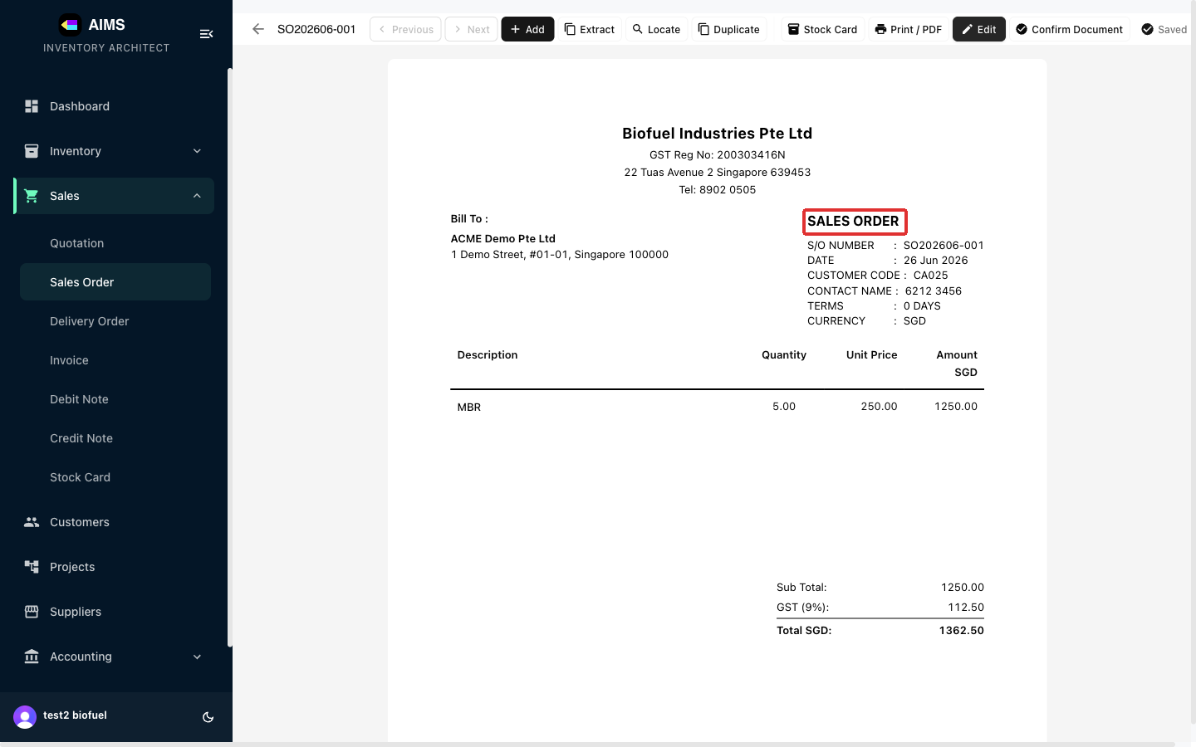

Note: The Extract button in the editor toolbar turns an accepted quotation into this Sales Order — it opens “Extract Quotation to Sales Order”, lists the customer's quotations, and copies the chosen quote's line items in so you don't re-key them.

1.4 Creating a Delivery Order
Step 1 Open Delivery Order and start a new DO
A Delivery Order (DO) is the packing slip that goes with goods delivered to the customer — it records what was shipped. Open Sales › Delivery Order and click Create Delivery Order. Fill it in like a Quotation; use the Delivery Address tab to set where the goods are going. Upload Delivery Order creates one from a file.
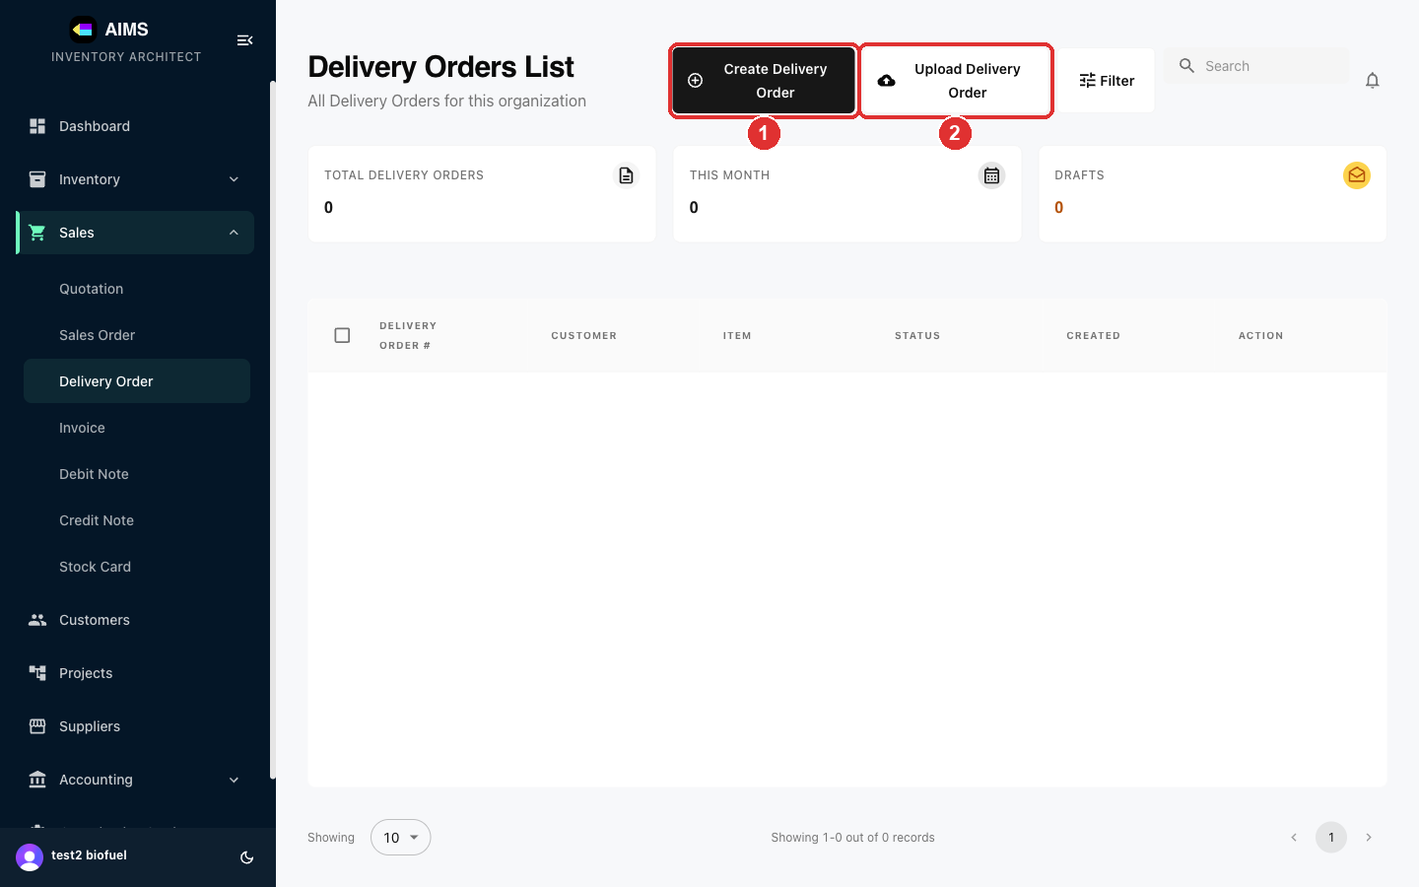

Step 2 Preview and finalise
A Delivery Order is a packing slip — it lists quantities, not prices (Item · Description · Quantity · UoM · Remarks). Preview shows the finished DO; use Print / PDF or Confirm Delivery.
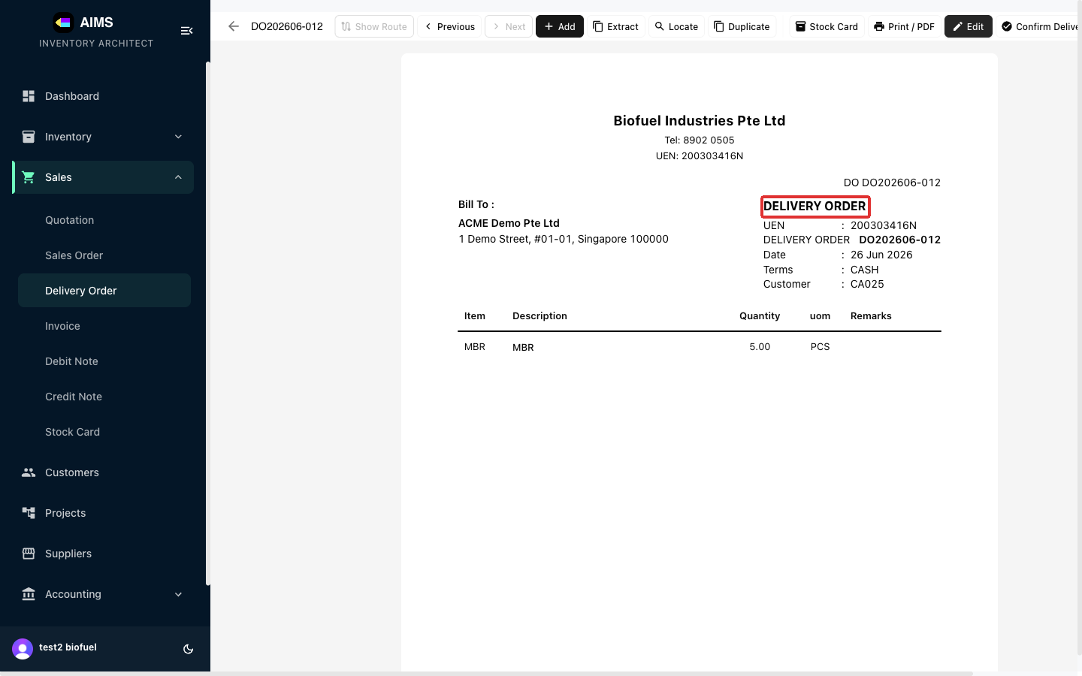

Note: The Extract button in the editor toolbar turns a quotation into this Delivery Order — “Extract Quotation to Delivery Order” lists the customer's quotations; pick one to copy its items straight in.

1.5 Creating an Invoice
Step 1 Open Invoice and start a new invoice
A Tax Invoice bills the customer for goods or services, including GST — it's the document your customer pays against. Open Sales › Invoice and click Create Invoice. Fill it in like a Quotation. Tip: inside the invoice editor, Extract from Quotation pulls the customer and line items straight from an existing quotation; Import Invoices creates invoices from uploaded files.
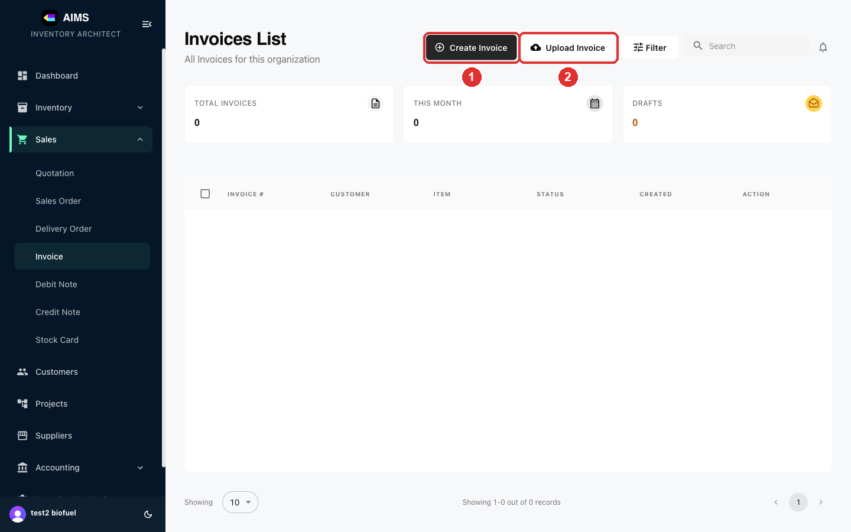

Step 2 Preview and issue
The finished Tax Invoice shows your GST registration number and totals. Use Print / PDF to send it, or Confirm Invoice to issue it.
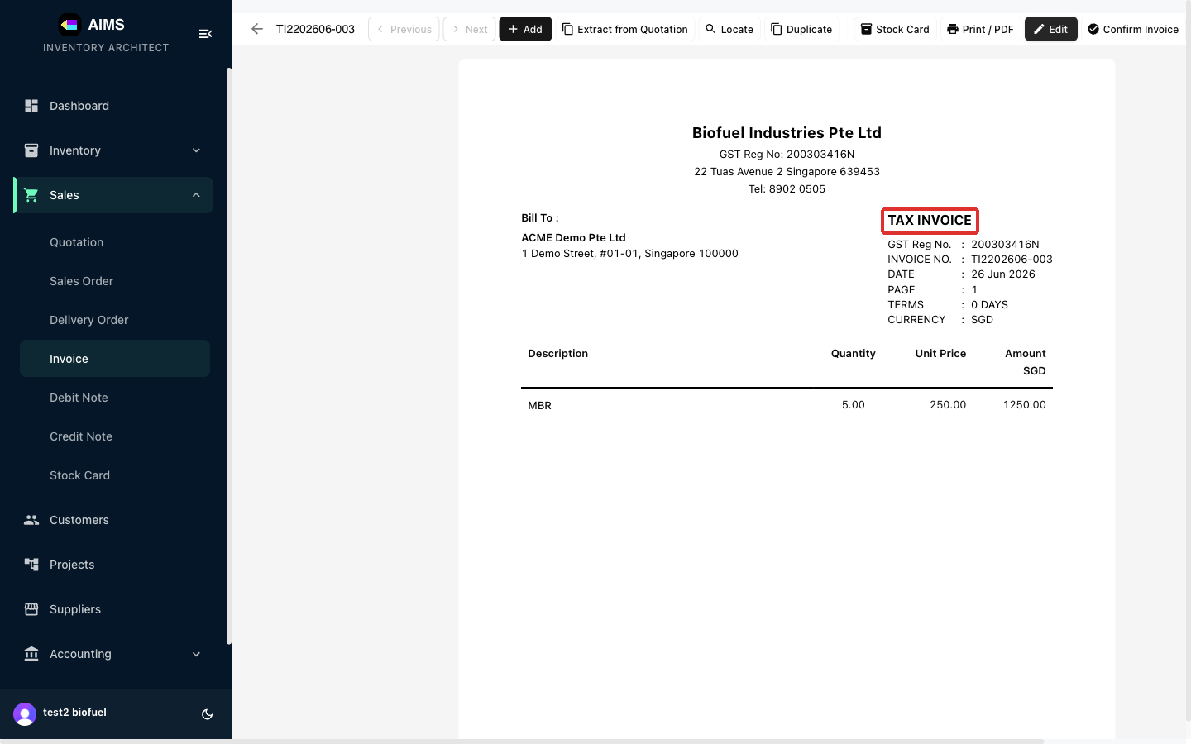

Note: The Extract from Quotation button in the editor toolbar does the same for invoices — it copies the customer and line items from an existing quotation straight into the invoice, so an accepted quote becomes an invoice in one click.

1.6 Creating a Debit Note
Step 1 Open Debit Note and start a new note
A Debit Note increases the amount a customer owes — for example to charge for extra items or correct an under-billed invoice. Open Sales › Debit Note and click Create Debit Note. Fill it in like a Quotation (it usually references the original invoice).
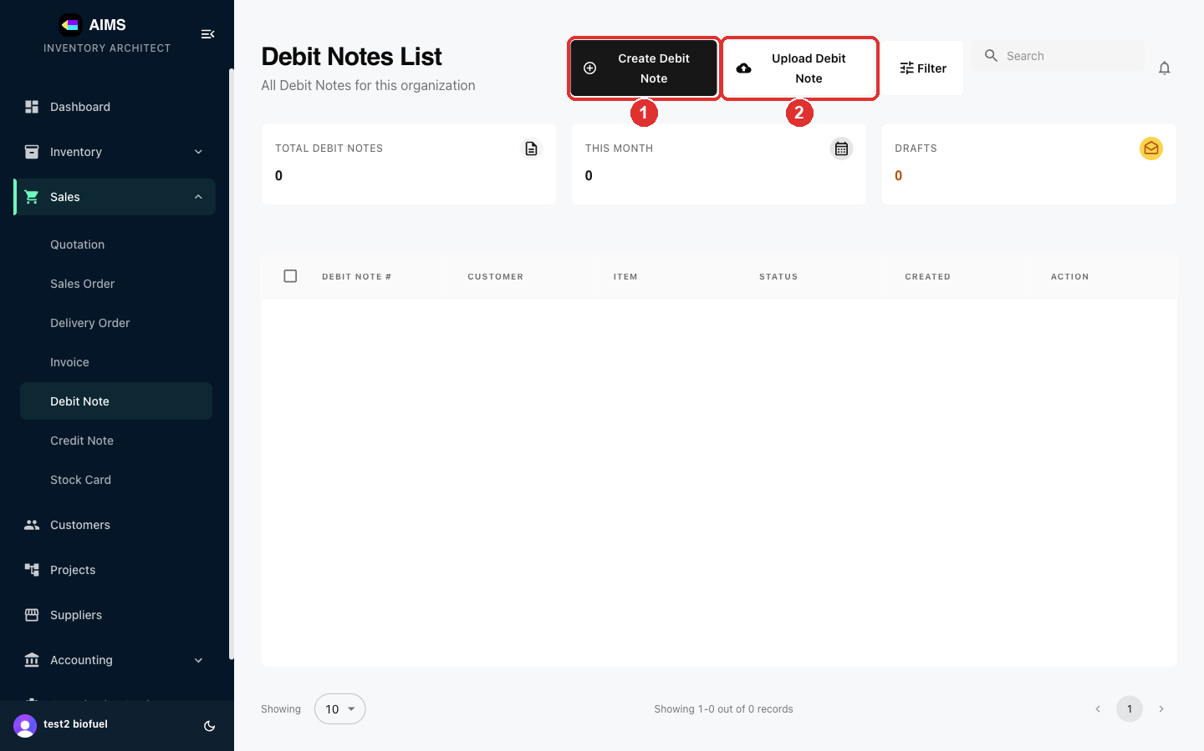

Step 2 Preview and finalise
The finished Debit Note. Use Print / PDF or Confirm Document.
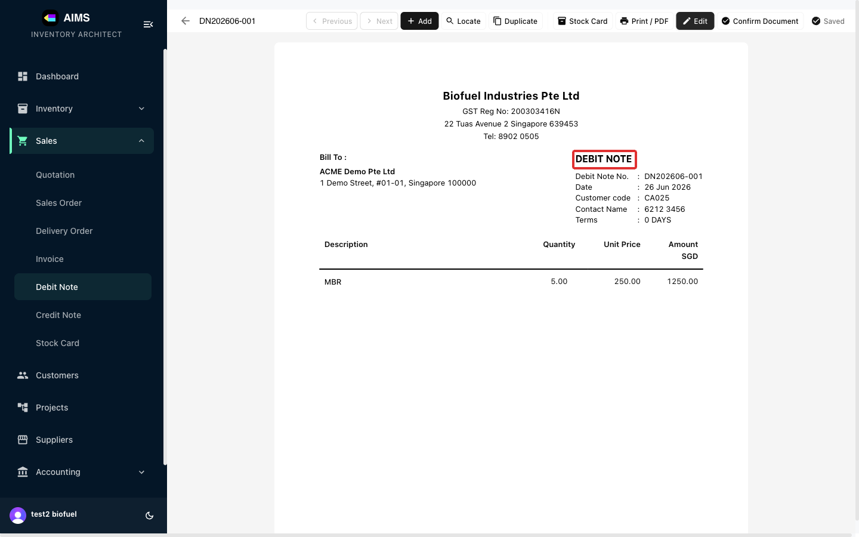

1.7 Creating a Credit Note
Step 1 Open Credit Note and start a new note
A Credit Note reduces the amount a customer owes — for returns, refunds, or correcting an over-billed invoice. Open Sales › Credit Note and click Create Credit Note. Fill it in like a Quotation (it usually references the original invoice).
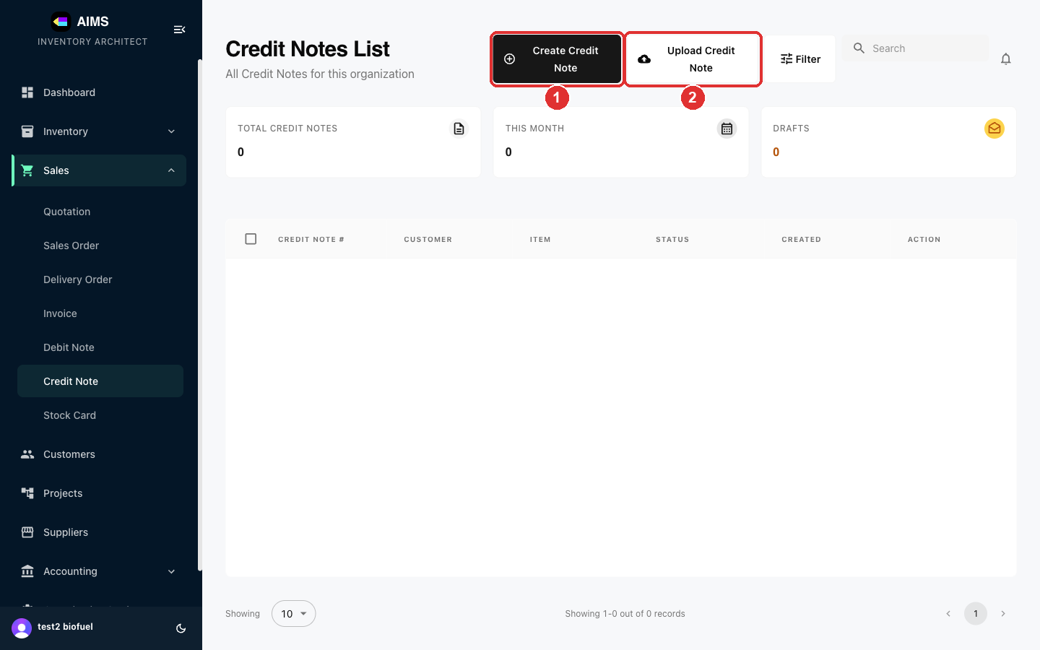

Step 2 Preview and finalise
The finished Credit Note. Use Print / PDF or Confirm Document.
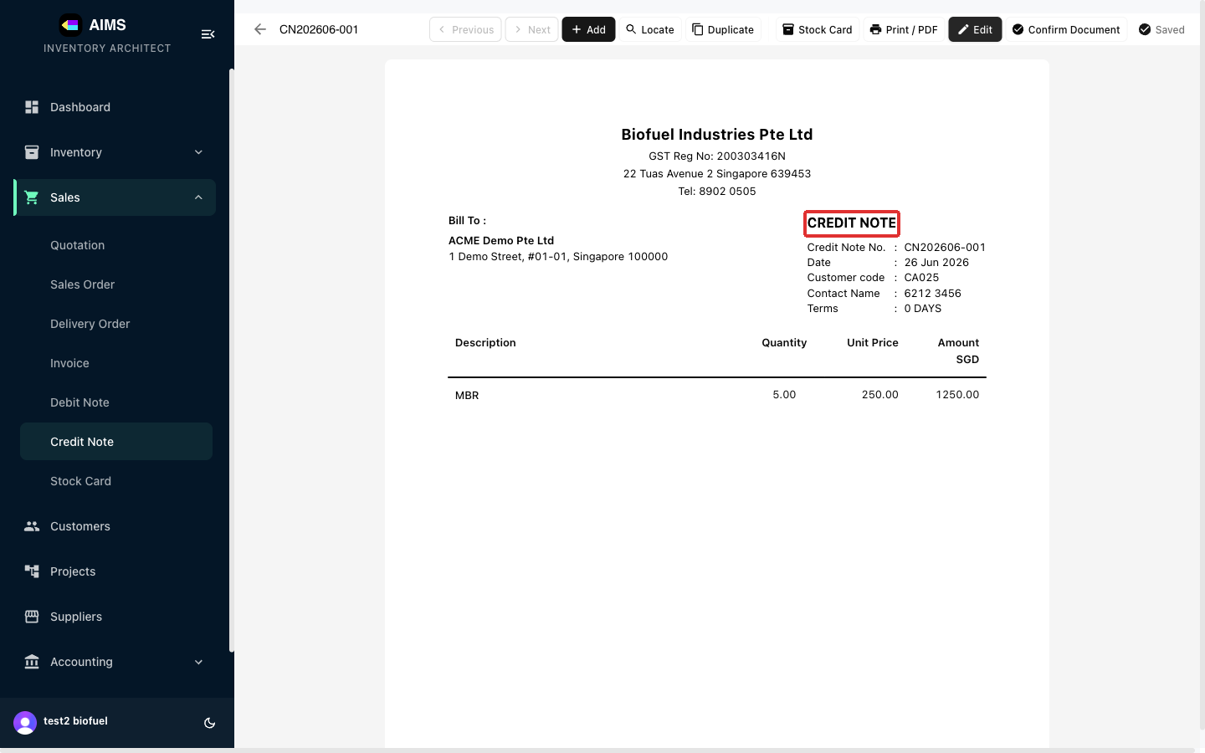

2. Inventory
Inventory has two layers: Products (the master record for an item — its name, SKU key, category and default pricing) and Inventory Items (the actual stock units of a product). This section covers adding both, plus the documents that move stock — Purchases, Purchase Returns and Stock Adjustments.

2.1 Adding a Product
Step 1 Open Products and start a new product
In the sidebar, open Inventory › Products and click Add Product. A product is the master record for an item; every product needs a unique SKU key. (To change the quantity of an existing product, use Add Items on the Inventory Items page instead — see the next section.)
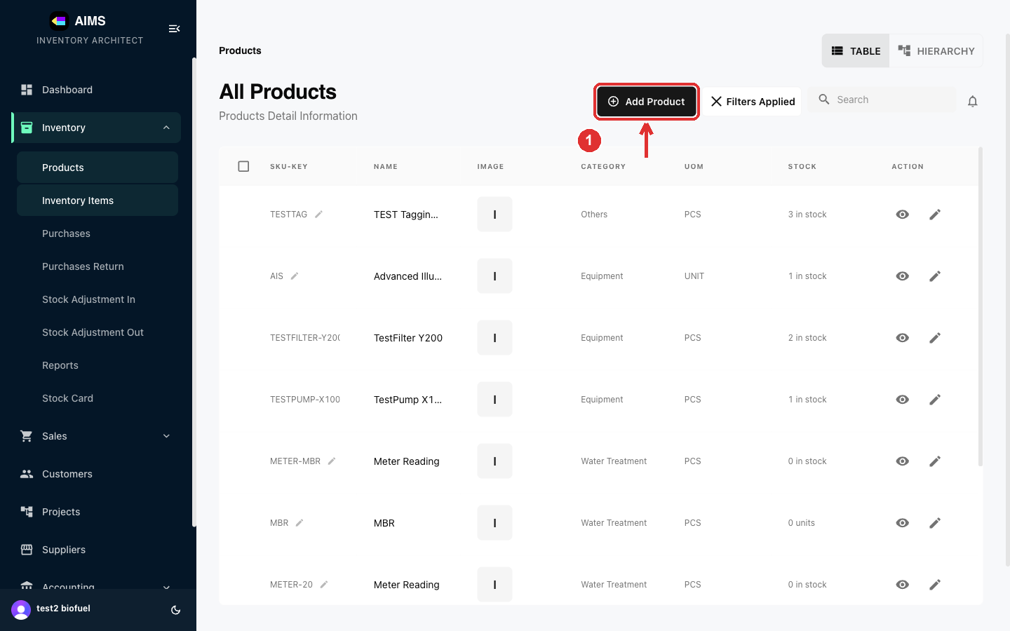

Step 2 Step 1 — Asset Creation
The form is a 3-step wizard (Asset Creation → Additional Details → Review). Fill the required fields: Name, SKUKEY (unique identifier), Category, Unit of Measure, and the starting Quantity. Click Next.
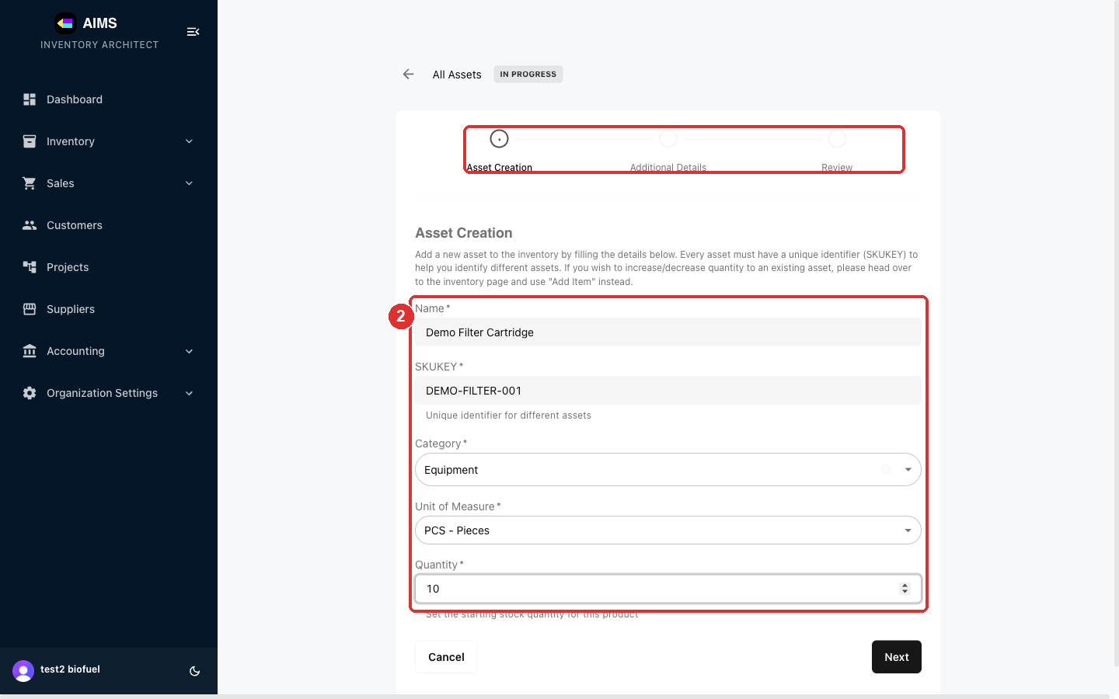

Step 3 Step 2 — Additional Details (optional)
Add optional details: a Description, Cost Price (what you pay — for margin tracking), Selling Price (the default unit price when this product appears on a document), custom price tiers, and a low-stock Minimum Quantity. Click Next.
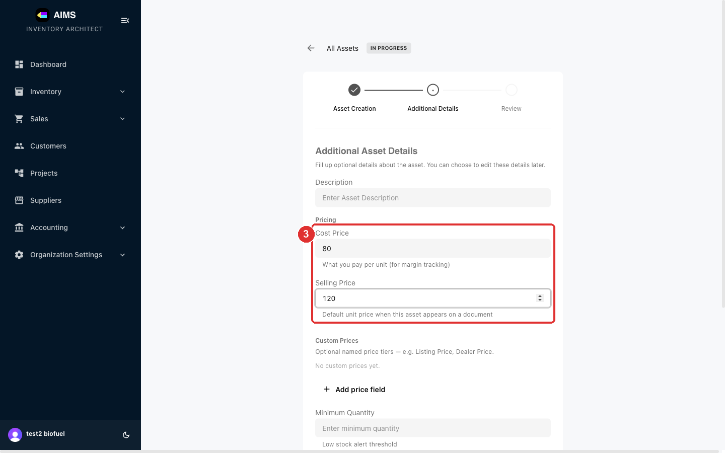

Step 4 Step 3 — Review and create
Review the details, optionally upload a product Image, then click Create Asset.
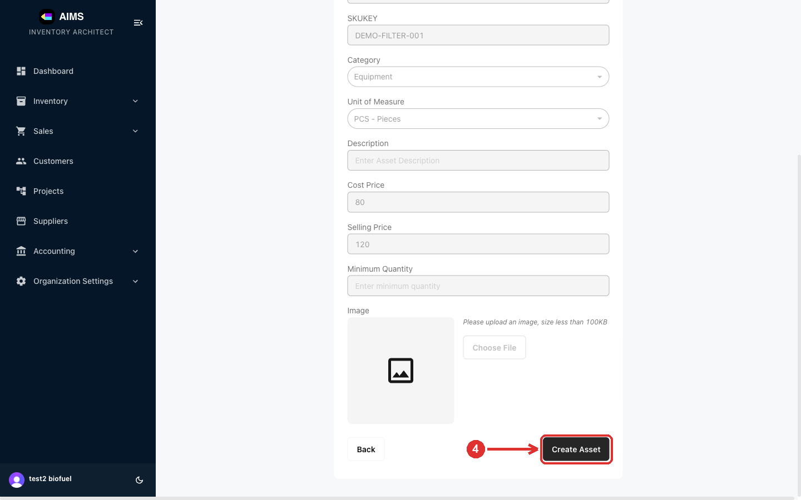

Step 5 Done — the product is created
The new product appears at the top of the Products list with its SKU key, category and stock. It's now selectable when adding items to quotations, invoices and other documents.
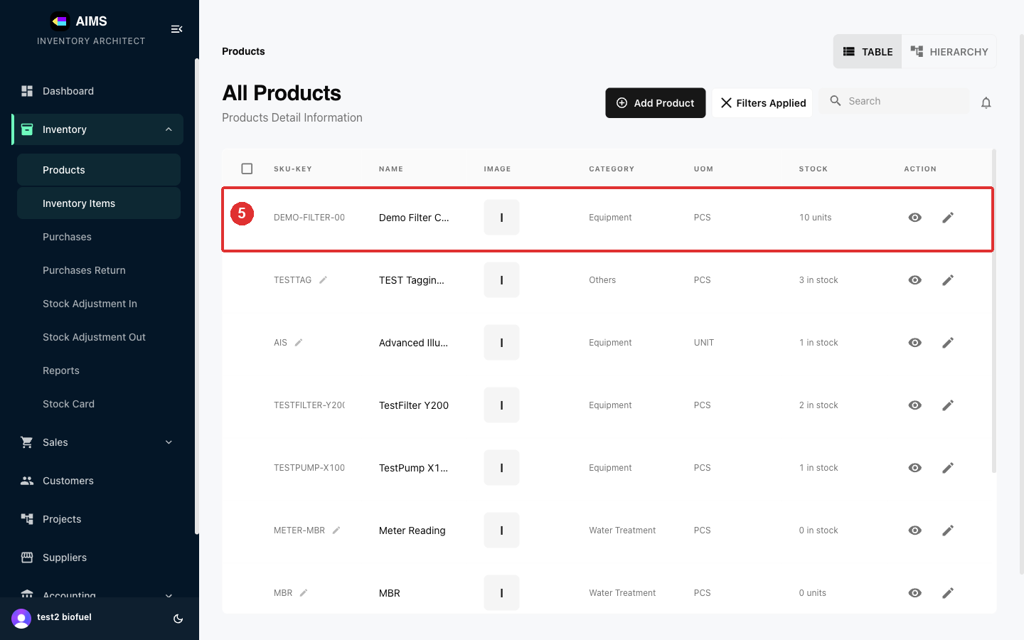

2.2 Adding Inventory Items (stock)
Step 1 Open Inventory Items and click Add Items
Products is the master record; Inventory Items are the individual stock units of a product. To add stock to an existing product, open Inventory › Inventory Items and click Add Items.
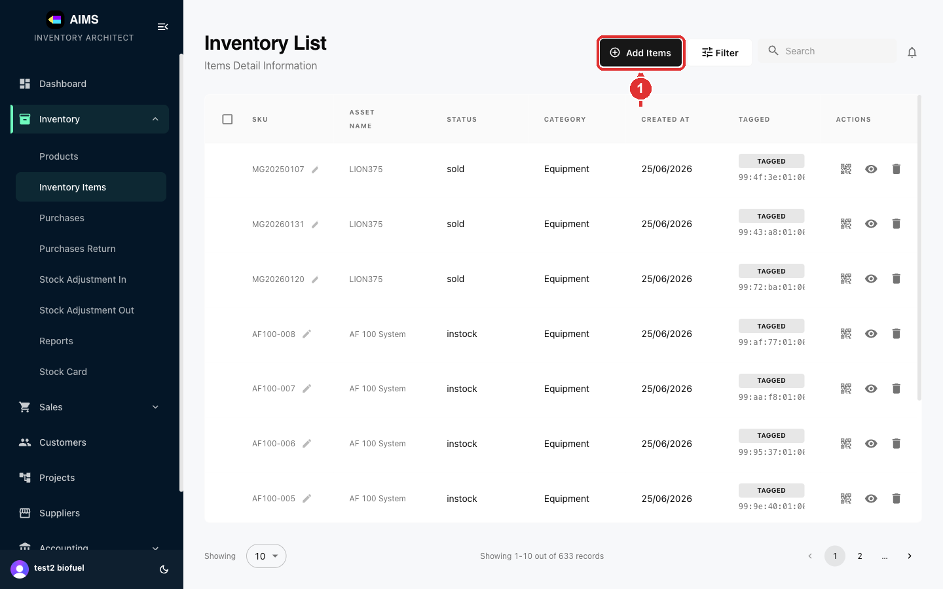

Step 2 Fill in the stock details and save
Choose the Asset (the product), enter the SKU for the unit, the Quantity, Category, Location, and Status (e.g. in stock), then click Save. The stock is added to that product's on-hand quantity.
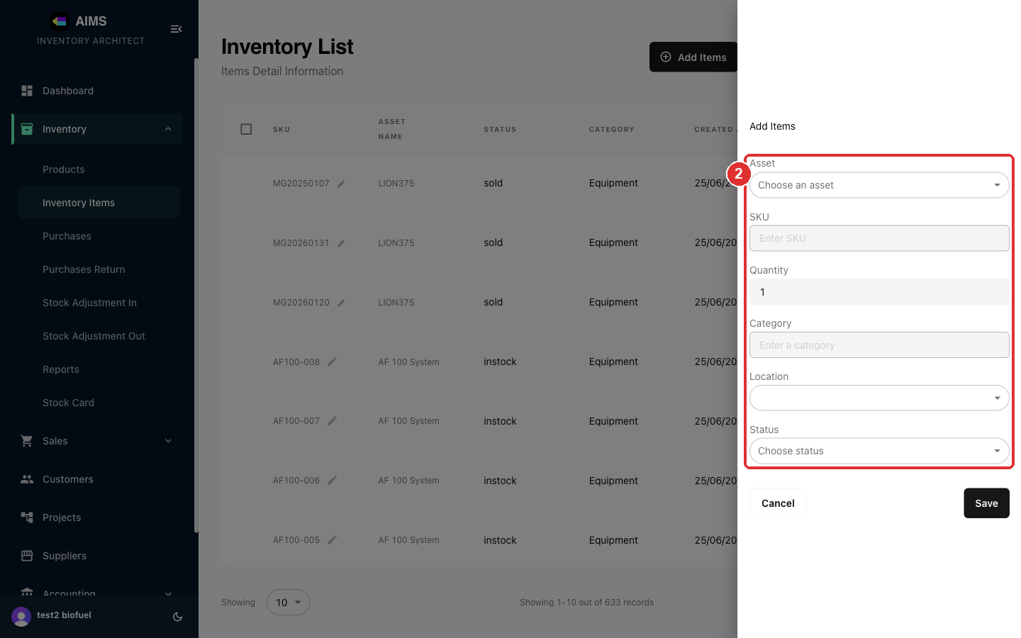

2.3 Purchase Order (ordering stock)
Step 1 Open Purchases and start a Purchase Order
Inventory documents move stock. A Purchase Order (PO) orders goods from a supplier. Open Inventory › Purchases and click Create Purchase Order (or Upload Purchase Order to create one from a PDF/image).
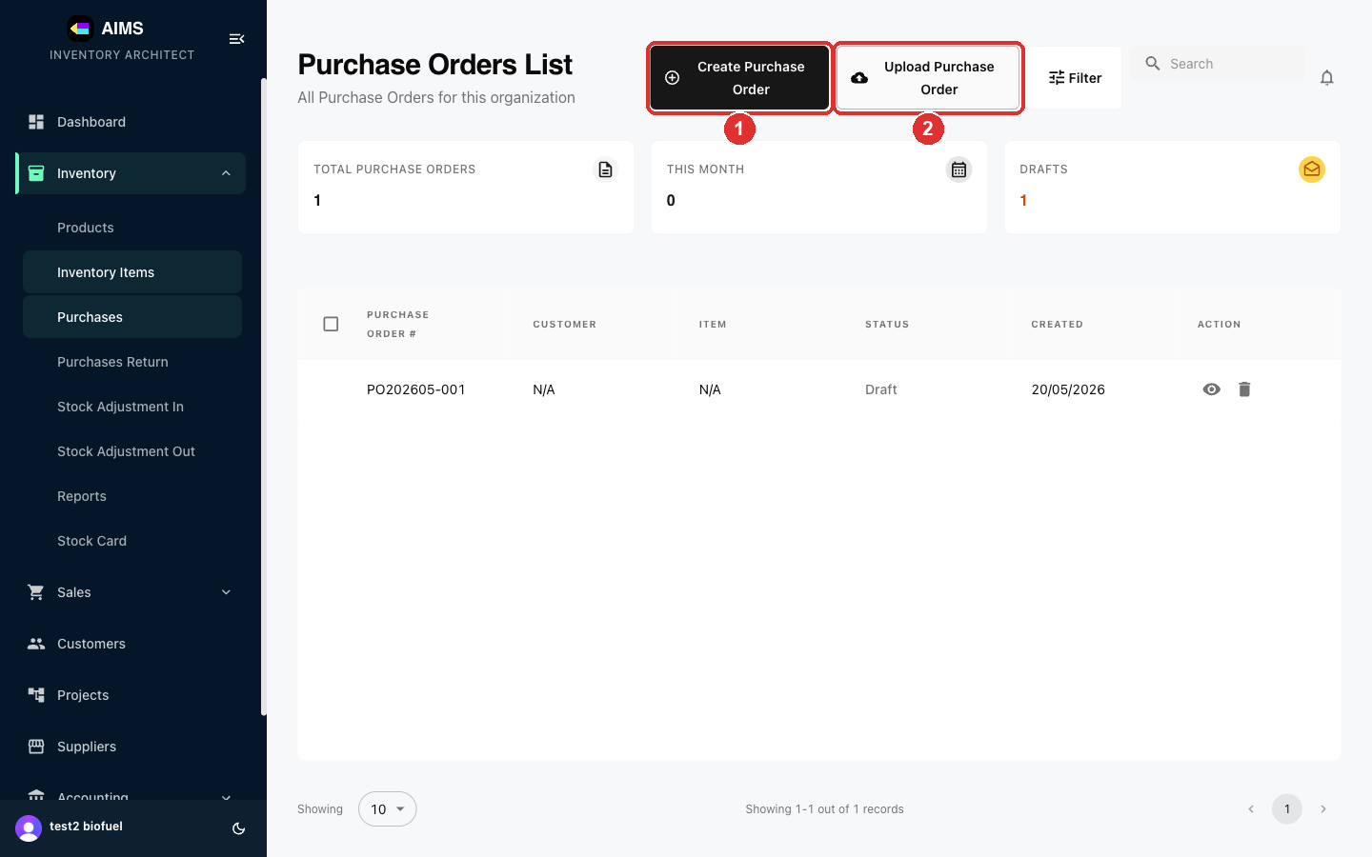

Step 2 Select the supplier
Unlike sales documents, a PO is addressed to a supplier, not a customer. Click the Supplier Code field's search icon to open the supplier picker.
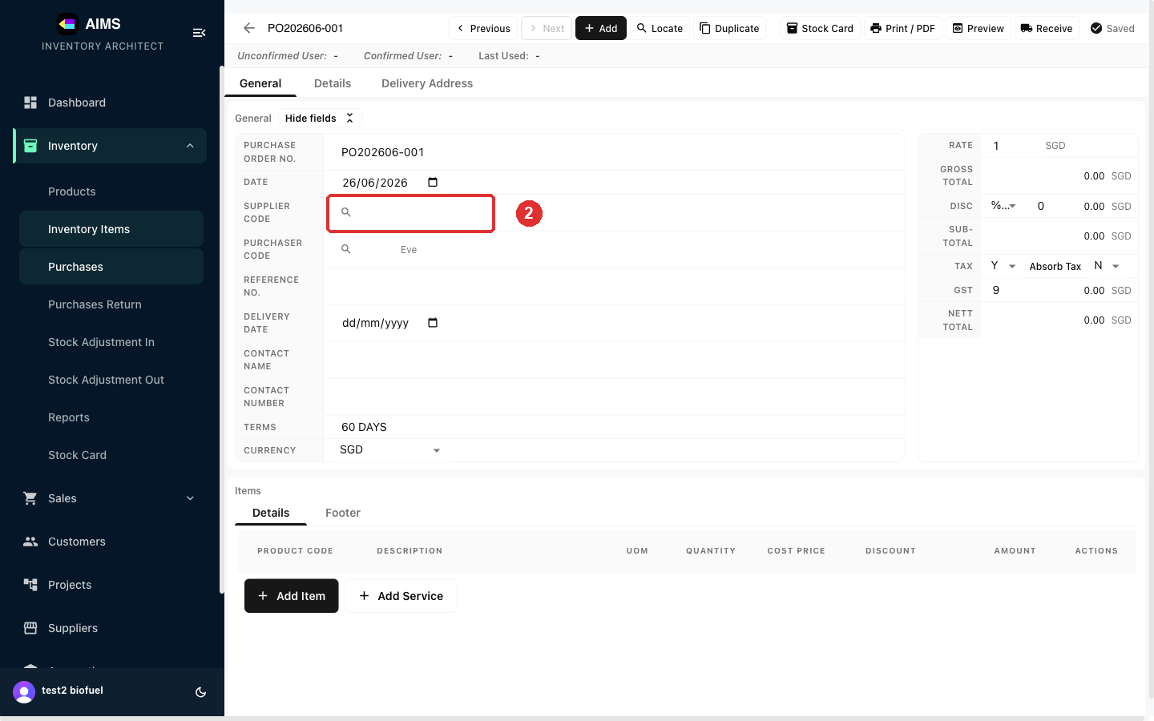

Step 3 Pick the supplier
Choose the supplier from the list — their address and contact details fill in automatically.
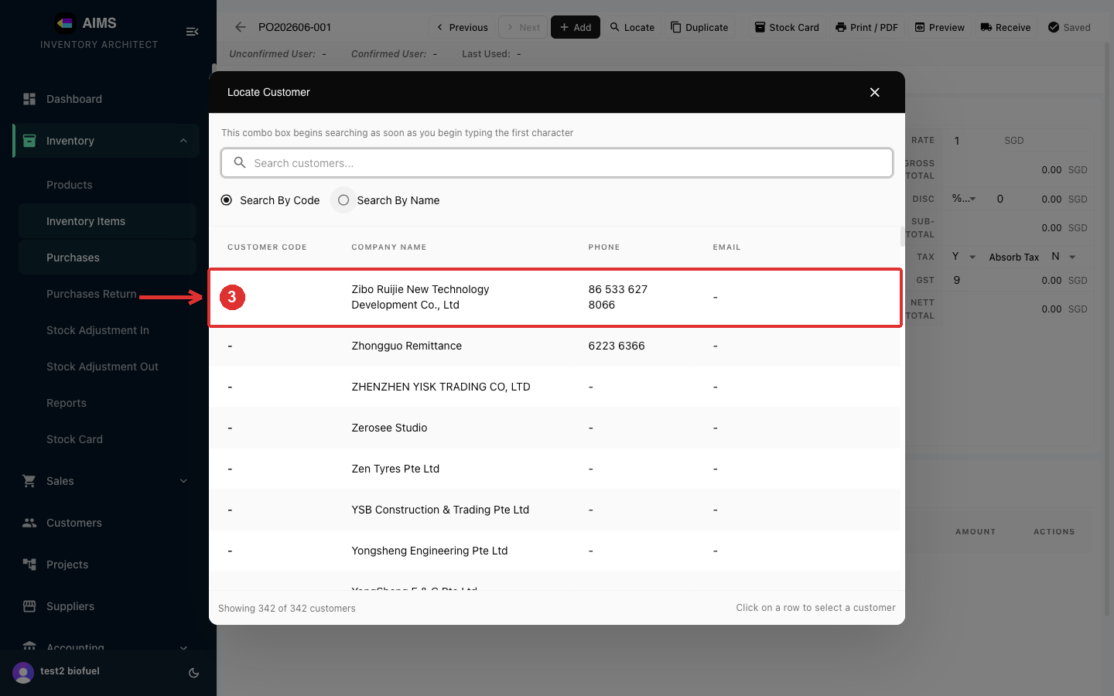

Step 4 Add items and quantities
Click Add Item and pick products from the Stock Card. Each line shows the Cost Price (what you pay the supplier); set the Quantity to order. The totals update on the right.
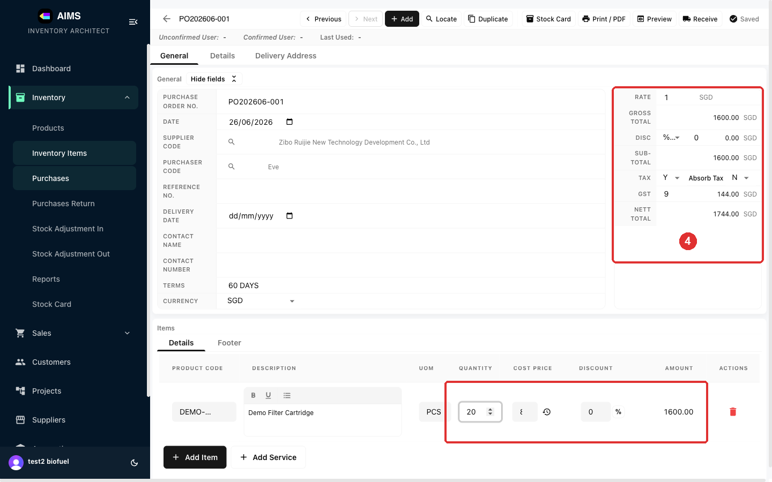

Step 5 Preview, then receive the goods
Preview shows the finished PO on your letterhead. Use Print / PDF to send it to the supplier, or Receive (top-right) to receive the goods into stock — which increases your on-hand inventory.
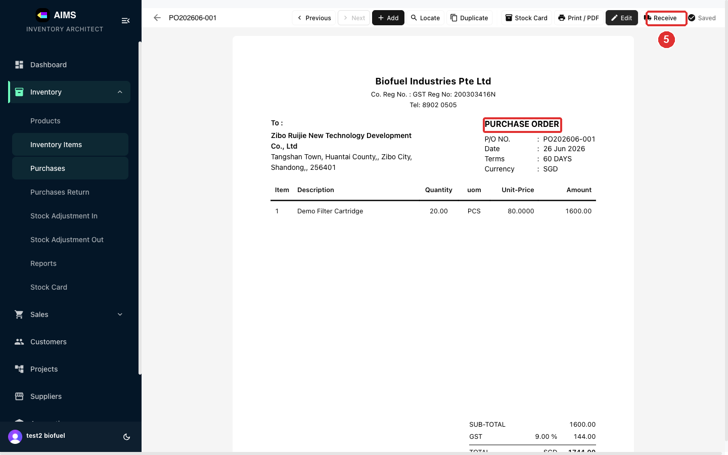

2.4 Purchase Return (returning stock to a supplier)
Step 1 Open Purchases Return and start a return
A Purchase Return (PR) returns goods to a supplier (e.g. faulty or wrong items). Open Inventory › Purchases Return and click Create Purchase Return.
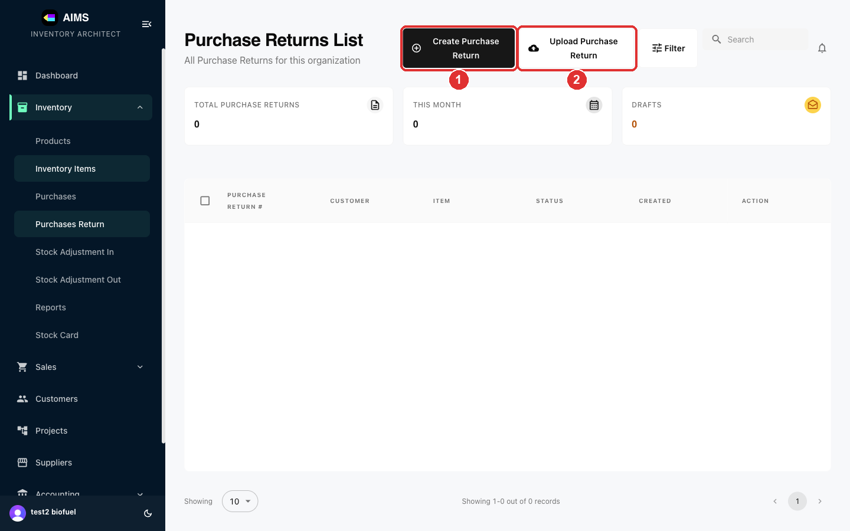

Step 2 Select the supplier
Like a PO, a return is addressed to the supplier. Click the Supplier Code search icon to open the picker.
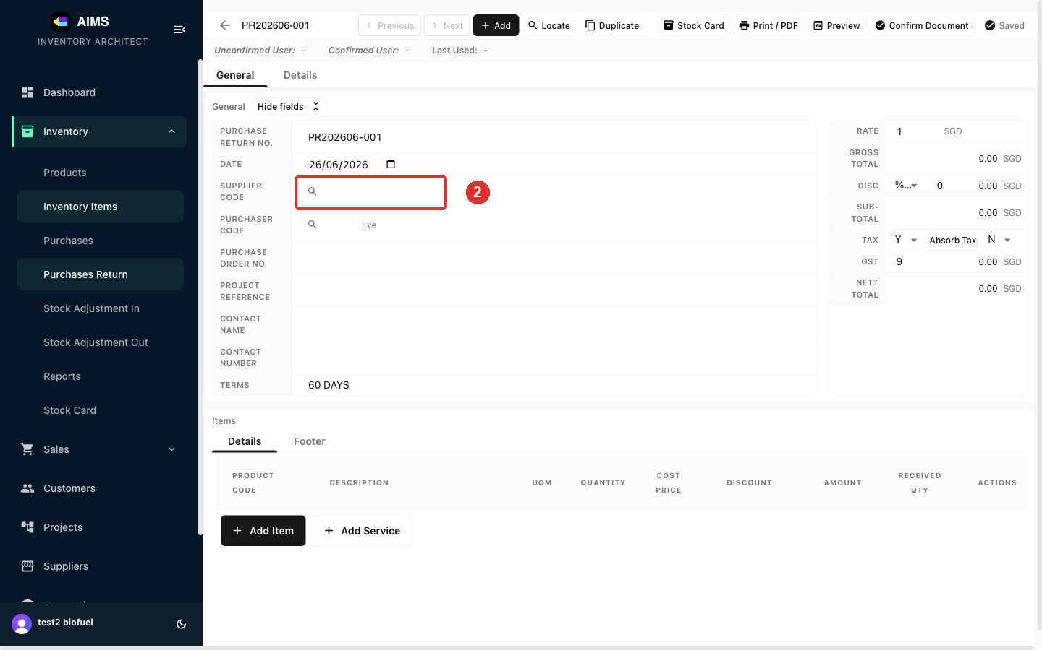

Step 3 Pick the supplier
Choose the supplier you're returning goods to.
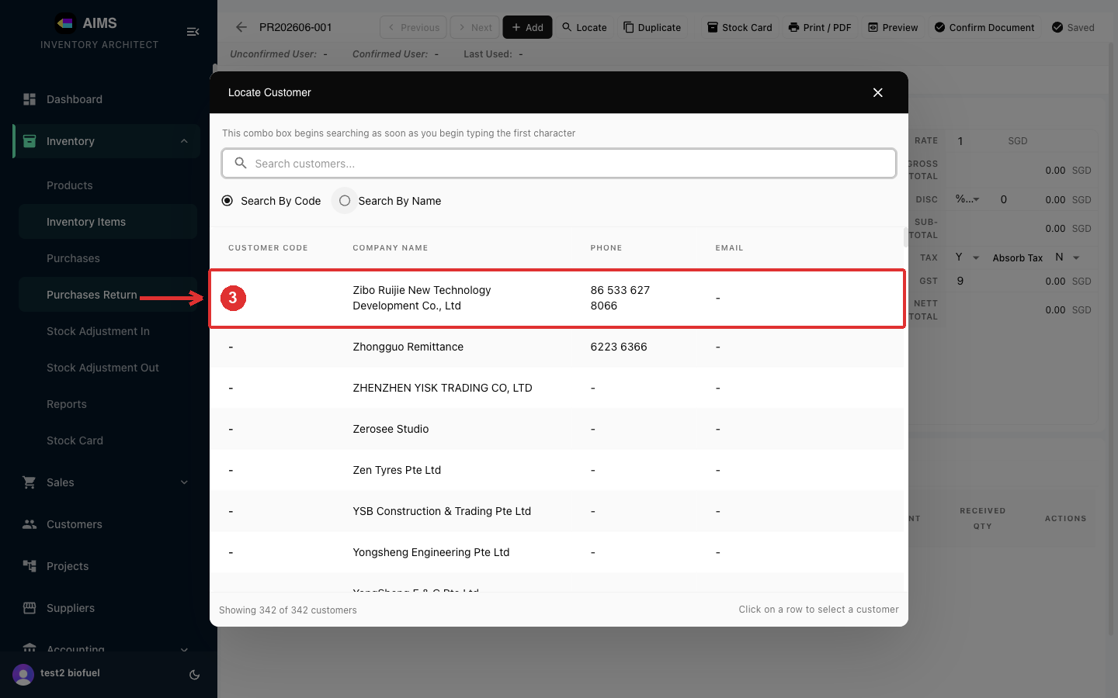

Step 4 Add the returned items and preview
Add the items and quantities being returned, then Preview. Use Print / PDF or Confirm Document to finalise.
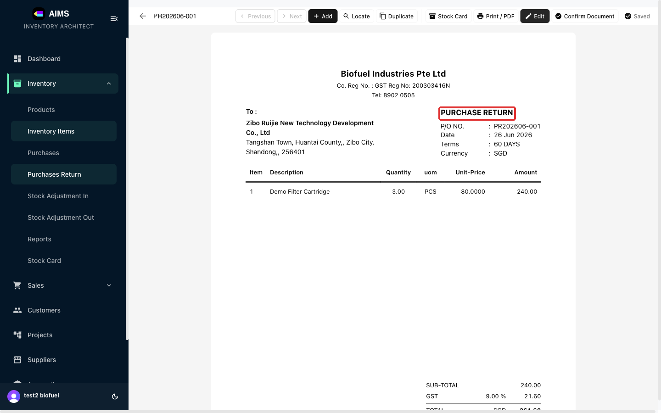

2.5 Stock Adjustment In (increase stock)
Step 1 Open Stock Adjustment In and start one
A Stock Adjustment In (SAI) increases stock without a purchase — e.g. found stock, a stock-count correction, or items returned back into inventory. Open Inventory › Stock Adjustment In and click Create Stock Adjustment In.
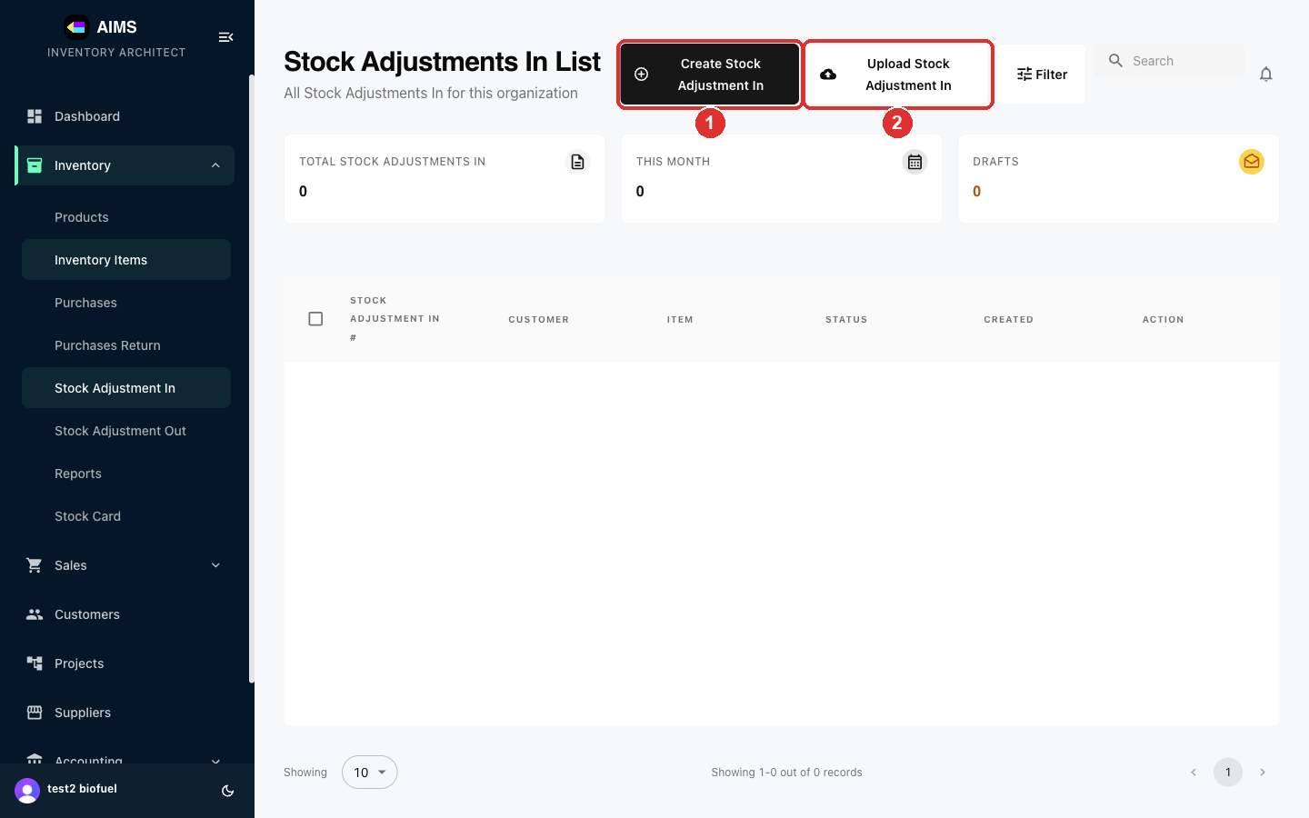

Step 2 Add the items being adjusted in
A stock adjustment has no mandatory customer or supplier — just the items. Click Add Item, pick the product, and set the Quantity to add to stock. (Supplier and W/O Number are optional.)
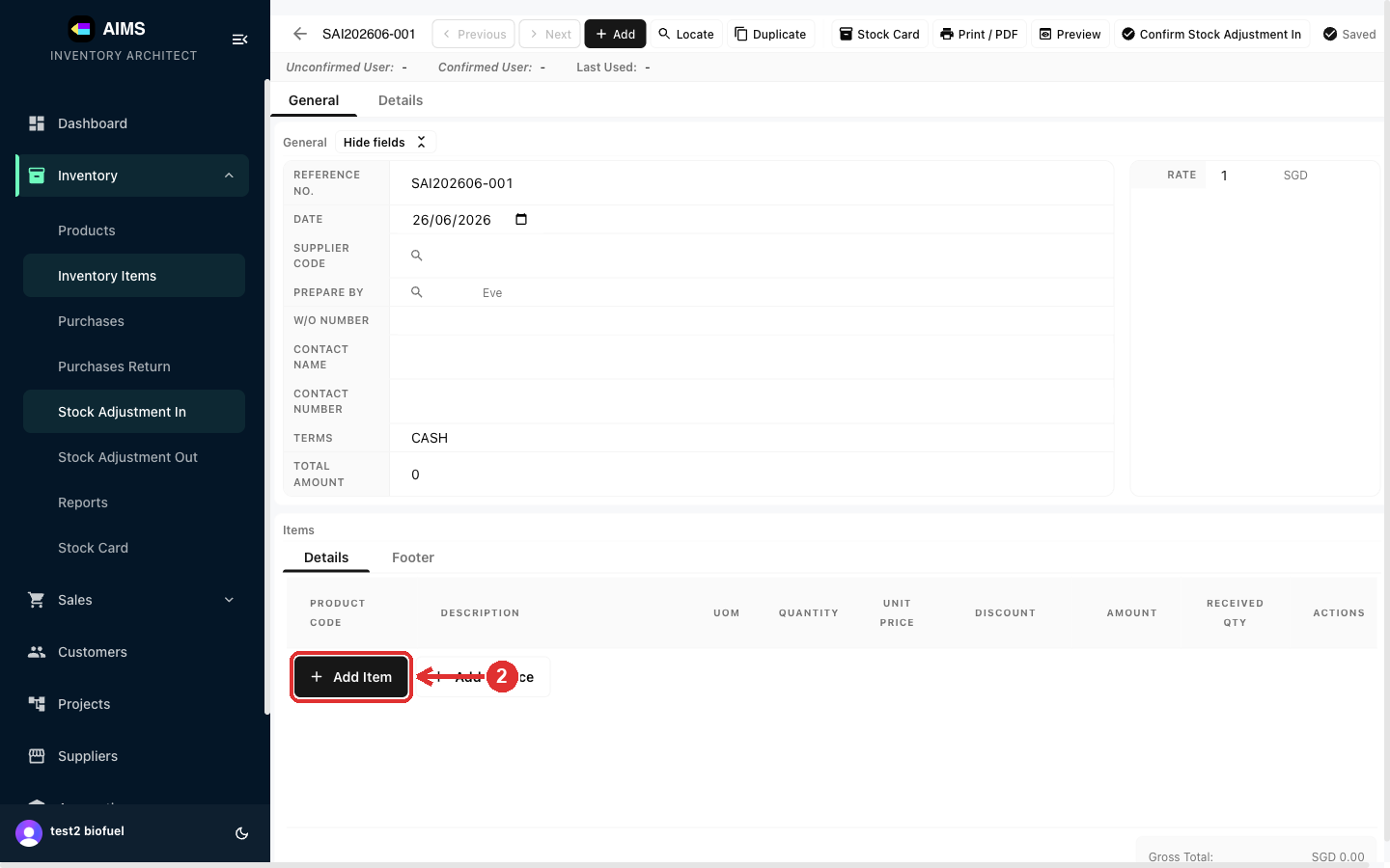

Step 3 Preview and confirm
Preview the adjustment, then Print / PDF or Confirm Stock Adjustment In to apply it — this increases the product's on-hand quantity.
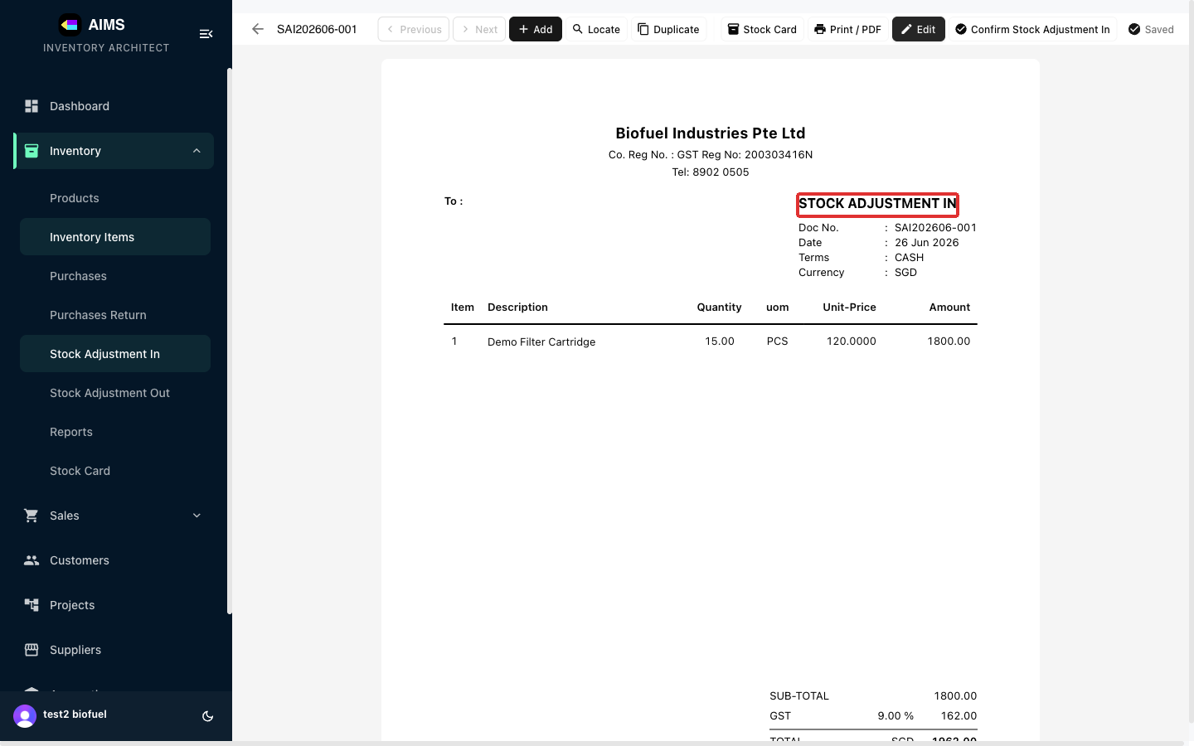

2.6 Stock Adjustment Out (decrease stock)
Step 1 Open Stock Adjustment Out and start one
A Stock Adjustment Out (SAO) decreases stock without a sale — e.g. damage, loss, samples, or write-offs. Open Inventory › Stock Adjustment Out and click Create Stock Adjustment Out.
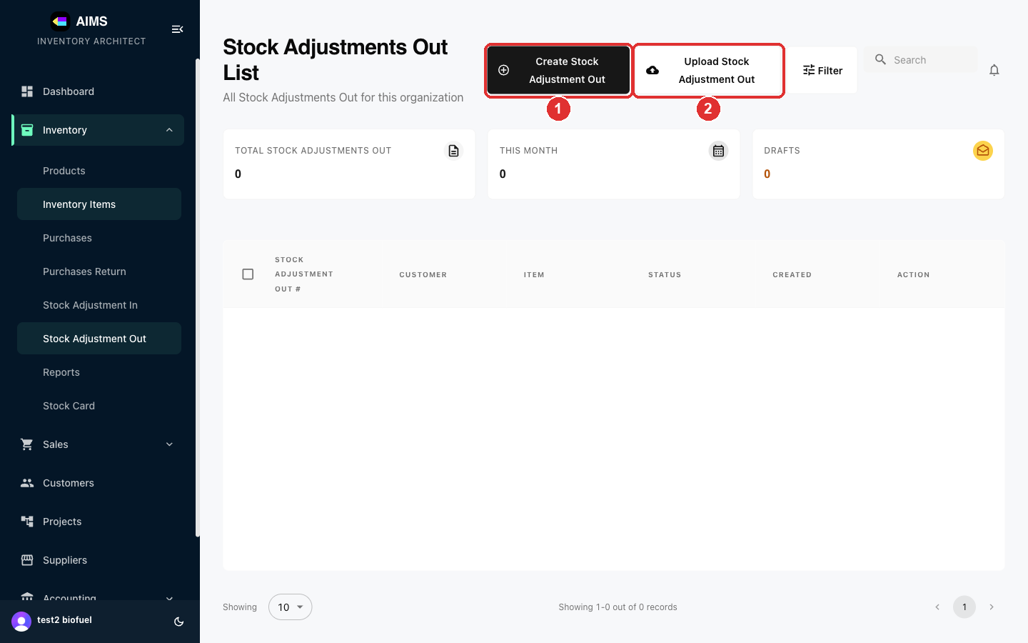

Step 2 Add the items being adjusted out
As with adjustment in, there's no customer or supplier — click Add Item, pick the product, and set the Quantity to remove from stock.
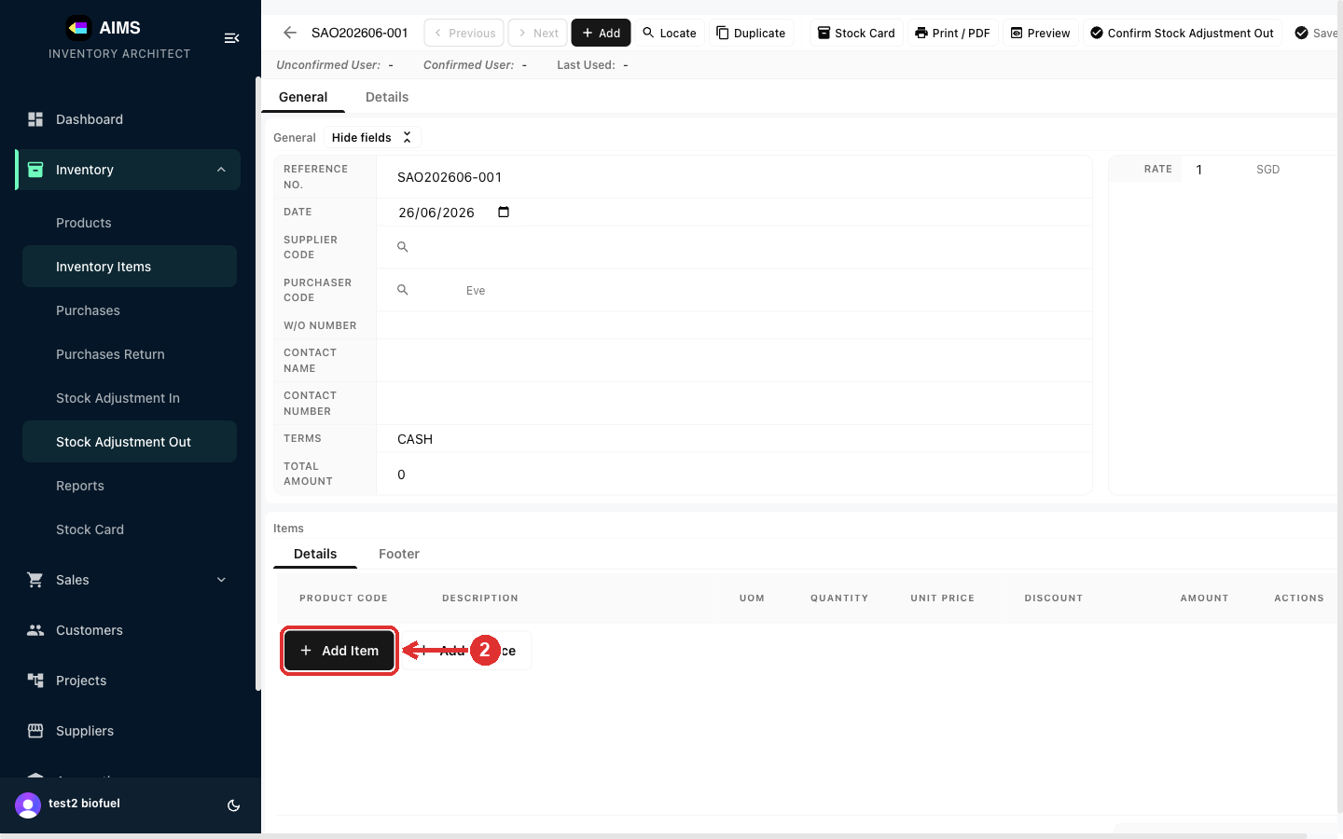

Step 3 Preview and confirm
Preview, then Print / PDF or Confirm Stock Adjustment Out to apply it — this reduces the product's on-hand quantity.
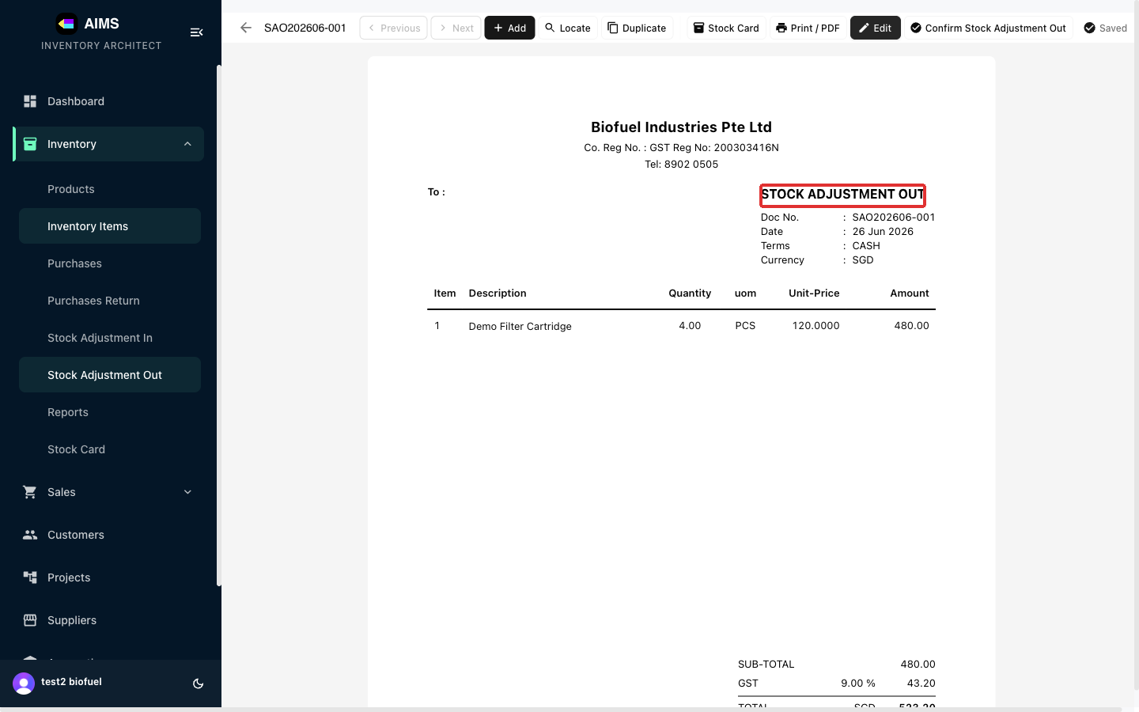

3. Customers
Customers are the companies and people you sell to. This section covers adding a new customer to AIMS.

3.1 Creating a Customer
Step 1 Open the Customers page and start a new customer
In the left sidebar, click Customers. At the top-right of the Customers List, click the Add Customer button.
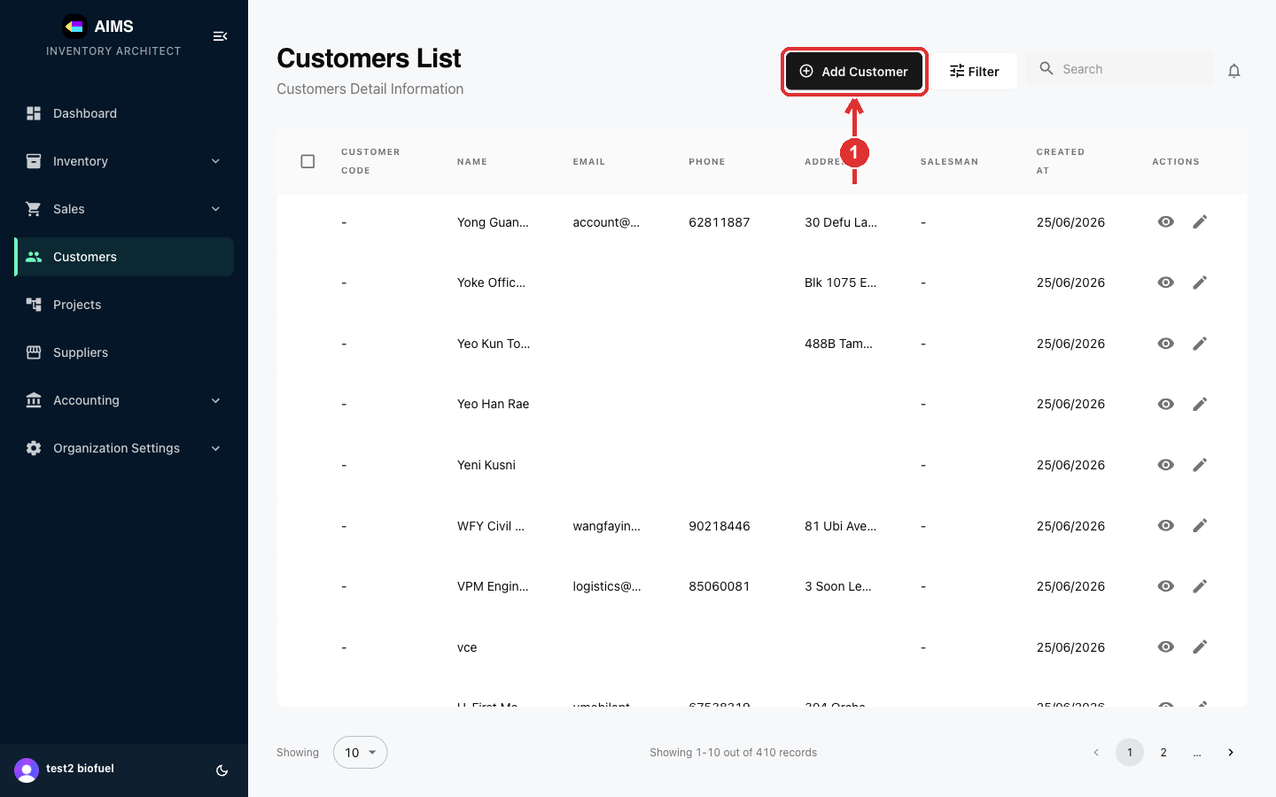

Step 2 Enter the customer's details
The Add Customer panel slides in from the right. Fill in the customer information. Name is required; Email, Phone, Address and GST Reg. No. are optional but recommended so they auto-fill on quotations and invoices.
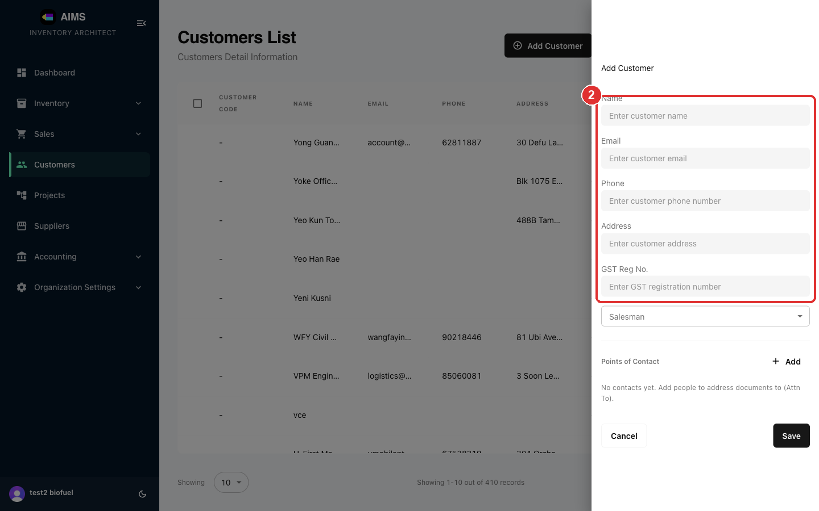

Step 3 (Optional) Assign a salesman and contacts, then Save
Optionally pick a Salesman and add Points of Contact (the people documents are addressed to, shown as “Attn To”). When the details are correct, click Save.
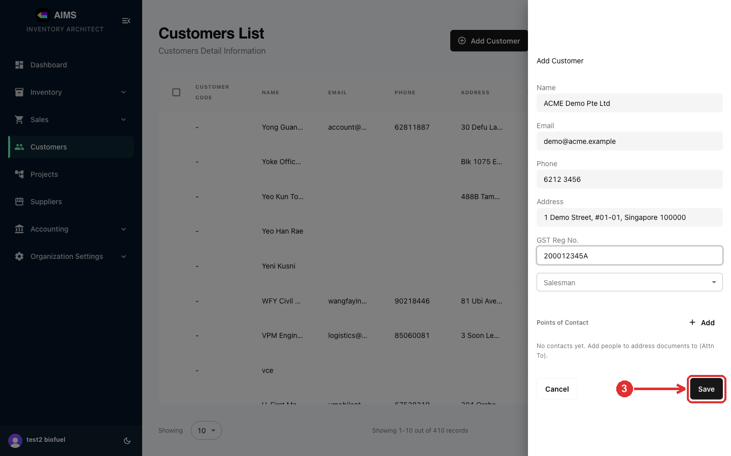

Step 4 Done — the customer is created
The panel closes and the new customer appears at the top of the Customers List, with an auto-generated Customer Code. You can now select this customer when creating quotations, invoices and other documents.
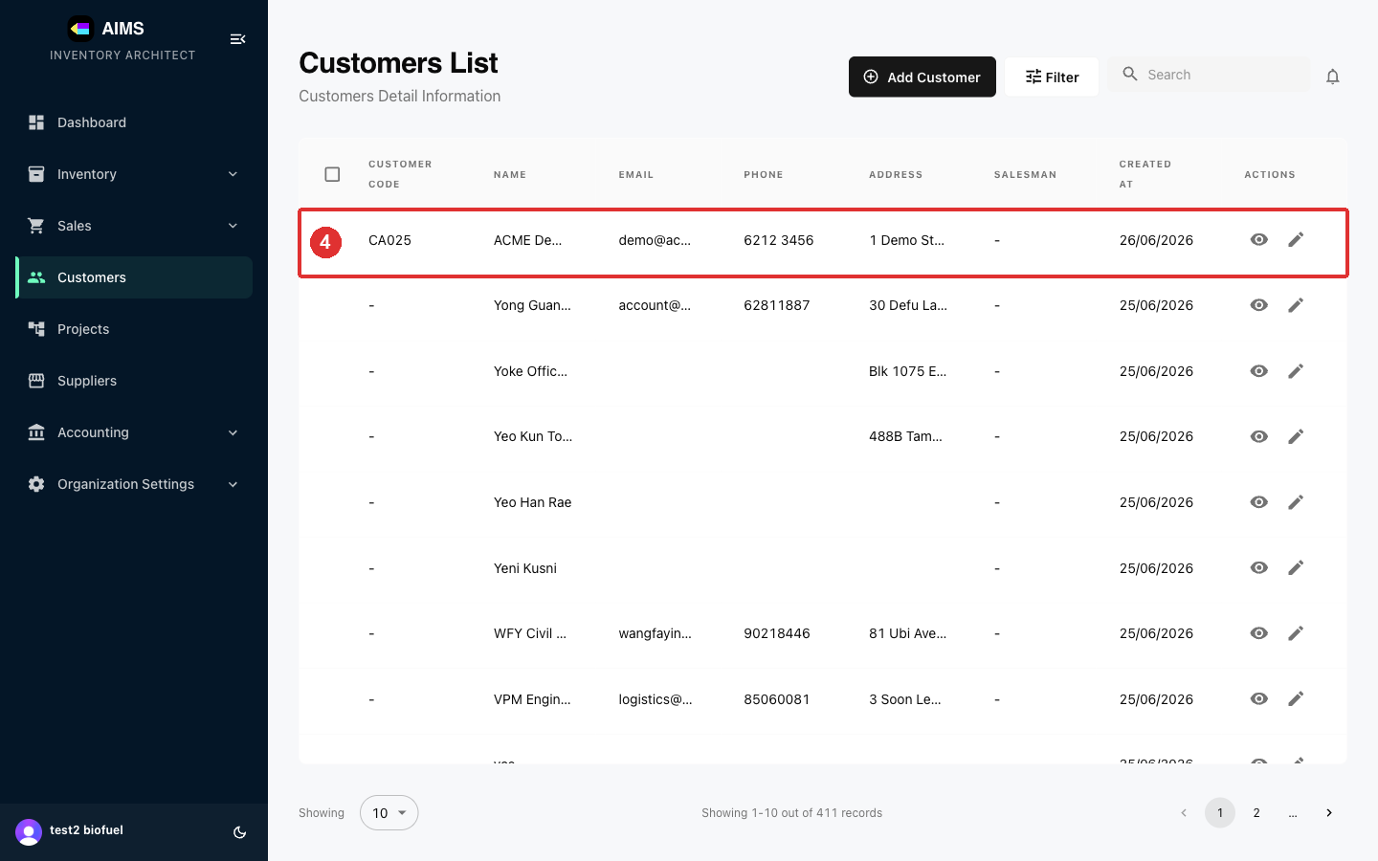

4. Suppliers
Suppliers are the vendors you buy from — they appear on Purchase Orders, Purchase Returns and stock documents. Adding a supplier works just like adding a customer.

4.1 Creating a Supplier
Step 1 Open Suppliers and start a new supplier
In the left sidebar, click Suppliers, then click Add Supplier at the top-right of the Suppliers List.
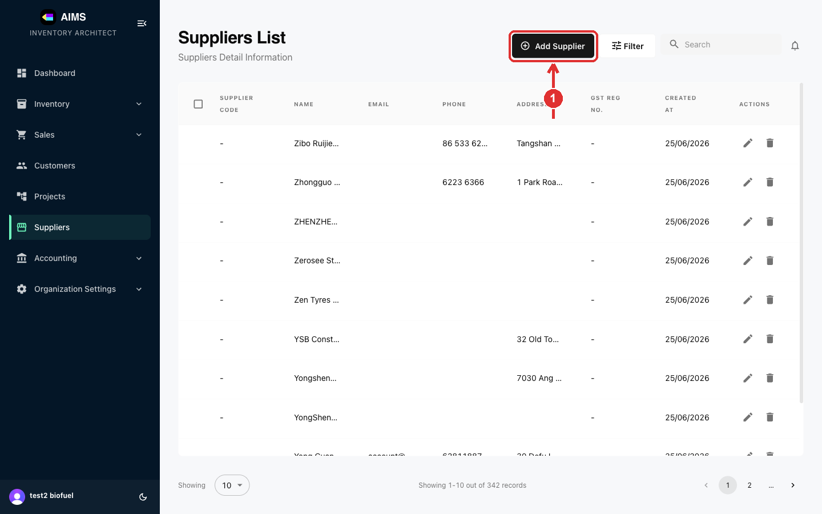

Step 2 Enter the supplier's details
Fill in the supplier information. Name is required; Email, Phone, Address and GST Reg. No. are optional but recommended so they auto-fill on purchase documents.
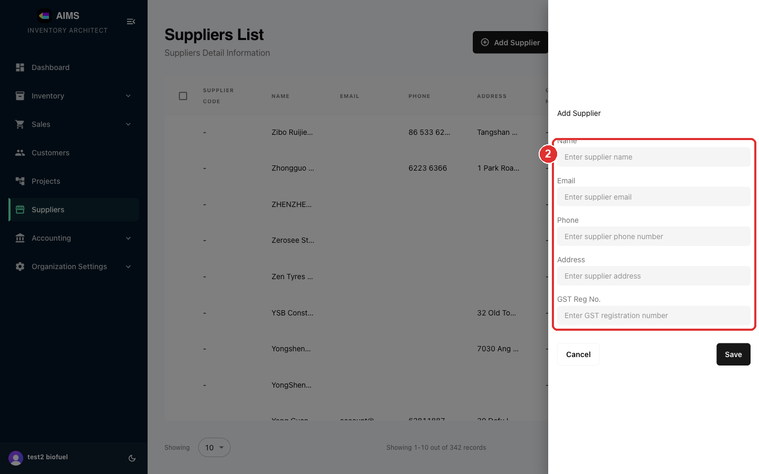

Step 3 Review and save
Check the details, then click Save.
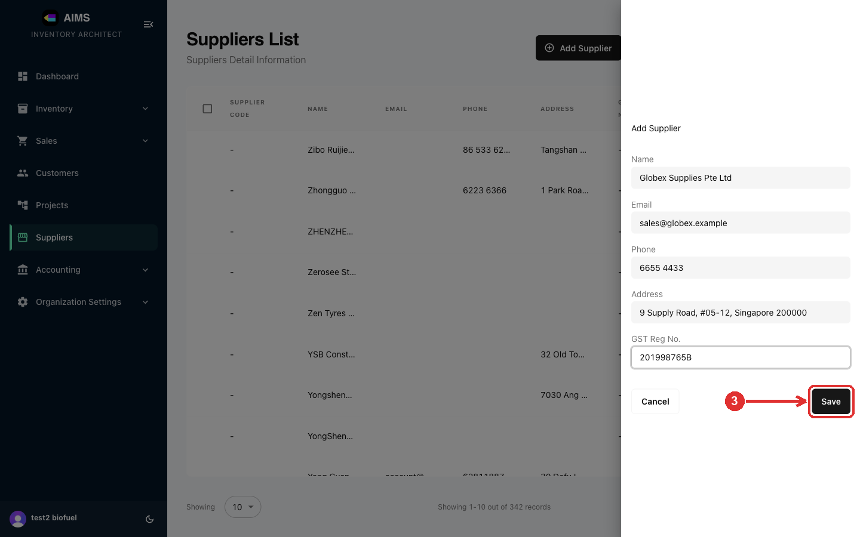

Step 4 Done — the supplier is created
The new supplier appears at the top of the Suppliers list with an auto-generated Supplier Code. You can now select it when creating Purchase Orders and other supplier documents.
