Welcome to OSI Recruitment Portal Help Center

***Features***

***Login***

User can login to the portal using OSI account and with google credentials as well.

Any new user who logs in for the first time by default will have a **ROLE_USER.**

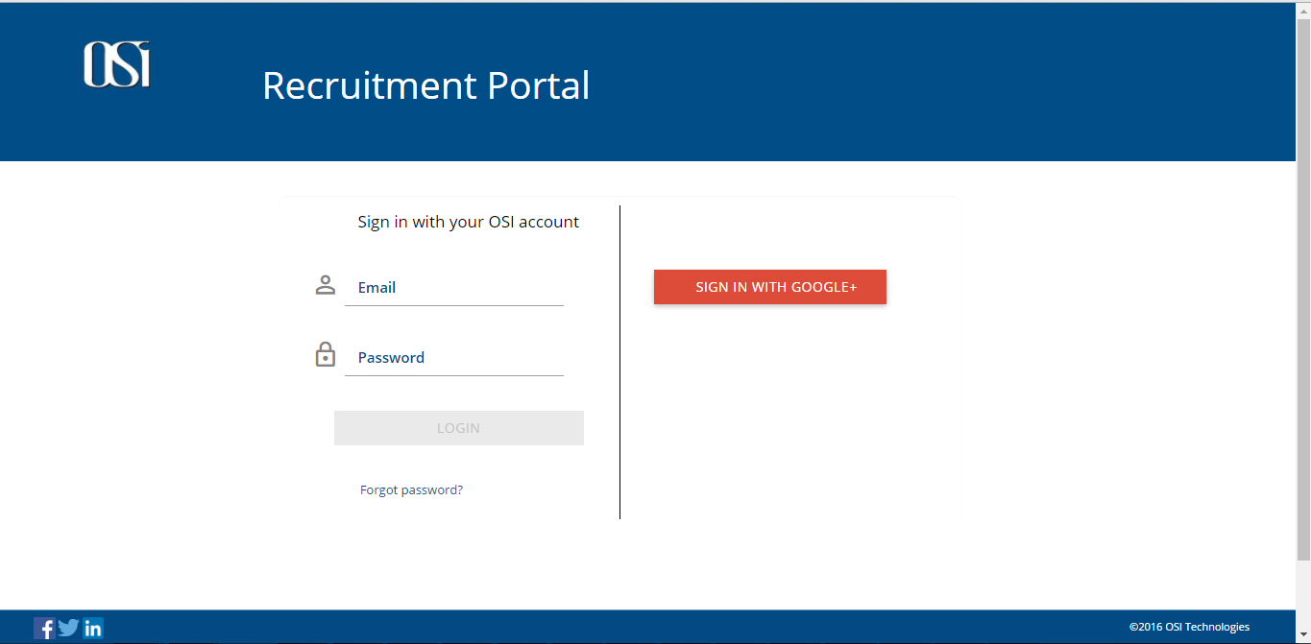

*Figure: User Login page*

***Dashboard***

This page is accountable for showing following objects,

1. Open job Positions in OSI.
2. Open job Requisitions.
3. All upcoming interviews
4. Scheduled interviews for the logged in user.
5. Requisitions to approve.
6. And at the bottom you can view your referred candidate’s profile.

All these fields are subjected to the respective USER_ROLES. Dashboard page also has shortcuts to search Users, Positions, Requisitions, Profiles and Interviews.

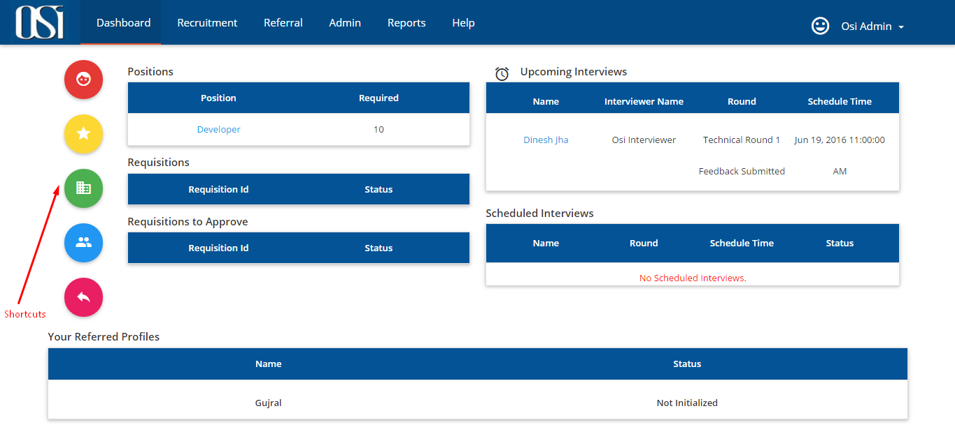

*Figure: Dashboard*

***Recruitment***

We can create new job requirements as per the Organization’s need for desired positions and experience levels called as Requisitions. ` Reject Requisition functionality is also provided to the Approver in case it has unacceptable data.

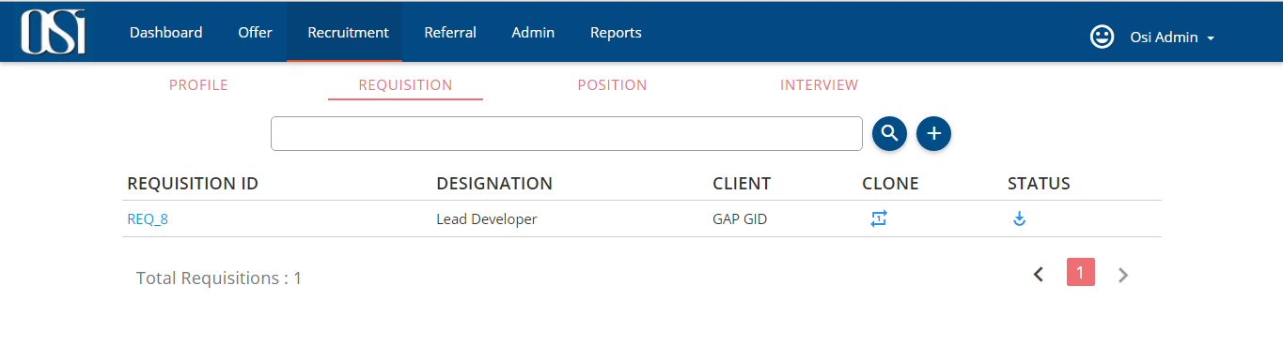

*Figure: Recruitment*

***Offer***

This page allows HR to create a recommendation letter in which the HR assesses the qualities, characteristics, and capabilities of the person being recommended in terms of that individual's ability to perform a particular task or function. HR thus can send the offer for approval (Approver here could be the head of business unit or Managing Director). Approver can Approve, Reject or demand Negotiation. This page would also have a link to the candidate’s profile for Approver’s perusal.

***Referral***

User can refer his acquaintance by uploading his/her profile under Profile sub tab and can also view open job positions under positions sub tab.

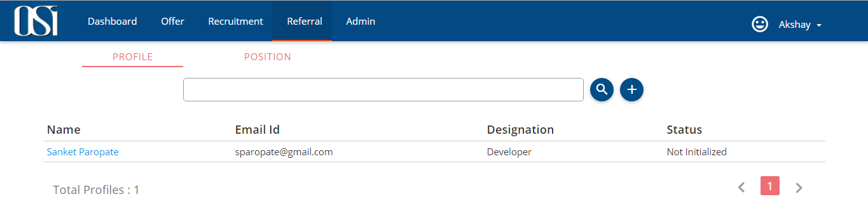

*Figure: Referral*

***Admin***

We can Add/Update all the static data of Portal like, User Roles, Interview Rounds and Client Specific Pre-defined Job Descriptions. This tab will only be visible to ROLE_ADMIN.

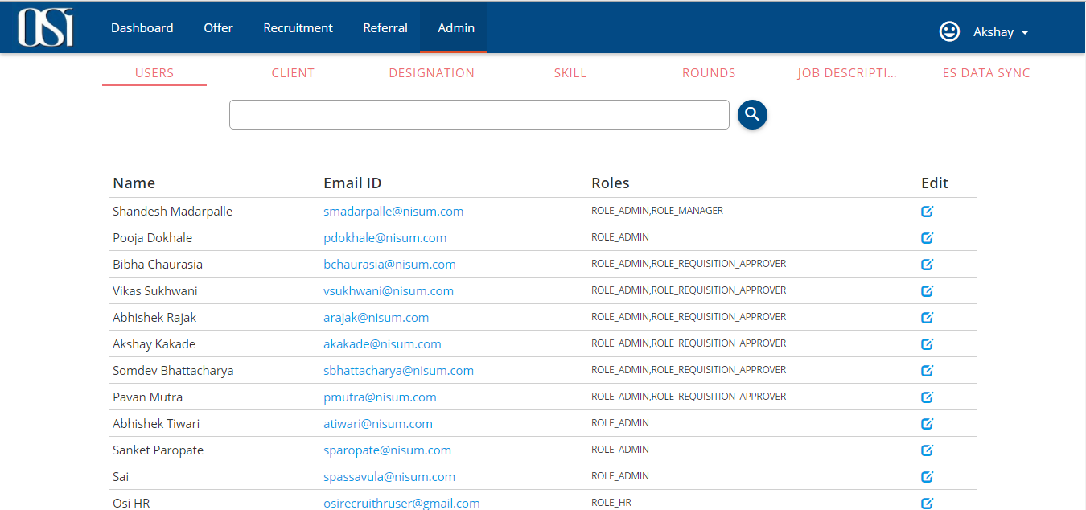

*Figure: Admin*

***USER_ROLES***

Every employee will be able to access the portal and be able to take actions as per the assigned ROLE.

Portal has 7 significant roles, namely,

***Role_Admin*** – Portal Administrator

***Role_HR*** – Human Resource executive

***Role_Manager*** – Project Manager

***Role_Requsition_Manager*** – Requisition Manager / Recruitment Manager

***Role_Interviewer*** - Interviewer

***Role_Requisition_Approver*** – Requisition Approver, Business Unit Head

***Role_User*** – Common user

***User Profile:***

Logged in user can navigate to profile page and can edit and update Name, Mobile, Location and Skype ID fields anytime. User can also view non-editable fields like the assigned roles, Skill sets and Clients.

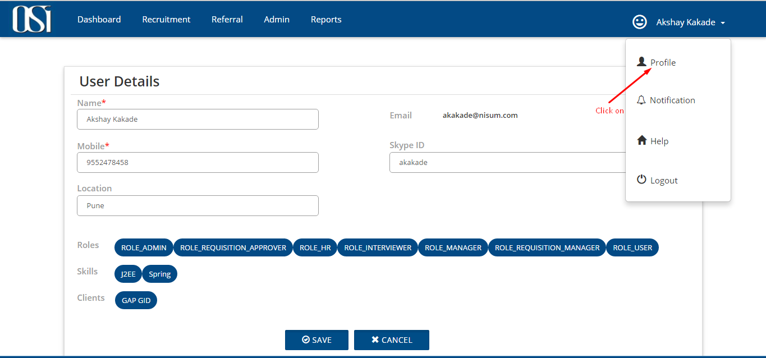

*Figure: User Profile*

**Admin functionalities (ROLE_ADMIN):**

**Visibility of tabs:**

|  |  |  |  |  |  |  |
| --- | --- | --- | --- | --- | --- | --- |
| **Main Tabs** | **Sub Tabs** | | | | | |
| **Dashboard** |  |  |  |  |  |  |
| **Offer** |  |  |  |  |  |  |
| **Recruitment** | **PROFILE** | **REQUISITION** | **POSITION** | **INTERVIEW** |  |  |
| **Referral** | **PROFILE** | **POSITION** |  |  |  |  |
| **Admin** | **USERS** | **CLIENT** | **DESIGNATION** | **SKILL** | **ROUNDS** | **JOB DESCRIPTION** |
| **Reports** |  |  |  |  |  |  |
| **Help** |  |  |  |  |  |  |

***Admin Sub Tab utilities:***

|  |  |  |  |  |  |  |
| --- | --- | --- | --- | --- | --- | --- |
| **Main Tab** | **Sub Tabs** | | | | | |
| **Admin** | **USERS** | **CLIENT** | **DESIGNATION** | **SKILL** | **ROUNDS** | **JOB DESCRIPTION** |

***USERS:*** Under this tab Admin can view all the users who have logged in to the portal at-least once.

Only Admin has the authority to change the **Roles**, **Skill** sets and **Clients** name.

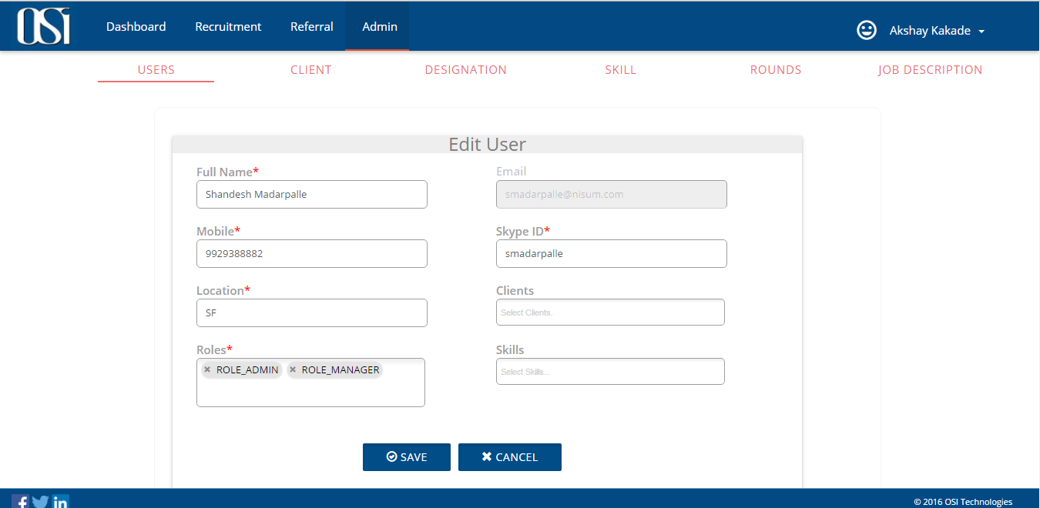

*Figure: Users*

***CLIENT:*** Under this tab Admin can create, add and view Clients associated with the organization.

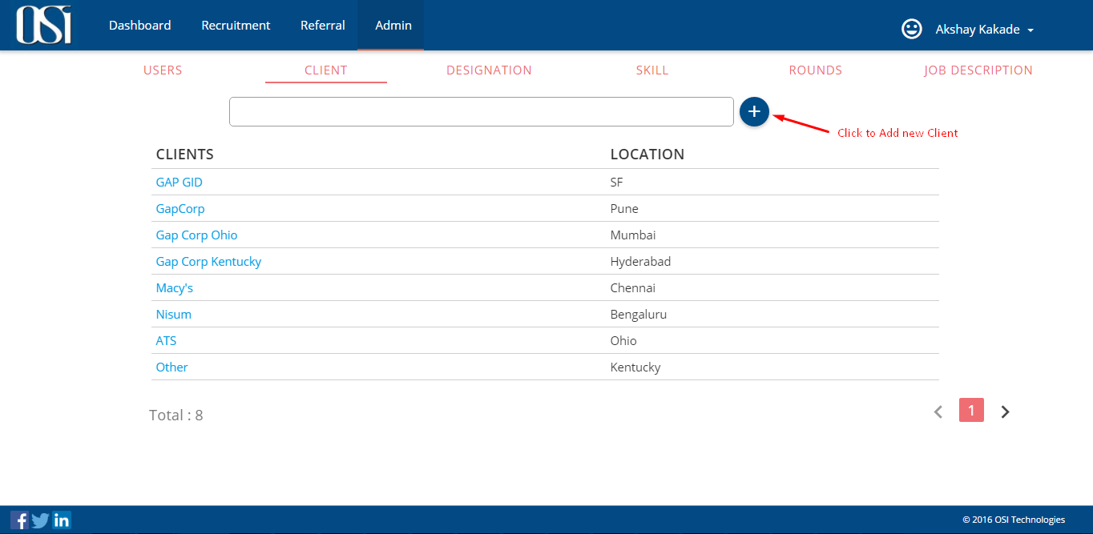

*Figure: Client*

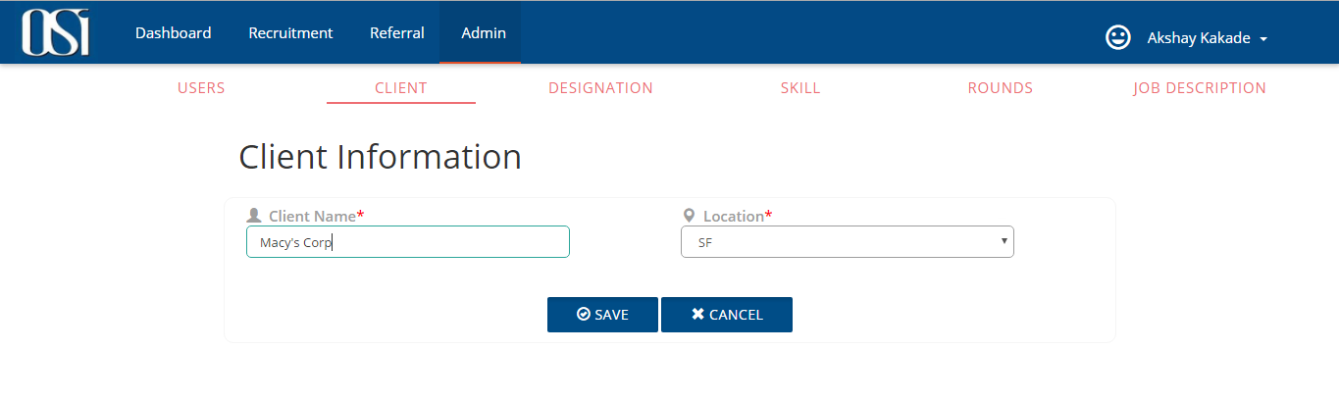*Figure: Add New Client*

***DESIGNATION:*** Under this tab Admin can Create, Add and View designations that an organization gives to the employees.

***SKILL:*** Under this tab Admin can Create, Add and View skills that an employee in the organization possess.

***ROUNDS:*** Under this tab Admin can Create, Add and View Interview rounds for the organization.

***JOB DESCRIPTION:*** Under this tab Admin can Create, Add and View job description required for the different Clients.

**Requisition Manager Functionalities (ROLE_REQUISITION_MANAGER):**

**Visibility of tabs:**

|  |  |  |  |  |
| --- | --- | --- | --- | --- |
| **Main Tabs** | **Sub Tabs** | | | |
| **Dashboard** |  |  |  |  |
| **Recruitment** |  |  |  |  |
| **Offer** | **PROFILE** | **REQUISITION** | **POSITION** | **INTERVIEW** |
| **Referral** | **PROFILE** | **POSITION** |  |  |
| **Reports** |  |  |  |  |
| **Help** |  |  |  |  |

***Requisition Manager’s Sub Tab utilities:***

|  |  |  |  |  |
| --- | --- | --- | --- | --- |
| **Main Tabs** | **Sub Tabs** | | | |
| **Recruitment** | **PROFILE** | **REQUISITION** | **POSITION** | **INTERVIEW** |

PROFILE: Under this tab Requisition manager can view the list of candidate profiles submitted by several sources. He can also submit a new profile for a candidate with required set of skills.

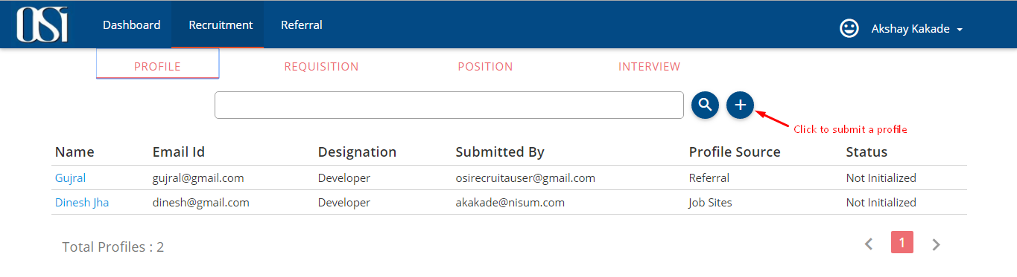

*Figure: View Profiles*

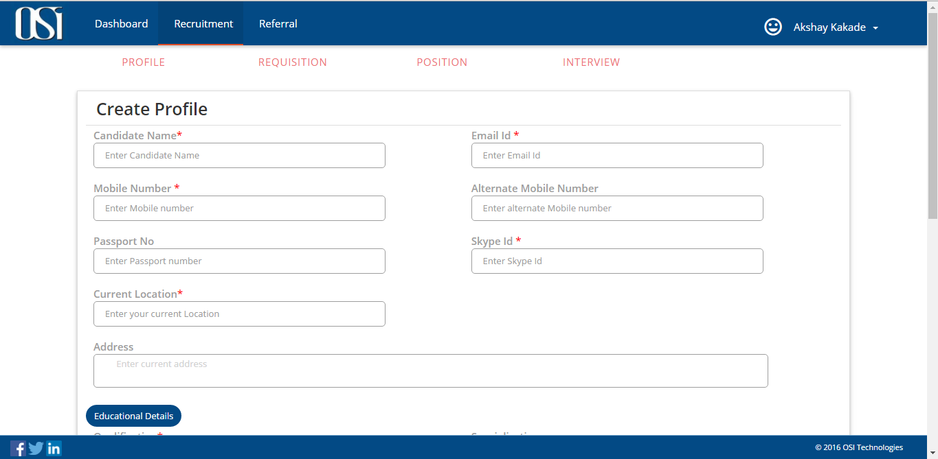

*Figure: Create and Submit a Profile*

REQUISITION: Requisition manager and Requisition Approver are the only roles capable of creating new requisitions. Requisition manager can view the list of previously created requisitions and can also create new job requirements as per the Organization’s need for desired positions and experience levels. These Requisitions are assigned to the Requisition Approver for his perusal and approval.

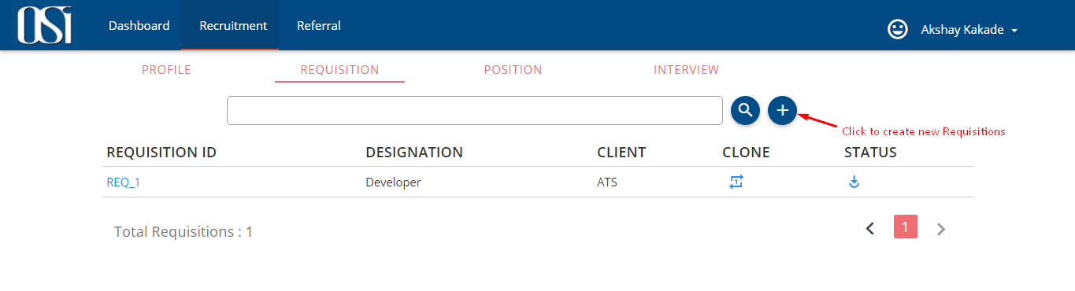

*Figure: view Requisitions*

To create new requisition, Requisition Manager need to fill all the mandatory data and finally click on create button. On create requisition page, we have ‘Client’ field. As soon as we select the client from the drop down, all the respective Job Description gets listed under ‘Job Description Title’ drop down field. On selecting appropriate JD Title, ‘Skills’ and Job Description’ fields will be populated accordingly. These Requisitions are assigned to the Requisition Approver for the approval. Approval will be done at two levels. First level approval is mandatory to create job Positions. As soon as the Requisition Manager creates a requisition it will shoot a mail to the selected Approver to approve.

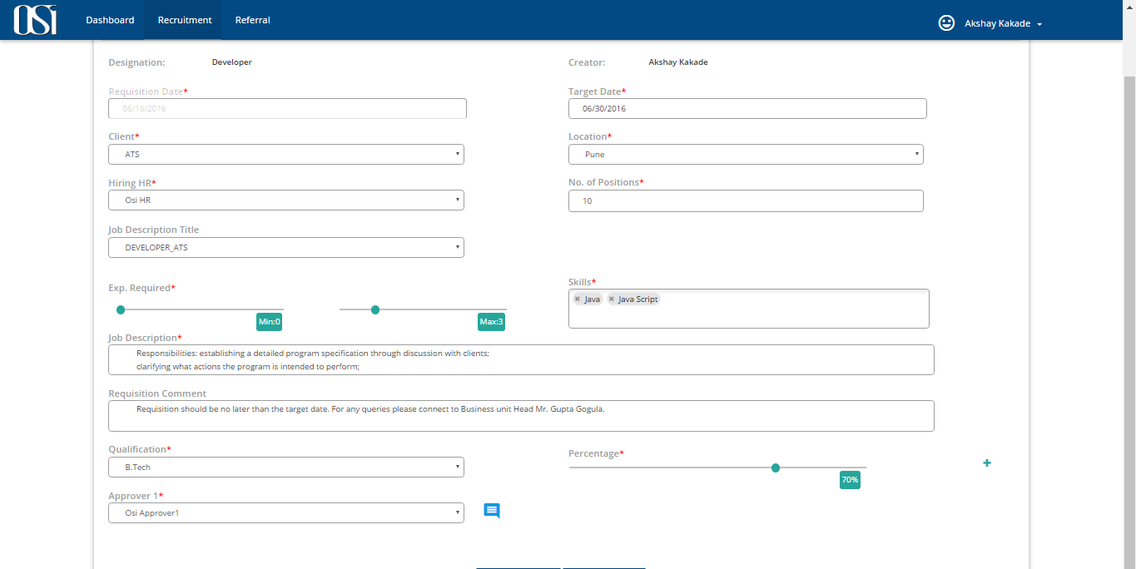

*Figure: Create Requisitions*

**CLONE**: As an effort to ease the requisition creation process, this application offers clone functionality where in the Requisition manager can clone an existing Requisition just by a click of mouse. He can also edit different fields before cloning. One can clone a requisition if and only if its status is either ‘initiated’ or Approved or partially Approved.

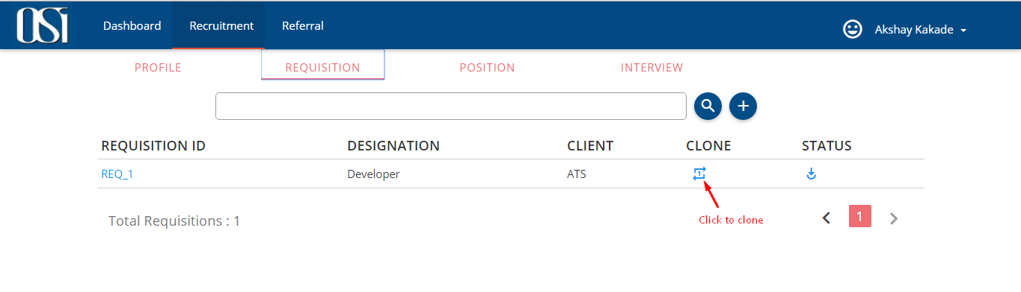*Figure: Clone a Requisition*

**Requisition Approver functionalities (ROLE_REQUISITION_APPROVER):**

**Visibility of tabs:**

|  |  |  |  |  |
| --- | --- | --- | --- | --- |
| **Main Tabs** | **Sub Tabs** | | | |
| **Dashboard** |  |  |  |  |
| **Recruitment** |  |  |  |  |
| **Offer** | **PROFILE** | **REQUISITION** | **POSITION** | **INTERVIEW** |
| **Referral** | **PROFILE** | **POSITION** |  |  |
| **Reports** |  |  |  |  |
| **Help** |  |  |  |  |

**Visibility of sub tabs:**

|  |  |  |  |  |
| --- | --- | --- | --- | --- |
| **Main Tabs** | **Sub Tabs** | | | |
| **Recruitment** | **PROFILE** | **REQUISITION** | **POSITION** | **INTERVIEW** |

**Requisition Approver:** A user with this role can perform all the actions of a Requisition Manager. In addition he is also responsible for the perusal of the Requisition and shall finally Approve or Reject the same. Approver would also see a list of all the pending requisitions that he has to approve on the Dashboard under ‘Requisitions to Approve’ table. He can also edit the requisition before Approval. Once approved, application will create open Job positions under POSTION tab and a mail will be sent to HR and respective Manager who created it notifying about the status.

In case there are two approvers for a requisition then Approver_1 shall approve first, this will change the status of requisition to ‘Partially Approved’ and will shoot a mail to Approver_2 requesting his approval. Once Approver_2 gives a go ahead, HR and respective Manager who created it would be notified by an email. Any Rejection will also trigger a notification email that will be received by intended user (i.e. Creator of that requisition).

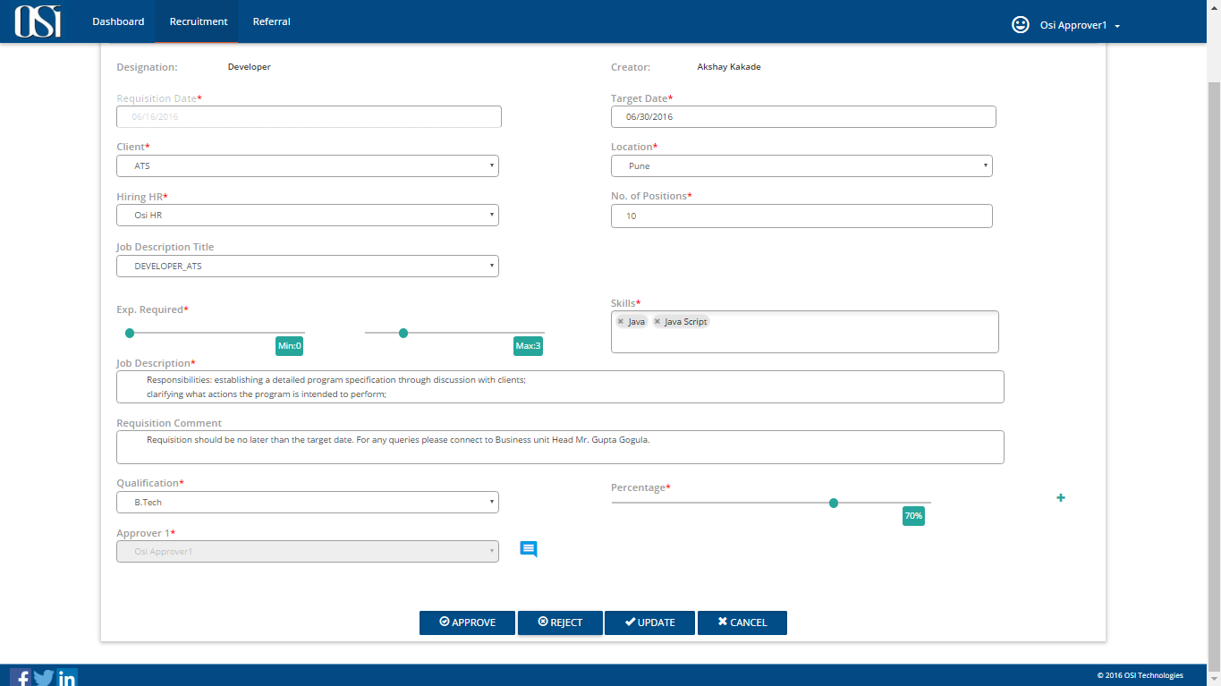

*Figure: Approve/Reject Requisition*

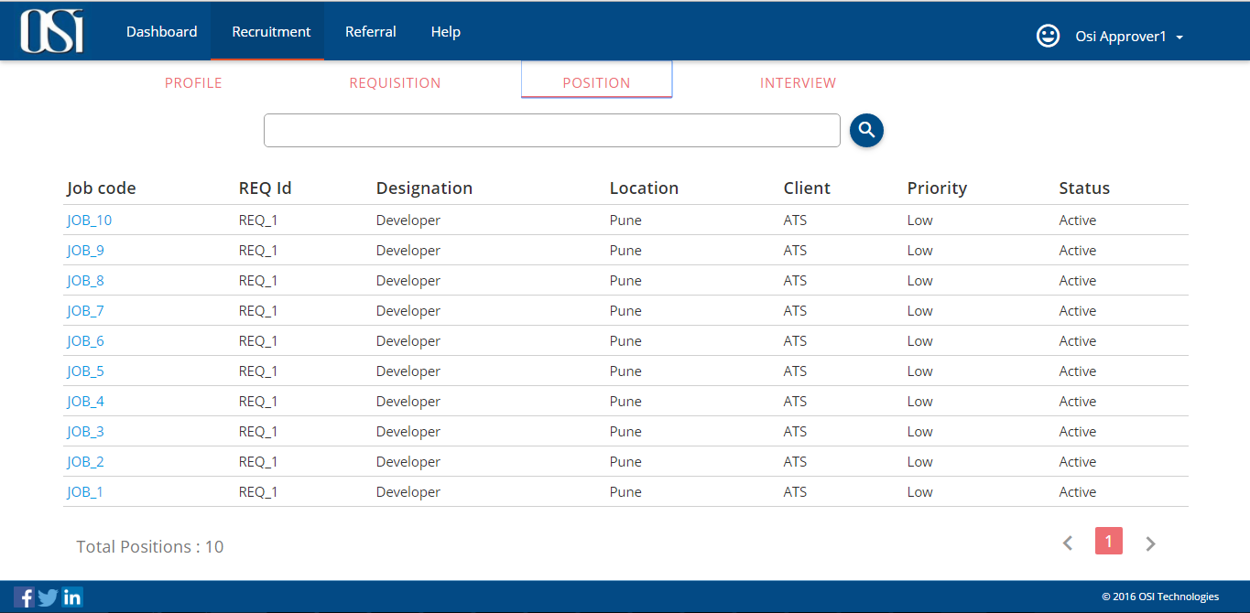

*Figure: Open job positions created after Approval*

**POSITION:** Under this tab all the positions will be listed. HR, Requisition Manager and Approver can edit and update each job position. They can also decide if the hiring would be through open walkin or referral walkin. When either of the users update ‘Position Type’ field as referral then this job position will get visible to all the common users under Referral > Position. User can see all the position details by clicking on the JOB_CODE object.

**Human Resource Manager Functionalities (ROLE_HR):**

**Visibility of tabs:**

|  |  |  |  |  |
| --- | --- | --- | --- | --- |
| **Main Tabs** | **Sub Tabs** | | | |
| **Dashboard** |  |  |  |  |
| **Recruitment** | **PROFILE** | **REQUISITION** | **POSITION** | **INTERVIEW** |
| **Offer** |  |  |  |  |
| **Referral** | **PROFILE** | **POSITION** |  |  |
| **Reports** |  |  |  |  |
| **Help** |  |  |  |  |

**Visibility of sub tabs:**

|  |  |  |  |
| --- | --- | --- | --- |
| **Main Tabs** | **Sub Tabs** | | |
| **Recruitment** | **PROFILE** | **POSITION** | **INTERVIEW** |

**PROFILE**: The profile sub tab can be seen under two main tabs i.e. Recruitment > PROFILE and Referral > PROFILE. Under Recruitment > PROFILE, HR shall upload the profiles of only those candidates that are coming through consultancy, job sites and referral (referred by colleagues). While under Referral > PROFILE, he can upload the profiles of his personal contacts.

Once job positions are created, HR will traverse through candidate profiles for screening and schedule an interview.

**Interview:** After screening profiles, HR shall schedule an interview for shortlisted candidates. He would select Requisition, job position, type of round, interviewer, date and time etc. for the interview and click schedule. HR can also schedule multiple rounds for the same candidate by checking the ‘Allow multiple rounds’ box. Once scheduled, Candidate and corresponding interviewer would get an email notification for the same. This scheduled will also be visible on Dashboard. Interviewer will see this schedule under ‘Scheduled Interviews’ table and HR would see under ‘Upcoming Interviews’ table. Only those interviews which are scheduled within next 4 days from the present day date would be listed in these tables.

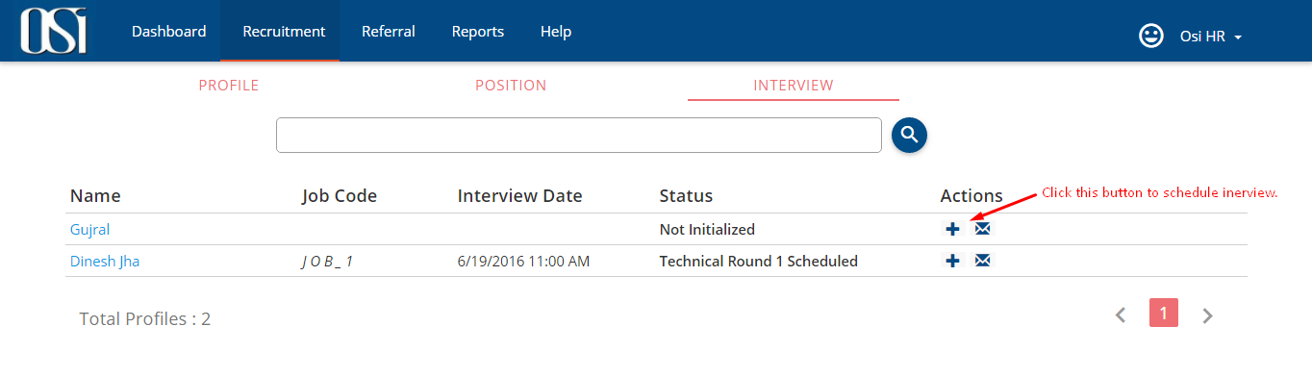

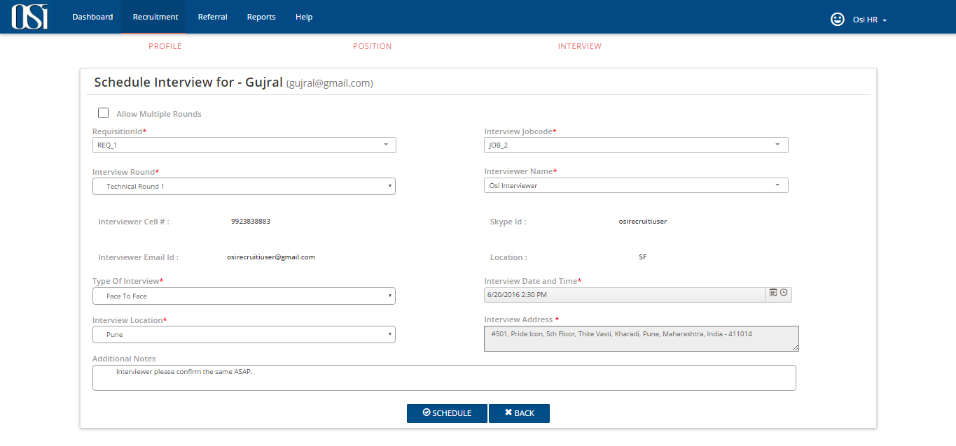

*Figure: Schedule Interview*

**Interviewer Functionalities (ROLE_INTERVIEWER):**

**Visibility of tabs:**

|  |  |  |
| --- | --- | --- |
| **Main Tabs** | **Sub Tabs** | |
| **Dashboard** |  |  |
| **Recruitment** | **INTERVIEW** |  |
| **Referral** | **PROFILE** | **POSITION** |
| **Help** |  |  |

**Visibility of sub tabs:**

|  |  |
| --- | --- |
| **Main Tabs** | **Sub Tabs** |
| **Recruitment** | **INTERVIEW** |

**INTERVIEW:** Interviewer will be notified by an email about the scheduled interview and its whereabouts.

After candidate is been interviewed, he will submit the feedback of the interview and will also state if the candidate is selected, onHold or Rejected. HR will be notified about the same via email.

Interviewer can also cancel the interview scheduled upon his name. In this case HR will be notified about the same via email. HR then would have to again reschedule the interview with different interviewer name.

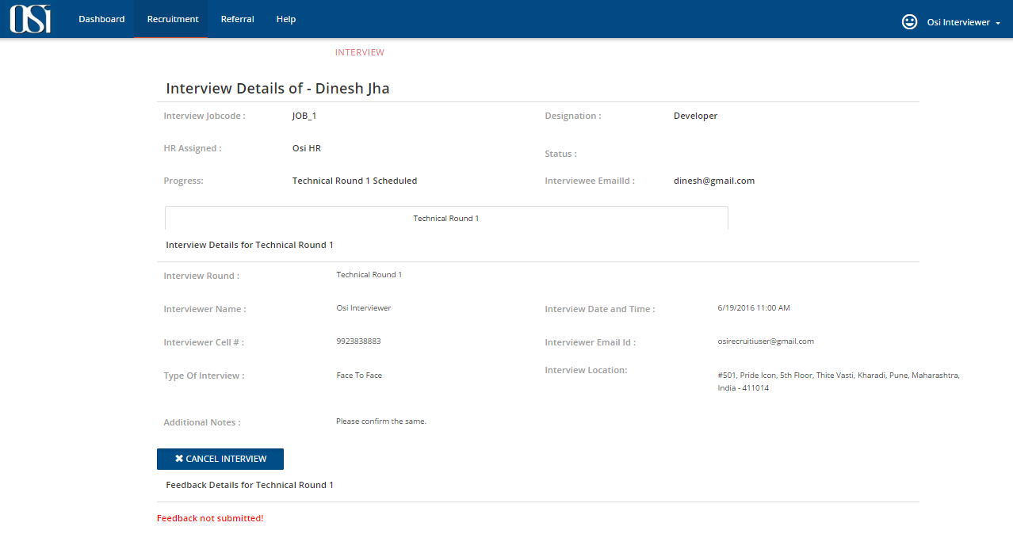

*Figure: Interviewer’s page of scheduled interview*

HR can also monitor the interview status.

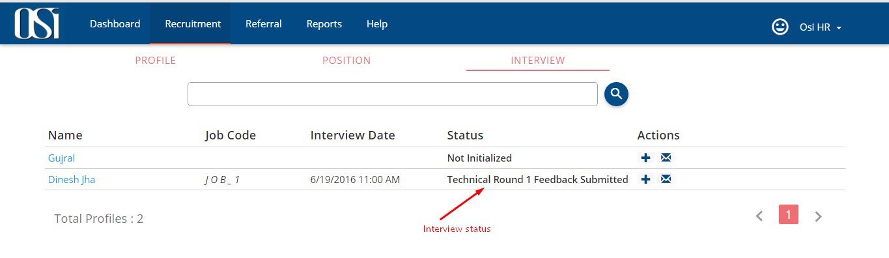

*Figure: Interview status for HR*

HR also has the privilege to submit the feedback on behalf of the interviewer.