**Smart Home System Application Proposal**

**Introduction**

The proposed smart home system is designed to provide users with comprehensive control and monitoring capabilities for various smart devices within their homes. With the increasing popularity of Internet of Things (IoT) technology, smart homes have become a focal point for enhancing convenience, comfort, and energy efficiency. This system aims to streamline the management of essential home devices, such as lights, thermostats, and curtains, through a user-friendly interface accessible remotely.

**Domain Description**

The smart home system encompasses an array of smart devices commonly found in modern households. These devices serve different purposes but collectively contribute to creating a connected and intelligent living space. Some examples of smart devices include:

**Lights:** These can be controlled remotely to adjust brightness, color, and ambiance, enhancing comfort and ambiance according to user preferences.

**Thermostats:** Smart thermostats enable users to regulate indoor temperature efficiently, optimizing energy usage and ensuring comfort while reducing utility costs.

**Curtains:** Motorized curtains offer convenience and privacy control, allowing users to open or close them remotely via smartphone apps or voice commands.

**The core functionalities of the system include:**

**Remote Control:** Users can remotely interact with smart devices, such as turning lights on/off, adjusting thermostat settings, and controlling curtain positions, through intuitive user interfaces accessible via web or mobile applications.

**Device State Monitoring:** The system continuously monitors the state of each connected device, providing real-time feedback on whether a device is on/off, its current settings (e.g., temperature for thermostats), and the position of curtains.

**Real-time Communication:** Leveraging gRPC for bi-directional communication between the client application and the server ensures seamless interaction, enabling instant updates on device states and user commands. This real-time communication enhances the user experience by providing immediate feedback and responsiveness.

**Service Definition and RPC (for all the services)**

The gRPC service definition is structured around a single service named SmartHome, encompassing the following RPC method:

**UpdateSmartHomeState:** This method utilizes a streaming message format to handle a sequence of user commands and provide corresponding responses. It facilitates real-time interaction between the client and server, allowing for dynamic updates and feedback.

**Messages:**

**UpdateRequest:** This message carries a string parameter named message, specifying the desired action the user wishes to perform. Supported actions include turning lights on/off, adjusting thermostat settings, and controlling curtain positions.

**UpdateResponse:** The UpdateResponse message carries a string parameter named message, conveying the server's response to the user's request. It confirms the action taken or provides feedback if the request is invalid or encounters an error.

**Example RPC Interaction**

**Client Request:** Suppose the user selects "Turn on lights" from the user interface. The client application sends an UpdateRequest message with message set to "TurnOnLights."

**Server Processing:** Upon receiving the request, the server updates the internal state variable for lights, turning them on, and generates an UpdateResponse message.

**Server Response:** The server sends the UpdateResponse message back to the client, confirming the action with a message such as "Lights turned on successfully."

**Overall Service Functionality**

**Service Definitions:** The gRPC service definition establishes a structured interface for client applications to interact with the server, ensuring compatibility and ease of integration across different platforms and devices.

**Service Implementations:** On the server-side, the implementation logic handles various user requests, updating device states accordingly, and generating appropriate response messages. This implementation encapsulates the core functionality of the smart home system, ensuring reliability and efficiency.

**Naming Services:** Given that the server operates on a well-defined port (50051), and clients connect directly to it, a separate naming service is unnecessary. This simplifies deployment and configuration, streamlining the setup process for users.

**Conclusion**

In conclusion, the proposed smart home system framework offers a comprehensive solution for managing and controlling smart devices within the home environment. While the current implementation focuses on basic functionalities such as remote control and device state monitoring, there is immense potential for further enhancements and expansion. Future iterations could incorporate advanced features such as scheduling, automation, energy optimization, and integration with a broader range of smart devices and platforms. By leveraging gRPC for real-time communication and providing intuitive user interfaces, this system aims to enhance convenience, comfort, and efficiency in modern living spaces.

**GitHub Repository**

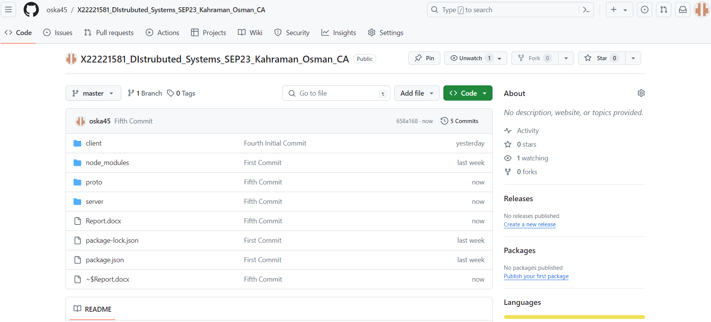

GitHub Link: <https://github.com/oska45/X22221581_DIstrubuted_Systems_SEP23_Kahraman_Osman_CA>

**Command Prompt Outputs**

