### **1. Data Familiarization and Preprocessing**

* ****Initial Assessment****: Review the column headers and a few rows of data to understand the types of questions asked and the range of responses.
* ****Data Cleaning****:
  + ****Missing Values****: Identify columns with "N/A" or similar indicators of missing data. Decide on a strategy for handling these, such as imputation or exclusion.
  + ****Text Standardization****: For text responses, standardize to a common case, correct misspellings, and decide how to handle open-ended responses.
  + ****Categorical Encoding****: Convert categorical text data to numerical codes if necessary, using one-hot encoding or label encoding where appropriate.

### **2. Exploratory Data Analysis (EDA)**

* ****Descriptive Statistics****: Calculate statistics such as mean, median, mode, and standard deviation for numerical data.
* ****Distribution Analysis****: Plot histograms or bar charts for individual variables to understand their distribution.
* ****Correlation Analysis****: Explore potential relationships between variables, especially those that may directly relate to mental health outcomes.

### **3. Feature Engineering and Dimensionality Reduction**

* ****Feature Selection****: Identify which survey questions (features) are most relevant to the HR department's goals.
* ****Dimensionality Reduction****: Use techniques like PCA to reduce the number of variables, if needed, focusing on the most informative ones.

### **4. Clustering and Segmentation**

* ****Choice of Clustering Algorithm****: Decide on an algorithm like K-means, DBSCAN, or hierarchical clustering based on the data's characteristics.
* ****Cluster Validation****: Use silhouette scores or other metrics to evaluate the quality of the clustering.

### **5. Visualization for Insight**

* ****Cluster Visualization****: Use techniques like t-SNE or PCA plots to visualize clusters in two or three dimensions.
* ****Interactive Dashboards****: Consider tools like Tableau or Power BI to create interactive dashboards that HR can use to explore the data.

### **6. Interpretation of Clusters**

* ****Profile Clusters****: Develop profiles for each cluster, identifying their key characteristics and differences.
* ****Link to Mental Health Programs****: Relate cluster characteristics to potential mental health programs that could be beneficial.

### **7. Reporting and Recommendations**

* ****Documentation****: Write a detailed report summarizing your methodology, findings, and the rationale behind your recommendations.
* ****Actionable Insights****: Highlight specific survey questions or clusters that offer actionable insights for HR initiatives.

### **1. Data Familiarization and Preprocessing**

****Initial Assessment****

* ****Understanding the Dataset****: Open the dataset using a data analysis tool like Python's Pandas library or R, and use functions to get a summary of the data (**head()**, **info()**, and **describe()** in Pandas). This will help you understand the types of data (numerical, categorical, text), the range of responses, and get a sense of data quality and structure.
* ****Identifying Variable Types****: Look at each column header and the corresponding responses to classify them into variable types: binary (yes/no), ordinal (ranked but not numerical), nominal (categories without an inherent order), or continuous (measurable quantities).
* ****Survey Structure****: Note the structure of the survey questions - are there multiple parts to a question, are there any follow-up questions that only apply if a certain answer is given to a previous question, etc.

****Data Cleaning****

* ****Missing Values****:
  + ****Identification****: Use appropriate functions to identify missing values (**isnull()** in Pandas). Check for placeholders that might not be standard null values in the dataset, like "N/A", "None", or blank spaces.
  + ****Handling Strategy****: Decide on strategies for handling missing data. Options include:
    - ****Deletion****: Remove the data point entirely, which is suitable if the missing data is not significant.
    - ****Imputation****: Replace missing values with a statistic like the mean, median, or mode for numerical data, or the most frequent category for categorical data. For more sophistication, consider predictive imputation or using algorithms like k-Nearest Neighbors (k-NN).
    - ****Flagging****: Create a new binary variable to flag data as missing, which can sometimes be informative for the analysis.

****Text Standardization****

* ****Uniformity****: Convert all text to lowercase or uppercase to ensure uniformity (**str.lower()** or **str.upper()** in Pandas).
* ****Correction****: If misspellings are present, you may need a dictionary of correct spellings to map and correct them, or utilize a spell-checker library.
* ****Handling Open-Ended Responses****: For open text responses, consider:
  + ****Categorization****: If there are common themes, categorize responses into a finite set of categories.
  + ****Sentiment Analysis****: Use sentiment analysis to gauge the general feeling or tone of the response.
  + ****Keyword Extraction****: Use NLP techniques to extract keywords or phrases which could be coded into separate binary variables.

****Categorical Encoding****

* ****Binary Variables****: Convert "Yes/No" type questions to 1/0 using binary encoding.
* ****Nominal Variables****: For categorical data without an intrinsic order, apply one-hot encoding which creates a new binary column for each category (**get_dummies()** in Pandas). one hot encoding.
* ****Ordinal Variables****: For categorical data with a rank or order, encode the categories with appropriate numerical values that preserve the order. Mapping functions or the **Categorical** type in Pandas can be helpful here. Label Encoder

****Additional Considerations****

* ****Consistency Checks****: Ensure that all responses are consistent, such as a respondent not being able to have more current than past employers.
* ****Data Transformation****: Depending on the analysis technique you plan to use, you might need to transform the data (e.g., log transformation for skewed data).
* ****Anonymization****: If the data contains any personally identifiable information (PII), make sure to anonymize it to protect privacy.

Remember, the preprocessing steps set the stage for all subsequent analysis, so take the time to perform these tasks carefully. The more thorough you are in this stage, the more reliable your subsequent insights will be.

窗体顶端

窗体底端

* ****Correlation Analysis****: Identify variables that show a strong correlation with the presence of mental illness.
* ****Feature Importance****: Utilize machine learning models that provide feature importance scores, such as Random Forests or Gradient Boosting Machines.
* ****Recursive Feature Elimination****: Use techniques that iteratively build models and eliminate the least important features to identify the most impactful ones.

M F And Bigendere : 1,2,3

* ****Correlation Analysis****: Identify variables that show a strong correlation with the presence of mental illness.
* ****Feature Importance****: Utilize machine learning models that provide feature importance scores, such as Random Forests or Gradient Boosting Machines.
* ****Recursive Feature Elimination****: Use techniques that iteratively build models and eliminate the least important features to identify the most impactful ones.

**ENCODING**

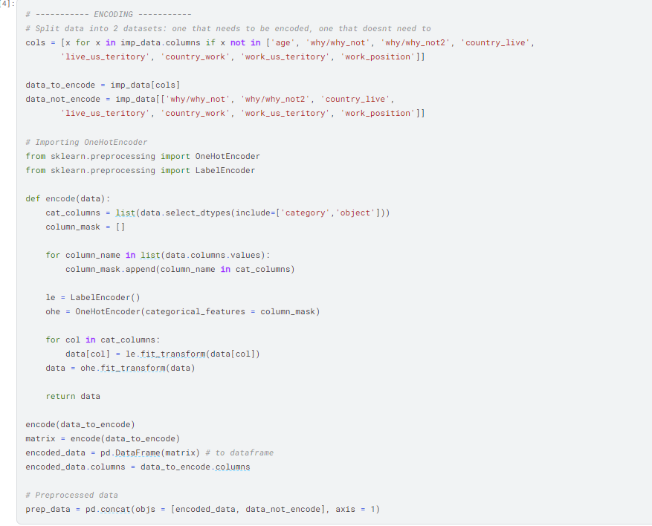

**VISUALIZE**

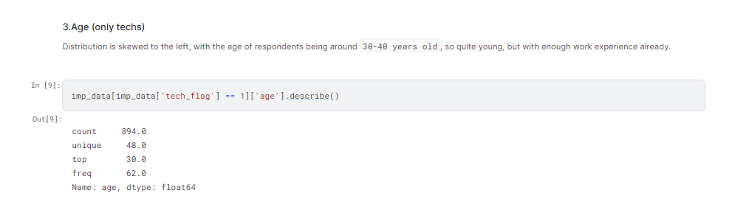

**FEATURE IMPORTANCE**

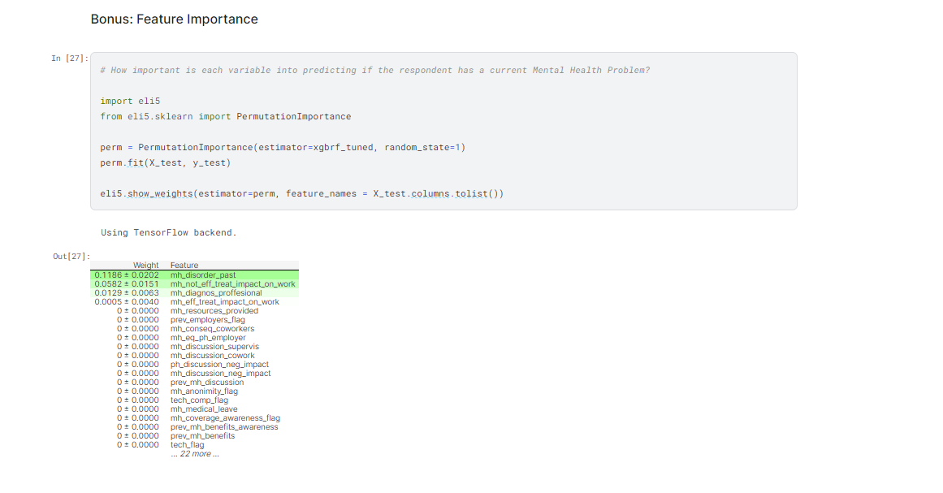

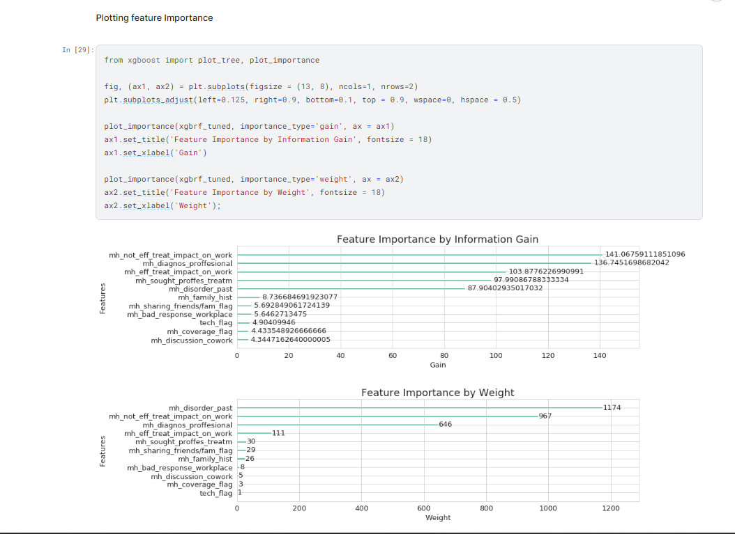

**PREDICTIONS:**  
  
