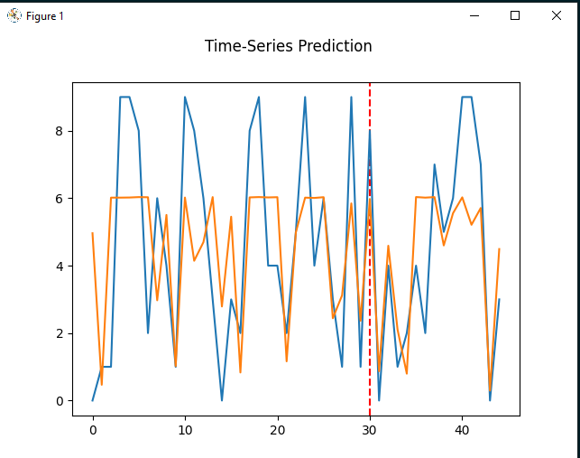

N1 = 3

[[3.283598]] i:5000 j:0.1 1.002645 2.063109 1.436353

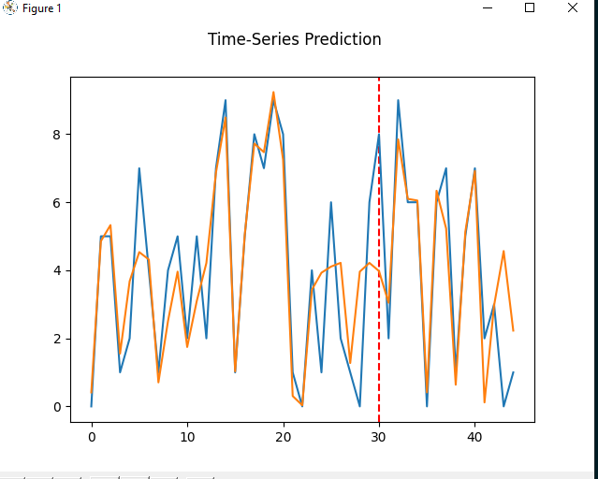

N2 = 1

[[1.3779783]] i:5000 j:0.01 0.733901 0.964749 0.982216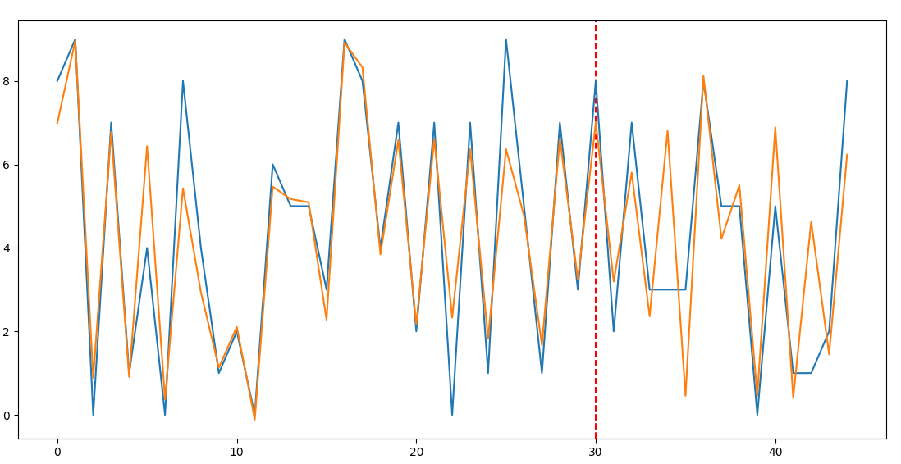

N3 = 9

[[9.066741]] i:5000 j:0.01 0.597945 0.652514 0.807784

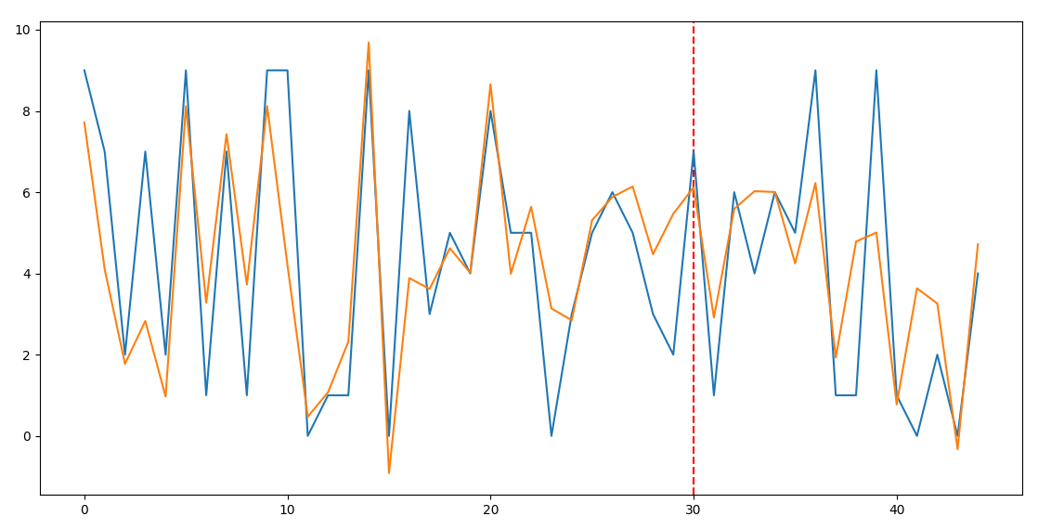

[[6.0998397]] i:3000 j:0.01 0.764345 1.109184 1.053178