# Viikko 43 -tehtävät

## Tehtävä 1

import pandas as pd

from sklearn.model_selection import train_test_split

from sklearn.metrics import confusion_matrix, accuracy_score, precision_score, recall_score

import matplotlib.pyplot as plt

import seaborn as sns

from sklearn.tree import export_graphviz

import graphviz

from sklearn import tree

df = pd.read_csv('./work/viikko8/datasets/iris.csv')

sns.scatterplot(x='petal length (cm)', y='petal width (cm)', hue='Species', data=df)

plt.show()

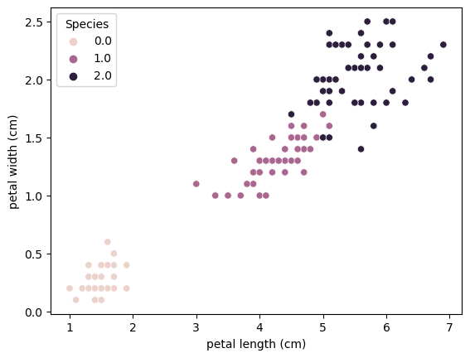

X = df.iloc[:, 0:4]

y = df.iloc[:, [4]]

columns = X.columns

*# Splitting the dataset into the Training set and Test set*

X_train, X_test, y_train, y_test = train_test_split(X, y, test_size = 0.25, random_state = 0)

*# Training the Decision Tree Classification model*

model = tree.DecisionTreeClassifier(max_depth=4, criterion='gini')

model.fit(X_train, y_train)

mfi = model.feature_importances_

*# Predicting the Test set results*

y_pred = model.predict(X_test)

y_pred_pros = model.predict_proba(X_test)

*# Making the Confusion Matrix and accuracy_score*

cm = confusion_matrix(y_test, y_pred)

ax = plt.axes()

sns.heatmap(cm, annot=True, fmt='g', ax=ax)

ax.set_title("DT")

plt.show()

*# Calculate accuracy score*

score = accuracy_score(y_test, y_pred)

print(f"Accuracy score: {score}")

Accuracy score: 0.9736842105263158

*# Create dot file for graphviz visualization*

dot_data = export_graphviz(

            model,

            out_file =  None,

            feature_names = columns,

            class_names = df['Class'].unique(),

            filled = True,

            rounded = True)

graph = graphviz.Source(dot_data)

graph.render('./work/viikko8/iris')

*# predict new*

df_new = pd.read_csv('./work/viikko8/datasets/new-iris.csv')

predictions = model.predict(df_new)

print(predictions)



## Tehtävä 2

Sama koodi kuin tehtävässä 1. Vaihdetaan vain malli:

*# Training the Decision Tree Classification model*

model = ensemble.RandomForestClassifier(max_depth=5)

Accuracy score: 0.9736842105263158

*# predict new*

df_new = pd.read_csv('./work/viikko8/datasets/new-iris.csv')

predictions = model.predict(df_new)

print(predictions)



## Tehtävä 3

import pandas as pd

from sklearn.model_selection import train_test_split

from sklearn.metrics import confusion_matrix, accuracy_score, precision_score, recall_score

import matplotlib.pyplot as plt

import seaborn as sns

from sklearn.compose import ColumnTransformer

from sklearn.preprocessing import OneHotEncoder

from sklearn.tree import export_graphviz

import graphviz

from sklearn import tree

df = pd.read_csv('./work/viikko8/datasets/titanic.csv')

X = df.iloc[:, 0:3]

y = df.iloc[:, [3]]

columns = ['PClass_1', 'PClass_2', 'Gender', 'Age']

print(columns)

*# dummies*

X_org = X

ct = ColumnTransformer(transformers=[('encoder', OneHotEncoder(drop='first'), ['PClass', 'Gender'])], remainder='passthrough')

X = ct.fit_transform(X)

*# Splitting the dataset into the Training set and Test set*

X_train, X_test, y_train, y_test = train_test_split(X, y, test_size = 0.25, random_state = 0)

*# Training the Decision Tree Classification model*

model = tree.DecisionTreeClassifier(max_depth=4, criterion='gini')

model.fit(X_train, y_train)

mfi = model.feature_importances_

*# Predicting the Test set results*

y_pred = model.predict(X_test)

y_pred_pros = model.predict_proba(X_test)

*# Making the Confusion Matrix and accuracy_score*

cm = confusion_matrix(y_test, y_pred)

ax = plt.axes()

sns.heatmap(cm, annot=True, fmt='g', ax=ax)

ax.set_title("DT")

plt.show()

*# Calculate accuracy score*

score = accuracy_score(y_test, y_pred)

print(f"Accuracy score: {score}")

Accuracy score: 0.7957317073170732

*# Create dot file for graphviz visualization*

dot_data = export_graphviz(

            model,

            out_file =  None,

            feature_names = columns,

            class_names = df['Survived'].astype(str).unique(),

            filled = True,

            rounded = True)

graph = graphviz.Source(dot_data)

graph.render('./work/viikko8/titanic')

*# predict new*

df_new = pd.read_csv('./work/viikko8/datasets/titanic-new.csv')

df_new = ct.transform(df_new)

predictions = model.predict(df_new)

print(predictions)



## Tehtävä 4

Sama koodi kuin tehtävässä 3. Vaihdetaan vain malli:

*# Training the Decision Tree Classification model*

model = ensemble.RandomForestClassifier(max_depth=5)

*# Making the Confusion Matrix and accuracy_score*

cm = confusion_matrix(y_test, y_pred)

ax = plt.axes()

sns.heatmap(cm, annot=True, fmt='g', ax=ax)

ax.set_title("DT")

plt.show()

*# Calculate accuracy score*

score = accuracy_score(y_test, y_pred)

print(f"Accuracy score: {score}")

Accuracy score: 0.8201219512195121

*# predict new*

df_new = pd.read_csv('./work/viikko8/datasets/titanic-new.csv')

df_new = ct.transform(df_new)

predictions = model.predict(df_new)

print(predictions)



Satunnaismetsällä saadaan hieman parempi accuracy score, mutta ennustukset ovat kuitenkin samat uudelle datalle.