Name | Parcel
ID | parcelselector
API

Description
This bundle shows Tile in UI to open Flyout that asks for a parcel FID that is used to send an event for another bundle. Then, another bundle may update the map with the requested feature.

Screenshot
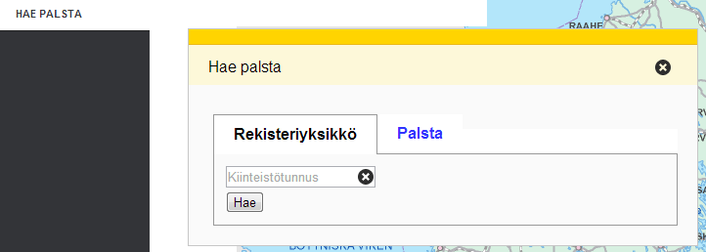

Bundle configuration
Does not require any configurations in application config.json.

Requests the bundle handles
This bundle doesn't handle any request.

Requests the bundle sends out
Request | Where/why
userinterface.AddExtensionRequest | Register as part of the UI in start()-method.
userinterface.RemoveExtensionRequest | Unregister from UI in stop()-method.

Events the bundle listens to
This bundle doesn't listen to any events.

Events the bundle sends out
Event | Why/when
Oskari.mapframework.bundle.parcelselector.event.ParcelSelectedEvent | Inform listener that parcel with the given fid is requested by the user.
Oskari.mapframework.bundle.parcelselector.event.RegisterUnitSelectedEvent | Inform listener that register unit with the given fid is requested by the user.

Dependencies
Dependency | Linked from | API | Purpose
jQuery | Expects jQuery already linked. | http://api.jquery.com | Used to create component UI from begin to end.
Oskari DivManager | Expects to be present in application setup. | DivManazerBundle | Needed for flyout/tile functionality.

