Name | Parcel
ID | parcel
API

Description
This bundle listens for events that provide feature ID (fid) for parcels or register units and loads the requested feature data. Features are shown on the map. Also, tools are provided to split the feature areas. Provides means to save feature data to server by using WFST. Also, uses ParcelInfo bundle to show area information.

Screenshot
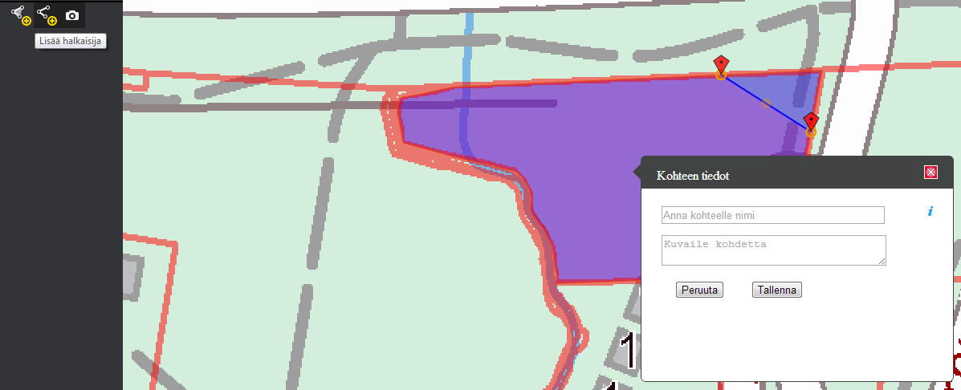

Bundle configuration
This bundle requires configurations in application config.json.
For example:
"parcel": {
"conf": {
"queryUrl": "https://ws.nls.fi/ktjkii/wfs/wfs",
"parcelFeatureType": "PalstanTietoja",
"registerUnitFeatureType": "RekisteriyksikonTietoja",
"hideSomeToolbarButtons": "hide",
"transactionUrl": "",
"proxyUrl": "proxy.cgi?url="
}
}

Above parameters are for:
- queryUrl - URL that is used for loading feature data
- parcelFeatureType - feature type that is used when parcels are requested for features
- registerUnitFeatureType - feature type that is used when register units are requested for features
- hideSomeToolbarButtons - hide means that hide some buttons of other bundles that may not be usefull for this bundel from toolbar. If this parameter is left out or 'false' it means that show all buttons of other bundles. For more specific implementation, see {Oskari.mapframework.bundle.parcel.handler.ButtonHandler} init -function.
- transactionUrl - URL that is used for WFST saving. If not defined, queryUrl is used for this. Notice, if queryUrl and transactionUrl differ WFST uses INSERT, otherwise UPDATE.
- proxyUrl - If set, OpenLayers uses this for proxy.

Requests the bundle handles
This bundle doesn't handle any request.

Requests the bundle sends out
Request | Where/why
Toolbar.AddToolButtonRequest | Adds tool buttons into toolbar for editing and saving.
Toolbar.RemoveToolButtonRequest | If configuration has defined that some tool buttons, that are irrelevant for this bundle, should be hidden. Notice, this affects to buttons that other bundles may want to show.
Toolbar.SelectToolButtonRequest | Ask toolbar to select specific button.

Events the bundle listens to
Event | How does the bundle react
ParcelSelector.ParcelSelectedEvent | Starts loading parcel of the given fid.
ParcelSelector.RegisterUnitSelectedEvent | Starts loading register unit of the given fid.
Toolbar.ToolSelectedEvent | Selects editing tool or starts saving feature.

Events the bundle sends out
Event | Why/when
Oskari.mapframework.bundle.parcel.event.ParcelInfoLayerRegisterEvent | Registers layer for ParcelInfo bundle that shows information about the selected or modified feature of the registered layer.
Oskari.mapframework.bundle.parcel.event.ParcelInfoLayerUnregisterEvent | Unregister registered layer from the ParcelInfo bundle.

Dependencies
Dependency | Linked from | API | Purpose
jQuery | Expects jQuery already linked. | http://api.jquery.com | Used to create component UI from begin to end.
Oskari mapmodule | Expects to be present in application setup. | mapmodule | To register plugin to map/gain control to Openlayers map.
OpenLayers | Expects OpenLayers already linked. | http://openlayers.org | To control map.

