lens
Standard Operating Procedure

SOP ID | eb9fd54f-47ae-42bc-a624-9d2e95a5a309
Process Level | L3
Process Hierarchy | Auto-created placeholder Level 0 → Auto-created placeholder Level 1 → Auto-created placeholder Level 2 → lens
Owner | Oskar-Emil Ipsen (oskaripsen@yahoo.dk)
Last Updated | 2026-01-24

1. Purpose
The purpose of this process is to efficiently manage and organize document handling by copying, renaming, compressing, and relocating files to a designated folder. This ensures that documents are systematically archived and easily accessible in a compressed format, optimizing storage space and retrieval efficiency. Team members responsible for document management rely on this process to maintain an orderly and streamlined digital filing system. Successful completion results in the document being securely stored as a compressed file in the appropriate folder, ready for future use or reference.

2. Scope
This SOP applies to the L3 process: lens
Parent process (L2): Auto-created placeholder Level 2
Parent process (L1): Auto-created placeholder Level 1
Parent process (L0): Auto-created placeholder Level 0

3. Roles & Responsibilities
Role | Steps Performed
TBD | 1, 2, 3, 4

4. Systems Used
System | Used In Steps
TBD | 1, 2, 3, 4

5. Detailed Procedure
The following steps describe the end-to-end workflow.

Step 1 — Copy document
Role: TBD (TBD)
System: TBD
Manual / Automated: Manual

Description:
Upon receiving the necessary input from the preceding task, the responsible party initiates the process of duplicating the relevant document. This step is crucial as it ensures that a working copy of the document is available for further modifications, thereby preserving the integrity of the original file. The action is triggered by the completion of the prior task, which involves preparing the document for subsequent processing. The output of this step is a duplicate document, which is then ready for renaming in the following phase. This step involves a handoff to the next role, ensuring a seamless transition to the subsequent task in the workflow.
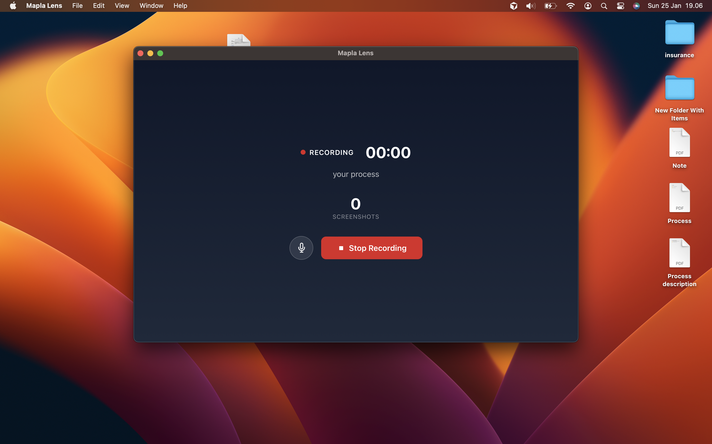

→ Next: Step 2

Step 2 — Rename document to SOP6
Role: TBD (TBD)
System: TBD
Manual / Automated: Manual

Description:
Upon completion of the document duplication, the next step involves updating the document's title to reflect its new designation as SOP6. This process is essential to ensure that the document is easily identifiable and aligns with the organization's standard operating procedures. Triggered by the successful copying of the document, this step facilitates the transition to the subsequent phase, where the document will be prepared for compression. The renaming process ensures a seamless handoff to the next responsible party, maintaining continuity and clarity in document management.


→ Next: Step 3

Step 3 — Compress document
Role: TBD (TBD)
System: TBD
Manual / Automated: Manual

Description:
Upon completion of the document renaming process, the next step involves preparing the document for efficient storage and transfer by reducing its size. This process is essential to optimize storage space and facilitate quicker data handling in subsequent operations. Triggered by the successful renaming of the document, this step involves utilizing an appropriate system to compress the document into a zip file format. The outcome of this step is a compressed file, which is then ready for relocation to the designated compressed data folder. The responsibility for executing this step and the specific system to be used will be determined, ensuring a seamless transition to the next phase of the workflow.


→ Next: Step 4

Step 4 — Move zip file to compressed data folder
Role: TBD (TBD)
System: TBD
Manual / Automated: Manual

Description:
Upon successful compression of the document, the next step involves transferring the resulting zip file into the designated folder for compressed data. This step is crucial for maintaining organized storage and ensuring that all compressed files are readily accessible for subsequent actions. Triggered by the completion of the document compression, this process step facilitates the seamless transition to the finalization phase by ensuring that the compressed file is correctly positioned for further processing. The role responsible for executing this step will be determined, as will the system used to perform the transfer. This step ensures that the compressed data is systematically archived, enabling efficient retrieval and completion of the overall process.


→ Next: End

6. Records & Documentation Requirements
Process End States:
• Complete process

7. Appendix
Additional materials and references:

[Appendix materials will be added here]

