lens
Standard Operating Procedure

SOP ID | eb9fd54f-47ae-42bc-a624-9d2e95a5a309
Process Level | L3
Process Hierarchy | Auto-created placeholder Level 0 → Auto-created placeholder Level 1 → Auto-created placeholder Level 2 → lens
Owner | Oskar-Emil Ipsen (oskaripsen@yahoo.dk)
Last Updated | 2026-01-24

1. Purpose
The purpose of this process is to efficiently capture, organize, and preserve information by creating and formatting notes within the Notes app. This process supports the organization’s need for systematic documentation and easy retrieval of important text-based information. Individuals who rely on accurate and well-organized notes, such as team members or project managers, depend on its correct execution. Successful completion results in a neatly formatted and saved note that is readily accessible for future reference or action.

2. Scope
This SOP applies to the L3 process: lens
Parent process (L2): Auto-created placeholder Level 2
Parent process (L1): Auto-created placeholder Level 1
Parent process (L0): Auto-created placeholder Level 0

3. Roles & Responsibilities
Role | Steps Performed
TBD | 1, 2, 3, 4, 5, 6

4. Systems Used
System | Used In Steps
Notes | 1, 2, 3, 4, 5, 6

5. Detailed Procedure
The following steps describe the end-to-end workflow.

Step 1 — Open Notes app
Role: TBD (TBD)
System: Notes
Manual / Automated: Manual

Description:
The user initiates the process by accessing the Notes application. This step is intended to prepare the system for creating and managing notes. It is triggered by the need to document information and results in the application being ready for note creation. The handoff to the next step involves the user proceeding to create a new note.
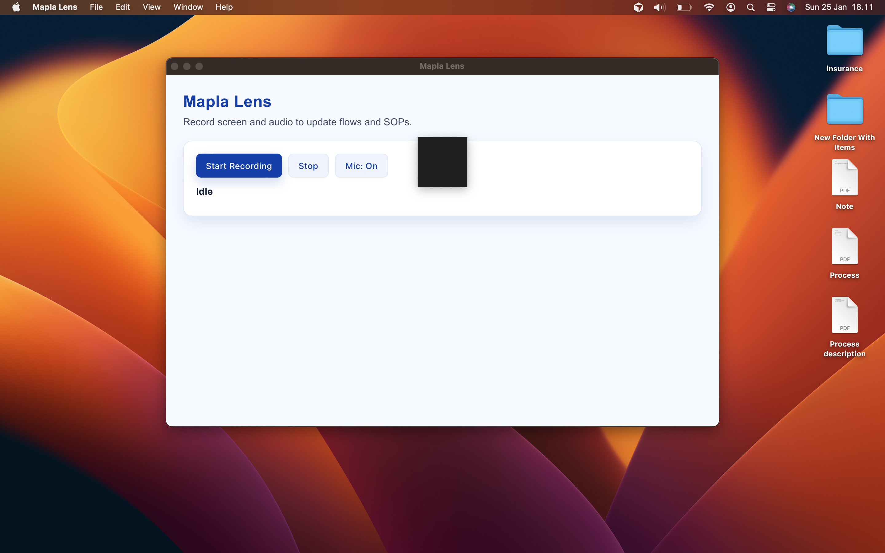

→ Next: Step 2

Step 2 — Create new note
Role: TBD (TBD)
System: Notes
Manual / Automated: Manual

Description:
The user creates a new note within the Notes application. This step aims to provide a blank canvas for entering information. It is triggered by the user's need to document new information and results in a new note being available for content entry. The handoff to the next step involves the user copying text into the newly created note.
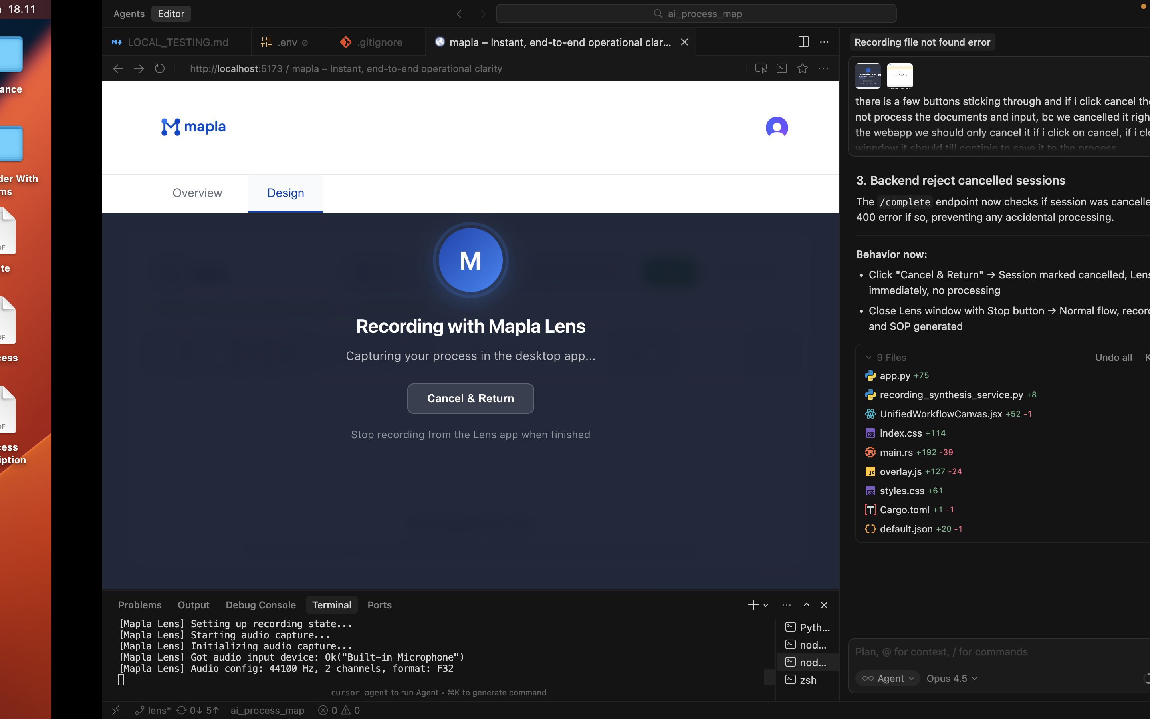

→ Next: Step 3

Step 3 — Copy text into note
Role: TBD (TBD)
System: Notes
Manual / Automated: Manual

Description:
The user copies the required text into the newly created note. This step is intended to transfer information from an external source into the note. It is triggered by the availability of content to be documented and results in the note containing the desired text. The handoff to the next step involves the user formatting the note content.
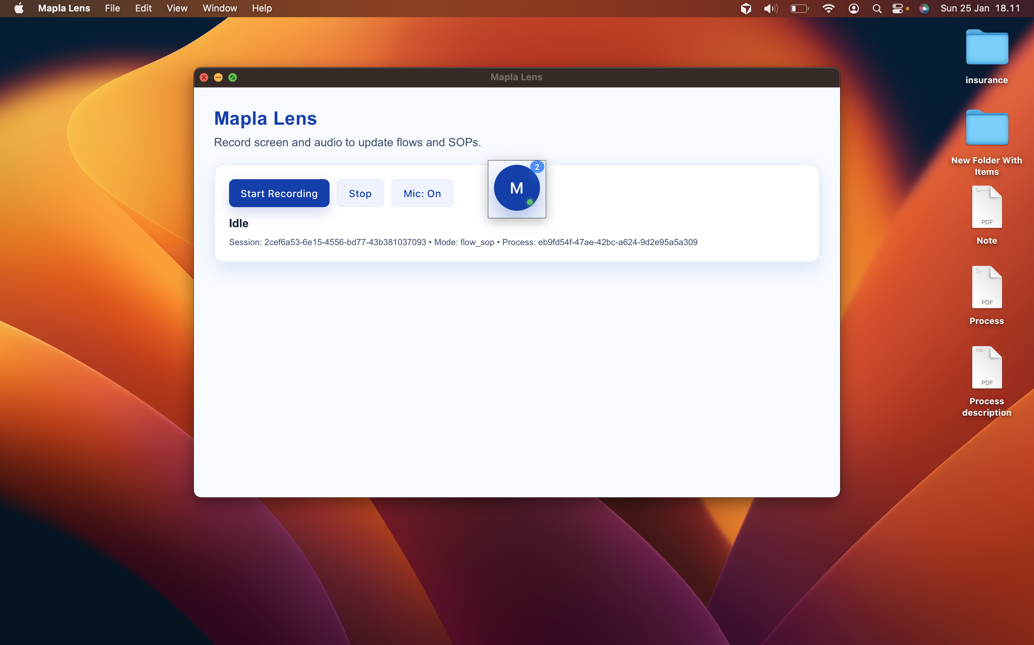

→ Next: Step 4

Step 4 — Format note content
Role: TBD (TBD)
System: Notes
Manual / Automated: Manual

Description:
The user formats the content within the note to enhance readability and organization. This step is intended to ensure that the information is presented clearly and is easy to navigate. It is triggered by the completion of text entry and results in a well-structured note. The handoff to the next step involves saving the formatted note.
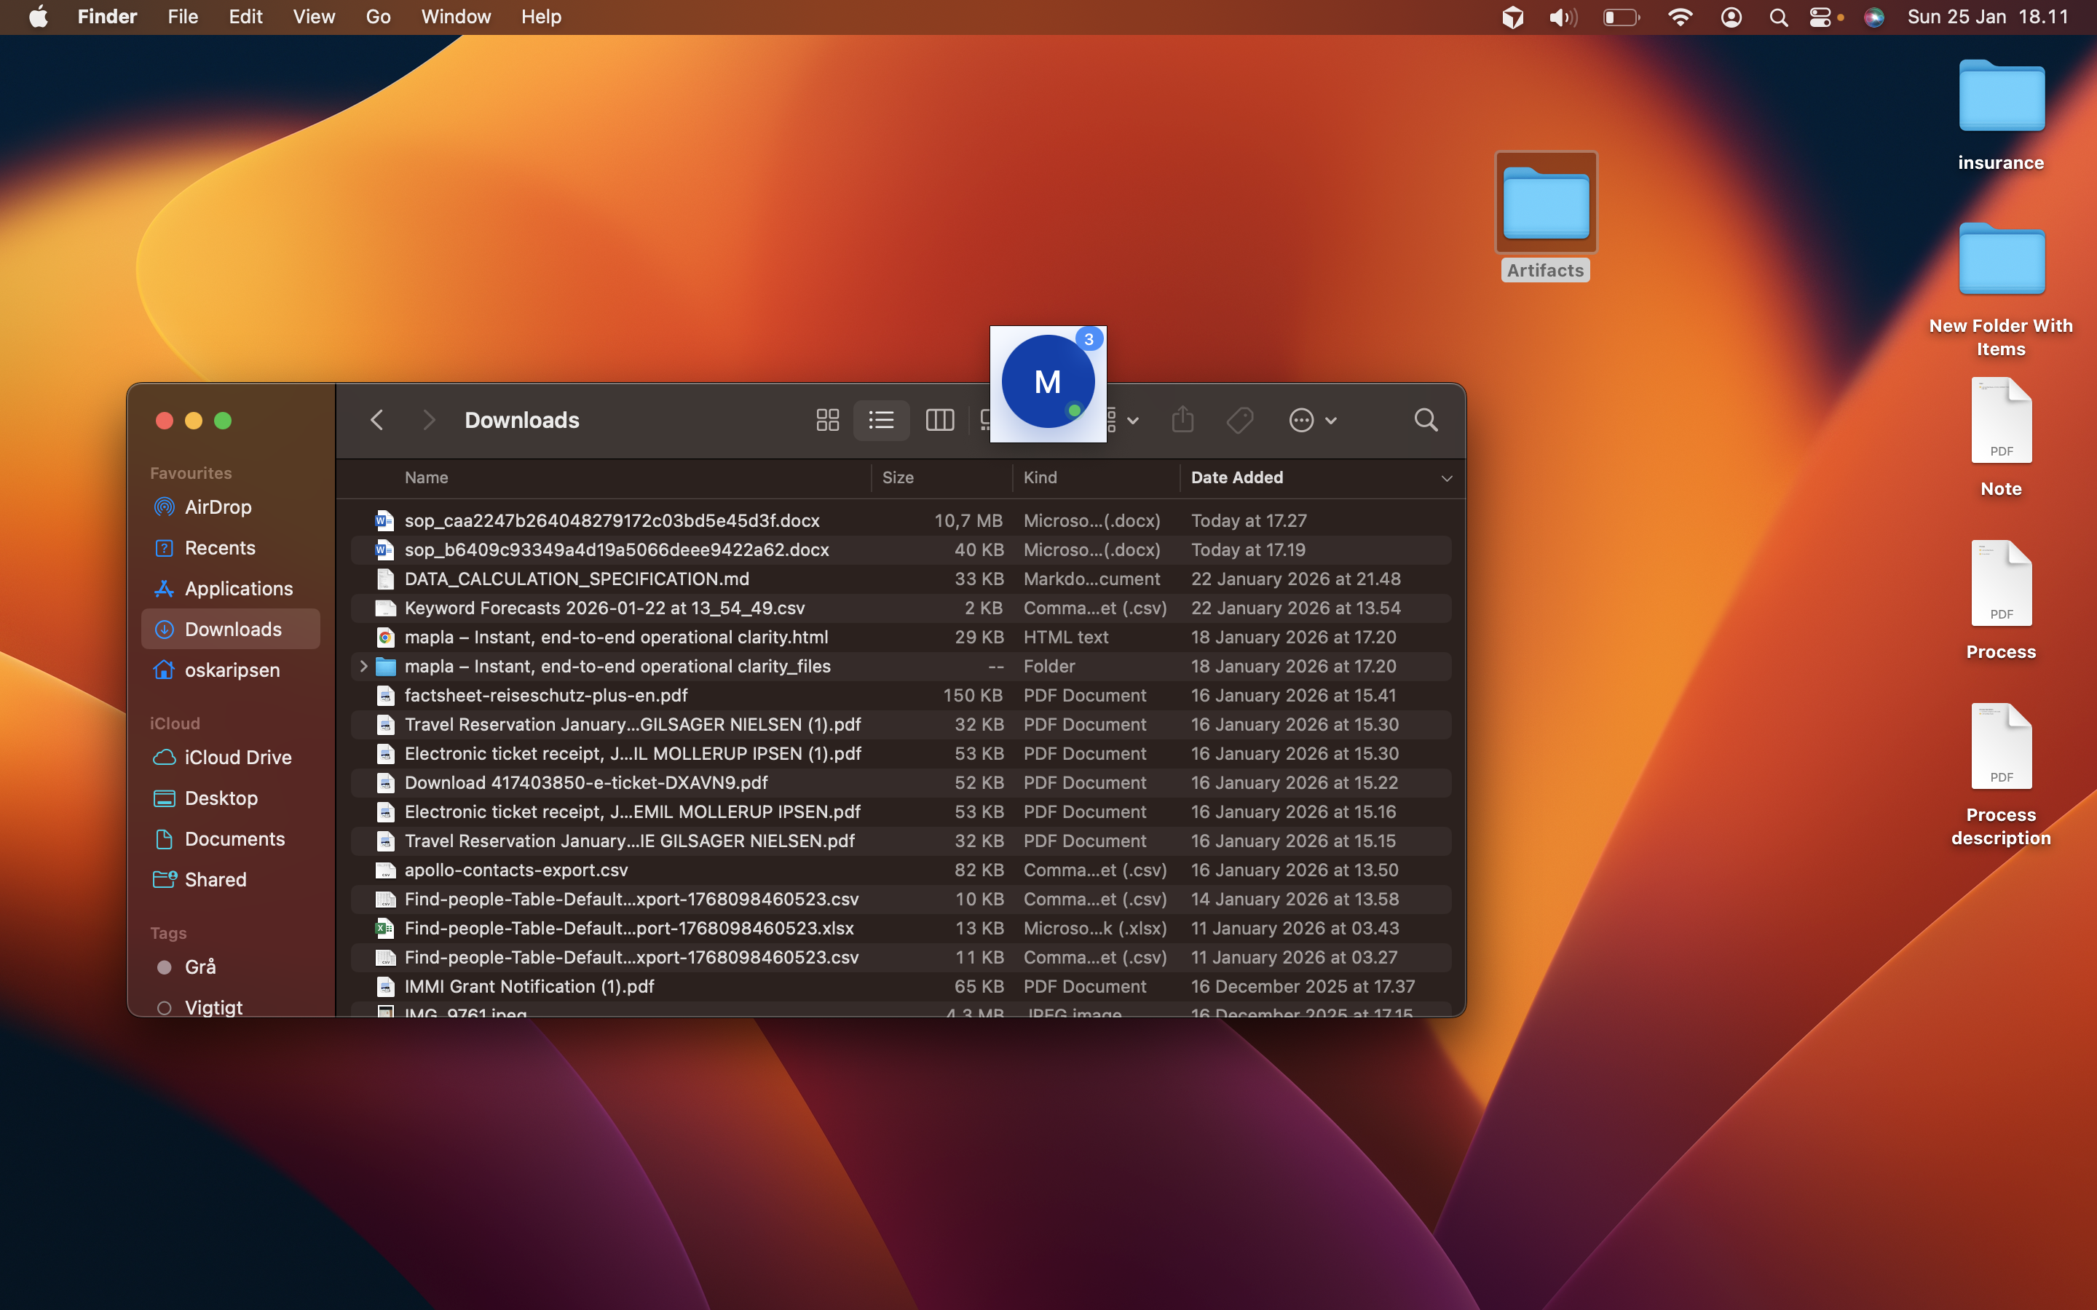

→ Next: Step 5

Step 5 — Save note
Role: TBD (TBD)
System: Notes
Manual / Automated: Manual

Description:
The user saves the note to ensure that all changes are preserved. This step is intended to finalize the documentation process by securing the information within the system. It is triggered by the completion of formatting and results in the note being stored in the application. The handoff to the next step involves closing the Notes application.
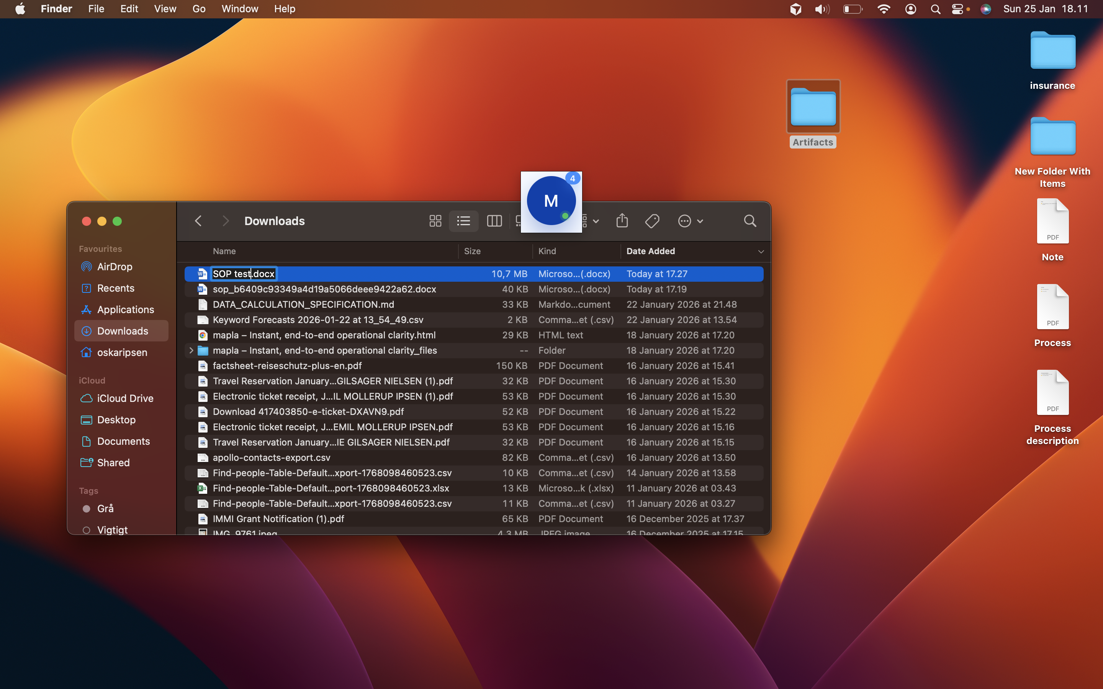

→ Next: Step 6

Step 6 — Close Notes app
Role: TBD (TBD)
System: Notes
Manual / Automated: Manual

Description:
The user closes the Notes application to complete the process. This step is intended to conclude the session and ensure that the application is not left open unnecessarily. It is triggered by the successful saving of the note and results in the application being closed. There is no further handoff as this marks the end of the process.
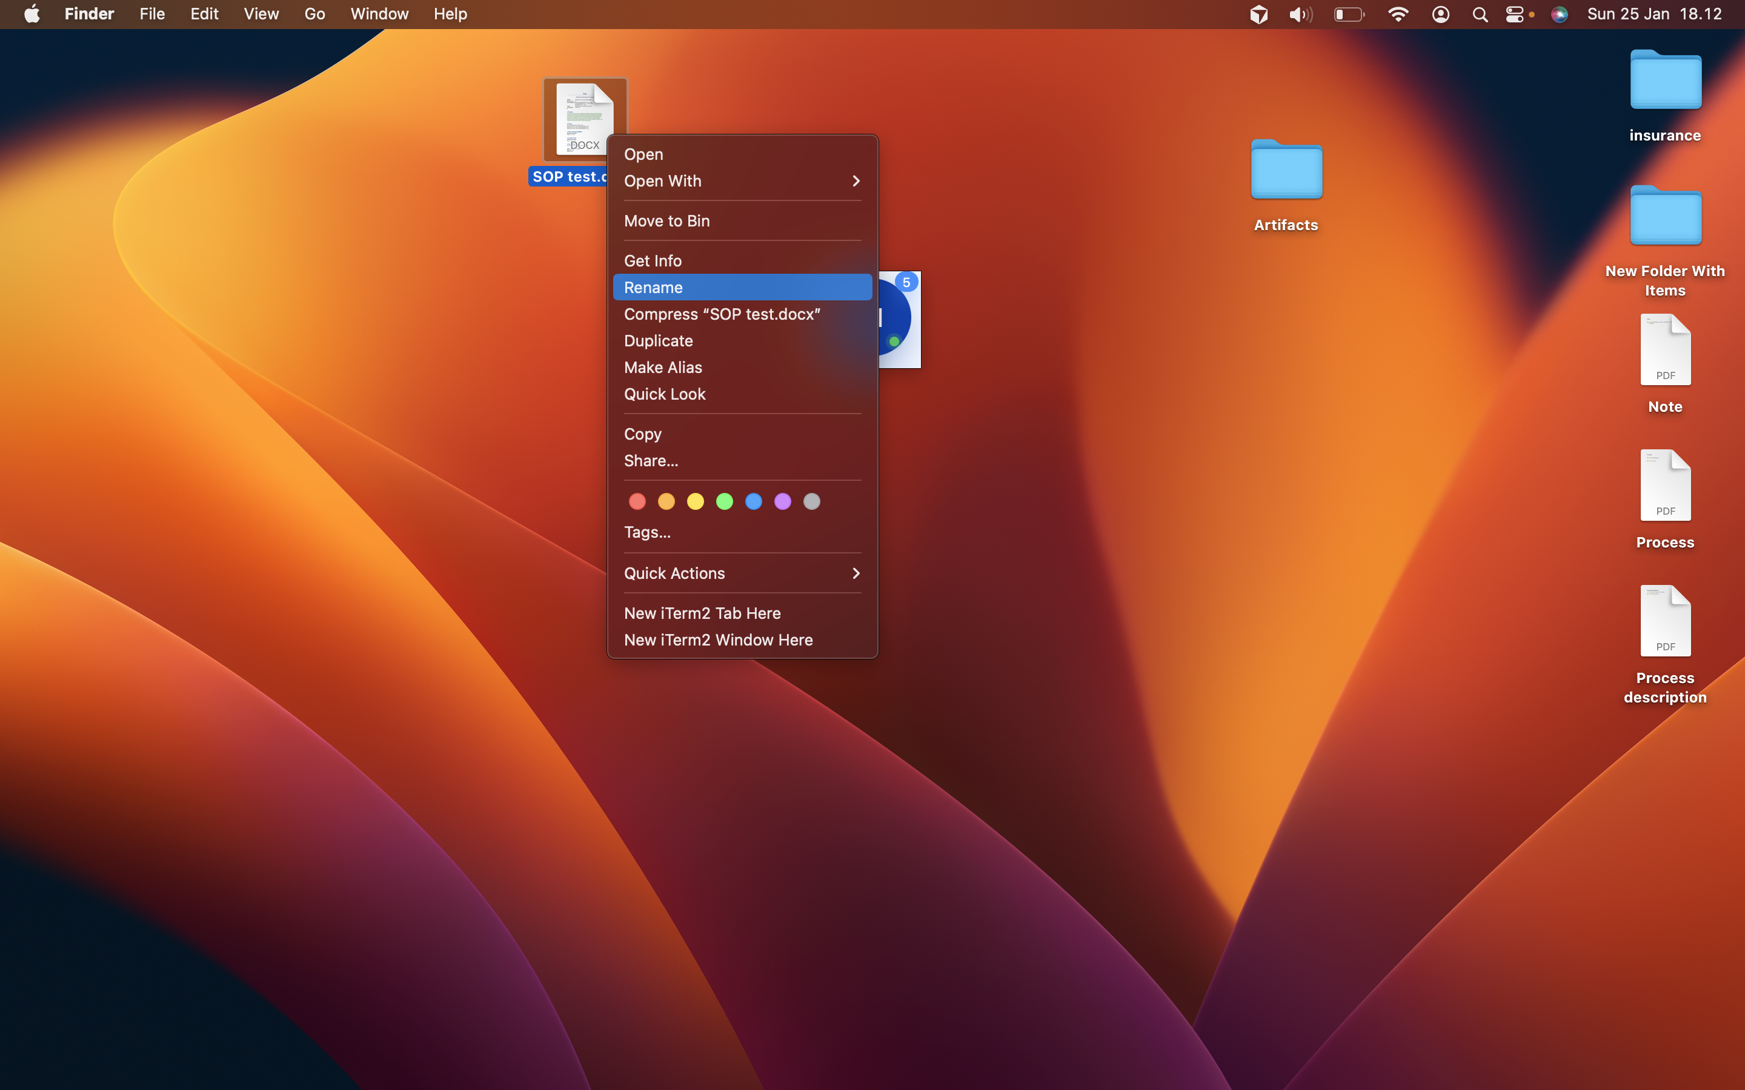

6. Records & Documentation Requirements
No specific end states defined.

7. Appendix
Additional materials and references:

[Appendix materials will be added here]

