lens
Standard Operating Procedure

SOP ID | eb9fd54f-47ae-42bc-a624-9d2e95a5a309
Process Level | L3
Process Hierarchy | Auto-created placeholder Level 0 → Auto-created placeholder Level 1 → Auto-created placeholder Level 2 → lens
Owner | Oskar-Emil Ipsen (oskaripsen@yahoo.dk)
Last Updated | 2026-01-24

1. Purpose
The purpose of this process is to facilitate the creation, formatting, and saving of notes within the Notes app, ensuring that important information is accurately documented and easily retrievable. This process is performed to maintain organized and well-structured notes, which are essential for effective communication and record-keeping within the organization. Individuals who rely on these notes for reference or decision-making depend on the process being completed correctly. Successful completion results in a well-formatted, saved note that is ready for future access and use.

2. Scope
This SOP applies to the L3 process: lens
Parent process (L2): Auto-created placeholder Level 2
Parent process (L1): Auto-created placeholder Level 1
Parent process (L0): Auto-created placeholder Level 0

3. Roles & Responsibilities
Role | Steps Performed
TBD | 1, 2, 3, 4, 5, 6

4. Systems Used
System | Used In Steps
Notes | 1, 2, 3, 4, 5, 6

5. Detailed Procedure
The following steps describe the end-to-end workflow.

Step 1 — Open Notes app
Role: TBD (TBD)
System: Notes
Manual / Automated: Manual

Description:
The process begins with the user accessing the Notes application. This step is initiated when there is a need to document information or ideas. The purpose is to prepare the application for note creation, ensuring that the user is ready to input new content. Once the application is open, the process moves to creating a new note.
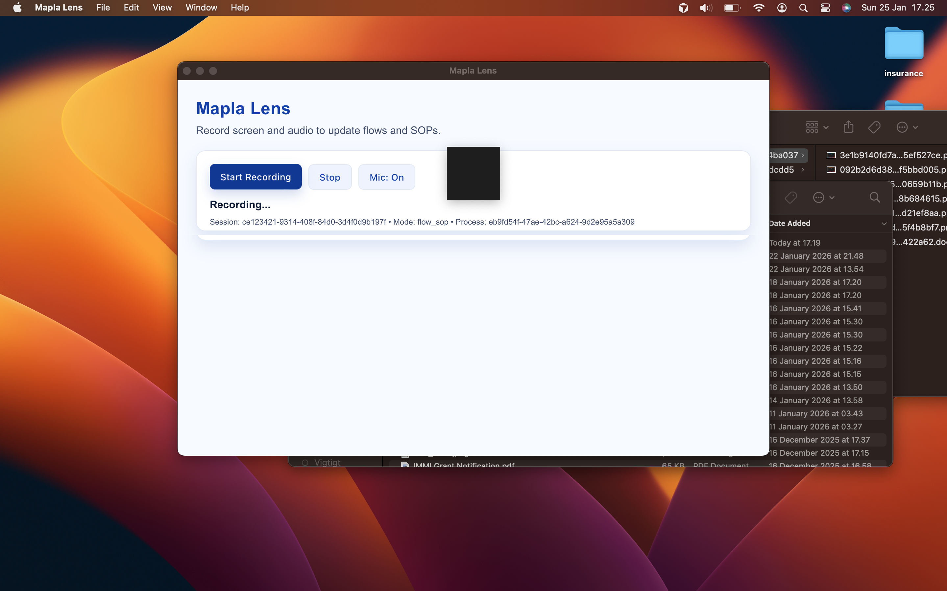

→ Next: Step 2

Step 2 — Create new note
Role: TBD (TBD)
System: Notes
Manual / Automated: Manual

Description:
In this step, the user initiates the creation of a new note within the Notes application. This action is triggered by the user's need to document specific information. The intent is to provide a blank canvas for content entry. Upon creation, the user proceeds to write content in the note.
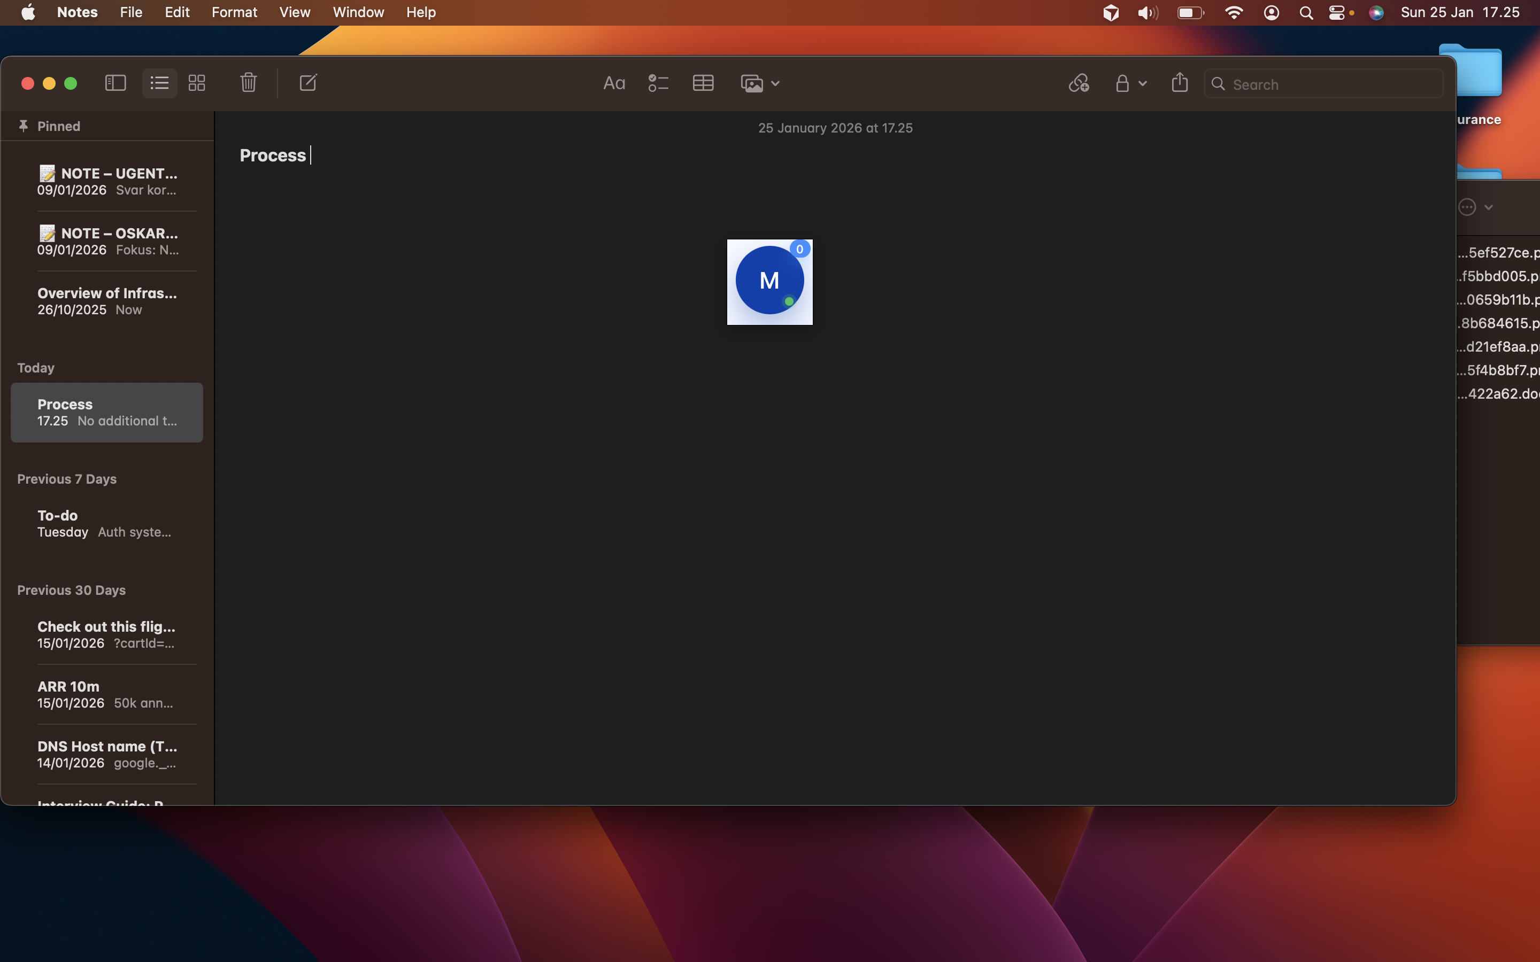

→ Next: Step 3

Step 3 — Write content in note
Role: TBD (TBD)
System: Notes
Manual / Automated: Manual

Description:
The user enters the necessary content into the newly created note. This step is driven by the need to capture relevant information accurately. The purpose is to ensure that all required details are documented. After content entry, the process advances to formatting the note.
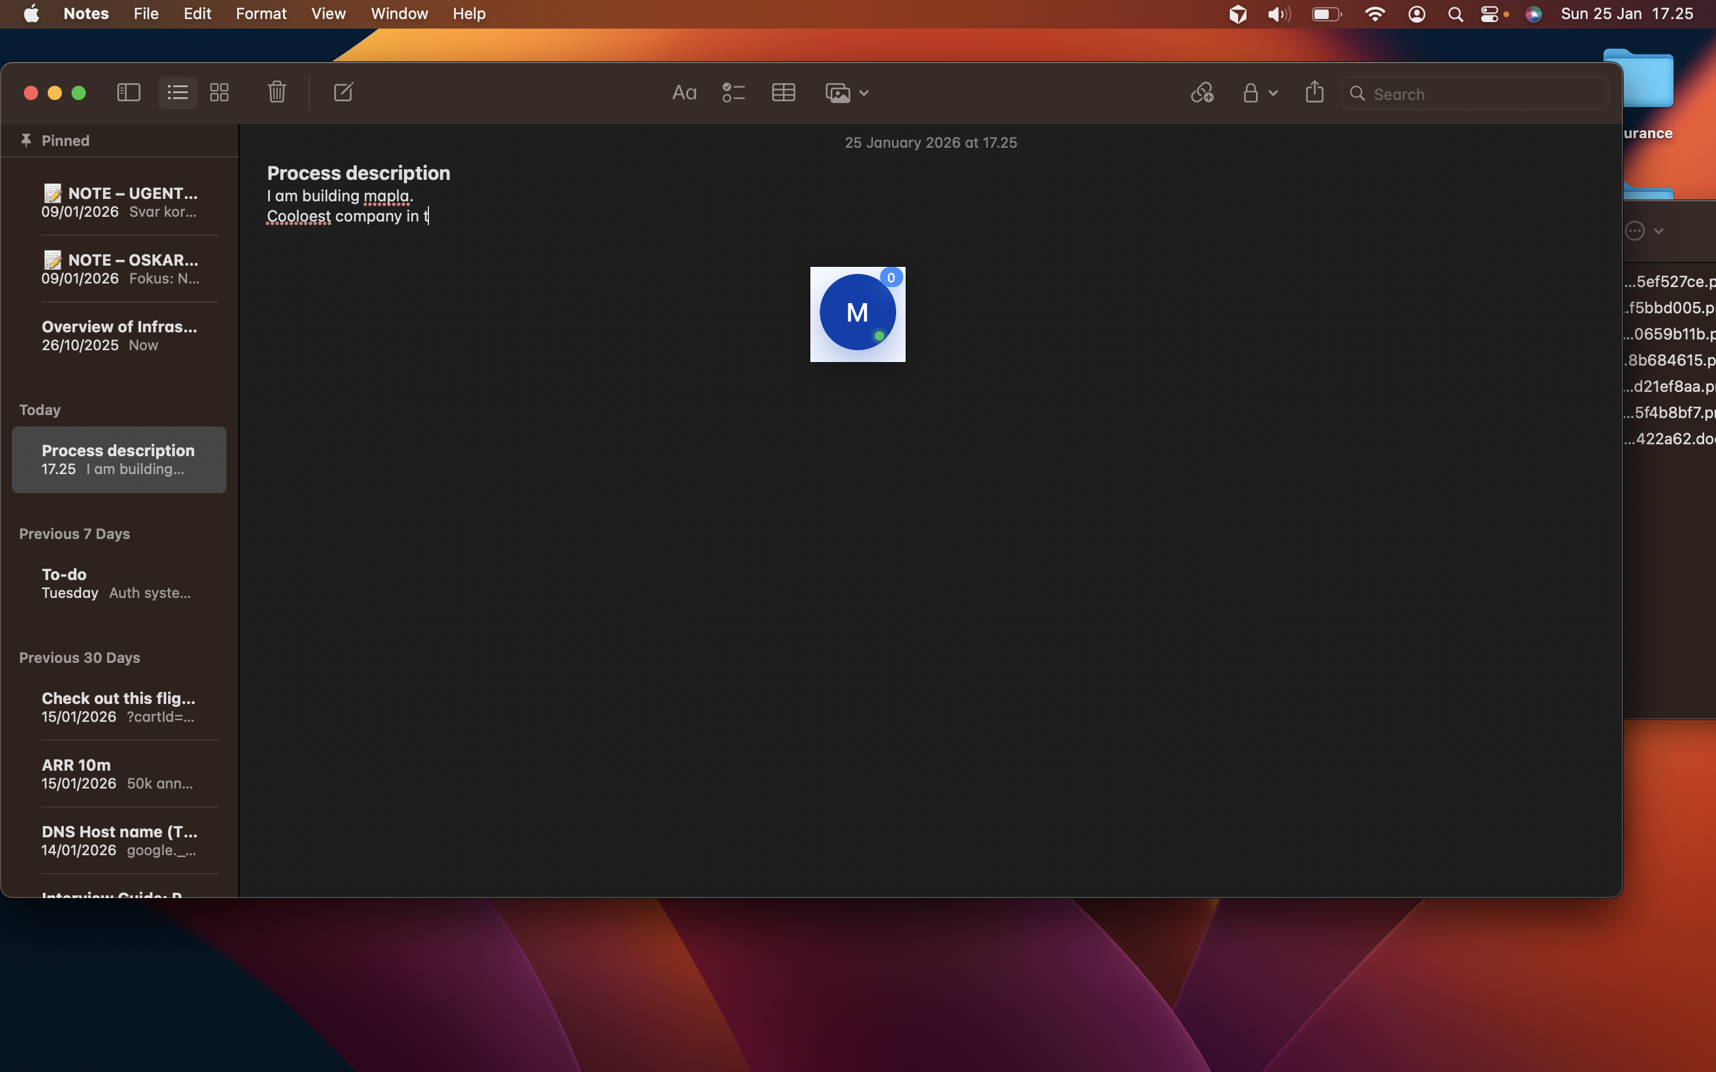

→ Next: Step 4

Step 4 — Format note
Role: TBD (TBD)
System: Notes
Manual / Automated: Manual

Description:
The user formats the note to enhance readability and organization. This step is initiated after content entry and aims to structure the information clearly. Formatting may include adjusting text styles or organizing sections. Once formatting is complete, the note is ready to be saved.
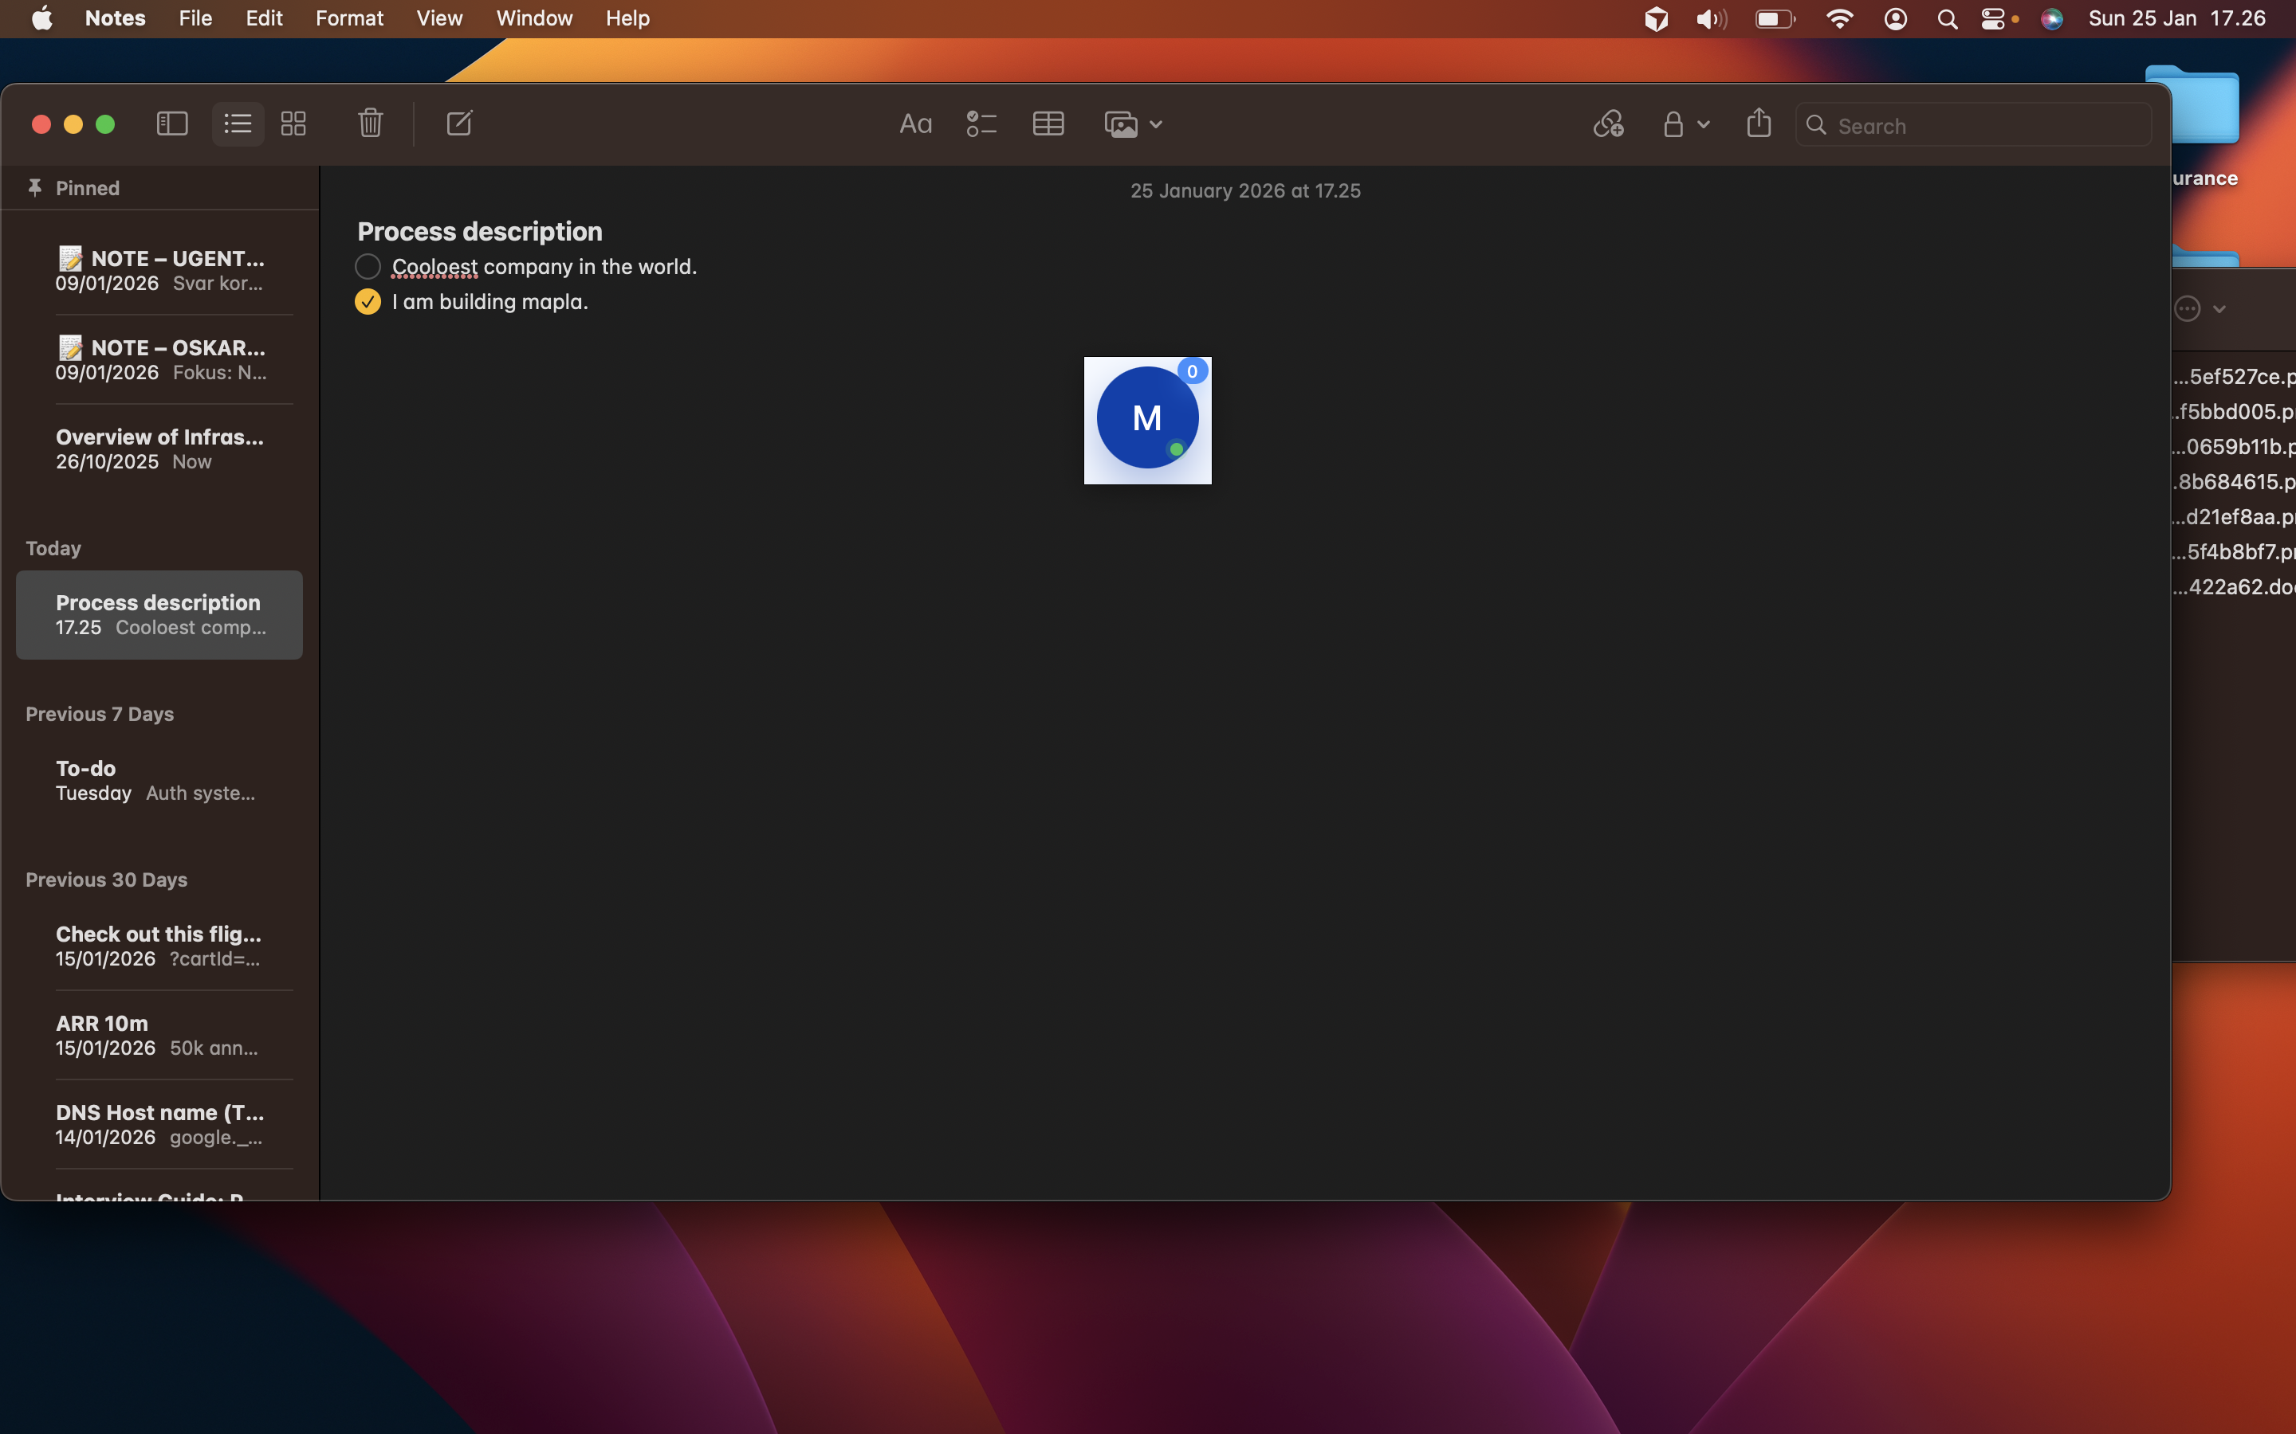

→ Next: Step 5

Step 5 — Save note
Role: TBD (TBD)
System: Notes
Manual / Automated: Manual

Description:
The user saves the formatted note to ensure that all content and changes are securely stored. This step is crucial for preserving the information and is triggered after formatting is finalized. Saving the note prepares it for future retrieval or sharing. The process then concludes with closing the Notes application.
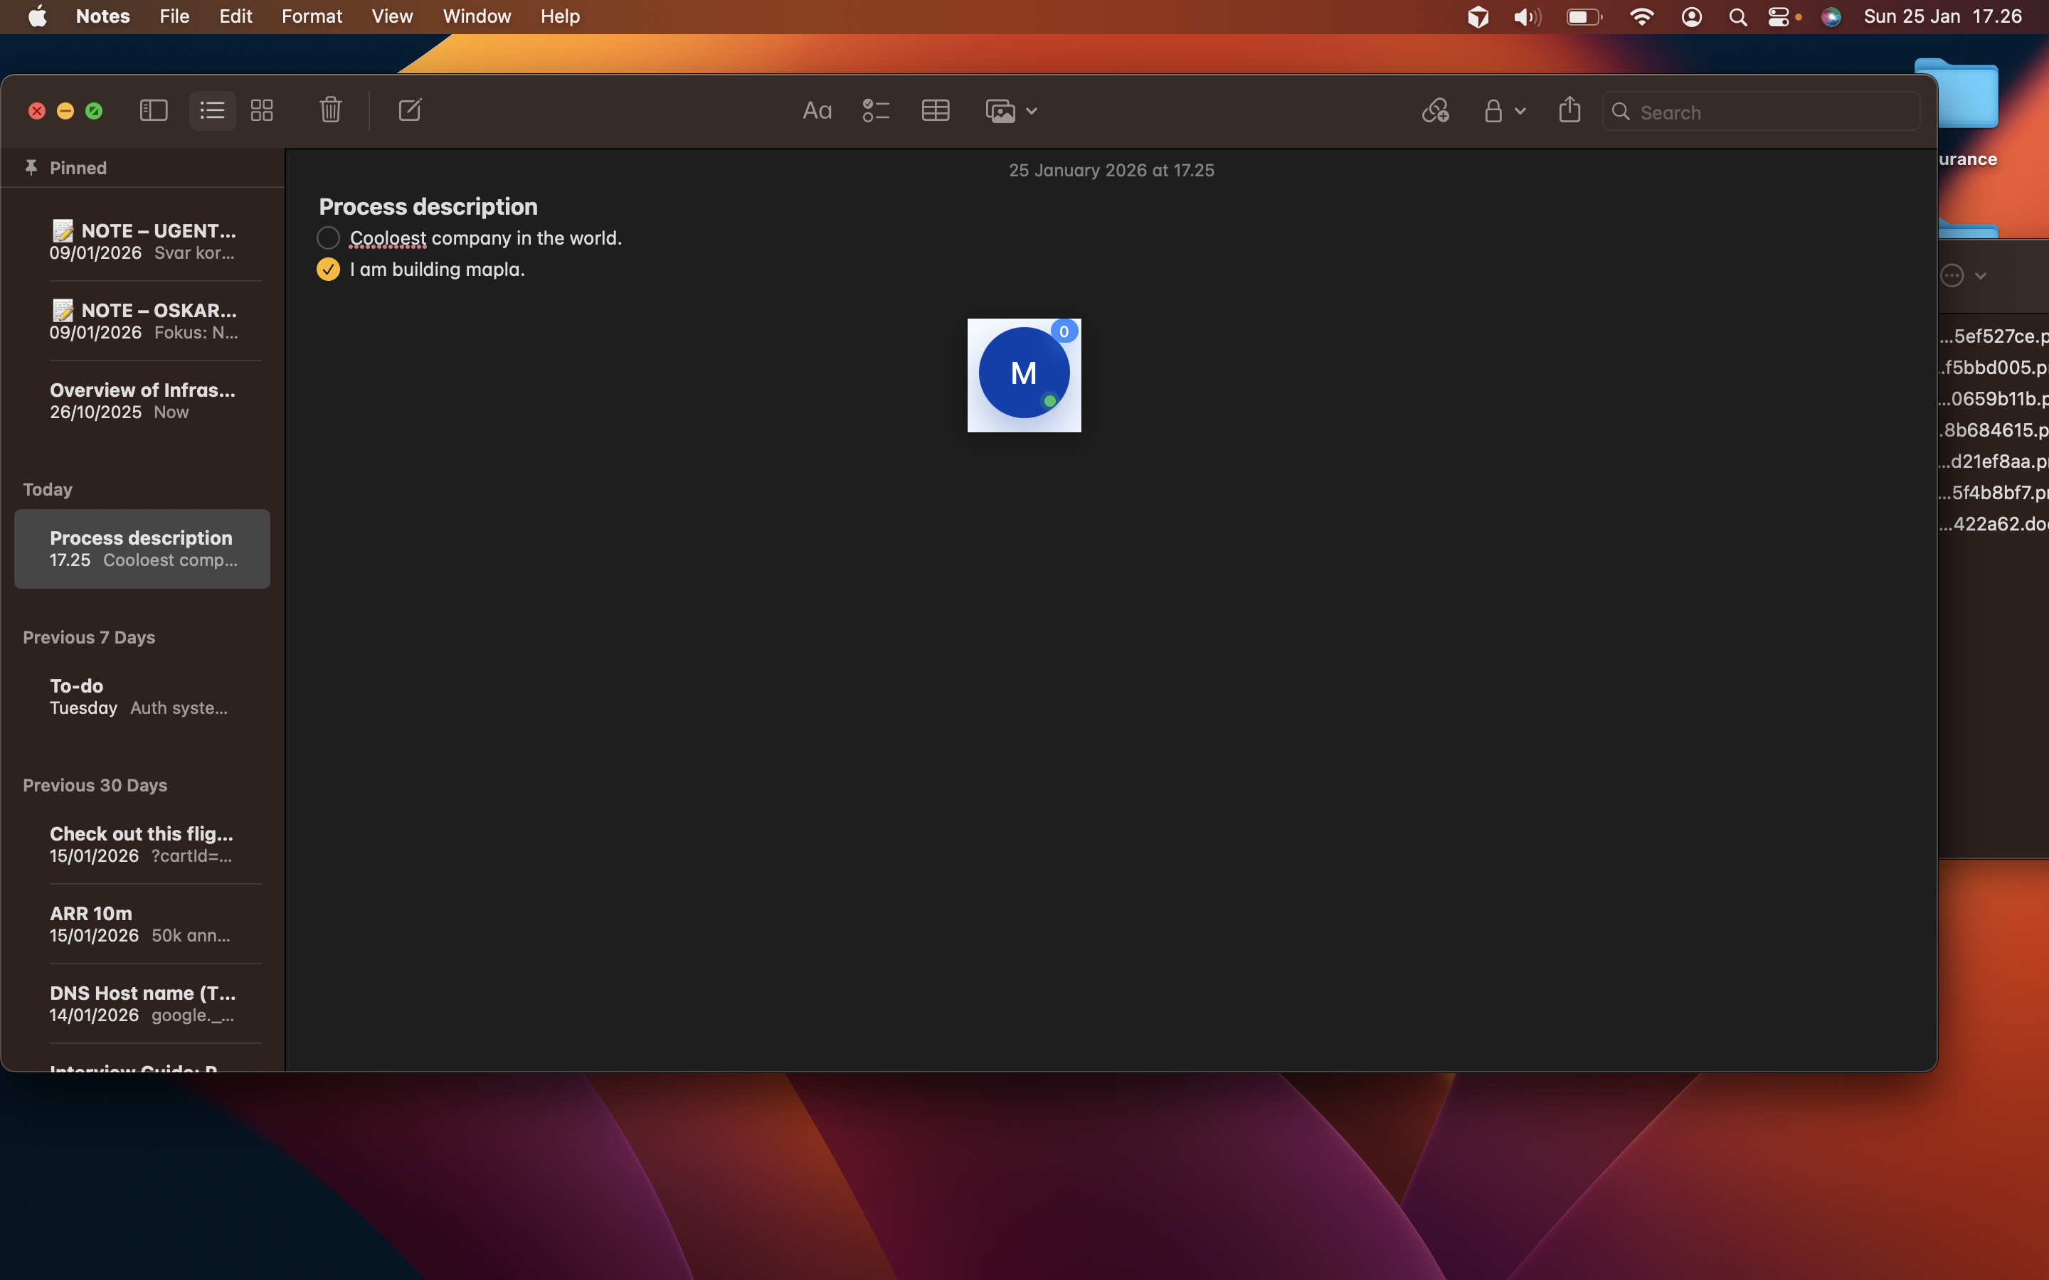

→ Next: Step 6

Step 6 — Close Notes app
Role: TBD (TBD)
System: Notes
Manual / Automated: Manual

Description:
The user closes the Notes application, marking the end of the note-taking process. This step is triggered once the note is saved and ensures that the application is properly exited. Closing the application finalizes the process and prepares the system for future use.
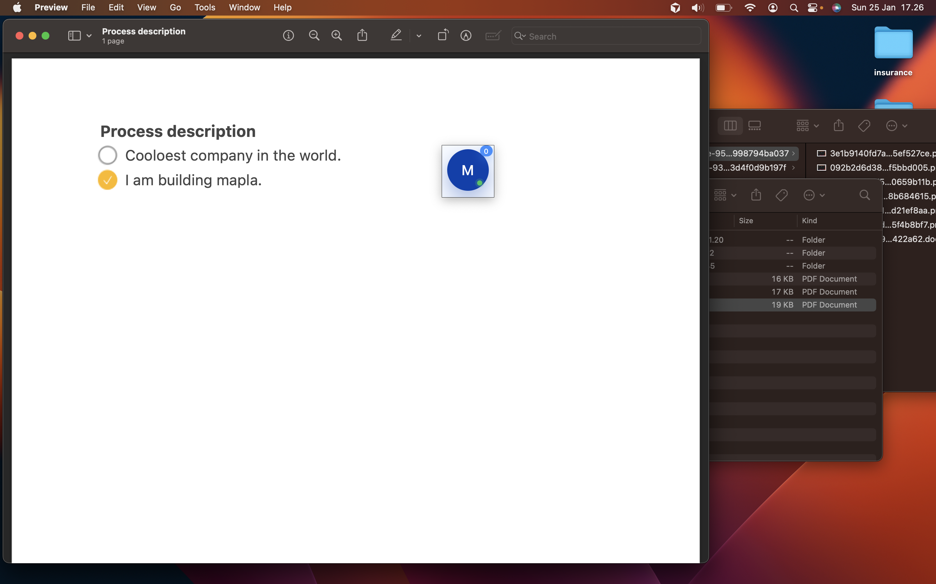

6. Records & Documentation Requirements
No specific end states defined.

7. Appendix
Additional materials and references:

[Appendix materials will be added here]

