CALL-project: Developing a native language specific grammar corrector

Celia Medina Gimenez
Business Information Technology
University of Twente
Enschede, The Netherlands
c.medinagimenez@student.utwente.nl
Oskar Piibar
Business Information Technology
University of Twente
Enschede, The Netherlands
o.j.piibar@student.utwente.nl
Pietro Calliari
Business Information Technology
University of Twente
Enschede, The Netherlands
p.calliari@student.utwente.nl
Rahul Nanduri
Business Information Technology
University of Twente
Enschede, The Netherlands
r.s.s.nanduri@student.utwente.nl

Defined Goal

Before taking any actions regarding the data or coding, it is important to define the criteria for a successful or unsuccessful project. In this section, the goals for the project are defined.

The main goal of this project is to develop a language correction model, like Grammarly, grammar corrector for Microsoft Word or Google Docs. However, the difference is that the language correction model takes into account the native language of the speaker and provides a model trained specifically for them. This means that the provided correction for a similar mistake might differ, depending on the native language of the user. However, we are not building a language correction model from scratch as we do not have the computational power for it. We are taking an already existing model and altering it, so it could provide a personalized correction for a group of native language speakers.

A secondary goal of our project is to apply the model. For that a simple website will be built, where the user can choose between a few languages and depending on the language selection, a specific model will be provided. The model will then correct the inputted sentence and ideally mark the made errors.

Motivation
The relevance of the project, contribution to the module and the taught subjects are discussed in this section.
The amount of English as a Second Language (ESL) speakers is already bigger than the number of native English speakers [1]. All of the members of our group are also part of the ESL speakers. It was found that the grammatical error correction (GEC) models do a better job at correcting English as a Second Language (ESL) text when using a corpora written by learners of ESL, rather than a native English corpora [2]. This is due to the fact that the errors made by non-native English speakers are mostly systematic and can be traced back to the habits they have from their first language [2].
Building a GEC model that takes into account ESL corpora requires knowledge in different areas, which are mostly part of our module. It requires knowledge about machine learning for data types (ML4DT) to alter existing GEC models to our needs. The data for training the model needs to be preprocessed according to the principles of data quality. Each project that deals with input from a human needs to consider ethical risks and respective mitigations. The model and its functioning is necessary to be understood by humans, which integrates explainable artificial intelligence into this project. Lastly, the model needs to be used outside of the command line, which requires web development skills and integration of the previously acquired knowledge.

Ethical Perspective and Framework Application
A natural language processing task inherently brings risk to violating conventional ethics. Collecting data from online forums without obtaining explicit consent from users can infringe on privacy rights and violate data protection laws like GDPR. Furthermore, the dataset may contain biases if certain native languages are overrepresented, leading to unfair or less accurate corrections for speakers of underrepresented languages. The model could consequently inadvertently reinforce negative stereotypes by associating specific grammatical errors with particular language groups, potentially stigmatizing users when we attach it to our web application. Without transparency about how data is collected and used, users may lose trust in the system, especially if they are unaware of the ways their data contributes to the model, and there is the significant risk that technology could be misused in discrimination or unfair profiling of non-native speakers based on their language patterns. However, acquiring this data source from a publicly available forum, anonymizing the data and being stringent in not enforcing bias, this is alleviated.
During our data manipulation process, we were attentive to several ethical aspects to ensure our project met high standards of integrity. Starting with a dataset of 80,000 entries containing users' native language, language proficiency, and written text, we took steps to protect user privacy and adhere to ethical guidelines regarding human subject data [3]. This involved removing special characters, emoticons, sentences shorter than three sentences, empty text entries, and non-English sentences, thereby anonymizing the data as much as possible and eliminating potentially sensitive information. This also allowed us to level the playing field for over-represented and under-represented languages by volume.
We recognized the potential for bias in our dataset [4]. We selected the two languages with the most data—Spanish, and Chinese (Mandarin). This allows us to get a broad overview of the types of grammatical mistakes made by non-native English speakers. However, we were conscious that focusing on these languages alone might overrepresent certain groups. To address this, we documented our data sources and preprocessing steps thoroughly to maintain transparency and allow for scrutiny of our methods.
Moreover, we employed methods such as part-of-speech (POS) tagging and error frequency analysis to understand and classify error patterns without attributing them to inherent deficiencies in any language group, thus avoiding the reinforcement of negative stereotypes [5]. Our extraction methods—based on relative frequencies, error-prone POS-tag sequences, and error positions—were designed to enhance the model's ability to provide accurate corrections and helpful feedback, ensuring fairness and inclusivity in our approach.

Method
In the following section we will discuss our planning, the data, steps we took during data preprocessing and the algorithms used.

Planning
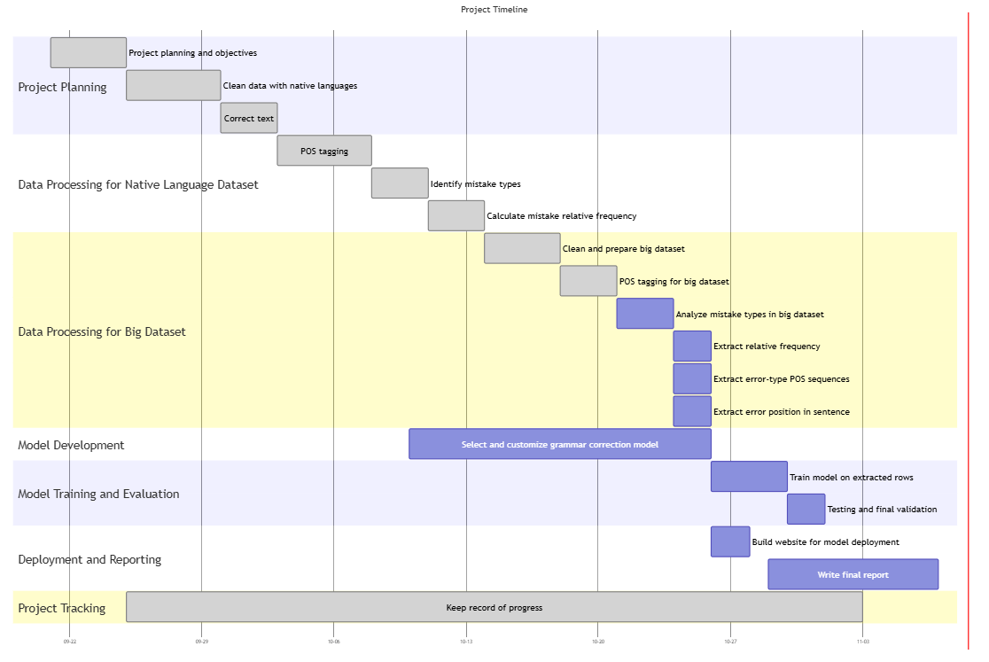
- Gantt chart of grammar correction model development.
In the figure above, Fig. 1, a Gantt chart of the project has been displayed. The first major phase after the project planning consists of the data preprocessing of both a native language specific dataset and a larger general dataset. For both, the subtasks are similar except for the text correction which is only necessary for the language specific dataset. Overlapping with the actions on the datasets is the tailoring of a native-specific language correction model. Once both of those phases are complete, the model is trained with the extracted rows. Then, it’s tested and validated. The final phase involves creating a website for the model’s deployment and writing the report.

Data Manipulation
Our initial native language specific dataset consisted of 80 thousand rows, where the native language, their language proficiency and written text were included. For the data preprocessing all special characters, emoticons, sentences shorter than 3 words, empty text entries and non-English sentences were removed. These steps were taken, to exclude noisy data, remove sentences, such as “Hi there”, “I’m Alex”, etc., which do not provide us with valuable information, even if mistakes are made in these types of sentences and to only include sentences useful for an English language correction model. Afterwards, the data was filtered based on the native language of the writer. We selected two languages, Spanish and Chinese (Mandarin), which had the most rows, to get a broad overview of the types of mistakes. We corrected these text entries using a grammar correction found from Huggingface [6]. Following that, we ran a part-of-speech (POS) tagging algorithm on both the incorrect and correct text, which assigns each word with a tag, like ‘PRON’ for pronoun or ‘ADJ’ for adjective. Running it on both text columns allowed us to compare the POS-tags and determine the mistake types of the sentences. Following that we counted the errors, which was necessary for a relative frequency calculation. From here onwards we used three different methods to extract rows, which will be in detail described in the technical depth section, from a bigger dataset to later use for the training of our different models.
The given dataset was too small and included very arbitrary conversations. Training a language correction model on that dataset would not have yielded good results. Therefore we needed a bigger dataset, that consisted of two columns, the text and its correction, which we found from Lang-8 Learner Corpora [7]. This dataset contained a large variety of sentences from people of many different nations learning mainly English and Japanese. We eliminated every non-English sentence and some tags present in the corrected sentences. We believe that these tags symbolized the type mistake and a respectful correction made. To be certain, we emailed the creator of the dataset, but he was uncertain of what these tags represented. As a result we cannot be confident about their interpretation and have decided to eliminate these tags to avoid unwanted noise. Similarly to the smaller dataset, we also ran a POS-tagging algorithm, classified the errors and counted them. Now both of the datasets were ready for row extractions.

Model
Building a model from the scratch, specifically for our needs is computationally too demanding and not feasible with the available options. Therefore, we decided on an approach where we fine tune an existing model built for natural language processing. Looking at existing models, primarily explored pretrained models like BERT, T5, and GECToR, which are suitable for grammar correction. BERT’s contextual understanding, T5’s versatility, and GECToR’s specialization in grammatical error correction made them ideal choices. BERT, being an encoder-only model, is proficient in understanding text but lacks the capability to generate corrected sentences, which is essential for our application [8]. GECToR, while tailored for grammatical error correction using an edit-based approach, is limited in producing comprehensive corrections and providing explanatory hints to learners [8]. We ultimately selected T5, an encoder-decoder model, because it excels in both understanding and generating text. Its text-to-text framework effectively handles the sequence-to-sequence nature of grammatical corrections. Training T5 on our dataset gives us the perfect sweet-spot between natural language processing for understanding, training and testing [8]. Within T5, there are several ‘classes’ of model robustness to choose from. We chose the t5-base model specifically because it strikes a balance between performance and computational efficiency, providing robust capabilities without the prohibitive computational costs associated with larger T5 variants [8]. In the Technical Depth section, we will analyze the functioning of the model and its settings.

Technical Depth
In this section we will go deeper into the data extraction methods and discuss the working of our model.

Data Extraction
We performed data extraction from the bigger file in three different ways. Firstly, we extracted the rows from the bigger dataset based on the relative frequencies of the mistakes. This was a chosen method because it matches the error types per language and provides a good representation of the mistakes made by a specific language speaker. If the frequency was matched at a 90% confidence interval, then the correct and incorrect text of that entry were saved separately and classified suitable to train a specific language model. Analyzing relative error frequencies lets us identify systematic mistakes that could come from speaking specific native languages, which differentiates the models to specific language groups from each other and improves its capability to adapt [1].
Secondly, we used the most error prone POS-tag sequences to extract the rows. This method located where the error was and took the two adjacent POS-tags and saved this sequence with a count. We then extracted 4 highest count sequences for each language and if the specific sequence was matched with the same sequence in the big dataset, then it extracted the row with a respective native language tag. This approach was chosen because error-prone sequences are language-specific, allowing us to target and extract rows that reflect recurring structural patterns and common mistakes unique to each language group.
Lastly, we used error positions to extract rows from the big dataset. For this approach, we identified the section where a mistake occurred: if within the first or last 20%, it was categorized as "beginning" or "end," respectively, while errors in the middle 60% were classified as "middle”. Later rows were extracted from the big dataset where the errors were made in similar places. This approach was chosen to enhance model robustness - errors at the beginning or end require focused, localized corrections, while mid-sentence errors demand an understanding of the entire sentence context. So, adding the error positions makes the model handle error patterns better, making the corrections more accurate taking context into account [4].

Model Analysis
For starters we chose the T5-base model because it has a moderate number of parameters (220 million) and layers (12), instead of T5-small that has a lot less parameters (80 million) and layers (6) or T5-large that has too many parameters (770 million) and layers (24) [9]. This way we can complete our task without having to spend too much time and computational power that we, even though we used the university servers for this project, do not have.
For the correct training of the model we uploaded the tailor-made dataset for the specific learner native language that we wanted to correct in a pandas data frame. For T5-base to work we needed to make two specific modifications to this data frame: firstly, we needed to have an input and target column, so we changed the name of the columns accordingly, secondly, we needed to add at the beginning of each input row the tag “grammar: “. This is done because T5 models can perform multiple tasks like translation, using “translate English to Dutch: “ for example, and summarization, using "summarize: ", with a single model, and the unique prefix is used for each task so that the model knows which task to perform [10]. We then proceed to split the data frame for training and evaluation.
For training we used HappyTextToText from the happytransformers library because it is built on Hugging Face Transformers, it is very efficient with T5 models and outputs clear evaluations metrics [10]. We used a batch size of 4, as it was the largest number before encountering memory issues, we reduced the max input and output length to 32, the few sentences longer than this were truncated, and used only one epoch for not having too long training times. At the end of the training we saved each model using pickle for then being able to use it to generate corrections on the web app.

Web Application
To showcase our grammar correction model, we created a web application with an interactive interface where users can select their native language, input text, receive the grammatical corrections for it, and see the analysis of their mistakes. The frontend was built with HTML, CSS, and JavaScript. For the backend, the model was connected with Flask to handle requests from the frontend, process them through the model (the model is selected based on the selected native language), and return the results. The input text was sent from the frontend to the backend using API calls. After the model processes the text, the corrected output is returned and displayed on the web page along with the mistake analysis.
The mistake analysis consists of a display of each of the corrections (either if it’s a deletion, insertion or change of words), the relative frequency of the found error types and their position in the text.

Results
In the following section we will discuss the results of our native language specific correction models.
The evaluation shows clear results of a steady decrease for both training and validation loss. This indicates that the model is learning effectively, although after the initial big drop, there is a major decrease of the learning rate Fig. 2. We can also notice the loss plateauing from the half point on showing that it has reached its limits. We tried with different data quality techniques on the input data and we made some slight changes in the training arguments and our best results are shown in the figure below Fig. 2.
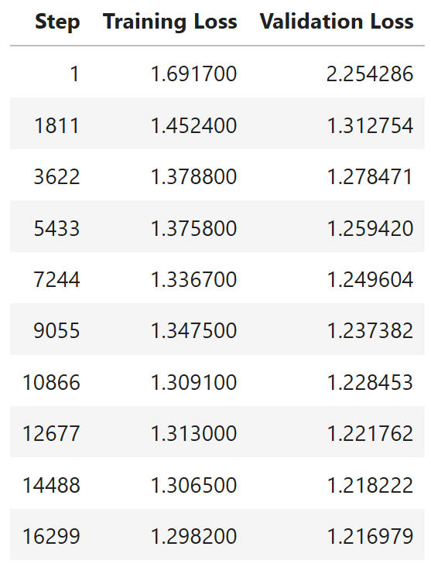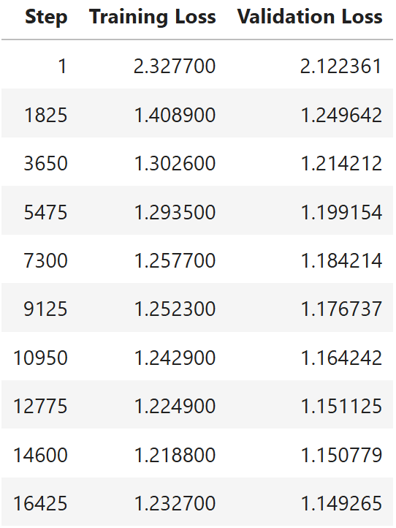
- Training loss and validation loss for Spanish (left) and Chinese (right) models.
Both models have reached very good results with having no overfitting or underfitting issues and are capable of correcting sentences with grammatical errors. To prove the working abilities of our two trained models, we will discuss some examples in the paragraphs below.
While testing our models with some incorrect sentences we found a specific one, where depending on the chosen model, Spanish or Chinese (Mandarin), the output sentence differed. The inputted sentence is: “On hot day the ice cream makes us delightful very much!!”, which was corrected to “On hot days the ice cream makes us very happy!” for the Spanish native language-based model and “On hot days the ice cream makes us very delightful!” for Chinese (Mandarin). One potential reason for this type of behavior is that in the dataset, which we trained our Spanish model on had many usages of happy and it decided to use that instead of delightful. Another reasoning for this type of behavior is that the model can at times “hallucinate”, which refers to nonsensical or unfaithful content with regards to the provided source content [11]. An example of this would be that for the same input the model generates two different outputs of which one is correct and the other incorrect. However, our models were trained on different data, which decreases chances of the potential “hallucination” of our models. In addition, neither of the outputs from our models were necessarily incorrect, as the mistakes were corrected and the message, even with different wording, remained the same.
We then tried to feed both models some longer sentences than we tested them with in our presentation. Each of these inputs contained multiple errors. The idea was to give the models entries, which contain a lot of mistakes, to determine if the models would get overwhelmed and struggle with fixing some easy mistakes, when in large quantities. Secondly, we wanted to determine, how often does it occur, that the corrections generated by our models differ, for the same input sentence. The sentences and their respectful corrections are displayed in Table 1 below.

- Spanish and Chinese models’ correction ability
Incorrect | Spanish model correction | Chinese model correction
The students was happy on their trip to the zoo, they seen lots of animal's and learn many new facts, which was very exciting for all of them | The students were happy on their trip to the zoo, they saw lots of animals and learned many new things, which was very exciting for all of them. | The students were happy on their trip to the zoo, they saw lots of animals and learned many new facts, which was very exciting for all of them.
She don't like watching movie's late at night, because it make her feel tire and unable to sleep good | She doesn't like watching movies late at night, because it makes her feel tired and unable to sleep well. | She doesn't like watching movies late at night, because it makes her feel tire and unable to sleep well.
Their is many reasons why the dogs chases their tails, including boredom and exercise which helps them stay fit and it keeps them busy | There are many reasons why the dogs chase their tails, including boredom and exercise which helps them stay fit and it keeps them busy. | There are many reasons why the dogs chase their tails, including boredom and exercise which helps them stay fit and it keeps them busy.
Each of the childrens in the class are bringing there own lunches and they has to bring drink too otherwise they gets thirsty | Each of the children in the class is bringing their own lunch and they have to bring drinks too otherwise they get thirsty. | Each of the children in the class is bringing their own lunches and they have to bring drinks too otherwise they get thirsty.
Both of our models performed well, being able to fix almost all the mistakes, as can be seen in Table 1 above. We have highlighted the mistakes in the incorrect column with yellow and highlighted the differences in corrections for the two models in green. The model trained on the Spanish corpora corrected all the mistakes, however as previously mentioned it sometimes changes some words. In the first entry the Spanish model changed the word “facts” to “things”. The Chinese (Mandarin) model did also well, fixing most of the mistakes, however being unable to detect two. In the second entry, the model did not correct “tire” into “tired” and in the fourth entry the “lunches” should have been changed to “lunch” as each child is bringing one lunch. Therefore, the models fix mistakes well, however sometimes struggle when the corrections require contextual background to be considered.

Conclusions
In conclusion, in this project we achieved our primary objective of developing a grammar correction model tailored for two specific groups of ESL learners, Spanish and Chinese. Through the adaptation of the T5 model we were able to provide specific corrections that follow the grammatical tendencies errors specific to Spanish and Chinese people. Training on different dataset built specially for this scope has revealed to be the key for our project. To gather the data necessary for each of these models, three data extraction methods were used: relative frequencies, error-prone POS-tag sequences and sentence error position tracking. Each of these metrics were calculated per language, from the smaller, language-specific dataset. When a similar metric was identified, at a specific confidence, from the bigger dataset, then the row was extracted to be later used for training a specific language model.
Our secondary objective, deploying and using the models from a web application was also a success. The web application has been an effective tool for testing our solutions, offering a real-world application of our models. Unlike command-line testing, the web app requires additional implementation to align more closely with typical machine learning (ML) model deployment.
Looking forward, this project has a lot of potential for expansion. Adding more native languages would result in being more inclusive and usable to a wider range of people in the future. In addition, a more detailed explanation can be given for the mistakes made. That could help the user to better understand why specific rules apply and potentially see patterns in the mistakes they make. Furthermore, the possibility of implementing a translation tool, given that the T5 model can face translation tasks, would be very interesting and useful for an ESL learner.
Overall, this project can be the foundation of a versatile, useful and user-friendly tool for ESL education.

Application of Module Components
This project provided an opportunity to apply concepts learned both in class as well as in the labs to a real-world task. The ML4DT module played a crucial role as we learned the fundamental skills for working with a ML model. The specific knowledge, mostly natural language processing (NLP) related, taught in the ML lectures and practicals, used in our project is the following: text tokenization, text lemmatization, regular expressions, POS-tagging - for text preprocessing, data manipulation and extraction; neural networks and nets, logistic regression, loss function, backwards propagation, learning algorithm, model saving - for model building, deployment and evaluation. These are the main taught elements of ML4DT subjects we used while working on our project.
For this project we tried to implement the XAI-Manifesto during all the stages of the project. Firstly, we tried to eliminate both positive and negative bias when creating the training datasets through cleaning processes. Secondly, in the web app the decisions made by the model are shown to attribute accountability and explainability of the outputted correct sentences from the model for both the user and us to understand and interpret the results. Finally, transparency on the internals by using a well-known and documented pretrained model, like T5, and explicating the training arguments beforehand in the code.
The data quality course provided us with the essential ideas and methods needed to make sure our dataset was appropriate for the grammar correction model's training. We focused on applying DQ concepts, such as error prevention and systematic data cleaning, to make our dataset accurate and consistent. This involved removing non-English sentences, eliminating duplicates, or fixing encoding errors and special characters, to mainly prevent model confusion and misinterpretation, and have an accurate representation of common errors. In this way, we used the fitness-for-use concept, allowing us to create a training data set to meet the specific needs of our model by filtering out low quality data and ensuring its relevance. Further application of XAI Concepts helped us solidify our choice of T5 as a grammar correction model since it has a high degree of explainability.
Additionally, we followed the course’s focus on improving data quality by, for instance, choosing an effective model for correcting the text to guarantee high data quality as some didn't fully meet the needs of our data set. For example, the Hassaanik model couldn't handle longer sentences and would cut them off. This made us change to the T5 model, which could process complete sentences and give more accurate corrections. By selecting a model that was suitable for our data, we ensured that our corrections were both reliable and consistent for training.

References
- Ronowicz, E., & Yallop, C. (2007). English : one language, different cultures. Continuum.
- Liu, Y. (2023). Grammatical Error Correction Incorporating First Language Information. Figshare. https://doi.org/10.25949/23897178.v1
- Metcalf, J., & Crawford, K. (2016). Where are human subjects in big data research? The emerging ethics divide. Big Data & Society, 3(1), 1–14. https://doi.org/10.1177/2053951716650211
- Bender, E. M., & Friedman, B. (2018). Data statements for natural language processing: Toward mitigating system bias and enabling better science. Transactions of the Association for Computational Linguistics, 6, 587–604. https://doi.org/10.1162/tacl_a_00041
- Hovy, D., & Spruit, S. L. (2016). The social impact of natural language processing. Proceedings of the 54th Annual Meeting of the Association for Computational Linguistics (ACL), 591–598. https://doi.org/10.18653/v1/P16-2096
- vennify/t5-base-grammar-correction · Hugging Face. (2024, February 6). Huggingface.co. https://huggingface.co/vennify/t5-base-grammar-correction
- NAIST Lang-8 Learner Corpora. (n.d.). Sites.google.com. https://sites.google.com/site/naistlang8corpora/
- Raffel, C., Shazeer, N., Roberts, A., Lee, K., Narang, S., Matena, M., Zhou, Y., Li, W., & Liu, P. J. (2020). Exploring the Limits of Transfer Learning with a Unified Text-to-Text Transformer. Journal of Machine Learning Research, 21(140), 1–67. https://jmlr.org/papers/v21/20-074.html
- google-t5 (T5 community). (2024, February 14). Huggingface.co. https://huggingface.co/google-t5
- Fine-Tune a Transformer Model for Grammar Correction. (2021, August 18). Vennify Inc. https://www.vennify.ai/fine-tune-grammar-correction/
- Ji, Z., Lee, N., Frieske, R., Yu, T., Su, D., Xu, Y., Ishii, E., Bang, Y., Madotto, A., & Fung, P. (2022). Survey of Hallucination in Natural Language Generation. ACM Computing Surveys, 55(12). https://doi.org/10.1145/3571730

