Real time systems Tutorial 1
- Write a list at least 4 of the types of intelligent system/embedded system that are within your experience. In particular, we are interested in knowing which devices contain a microprocessor. For each device, can you classify it as a Small, Medium, or Large scale embedded system?
- Elevator – Medium
Don’t need much processing power. It doesn’t need to be programmed in a high level-language. It should not need an operating system, but one would sure be helpful.
- Autopilot - Large
- Car engine control - Large
- Ticket control (at subway) - Small
- For each system, try and list the components it might contain. Consider the following:
    - How much processing power do you think it needs?
    - Does it need to be programmed in a high‐level language?
    - Does it require an operating system?
    - What is its power source, and (apart from cost), what were the main design constraints in its construction?
    - Does it require non‐volatile memory, if so roughly how much, and of what type?
    - How much volatile memory might it contain, and what type of memory is it?
    - What special IO does it need in the form of timers, input sensors and output actuators?
    - Is this a real‐time system (and if so, how 'hard' is it?)
- Spend a moment reflecting on whether the systems you have identified could be improved in any way from a users' perspective. Now ask yourself what type of technology would be needed to achieve this (in addition to what it already contains), and how much money that would add to the system cost. Note down the questions and your answers.
- Building upon the previous exercise, select one technology from your experience that does not currently contain an embedded/intelligent system (but might usefully contain one – as example room lighting, heating, cleaning system, fire alarm). Identify the following:
    - How the system could be improved by including an intelligent system.
    - The hardware and software requirements of such a system
- Cars approaching an intersection are counted by a magnetic loop detector in the road. The detector is 1.5 metres long, and produces a digital signal which is true while at least 0.5 m of a car's body is over the detector. If a stream of cars is passing through the intersection at 50 km per hour, the cars’ lengths are from 1.8 to 6 meters and the cars are about 15 meters apart:

Tutorial 4 STATECHARTS
- Draw the state chart for an LED class that can be in one of three modes: on, off and flashing at 1Hz.
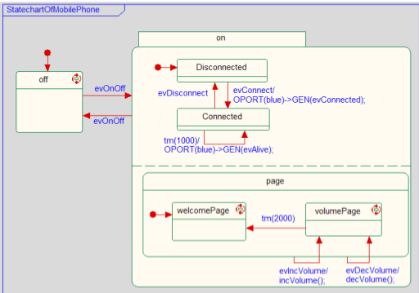
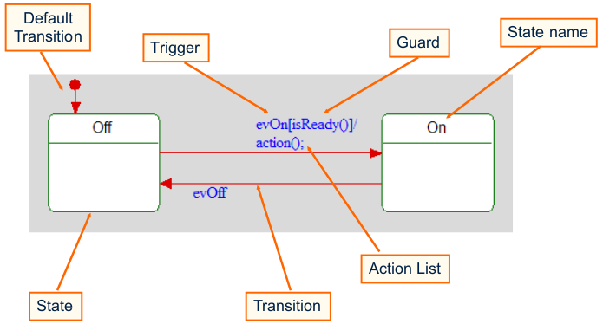

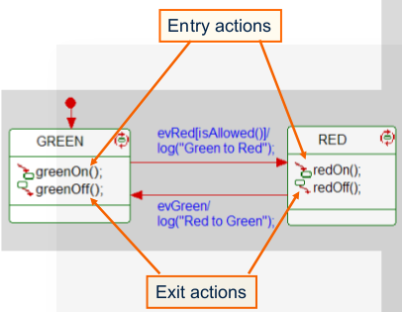

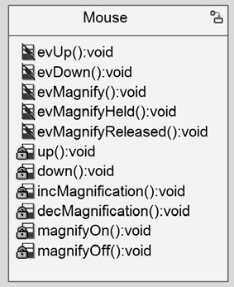
- Draw the state chart for the following mouse that has three extra buttons:
  - One of these buttons allows the Mouse to magnify the area around the mouse. This magnify mode is invoked and exited by pressing the magnify button (evMagnify).
  - When in the magnify mode, if the magnify button is held (evMagnifyHeld), then the up (evUp) and down (evDown) buttons control the magnification, invoking operations incMagnification() and decMagnification(). It remains in this mode until the magnify button is released (evMagnifyReleased).
  - When the magnify button is not held, the up (evUp) and down (evDown) buttons invoke operations up() and down().

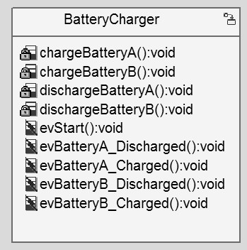
- Battery charger
  - Draw the state chart for a simple Battery Charger that can charge two batteries in parallel. The charger has three modes: idle, discharging, and charging.
  - A button can be pressed (evStart) to start charging the batteries.
However, before each battery can be charged, it must be discharged.
  - When each battery is discharged, it sends an event
(evBatteryA_Discharged or evBatteryB_Discharged) to the Battery Charger.
  - When each battery is charged, it sends an event (evBatteryA_Full or evBatteryB_Full) to the Battery Charger.
  - When both batteries are charged, the Battery Charger returns to the idle mode.

Tutorial 5 The following questions are taken from the class notes on Rhapsody real‐time UML
- Study the elevator state diagrams from elevator example in the notes and then:
  - Give the initial state of all the components when it is first powered up.
Car: Stopped, Direction: downwards, Door: closed, Button: unpressed, (Button visit(1): pressed)
  - When the elevator becomes idle after completing a series of requests, what is the state of all the components?
Car: Stopped, Direction: unknown (this depends on last operation), Door: closed, Button: unpressed
  - Are the above two sets of states the same and if not, why not?
The inital state is to go to floor 1 as it starts up. Direction is also unknown in case b).

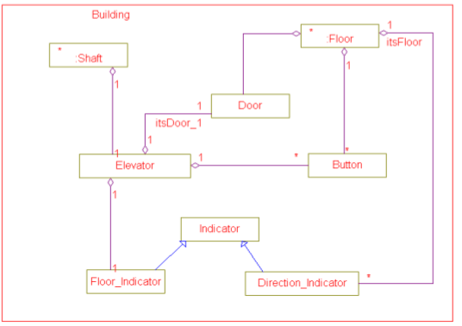
- An elevator system will have two elevators and eight floors. Each floor will have a couple of buttons to call the elevator. Each button has an indicator indicating that it has been pressed. Each elevator will have a button and corresponding indicator for each floor.
  - Draw the class diagram.

- MP3 player: Draw a use case diagram for an MP3 player:
  - The MP3 player must play both MP3 and WMA formats initially. It must be possible to support other future formats.
  - The user must be able to connect the player through a USB connection to a PC in order to upgrade the software through the Internet and to download music files.
  - The user must be able to browse the music on the player and select the music by artist, album, or track.
  - The user must be able to stop, start, pause, fast forward, fast reverse, select next and previous tracks, and so on.
  - The player should show the name of the artist and title for the current track.
  - The player must play continuously for at least eight hours without a battery change. To save battery life, the player switches off one minute after the music stops.
- Describe the difference between activity diagrams and state machine diagrams.
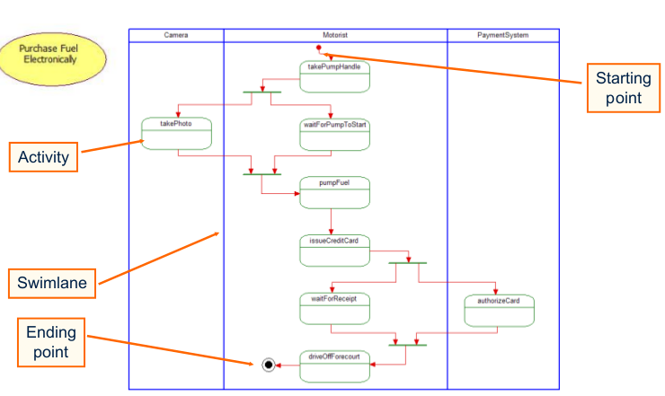
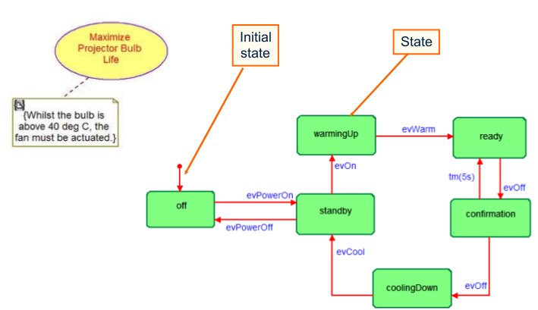

- What is the difference between a class and an object? How can a class and an object be implemented in Ada?
An object is something that has to be instanseiated. A class could just be a package of functions.
Objects vs. Classes
- An object is an instant of a class. A class is used to hold data and functions.
- When a class is declared, no memory is allocated but when the object of the class is declared, memory is allocated. So, class is just a template.
- An object can only be created if the class is already declared otherwise it is not possible
A class is implemented as a package in ADA.
A object could be implemented as a type in ADA. A type can be defined within a package.

Tutorial 6
- How do you change the priority of a task in Linux? What limitations might there be?
In Ada, use Pragma Priority to assign priorities to tasks.

- How many priority levels are available to users on Windows 7? How would you find out?

- The standard input routines in C, C++, Java, etc cannot be used in a timed loop to read input from a keyboard. Explain why not. Suggest solutions for Rhapsody and VxWorks.
Input prevents program execution while waiting for a keypress. In VxWorks, a task could be used for taking the input that preempts the other task running the timed loop.

- VxWorks does not have a calendar time routine. How would you set up a calendar clock?
Primary timer is the system clock • Interrupt the CPU periodically
Can be used to control when tasks run
- increments the tick count
– updates delays and timeouts
– checks scheduling
– sysClkRateSet(freq) Set the clock rate (default = 60 Hz)
– sysClkRateGet( ) Read the clock rate
Watchdog timers provide a user interface to the system clock trigger some action on a timer signal:
– WID wdCreate( ) Create a watchdog timer
– int wdStart(WID, ticks, myHandler, anArg)
• When the timer expires, run the routine myHandler(anArg). See wdLib for details and for other watchdog timer functions

- What is the difference between a binary semaphore, a mutex and a counting semaphore in VxWorks. When is each type used?
• binary
» The fastest, most general purpose semaphore. Optimized for synchronization. Can be used to force and execution order of a set of tasks
• mutual exclusion
» A special binary semaphore optimized for problems inherent in mutual exclusion: priority inheritance, deletion safety and recursion. Protected property in ada for data.
• counting
» Like the binary semaphore, but keeps track of the number of times the semaphore is given. Optimized for guarding multiple instances of a resource.

- Examine the Bottle Count example in the notes on Ada. Write statements for VxWorks in C/C++ that will set up and protect the shared variable bottle_count when accessed by tasks bottle_in_count and bottle_out_count
void bottle_in_count(void) /* Task bottle_in_count */
{
while (true)
{
bottle_in_signal.read(); /* External trigger */
semTake(mySem, WAIT_FOREVER);
bottle_count.increment(); /* critical section */
semGive(mySem);
}
}
void bottle_out_count(void) /* Task bottle_out_count */
{
while (true)
{
bottle_out_signal.read(); /* External trigger */
semTake(mySem, WAIT_FOREVER);
bottle_count.decrement(); /* critical section */
semGive(mySem);
}
}

- In the VxWorks notes on scheduling, timing drift is eliminated by using a watchdog timer to generate a timing signal as described in the notes. Does the resulting code still suffer from startup and termination jitter? If so, explain why.
The watchdog timer will listen to the system clock and send signals accuratly to when it should. However, the time to preemt a running task, put it to the stack and start next takes some time. This will create jitter. The watchdog timer remains synchronised with the system clock, but the jitter is hard to avoid.

Tutorial 7

- Switches are mechanical devices that bounce, that is, when pressed, the contacts bounce against each other, repeatedly making and breaking contact, until the mechanical switch arm settles down. The result is an output that oscillates between 0 and 1 for the bounce period and might produce as many as a dozen pulses. In order to prevent a program from interpreting the bounces as multiple inputs, the switch output must be debounced. Write code in C/C++ for VxWorks to achieve this.
void periodic_task(void)
{
wdId = wdCreate();
FOREVER /* task runs at least every P seconds*/
{
wdStart (wdID, DELAY_P_SEC, error_handler, 0);
do_some_work();
taskDelay(ticks); /* debounce period */
}
- A system includes three periodic tasks, Pressure, Temp and Flow which run with fixed priorities. Pressure runs once every 30 milliseconds and takes 5 ms to complete (if not interrupted), Temp runs once every 70 ms and completes in 20 ms and Flow runs every 100 ms and completes in 30 ms. Write statements in C/C++ for VxWorks that will start the tasks with priorities that are assigned by frequency – the more frequent the task, the higher its priority.

pressId = wdCreate();
tempId = wdCreate();
flowId = wdCreate();
pressSem = semBCreate((SEM_Q_FIFO, SEM_FULL);
tempSem = semBCreate((SEM_Q_FIFO, SEM_FULL);
flowsSem = semBCreate((SEM_Q_FIFO, SEM_FULL);

wdStart(pressID, 0.03, taskHandler, pressSem);
wdStart(tempID, 0.07, taskHandler, tempSem);
wdStart(flowID, 0.10, taskHandler, flowSem);

taskHandler(taskSem)
{ semGive(taskSem); /*must be initially busy*/
wdStart(wdID, taskPeriod, taskHandler, taskSem);
}
void pressTask()
{ /* initialise press task */
FOREVER
{ semTake(pressSem) /* wait for signal */
do_periodic_press_task_actions();
}
}
void tempTask()...
void flowTask()...
int main()
{ taskSpawn(pressTask, 1, ... ) // Pressure highest priority
taskSpawn(tempTask, 2, ... ) //Second highest priority
taskSpawn(flowTask, 3, ... ) //Lowest priority
}

Draw a time line covering 0-500 ms showing the task execution and determine
  - at which points each task starts
  - at which points tasks interrupt each other
  - slack time (time when the cpu is idle)
  - start-up delays on tasks
  - longest time to completion for each task
  - what is the repetition period for the task execution pattern (ie when does the time line start to repeat)?

- Programs frequently require use of a stack. The simplest way to protect a stack from interference in VxWorks is to use semaphores. Write code in C/C++ for VxWorks to implement a stack for handling doubles (double precision reals), using a semaphore to prevent interference if the stack is called from two (or more) tasks.

- A further problem with a stack is the need to prevent overflow or underflow. The simplest way in VxWorks to do this is to use counting semaphores. Write code using two counting semaphores (for empty and full) to protect the stack against underflow and overflow.

Tutorial 8 TASK SCHEDULING
  - Given 3 tasks with the following timing:
Task | Period | Exec  time
T1 | 10 | 2
T2 | 50 | 10
T3 | 90 | 21
    - Calculate the CPU utilisation for the 3 tasks. Are they guaranteed to be scedulable?
Utilization U_{I}=C_{i}/P_{I} (C=comuptation time, P=priority, in this case period)
U=2/10 + 10/50 + 21/90 = 63.3333%
Since Utilization is less than 63.3333%, it is possible to make this schedulable. With RMS, it is guaranteed to be schedulable since the CPU utilization is less than 69%.
    - If these 3 tasks are scheduled using Rate Monotonic Scheduling, construct a time line diagram for the tasks and apply the iterative completion time formula to determine if the tasks meet their deadlines. Check that your results from the time line diagram and the completion time formulae correspond.
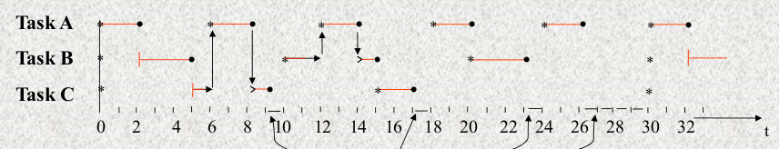
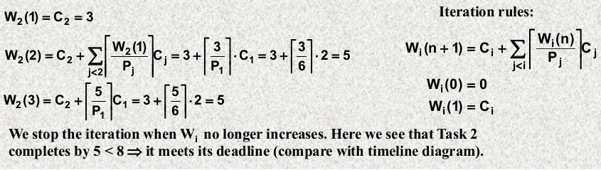
W_{I} = completation time
    - What is the maximum execution time for T1 such that T2 and T3 will both still meet their deadlines?
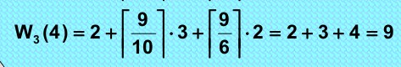

    - Set w₃ as 90 (15 in figure, period of task 3) and and vary C₁ instead, which is shown as 9/6 * 2 in this figure.

  - The following 3 tasks have the timing shown below. They are more demanding than the set in Qu 2.
Task | Period | Exec  time | Deadline
T1 | 10 | 3 | Period = 10
T2 | 50 | 10 | Period = 50
T3 | 60 | 21 | 45
    - Calculate the CPU utilisation for the 3 tasks.
3/10 + 10/50 + 21/60 = 85%
    - If these 3 tasks are scheduled using Rate Monotonic Scheduling, apply the iterative completion time formula to determine if the tasks meet their deadlines.
W₂(1) = C₂ = 10
W₂(2) = C₂ + ceil(W₂(1)/P₁) * C₁ = 10 + ceil(10/10)*3 = 10+3 = 13
W₂(3) = C₂ + ceil(W₂(2)/P₁) * C₁ = 10 + ceil(13/10)*3 = 10+3 = 16
W₂(4) = C₂ + ceil(W₂(3)/P₁) * C₁ = 10 + ceil(16/10)*3 = 10+3 = 16

W₃(1) = C₃ = 21
W₃(2) = C₃ + ceil(W₃(1)/P₂) * C₂ + ceil(W₃(1)/P₁) * C₁ = 21 + ceil(21/50)*10 + ceil(21/10)*3 = 40
W₃(3) = C₃ + ceil(W₃(2)/P₂) * C₂ + ceil(W₃(2)/P₁) * C₁ = 21 + ceil(40/50)*10 + ceil(40/10)*3 = 43
W₃(4) = C₃ + ceil(W₃(3)/P₂) * C₂ + ceil(W₃(3)/P₁) * C₁ = 21 + ceil(43/50)*10 + ceil(43/10)*3 = 46
W₃(5) = C₃ + ceil(W₃(4)/P₂) * C₂ + ceil(W₃(4)/P₁) * C₁ = 21 + ceil(46/50)*10 + ceil(46/10)*3 = 46
Task 3 fails to complete its deadline.
    - If these 3 tasks are scheduled using Deadline Monotonic Scheduling, apply the iterative completion time formula to determine if the tasks meet their deadlines.
W₃(1) = C₃ = 21
W₃(2) = C₃ + ceil(W₃(1)/P₁) * C₁ = 21 + ceil(21/10)*3 = 30
W₃(3) = C₃ + ceil(W₃(2)/P₁) * C₁ = 21 + ceil(30/10)*3 = 30

W₂(1) = C₂ = 10
W₂(2) = C₂ + ceil(W₂(1)/P₃) * C₃ + ceil(W₂(1)/P₁) * C₁ = 10 + ceil(10/60)*21 + ceil(10/10)*3 = 34
W₂(3) = C₂ + ceil(W₂(2)/P₃) * C₃ + ceil(W₂(2)/P₁) * C₁ = 10 + ceil(34/60)*21 + ceil(34/10)*3 = 43
W₂(4) = C₂ + ceil(W₂(3)/P₃) * C₃ + ceil(W₂(3)/P₁) * C₁ = 10 + ceil(43/60)*21 + ceil(43/10)*3 = 46
W₂(4) = C₂ + ceil(W₂(4)/P₃) * C₃ + ceil(W₂(4)/P₁) * C₁ = 10 + ceil(46/60)*21 + ceil(46/10)*3 = 46

All tasks meet their deadline.

Tutorial 9 TASK SCHEDULING
2. The 3 tasks shown below have the timing given:
Task | Exec time | Period | Deadline
T1 | 1 | 4 | period
T2 | 3 | 12 | period
T3 | 8 | 16 | Period
    - If these tasks are scheduled with DMPO, determine if they meet their deadlines.
    - Construct a timeline for the 3 tasks using EDF and determine if they meet their deadlines.
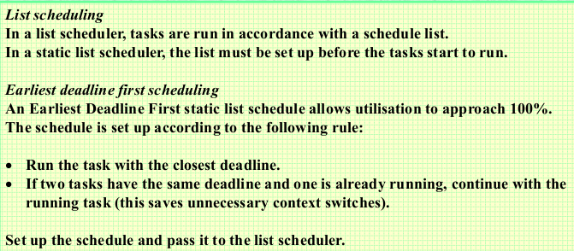
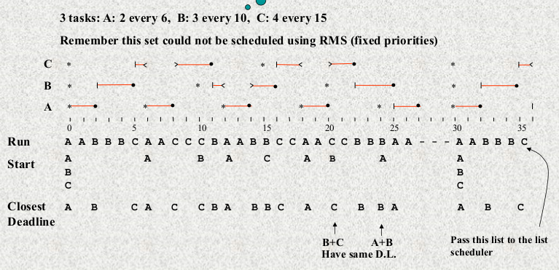
  - Sporadic server. In the 4 tasks shown below, with the timing given, tasks A, C & D are periodic. B is sporadic with an execution time of 0.03, a deadline of 0.3 and minimum interarrival rate of 0.4:
Task | Exec time | Period | Deadline
A | 0.1 | 0.2 | period
B | 0.03 | 0.4(min) | 0.3
C | 0.1 | 0.5 | period
D | 0.9 | 5 | period
Fill in the details for task B then determine if this task set is schedulable.

Capacity_{B} = (0.3 * 0.03) / (0.4*(0.3 – 0.03) = 8.3333%
0.1/0.2 + 0.083333333 + 0.1/0.5 + 0.9/5 = 96.333%
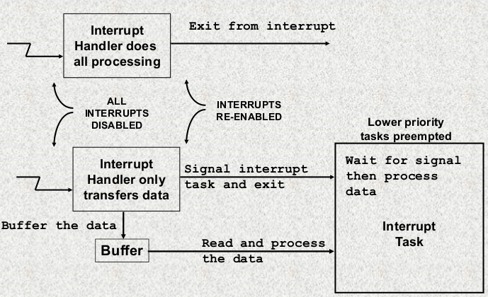

Tutorial 10 - Data Conversion

1. The measured input/output characteristics for a 3-bit A/D converter that accepts inputs over the range 0-12 volts are shown below:
Input steps(volts): | 00-1.4 | 1.4-2.8 | 2.8-4.4 | 4.4-5.9 | 5.9-7.5 | 7.5-9.2 | 9.2-  10.7 | 10.7-  12.0
Output value: | 000 | 001 | 010 | 011 | 100 | 101 | 110 | 111
- What is the offset error of the device?
Desired transition points: ∆=V_{max} / 2^{N} = 12.0 / 8.0 = 1.5V. Offset error is 1.5 – 1.4 = 0.1V
- What is the maximum relative accuracy error?
2*1.5 = 3V, but should be 2.8V, relative accuracy error = 3-2.8 = 0.2V
c) What is the differential non-linearity error?
DNLE = max_{K} | ∆_{k} - ∆| = 1.7 – 1.5 = 0.2V

2. The measured input/output characteristics for a 3-bit D/A converter that was designed to generate outputs over the range 0-9 volts are shown below:
Digital input: | 000 | 001 | 010 | 011 | 100 | 101 | 110 | 111
Analogue output  (volts): | 0.1 | Y1 | 2.8 | 4.1 | 5.3 | 6.4 | Y2 | 9.2
- When the digital input is 001, if Y1 = 1.4 v, what is the relative accuracy error?
Resolution = ∆ = output voltage range/(2^{N} -1) =(9-0) / (2³-1) = 1.285714286 v
1.4 – 1.285714286 = 0.114285714 v
- When the digital input is 110, if Y2 = 7.6 v, what is the relative accuracy error?
Desired transition: 6* 1.285714286 = 7.714285716 v
7.714285716 - 7.6 = 0.114285716 v
- What is the maximum RAE for this device?
4.1 - 3*1.285714286 = 0.242857142 v

- Why must the differential non-linearity of an A/D converter be less than the resolution of the device?
Because otherwise one bit will be skipped all together.

- What should the aperture time of the sampler be in order to convert a 5000 Hz, 5 v peak sine wave with 12-bit resolution and less than 1/2 l.s.bit aperture error?

- An ideal 12-bit bipolar A/D converter (no errors of any kind) converts an input voltage of 5.0 volts to a reading of 400h, with the transition precisely at 5 v.
  - What are the step size and full scale input voltages for the device?
  - A second device is now tested and produces a reading of 0 for an input of 0.0 volts and 3FEh for an input of 5 volts. If the device has zero RAE, what is its full scale error?
Tutorial 11 RELIABILITY

- List 3 ways of managing the reliability of a real-time system
- Fault prevention (Avoidance and removal)
- Fault tolerance
- Careful design, with error trapping and testing

- Can a program be regarded as reliable if it conforms to an erroneous specification?
The program can be regarded as reliable, but not the system. If the specification is erroneous, this means that the system will not do as expected.

- What are appropriate levels of degraded service for the computer controls of a motor car?
For a computer that controls the motor of car should strive for full fault tolerence – meaning the system continues to operate in the presence of faults, albeit for a limited period, with no significant loss of functionality or performance. However in practice many safety critical systems settle for Graceful Degradation (fail soft) - the system continues to operate in the presence of errors, accepting a partial degradation of functionality or performance during recovery or repair. The last level, Fail Safe - the system maintains its integrity while
accepting a temporary halt in its operation – Should not be used for a car motor control.

- Name 4 features of Ada2012 that enhance the reliability and fault tolerance of programs and give examples of the use of each.
- Strong typing – cannot accidently mix types
- Focus on use of packages (well defined and tested reusable code)
- Strong exception handling capability
- Timeouts to deal with errors, runaway code or external failures
- Atomic actions and protected types
- Subsets for safety – Ravenscar Profile and SPARK – exclude language features that are hard to verify
- Contracts via specification and pre and post conditions

- The following function computes the Greatest Common Divisor (GCD) of two numbers:

function GCD(N1, N2 : Integer) return Integer is
with Pre => Nl > O and N2 > 0,
Post => vl = v2;
v1 : Integer := N1;
v2 : integer := N2;
BEGIN
LOOP
IF v1 = v2 THEN RETURN V1;
ELSIF v1 > v2 THEN v1 := v1 - v2;
ELSE v2 := v2 - v1;
END IF; END LOOP;
END GCD;

Add pre- and post-conditions to this code for run-time validation of the result.

6. Write code that calls the above function and handles any exception that may be raised if the conditions are violated

procedure divisorProgram is
N1, N2, divisor : integer;
begin
divisor := GCD(N1, N2);
exception
when Constraint_Error =>
handle_error(N1,N2); --Handle_error might convert --N1,N2 to positive numbers
when others => put_line(“Don’t know what went wrong”);
end;

Note: to compile code with pre- and post-conditions, the compiler switch -gnat2012 must be used. In AdaGIDE, go to tools | project settings | debug and set this in the compiler options window.

