**How to install?**

**Starting Mongod**

First of all, MongoDB must be installed on the PC and it have to be running in CMD as shown in the example:

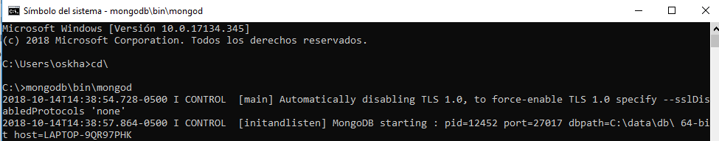

This path is because we have mongod.exe saved in that path, it may vary depending on where the user has it stored. Or simply go to the path and double click on mongod.exe for avoiding CMD usage.

**Creating the DB**

It doesn’t matter what DB manager the user uses (MongoDB Compass, Studio 3T, etc) the user has to click in create a database or add a database and name it “Laboratorio” because that’s the DB name we use.

**Importing the collections**

For importing the collections there is Database Dump.zip that contains all the JSONs with the collections information. It doesn’t matter what DB manager the user uses (MongoDB Compass, Studio 3T, etc) they all follow the same instructions. The user only has to click in import and then select all the JSONs with the collections and that’s it. For the API Documentation visit documentation.html located in the same folder as this document.

**Result**

It has to look like this to have it all correctly installed (Studio 3T or MongoDB Compass):

