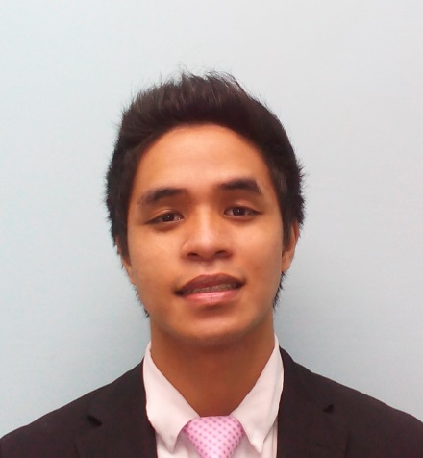

**Oscar II T. Sapinosa**

Tanza (Kaliwa) Navotas City

(+63) 905 137 5578

oscarsapinosa@gmail.com

**OBJECTIVE:**

BS Computer Science graduated seeking a position of Web Design and Developer where I may be able to employ my skills in developing specified website’s in order to meet customers’ specifications.

**EDUCATION:**

**2015 – 2016** **STI Academic Centers**

**2008 – 2012** **Malabon National High School**

**SKILLS:**

* Microsoft Office(excel,powerpoint,word)
* PHP - Advance
* HTML - Advance
* CSS - Advance
* Visual Basic - Advance
* Adobe Photoshop CS6 - Advance
* Adobe flash CS6 - Advance
* Adobe after Effect CS6 - Advance
* Video/Audio Editing - Advance

**REFERENCE:**

Marilou F. Bartolome Blenda Bensurto

09176232278 09236964748

Professor Professor

STI College Caloocan STI College Caloocan