Instances:



VPC:

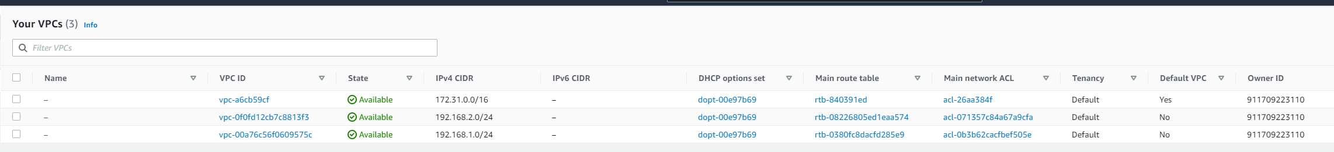

Peering:

