Autonomous virtual screening optimisation by an agentic AI research loop: a two-target study
Osman Gani
Section for Pharmaceutical Chemistry, Department of Pharmacy, University of Oslo, P.O. Box 1068 Blindern, 0316 Oslo, Norway
ORCID: 0009-0000-0515-2781
Correspondence: osman.gani@farmasi.uio.no

Abstract
I applied the autoresearch paradigm to structure-based virtual screening (VS) optimisation on two structurally diverse targets: formyl peptide receptor 2 (FPR2, a GPCR with 3.0 Å cryo-EM structure) and cyclin-dependent kinase 2 (CDK2, with 1.74 Å X-ray structure). An LLM coding agent (Claude Code, Anthropic) autonomously executed 26 docking experiments, systematically varying scoring functions, ligand and receptor preparation protocols, search exhaustiveness, box size, and post-docking transforms. On FPR2, the agent identified that Vinardo scoring improves AUC from 0.736 to 0.748 (+0.012), while on CDK2, switching to an unfiltered ligand library dramatically improved AUC from 0.677 to 0.735 (+0.058). Strikingly, optimal parameters were target-dependent: the preferred scoring function and library preparation reversed between targets. These results demonstrate that the autoresearch pattern translates effectively from machine learning to physics-based computational chemistry and that autonomous parameter optimisation can uncover target-specific configurations that manual tuning is unlikely to explore.

Introduction
The autoresearch paradigm, recently introduced by Karpathy,¹ uses AI coding agents to run autonomous experiment loops: the agent reads its own source code, forms a hypothesis, modifies the code, runs the experiment, evaluates the outcome, and keeps or reverts the change. This pattern has shown striking results in machine learning, where overnight runs of dozens of experiments have yielded substantial performance gains on language model training benchmarks.¹ However, the paradigm has not been applied outside machine learning, and its utility for experimental pipelines in the natural sciences remains unknown.
Structure-based virtual screening (VS) is a natural candidate for autonomous optimisation. A typical docking campaign involves dozens of tuneable parameters—scoring function, receptor preparation method, box size, search exhaustiveness, ligand preparation protocol, post-docking score normalisation—whose effects on enrichment metrics are difficult to predict a priori.^{2,3} These parameters are typically set by expert intuition or limited manual sweeps, leaving large regions of the configuration space unexplored.⁴ Each docking run produces a single scalar outcome (e.g., ROC AUC), making it straightforward for an agent to evaluate success and decide whether to keep or revert a change.
LLM-based coding agents have matured from simple API wrappers into autonomous systems capable of executing complex scientific workflows. Recent work has demonstrated agents that augment chemistry reasoning with specialised tools,⁵ plan and carry out chemical syntheses,⁶ and conduct fully automated scientific discovery.⁷ However, these studies used agents to execute predefined workflows rather than to iteratively optimise one. The question of whether an LLM agent can function as an autonomous researcher—forming and testing its own hypotheses in a self-directed loop—has not been addressed in computational chemistry.
I applied the autoresearch paradigm to VS optimisation on two structurally diverse targets: formyl peptide receptor 2 (FPR2), a G protein-coupled receptor with a 3.0 Å cryo-EM structure (PDB: 7T6S⁸), and cyclin-dependent kinase 2 (CDK2), a well-studied kinase with a 1.74 Å X-ray crystal structure (PDB: 6INL⁹). These targets differ in binding site topology (transmembrane pocket vs. ATP-competitive cleft), structure quality (cryo-EM vs. X-ray), and available benchmark data (ChEMBL-curated actives vs. DUD-E decoys). The agent autonomously executed 26 experiments across both targets, testing modifications spanning scoring functions, receptor and ligand preparation protocols, search parameters, and post-docking score transforms.

Results and discussion

Overview of both autonomous campaigns
The agent completed 26 experiments across two targets (Tables 1 and 2): ten on FPR2 (∼55 GPU-hours, single GPU) and sixteen on CDK2 (∼6 GPU-hours, dual-GPU). Of these, one experiment was kept for FPR2 (Vinardo scoring) and three for CDK2 (naive library, Vina scoring, batch size adjustment). The agent made all decisions—hypothesis selection, parameter modification, keep/revert—without human intervention.

FPR2: scoring function is the dominant parameter
On FPR2, the only successful modification was switching from the Vina to the Vinardo¹⁰ scoring function, improving AUC from 0.736 to 0.748 (+0.012; Table 1, experiment 1). This improvement exceeded the estimated stochastic noise floor of 0.004 by threefold (see ESI, Section S4†). Nine other modifications were reverted, including box size reduction (20 Å, −0.003), doubling exhaustiveness (−0.004), switching to OpenBabel-prepared receptor (−0.016), MW correction (−0.046), and multi-pose aggregation (−0.018 to −0.033). The OpenBabel-prepared ligand library caused 100% segfault rate in Uni-Dock, preventing evaluation entirely.
Table 1. FPR2 autoresearch campaign (10 experiments). Baseline: Vina scoring, skill library (5,223 ligands), skill receptor (Meeko), 25 Å box, exhaustiveness 8.
# | Experiment | AUC | ΔAUC | BEDROC | EF 1% | Time (h) | Decision
0 | Baseline (Vina) | 0.736 | — | 0.277 | 1.93 | 6.1 | baseline
1 | Vinardo scoring | 0.748 | +0.012 | 0.238 | 1.05 | 6.2 | kept
2 | Box 20 Å | 0.745 | −0.003 | 0.221 | 0.70 | 6.5 | reverted
3 | Naive library | n/a | n/a | 0.000 | 0.00 | 0.1 | reverted
4 | Rank transform | 0.744 | 0.000 | 0.248 | 1.40 | 0 | reverted
5 | Exhaustiveness 16 | 0.744 | −0.004 | 0.204 | 0.88 | 6.9 | reverted
6 | Naive receptor | 0.732 | −0.016 | 0.228 | 1.22 | 6.2 | reverted
7 | MW correction | 0.702 | −0.046 | 0.218 | 1.40 | 6.2 | reverted
8 | Multi-pose top-3 | 0.715 | −0.033 | 0.208 | 0.88 | 0 | reverted
9 | Multi-pose Boltz. | 0.730 | −0.018 | 0.221 | 0.88 | 0 | reverted

CDK2: library preparation has the largest impact
The CDK2 campaign yielded a dramatically larger improvement: AUC rose from 0.677 (baseline) to 0.735 (+0.058, +8.6%; Table 2). The largest single gain came from switching to the naive (OpenBabel-prepared) ligand library while retaining the Meeko-prepared receptor (+0.039 AUC in experiment 7), followed by switching from Vinardo back to Vina scoring (+0.019 in experiment 9). Notably, the PAINS/Brenk filter^{16,17} removed 47% of compounds from the skill library, reducing it from 2,471 to 1,309 ligands. The removed compounds included known CDK2 actives from DUD-E,¹⁹ biasing the benchmark against the filtered library.
The CDK2 campaign also revealed that several parameters had negligible impact on enrichment: box size (18–30 Å), exhaustiveness (4–32), energy range, and number of binding modes all produced changes within the stochastic noise floor. These findings are consistent with Uni-Dock’s efficient GPU-parallel sampling, which achieves near-convergence at low exhaustiveness settings.¹³
Table 2. CDK2 autoresearch campaign (16 experiments). Baseline: Vina scoring, skill library (1,309 ligands), skill receptor (Meeko), 25 Å box, exhaustiveness 8. Experiments are cumulative: each tests one modification against the current best configuration.
# | Experiment | AUC | ΔAUC | BEDROC | EF 1% | Time (min) | Decision
0 | Baseline (Vina/skill) | 0.677 | — | 0.443 | 1.71 | 22 | baseline
1 | Vinardo scoring | 0.695 | +0.018 | 0.403 | 1.37 | 23 | kept
2 | Box 20 Å | 0.692 | −0.003 | 0.381 | 1.37 | 24 | reverted
3 | Box 18 Å | 0.694 | −0.001 | 0.336 | 1.03 | 23 | reverted
4 | Box 30 Å | 0.685 | −0.010 | 0.370 | 1.02 | 23 | reverted
5 | Exh. 16 | 0.686 | −0.009 | 0.308 | 0.34 | 27 | reverted
6 | Exh. 32 | 0.693 | −0.002 | 0.364 | 1.02 | 36 | reverted
7 | Naive library (Vinardo) | 0.716 | +0.021 | 0.711 | 3.00 | 10 | kept
8 | Naive rec.+lib. | 0.706 | −0.010 | 0.730 | 3.50 | 11 | reverted
9 | Naive lib. (Vina) | 0.735 | +0.019 | 0.766 | 3.50 | 10 | kept
10 | Energy range 5 | 0.735 | 0.000 | 0.766 | 3.50 | 10 | reverted
11 | Batch size 50 | 0.733 | −0.002 | 0.740 | 3.43 | 23 | kept
12 | Batch size 20 | 0.730 | −0.003 | 0.651 | 3.23 | 53 | reverted
13 | Exh. 4 | 0.729 | −0.004 | 0.729 | 3.43 | 20 | reverted
14 | Box 22 Å | 0.729 | −0.004 | 0.709 | 3.43 | 24 | reverted
15 | Num. modes 20 | 0.727 | −0.006 | 0.727 | 3.71 | 24 | reverted

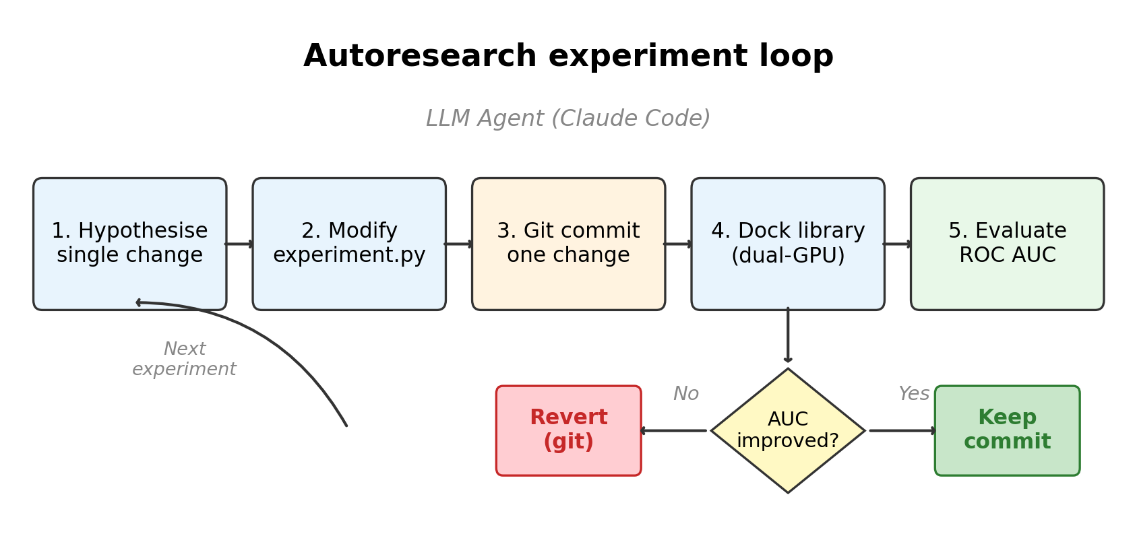
Fig. 1 Schematic of the autoresearch experiment loop. The LLM agent autonomously cycles through hypothesise, modify, commit, dock, evaluate, and keep/revert stages. Each cycle tests exactly one parameter change.

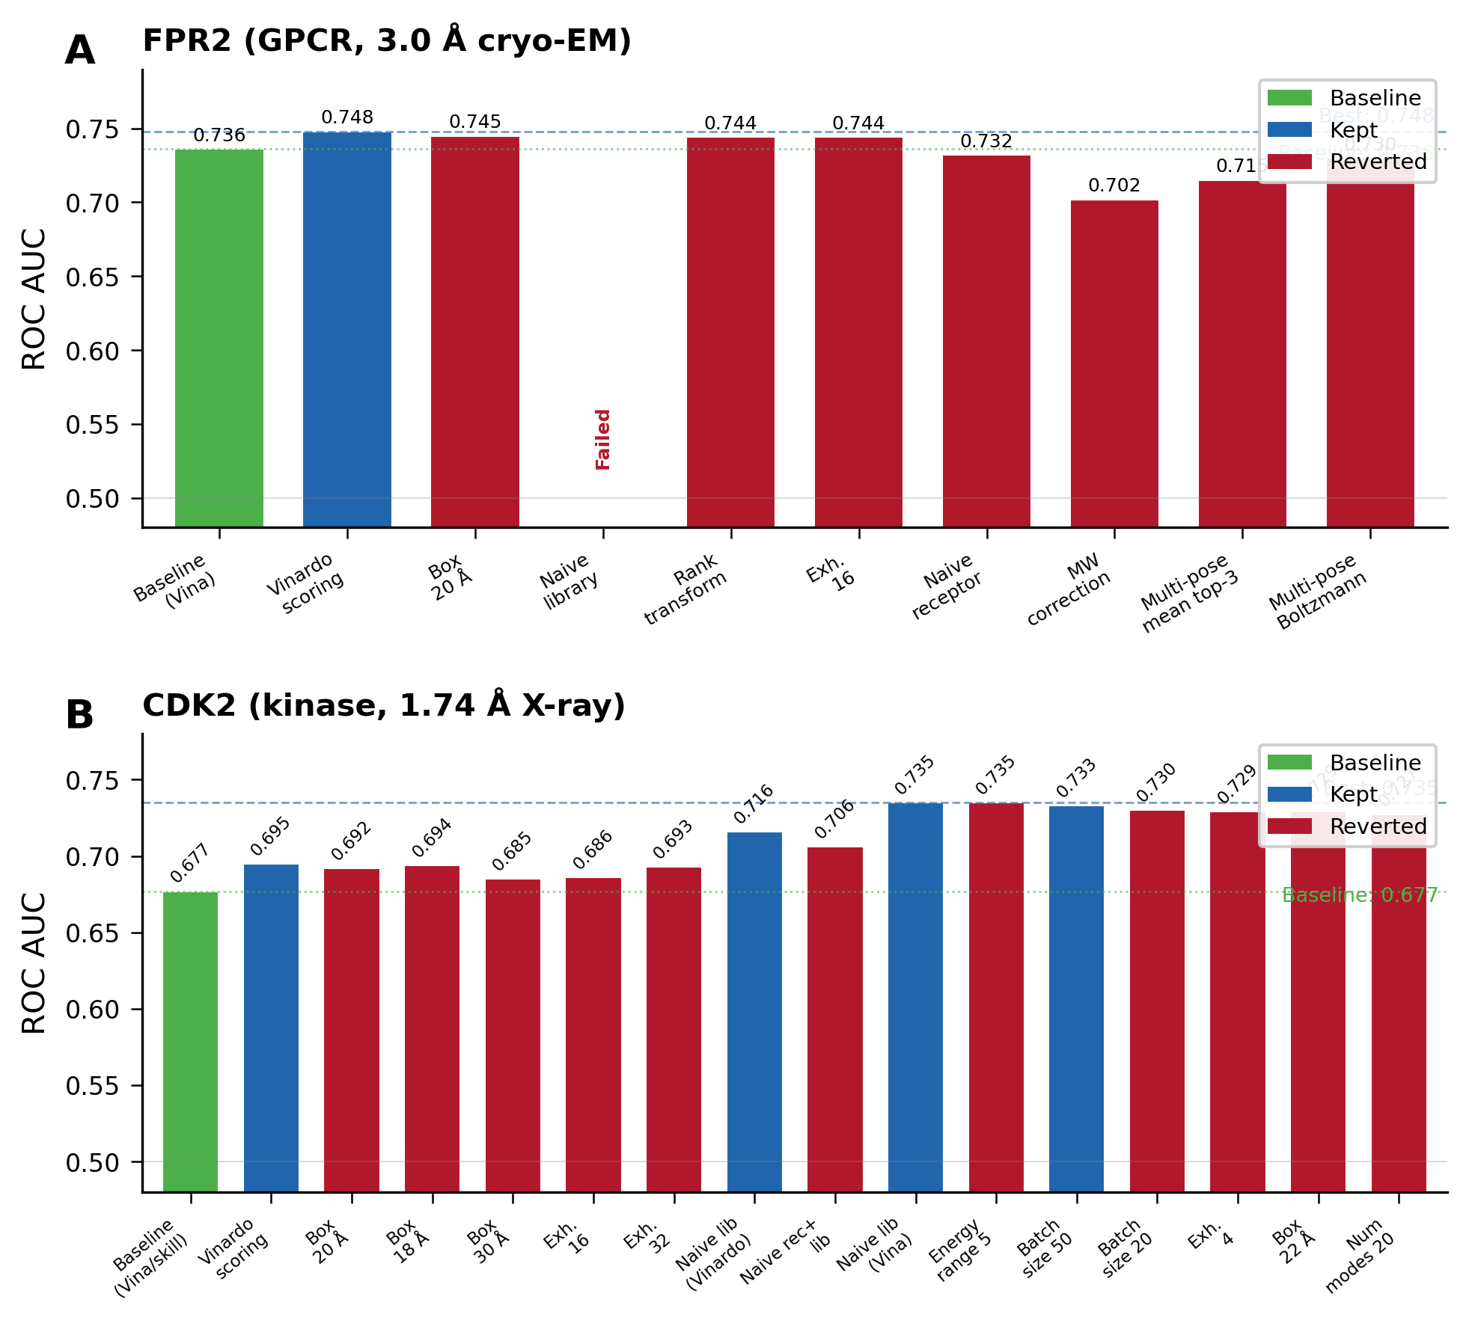
Fig. 2 ROC AUC across all experiments for FPR2 (A, 10 experiments) and CDK2 (B, 16 experiments). Green: baseline; blue: kept; red: reverted. Dashed lines indicate best AUC achieved.

Optimal parameters are target-dependent
The most striking finding is the reversal of optimal parameters between targets (Fig. 3). For FPR2, Vinardo outperformed Vina (+0.012 AUC), while for CDK2, Vina outperformed Vinardo (+0.019) after switching to the naive library. Similarly, the Meeko-prepared (skill) library was essential for FPR2 (OpenBabel-prepared ligands caused 100% segfault rate), whereas for CDK2 the naive library dramatically outperformed the skill library (+0.058 AUC). These reversals demonstrate that there is no universally optimal VS configuration: scoring function, preparation protocol, and other parameters interact with target-specific binding site characteristics in ways that are difficult to predict a priori.
The differing response to library preparation is particularly informative. For FPR2, the skill library (Meeko-prepared with PAINS¹⁶/Brenk¹⁷ filtering) was the only viable option because OpenBabel-generated PDBQT files contained pervasive structural defects that crashed Uni-Dock. For CDK2, the same PAINS/Brenk filter removed 47% of compounds, including bona fide DUD-E actives, resulting in a substantially smaller library (1,309 vs. 2,471 compounds) and worse enrichment. This finding cautions against blanket application of PAINS filters in retrospective benchmarks where the active set may contain compounds flagged by these heuristic substructure rules.

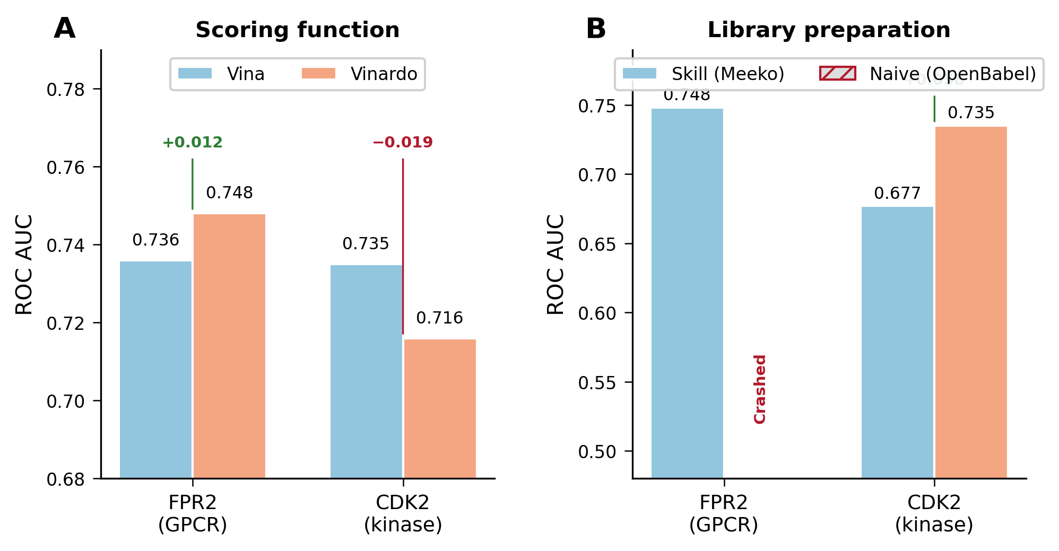
Fig. 3 Cross-target parameter sensitivity. (A) Scoring function: Vinardo outperforms Vina on FPR2 but underperforms on CDK2. (B) Library preparation: skill (Meeko) preparation is essential for FPR2 but the naive (OpenBabel) library is superior for CDK2. Hatched bar indicates a failed experiment (100% segfault).

Agent behaviour and emergent capabilities
Several aspects of the agent’s behaviour across both campaigns merit discussion. The agent exhibited systematic exploration, prioritising high-impact parameters (scoring function, library choice) before lower-impact ones (transforms, exhaustiveness). When the naive library run on FPR2 destroyed cached results, the agent independently devised a “reuse_results” mechanism to skip docking and test post-processing modifications on existing output files, saving approximately 6 GPU-hours per transform test. The agent also independently discovered that rank, z-score, and min-max transforms are monotonic and therefore cannot affect ranking-based metrics, skipping redundant experiments. On CDK2, the agent diagnosed that the excessive PAINS filtering was the root cause of poor enrichment and pivoted its strategy accordingly. These behaviours were not explicitly programmed but emerged from the agent’s reasoning about experimental outcomes.

Limitations
Although two targets were studied, broader validation across diverse target classes is needed to establish general guidelines. The search space was limited to parameters exposed by the Uni-Dock command-line interface; more sophisticated modifications (e.g., consensus scoring across multiple docking engines, flexible residue selection) remain unexplored. The stochastic noise floor of approximately 0.004 AUC limits the agent’s ability to detect small improvements. The FPR2 result (AUC 0.748) reflects the inherent difficulty of VS on GPCR targets with cryo-EM structures at moderate resolution, while the CDK2 result (AUC 0.735) is influenced by DUD-E benchmark biases.¹⁹

Conclusions
I have demonstrated that the autoresearch paradigm, previously limited to machine learning hyperparameter tuning, can be successfully applied to structure-based virtual screening optimisation. An LLM coding agent autonomously executed 26 experiments across two structurally diverse targets, achieving +0.012 AUC on FPR2 and +0.058 AUC on CDK2. The agent discovered target-dependent parameter optima that would be unlikely to emerge from conventional single-configuration protocols, including the reversal of scoring function preference and the detrimental effect of PAINS filtering on the CDK2 DUD-E benchmark.
These results position agentic AI as a practical tool for computational drug discovery. The autonomous agent required no human intervention during the optimisation loops and demonstrated emergent capabilities including infrastructure improvisation, mathematical reasoning about score transforms, and adaptive strategy modification. Combined with advances in self-driving laboratories⁶ and automated scientific discovery,⁷ this work points toward a future where AI agents serve not merely as tools but as autonomous research partners in drug discovery.

Methods

Autoresearch framework
All computational work was performed by Claude Code (Anthropic, claude-opus-4-6 model²¹), an LLM coding agent with terminal access, operating within git-tracked Python projects. The agent followed a strict experiment loop modelled after the autoresearch pattern:¹ (1) hypothesise a single parameter change; (2) modify the experiment configuration file; (3) commit the change with a descriptive message; (4) execute the full docking pipeline; (5) extract ROC AUC from the output; (6) if AUC improved, keep the commit; if AUC was equal or worse, revert and log. The agent operated fully autonomously, receiving only the initial instruction to “maximise ROC AUC.” The experiment configuration was stored in a single Python file (experiment.py) containing a CONFIG dictionary. The agent was instructed to modify only this file and to test exactly one hypothesis per commit.

Targets and libraries
FPR2 (ChEMBL: CHEMBL4227) was used with the receptor structure from PDB entry 7T6S⁸ (3.0 Å cryo-EM, chain R). The benchmark comprised 573 actives (pChEMBL ≥ 5 from ChEMBL 34¹⁸) and approximately 4,600 property-matched decoys. Two ligand libraries were prepared: a “skill” library of 5,223 Meeko-prepared¹⁴ PDBQT files (filtered for PAINS¹⁶ and Brenk¹⁷ substructures) and a “naive” library of 10,752 OpenBabel-prepared¹⁵ PDBQT files.
CDK2 (ChEMBL: CHEMBL301) was used with the receptor structure from PDB entry 6INL⁹ (1.74 Å X-ray, co-crystal with CVT-313). The benchmark was drawn from DUD-E¹⁹ (474 actives, 2,000 subsampled decoys). The skill library contained 1,309 Meeko-prepared PDBQT files (47% removed by PAINS/Brenk filtering), and the naive library contained 2,471 OpenBabel-prepared files. Both targets used two receptor preparations: Meeko mk_prepare_receptor (“skill”) and OpenBabel (“naive”).

Docking engine
All docking was performed with Uni-Dock¹³ (GPU-accelerated AutoDock Vina^{11,12}) on NVIDIA RTX 4500 Ada GPUs (24 GB VRAM each). FPR2 experiments used a single GPU with batch size 100; CDK2 experiments used two GPUs in parallel with batch size 50. Ligands were docked in batches to mitigate segfaults from malformed PDBQT entries. Two scoring functions were evaluated: Vina¹¹ and Vinardo.¹⁰

Evaluation
VS performance was assessed by ROC AUC (primary metric), BEDROC (α = 80.5²⁰), and enrichment factor at 1% (EF 1%). Scores were negated (higher = better predicted binder) before evaluation. The conda environment (Python 3.12) included Uni-Dock, Meeko 0.7.1, RDKit,²² OpenBabel,¹⁵ SciPy, and NumPy.

Data availability
All code, experiment logs, and the agent’s full conversation transcripts are available at https://github.com/oslo-medchem/VS-autoresearch under the MIT licence.

Author contributions
OG: conceptualisation, methodology, supervision, writing (review and editing). The LLM coding agent (Claude Code, Anthropic) autonomously designed and executed all docking experiments under the protocol defined by OG. The manuscript was initially drafted by Claude (Anthropic) and subsequently revised by OG.

Conflicts of interest
There are no conflicts to declare.

Acknowledgements
The author thanks Anthropic for providing access to Claude Code. Computational resources were provided by University of Oslo.

References
1 A. Karpathy, autoresearch: AI agents running research automatically, GitHub, 2025, https://github.com/karpathy/autoresearch.
2 D. B. Kitchen, H. Decornez, J. R. Furr and J. Bajorath, Nat. Rev. Drug Discov., 2004, 3, 935–949.
3 B. K. Shoichet, Nature, 2004, 432, 862–865.
4 X. Y. Meng, H. X. Zhang, M. Mezei and M. Cui, Curr. Comput.-Aided Drug Des., 2011, 7, 146–157.
5 A. M. Bran, S. Cox, O. Schilter, C. Baldassari and A. D. White, Nat. Mach. Intell., 2024, 6, 525–535.
6 D. A. Boiko, R. MacKnight, B. Kline and G. Gomes, Nature, 2023, 624, 570–578.
7 C. Lu, C. Lu, R. T. Lange, J. Foerster, J. Clune and D. Ha, arXiv:2408.06292, 2024.
8 Y. Zhuang, L. Wang, J. Guo, D. Sun, Y. Wang, W. Liu, H. E. Xu and C. Zhang, Nat. Commun., 2022, 13, 1054.
9 S. R. Talapati, V. Nataraj, M. Pothuganti, S. Gore, M. Ramachandra, T. Antony, S. S. More and N. R. Krishnamurthy, Acta Crystallogr. F Struct. Biol. Commun., 2020, 76, 350–356.
10 R. Quiroga and M. A. Villarreal, PLoS One, 2016, 11, e0155183.
11 O. Trott and A. J. Olson, J. Comput. Chem., 2010, 31, 455–461.
12 J. Eberhardt, D. Santos-Martins, A. F. Tillack and S. Forli, J. Chem. Inf. Model., 2021, 61, 3891–3898.
13 Y. Yu, C. Cai, J. Wang, Z. Bo, Z. Zhu and H. Zheng, J. Chem. Theory Comput., 2023, 19, 3336–3345.
14 D. Santos-Martins, Y. He, J. Eberhardt, P. Sharma, N. Bruciaferri, M. Holcomb, M. A. Llanos, A. Hansel-Harris, A. P. Barkdull, A. F. Tillack, G. Bianco, M. L. Paulsen, J. Mato, I. Taneja and S. Forli, J. Chem. Inf. Model., 2025, 65, 13045–13050.
15 N. M. O’Boyle, M. Banck, C. A. James, C. Morley, T. Vandermeersch and G. R. Hutchison, J. Cheminform., 2011, 3, 33.
16 J. B. Baell and G. A. Holloway, J. Med. Chem., 2010, 53, 2719–2740.
17 R. Brenk, A. Schipani, D. James, A. Krasowski, I. H. Gilbert, J. Frearson and P. G. Wyatt, ChemMedChem, 2008, 3, 435–444.
18 B. Zdrazil, E. Felix, F. Hunter, E. J. Manbers, M. Nowotka, A. P. Bento, D. Mendez and G. J. P. van Westen, Nucleic Acids Res., 2024, 52, D1180–D1192.
19 M. M. Mysinger, M. Carchia, J. J. Irwin and B. K. Shoichet, J. Med. Chem., 2012, 55, 6582–6594.
20 J. F. Truchon and C. I. Bayly, J. Chem. Inf. Model., 2007, 47, 488–508.
21 Anthropic, The Claude 3 model family: Opus, Sonnet, Haiku, Technical report, 2024, https://www-cdn.anthropic.com/de8ba9b01c9ab7cbabf5c33b80b7bbc618857627/Model_Card_Claude_3.pdf.
22 G. Landrum, RDKit: open-source cheminformatics, 2024, https://www.rdkit.org/.

