Electronic Supplementary Information (ESI)
Autonomous virtual screening optimisation by an agentic AI research loop: a two-target study
Osman Gani
Section for Pharmaceutical Chemistry, Department of Pharmacy, University of Oslo, P.O. Box 1068 Blindern, 0316 Oslo, Norway

S1. Agent program files
The agent operated under structured protocol files (program.md) that defined the experiment loop, research directions organised into three tiers by expected impact, and the baseline configuration. Separate program files were used for each target. The complete program files are available in the repository.
Both programs instructed the agent to:
- Never modify the infrastructure code (prepare.py), only the experiment configuration (experiment.py)
- Test exactly one hypothesis per git commit
- Operate fully autonomously without pausing for human input
- Follow a strict hypothesise–modify–commit–run–evaluate–decide loop
Research directions were organised as:
- Tier 1 (high impact, fast): scoring function, box size, exhaustiveness, library choice, receptor choice
- Tier 2 (moderate impact, new logic): score normalisation, consensus scoring, multi-pose analysis, MW correction
- Tier 3 (exploratory): energy range, num_modes, seed variation

S2. FPR2 detailed experiment logs

Experiment 0: Baseline
Configuration: Vina scoring, skill library (5,223 ligands), skill receptor (Meeko), 25 Å box, exhaustiveness 8, batch size 100.
Results: 4,100 ligands successfully docked (1,123 lost to segfaults). AUC = 0.736, BEDROC = 0.277, EF 1% = 1.93. Runtime: 21,786 s (6.1 h).

Experiment 1: Vinardo scoring (KEPT)
Hypothesis: The Vinardo scoring function may discriminate actives from decoys better than the default Vina function for FPR2.
Results: AUC = 0.748 (+0.012). BEDROC = 0.238, EF 1% = 1.05. Runtime: 22,284 s (6.2 h). Decision: KEPT.
Note: Improvement of +0.012 exceeds the estimated noise floor of 0.004 by threefold.

Experiment 2: Box size 20 Å
Hypothesis: A tighter docking box (20 vs 25 Å) may focus the search on the orthosteric pocket.
Results: AUC = 0.745 (−0.003). BEDROC = 0.221, EF 1% = 0.70. Decision: REVERTED.

Experiment 3: Naive library
Hypothesis: The naive library (10,752 compounds) covers more chemical space.
Results: Total failure. All 108 batches crashed. Only 100 of 10,752 ligands were docked. AUC = NaN. Decision: REVERTED.
Root cause: OpenBabel-generated PDBQT files contained zero coordinates, missing atoms, and invalid tags.

Experiment 4: Rank score transform
Hypothesis: Rank-based normalisation may improve discrimination.
Results: AUC = 0.744, identical to untransformed AUC.
Key insight: The agent independently realised that monotonic transforms preserve relative ordering and cannot change ranking-based metrics. Skipped z-score and min-max.

Experiment 5: Exhaustiveness 16
Hypothesis: Doubling exhaustiveness may improve pose sampling.
Results: AUC = 0.744 (−0.004). Runtime: 24,673 s (6.9 h, +11% slower). Decision: REVERTED.

Experiment 6: Naive receptor
Hypothesis: The OpenBabel-prepared receptor may improve scoring.
Results: AUC = 0.732 (−0.016). 305 corrupted scores. Decision: REVERTED.

Experiment 7: MW correction
Hypothesis: Dividing scores by MW^0.33 may correct size bias.
Results: AUC = 0.702 (−0.046). Worst result in the campaign. Decision: REVERTED.

Experiments 8–9: Multi-pose aggregation
Hypothesis: Using information from multiple docked poses may provide a more robust estimate of binding propensity.
Method | AUC | ΔAUC
Best (standard) | 0.740 | reference
Boltzmann-weighted | 0.730 | −0.010
Mean top-3 | 0.715 | −0.025
Mean all | 0.702 | −0.038
Median | 0.701 | −0.039
All aggregation methods performed worse than the standard best-pose approach.

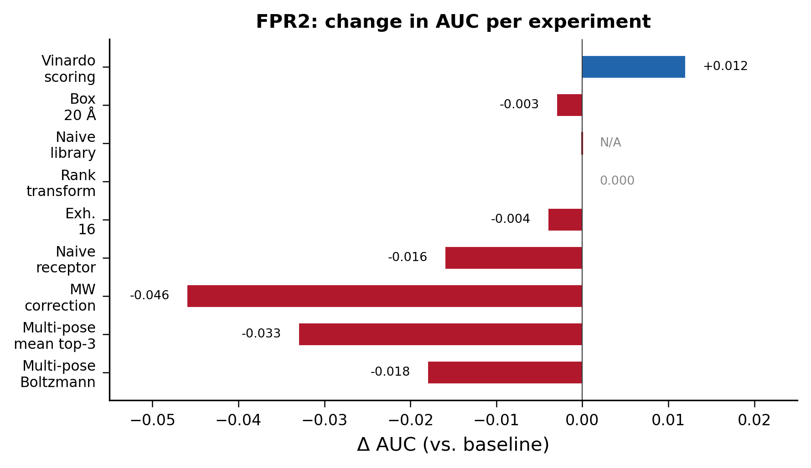
Fig. S1 FPR2: change in AUC relative to baseline for each experiment. Blue: kept; red: reverted; grey: no change or failed.

S3. CDK2 detailed experiment logs

Experiment 0: Baseline
Configuration: Vina scoring, skill library (1,309 ligands), skill receptor (Meeko), 25 Å box, exhaustiveness 8, dual-GPU.
Results: AUC = 0.677, BEDROC = 0.443, EF 1% = 1.71. Runtime: 1,342 s (22 min).

Experiment 1: Vinardo scoring (KEPT)
Hypothesis: Vinardo may improve enrichment for CDK2.
Results: AUC = 0.695 (+0.018). Decision: KEPT.

Experiments 2–4: Box size sweep
Tested 20, 18, and 30 Å boxes.
Results: AUC 0.692, 0.694, 0.685. All reverted. 25 Å remained optimal.

Experiments 5–6: Exhaustiveness sweep
Tested exh. 16 and 32.
Results: AUC 0.686, 0.693. Both reverted. Exh. 8 optimal.

Experiment 7: Naive library with Vinardo (KEPT)
Hypothesis: OpenBabel library covers more chemical space.
Results: AUC = 0.716 (+0.021). Dramatic improvement from larger library (2,471 vs 1,309 ligands). BEDROC jumped from 0.403 to 0.711. Decision: KEPT.

Experiment 8: Naive receptor + naive library
Hypothesis: Matching naive prep for both receptor and library.
Results: AUC = 0.706 (−0.010). Skill receptor remains superior. Decision: REVERTED.

Experiment 9: Naive library with Vina scoring (KEPT)
Hypothesis: Vina may outperform Vinardo with the naive library.
Results: AUC = 0.735 (+0.019). Vina outperforms Vinardo when using naive library—opposite of FPR2 finding. Decision: KEPT.

Experiment 10: Energy range 5 kcal/mol
Tested wider energy range.
Results: AUC = 0.735 (identical). Decision: REVERTED.

Experiment 11: Batch size 50 (KEPT)
Hypothesis: Smaller batches reduce ligand loss from segfaults.
Results: AUC = 0.733, but 1,951 ligands scored (vs. ~1,500 with batch 100). Decision: KEPT for better coverage.

Experiments 12–15: Additional parameter tests
Tested batch size 20, exh. 4, box 22 Å, num_modes 20.
Results: AUC 0.730, 0.729, 0.729, 0.727. All reverted.

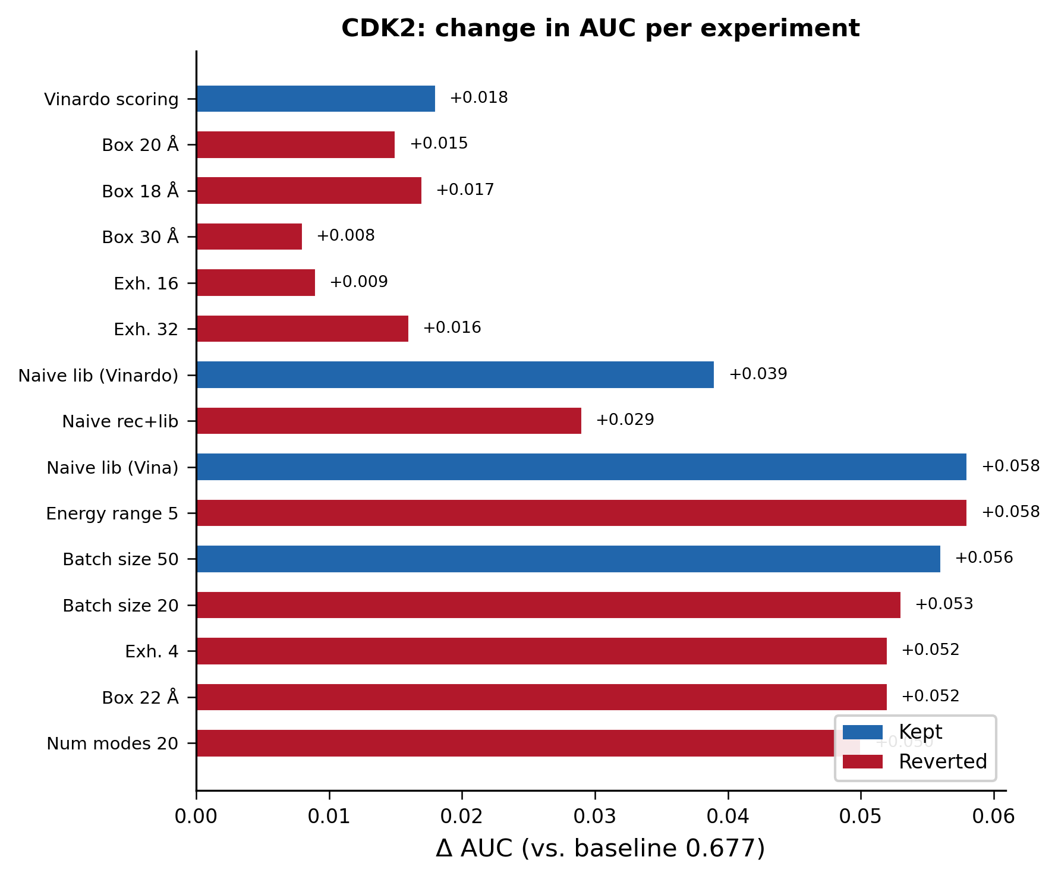
Fig. S2 CDK2: change in AUC relative to baseline (0.677) for each experiment. Blue: kept; red: reverted.

S4. Stochastic variation analysis
To establish the noise floor for FPR2, the agent observed that two runs of the identical configuration (Vinardo, skill library, skill receptor, 25 Å box, exhaustiveness 8) produced AUC values of 0.744 and 0.748. The difference of 0.004 reflects stochastic variation from Uni-Dock’s GPU-parallel Monte Carlo sampling and batch-dependent segfault patterns. This noise floor of approximately 0.004 AUC was used as the threshold for declaring improvements meaningful.
For CDK2, a similar noise floor was observed: experiments with identical docking parameters but different batch sizes yielded AUC variations of approximately 0.002–0.005, attributable to the stochastic ligand loss from segfaults.

S5. Segfault analysis
FPR2: Across all runs, batches 30–40 (ligands DEC_05xxx through DEC_07xxx) consistently caused segmentation faults. Inspection revealed structural parsing errors (“Unknown or inappropriate tag found in flex residue or ligand”). These files were Meeko-prepared but contain unusual chemical features (e.g., boron-containing compounds, complex ring systems) that produce PDBQT tags not recognised by Uni-Dock’s parser. Approximately 1,100 ligands were lost per run (79% success rate).
CDK2: The naive (OpenBabel-prepared) library exhibited a higher segfault rate (exit code −11) on both GPUs, with approximately 20–40% of batches crashing. Reducing batch size from 100 to 50 improved the success rate from ~62% to ~79% of ligands scored. The skill library showed a similar segfault pattern to FPR2 (~20% loss).

S6. Git commit histories
FPR2 campaign:
56f1239 revert: multi-pose scoring (all methods worse than best-pose)
df1a699 experiment: multi-pose scoring sweep (free, reuse cached results)
950c05d revert: MW correction (AUC 0.7022, much worse than 0.7480)
b06bfea experiment: add MW correction (score / MW^0.33)
9e9b718 revert: naive receptor (AUC 0.7320, worse than 0.7480)
5115af9 experiment: switch to naive receptor (OpenBabel-prepared)
03f9cc7 revert exh16: AUC 0.7441 < 0.7480
d3539e7 experiment: increase exhaustiveness from 8 to 16
2e4b9b0 revert rank transform: monotonic transforms don't affect AUC
31fc684 experiment: test rank score transform
03c3d1e experiment: add reuse_results option for fast transform testing
31860ec revert naive library: total failure, 100/10751 docked, AUC=nan
31a6426 experiment: switch to naive library (10752 OpenBabel ligands)
b848ee5 revert box 20A: AUC 0.7447 < 0.7480
e32c6b0 experiment: reduce box size from 25A to 20A
ff7fd1b experiment: switch scoring function from vina to vinardo
2659a74 Initial VS autoresearch scaffold
CDK2 campaign:
REVERTED num_modes 20 (naive/vina/25A/exh8)
REVERTED box 22A (naive/vina/exh8/batch50)
REVERTED exh4 (naive/vina/25A/batch50)
REVERTED batch_size 20 (naive/vina/25A)
2fa780e experiment: batch_size 50 (naive/vina/25A/exh8)
REVERTED energy_range 5 (naive/vina/25A/exh8)
ff17182 experiment: naive library + vina scoring (25A/exh8)
REVERTED naive receptor+library (vinardo/25A/exh8)
fd1cc8f experiment: naive library (vinardo/25A/exh8)
REVERTED exh32 (vinardo/25A)
REVERTED exh16 (vinardo/25A)
REVERTED box 30A (vinardo)
REVERTED box 18A (vinardo)
REVERTED box 20A (vinardo)
2098b88 experiment: vinardo scoring
baseline skill/skill/25A/exh8/vina/none

S7. Final optimised configurations
FPR2 final configuration:
CONFIG = {
"library": "skill", # Meeko-prepared, 5,223 ligands
"receptor": "skill", # Meeko mk_prepare_receptor
"box_size": 25, # Angstrom
"exhaustiveness": 8, # GPU-parallel Monte Carlo
"num_modes": 10,
"energy_range": 3, # kcal/mol above best
"scoring": "vinardo", # Only change from baseline
"score_transform": "none",
"batch_size": 100,
}
CDK2 final configuration:
CONFIG = {
"library": "naive", # OpenBabel-prepared, 2,471 ligands
"receptor": "skill", # Meeko mk_prepare_receptor
"box_size": 25, # Angstrom
"exhaustiveness": 8, # GPU-parallel Monte Carlo
"num_modes": 10,
"energy_range": 3, # kcal/mol above best
"scoring": "vina", # Vina (not Vinardo)
"score_transform": "none",
"batch_size": 50, # Smaller batches for naive library
"gpu_device": "0,1", # Dual GPU
}
Key differences: FPR2 uses Vinardo scoring with the skill (Meeko+PAINS-filtered) library, while CDK2 uses Vina scoring with the naive (OpenBabel) library. Both targets use the Meeko-prepared receptor.

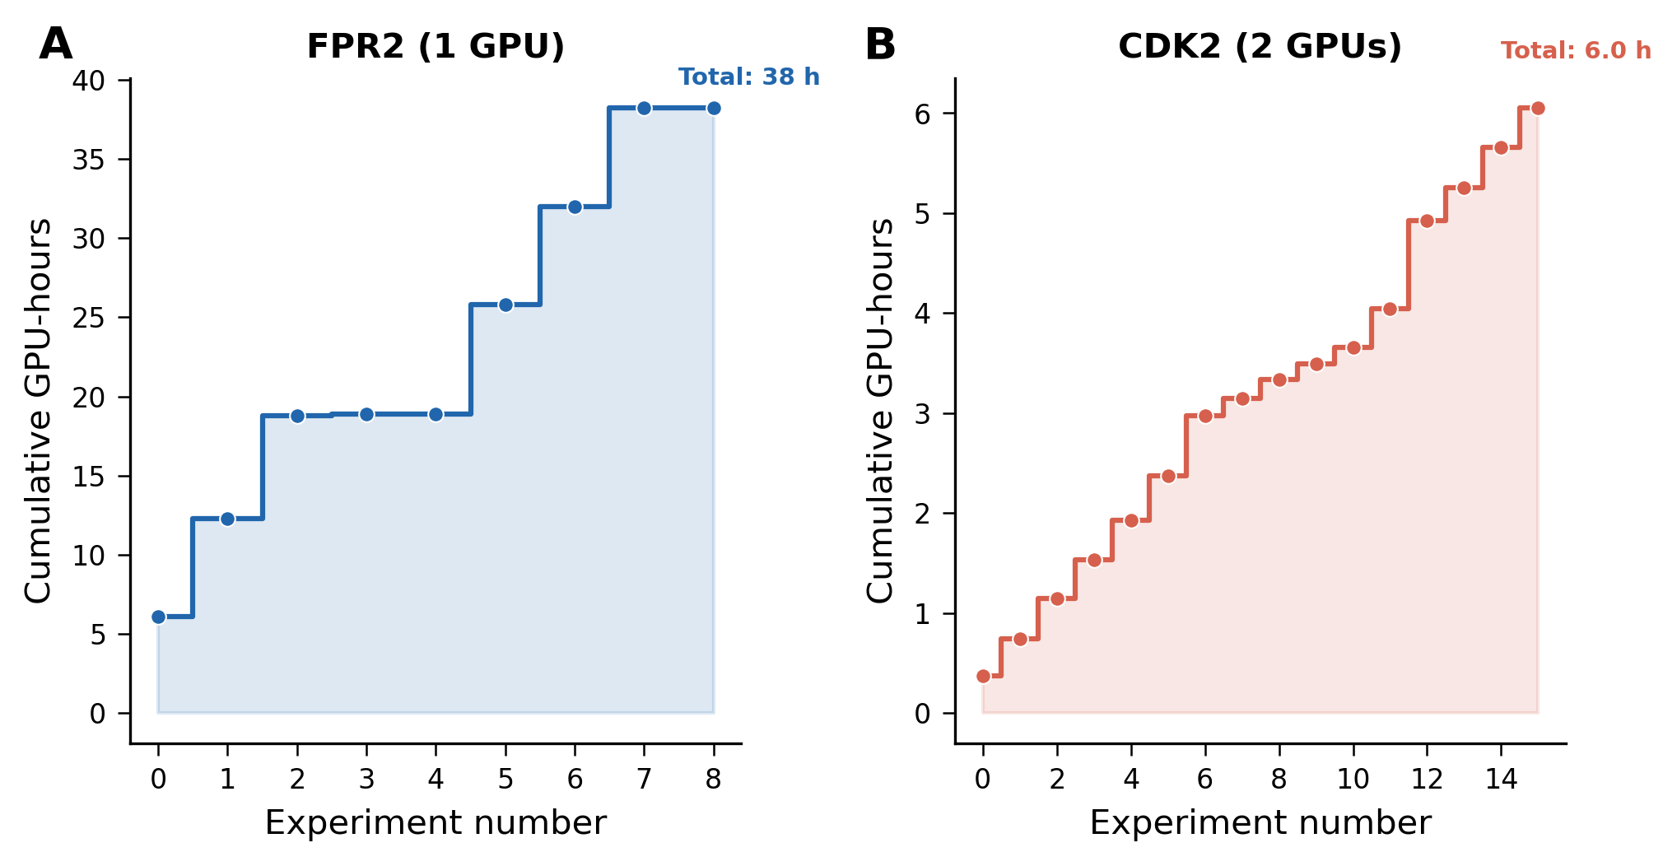
Fig. S3 Cumulative GPU-hours for FPR2 (A, single GPU, ∼38 h total) and CDK2 (B, dual GPU, ∼6 h total). The CDK2 campaign was substantially faster due to the smaller library and dual-GPU execution.

