

FOSS4G Buenos Aires 2013

Free Geomatics Conference

24th - 26th April

Instituto Geográfico Nacional
(National Geographic Institute)

Buenos Aires, Argentina

http://www.foss4g-ba.org

About the conference
The FOSS4G (Free and Open Source Software for Geospatial) are Free Geomatics conferences that are held every year at different places of the world. There is a global FOSS4G organized by OSGeo which will be celebrated in 2013 at Nottingham, United Kingdom. Besides the global FOSS4G there are other local ones held in: USA, Eastern Europe, Spain, Japan, India among others.
Starting on 2013, FOSS4G Buenos Aires intends to gather members of the geomatics community from Argentina and other latin american countries. As well as in the global conference, we expect to have a mix of workshops, projects presentations and expositions about use cases of free and open source tools applied to geomatics. Furthermore, it will promote the interaction between users of geomatics from different environments and places.
The conference is organized by Geoinquietos Buenos Aires, a group of people that shares knowledge, experience, insights, and doubts about geomatics, free and open source software and geospatial technology.
During the conference time, we will be looking for:
- Sharing experiences, projects and ideas around free and open source geomatics
- Consolidate the community to work towards transparency, collaboration and shared knowledge
The conference is aimed to:
- Decision makers coming from different government agencies
- Public Service officers related with GIS
- Members of IDERA
- Universities: professors and students
- General public
Hereby we invite you to take part of this unique event, as sponsors, presenting your projects or by just attending.
Of course, we will be glad to receive any suggestion, opinion or proposition that may help us making this event even more successful and productive for everyone.

See you soon!

Mauricio Miranda
Chairman
FOSS4G Buenos Aires 2013
chair@foss4g.org.ar
http://www.foss4g.org.ar

The Venue
The National Geographic Institute (Instituto Geográfico Nacional - IGN) is a public organism which has as its main mission the representation of the national territory through the official cartography and watching over so that maps of the Argentine Republic which are made, that come in or that circulate inside the country are compliant with that official cartography.
Being such an important organism inside the geomatic world, it's a pleasure, a pride and an honor to count with their facilities to accomplish this event in search of strengthening the community surrounding geographical information systems and geospatial data.
The IGN counts with an auditorium for approximately 300 people and many smaller rooms for the workshops and expositions.
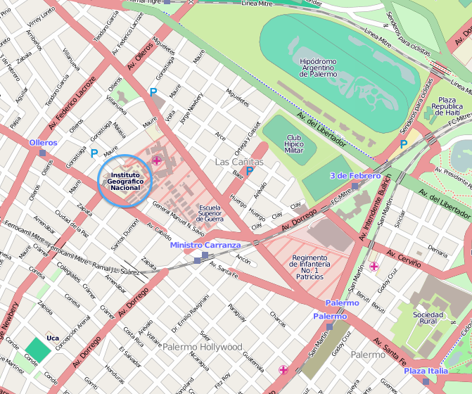
It is located on Cabildo street, in Palermo neighborhood and it's easily reached through public transportation.

Program
The preliminary agenda includes:
- One day of workshops
- Two days of presentations
- One extra day for code sprints and community meetings

Workshops
- Participative workshops covering the usage of free tools.
- Half day each.
- Aimed at different levels of expertise.

Presentations
- Presentations of FOSS4G projects or use cases of FOSS4G or other FLOSS tools.
- 30 minutes each, except for the plenaries, which are 50 minutes long.
- Simultaneous tracks held so that attendees can choose from different presentations on each block.
- Presentations of final products that are not available under a free license will not be accepted. Only use cases will be accepted: how free tools were chosen, configured, combined, its benefits and/or pitfalls, etc.

Sponsors
- We invite as sponsors only companies and public organizations that open and publicly support the usage, development and promotion of free and open source software.
- If an organization not fulfilling the above mention whishes to participate it will be held to a case by case analysis.
- Prices listed below are only for public or private organizations from Argentina. Foreign sponsorships are subject to negotiation.

Levels of sponsorship
 | Bronze | Silver | Gold | Platinum
Price | $1.000 | $5.000 | $10.000 | $20.000
Tickets included |  | 1 | 2 | 4
Logo on the website | · | · | · | ·
Logo on prints | · | · | · | ·
Mention during opening and closing |  | · | · | ·
Description on the website |  | · | · | ·
Logo on t-shirts |  |  | · | ·
30 minute exposition |  |  | · | ·
Goodies and print distribution |  |  |  | ·
Physical space for exhibition |  |  |  | ·

Exhibition areas
- Only public organisms and pro-FLOSS companies could be granted an exhibition space.
- Prices listed below are only for public or private organizations from Argentina. Foreign sponsorships are subject to negotiation.
- Exhibition spaces are differently priced for according to the kind of organizations:
  - Privately held companies: $4.000
  - Government organism: $3.000
  - NGOs and Universities: $2.000

Prices are expressed in Argentine Pesos
Exposition must be approved by the committee
Material must be provided by the sponsor and will be distributed within the welcome kit
Prices are expressed in Argentine Pesos

