PureMed Aesthetics Brand Strategy Document
PureMed Aesthetics is positioned as a medically-led, premium aesthetics clinic focused on natural-looking results, skin quality, and advanced non-surgical rejuvenation.

1. Brand Positioning
PureMed Aesthetics should position itself as the trusted choice for women aged 35–65 who want to look fresher, lifted, and healthier without looking fake or overdone. The brand’s biggest differentiator is the combination of medical expertise, advanced facial anatomy knowledge, and a calm, personalised patient experience.

2. Target Audience
- Women aged 35–65
- Professionals, mums, and women entering peri-menopause
- Clients wanting subtle, natural rejuvenation
- People who prioritise safety, expertise, and results over cheap pricing
- Women frustrated with skincare not giving enough lift or tightening

3. Core Brand Messaging
- Natural, refreshed results
- Medically-led and safety-first
- Advanced skin tightening and facial rejuvenation
- Age confidently, not artificially
- Long-term skin health over quick fixes
- High-touch, personalised treatment plans

4. Signature Treatments to Lead With
The hero treatment for growth should remain Laser Lift skin tightening (consumer-friendly language for Endolift/Endolaser). This treatment should act as the premium flagship service.
- Laser Lift Skin Tightening
- Liquid Facelift with Fillers
- Polynucleotides
- Microneedling
- BioRePeel and skin peels
- Skin boosters
- Anti-wrinkle treatments

5. Brand Voice & Tone
The tone should feel expert, warm, honest, confident, and reassuring. Messaging should sound human and conversational rather than corporate.
- Educational without overwhelming
- Confident but not pushy
- Luxury but approachable
- Straight-talking and clear
- Focused on empowerment and confidence

6. Visual Identity
PureMed’s visuals should feel luxurious, clinical, clean, modern, and feminine without being overly soft or generic.

Brand Colour Palette
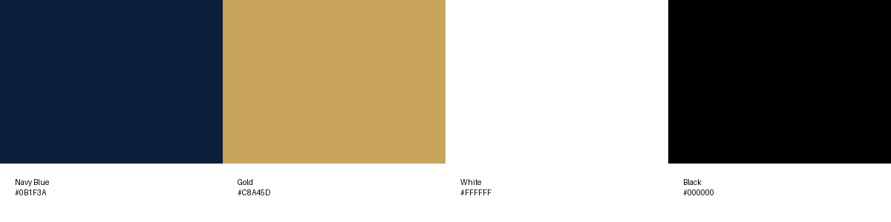
Primary colours:
• Navy Blue – trust, professionalism, luxury
• Gold – premium, elevated, aspirational
• White – cleanliness, clinical standards, freshness
• Black – sophistication and contrast

7. Content Strategy
- Before-and-after transformations
- Educational reels explaining ageing and skin laxity
- Client journey videos
- Natural result showcases
- Founder-led expert talking videos
- ‘What’s causing this?’ style problem-solving content
- Skin quality and confidence-focused messaging

8. Social Media Strategy
Instagram and Facebook should focus heavily on educational short-form video content. Hooks should explain what the treatment is, who it’s for, and why it matters within the first few seconds.
- 3–5 reels per week
- 1 educational carousel weekly
- Daily stories with behind-the-scenes content
- Client FAQs and myth-busting
- Regular consultations and treatment snippets
- Strong CTA to DM or WhatsApp for advice

9. Ideal Brand Perception
PureMed Aesthetics should become known locally as the premium medically-led clinic for women who want to age well naturally. The goal is for clients to associate the brand with trust, expertise, subtle transformation, and confidence.

10. Long-Term Growth Vision
- Dominate the local skin tightening and facial rejuvenation market
- Become known for Laser Lift treatments in Buckinghamshire and surrounding areas
- Build a recognisable founder-led personal brand
- Scale through premium treatment packages and patient journeys
- Expand recurring revenue with skin health memberships and skincare
PureMed Aesthetics is not competing on price. It is competing on expertise, trust, natural outcomes, and premium patient experience.

