Gaygusuz
Osman

Fundamentals of Data Science – Project
Soccer Results Prediction





Table of Contents
1 Objectif Statement 1
2 Data Description 1
3 Data preparation 2
4 Analysis 4
5 Difference Vectors 5
6 Defining models 6
7 First Try 7
7.1 SVC: 8
7.2 Logistic Regression 8
8 Second Try 9
8.1 Logistic Regression 10
9 Third Try 10
9.1 SVM 12
10 Finding the best number of matches 13
10.1 Logistic Regression 13
11 Conclusion 14

Objectif Statement

The project aim is to familiarize with practical algorithms and problems of modern data analysis and tools used to implement our task.

The task consists of analysing the dataset containing descriptions of football matches and predict the result of the Match by the Home team (Win, Draw, Lost), having as the input data, all the matches which happened before. I will use 80% of the matches as the training set, and 20% as the testing set. The assignments of matches to both sets are done randomly. The home team wins about 46% of the time, thus my objective is to have a better accuracy.

Data Description

The dataset provides us the following information:

- +25,000 matches
- +10,000 players
- 11 European Countries with their lead championship
- Seasons 2008 to 2016
- Players and Teams' attributes* sourced from EA Sports' FIFA video game series, including the weekly updates
- Team line up with squad formation (X, Y coordinates)
- Betting odds from up to 10 providers
- Detailed match events (goal types, possession, corner, cross, fouls, cards etc…) for +10,000 matches

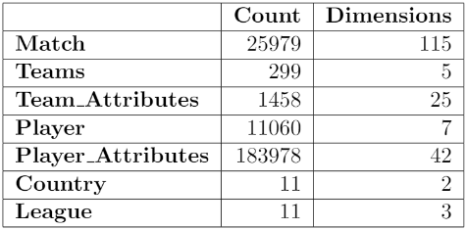

Fig 1: Magnitude of the available data

Data preparation

In order to predict the match result, I wanted first to use both of the table players attributes and Match, but since there are really a few players who are very good and manage to be consistent in term of performance. I thought that it was not relevant. Thus, I used only the table Match as it contains 115 columns, the table had enough features that I found relevant for our task. There are the columns that I found interesting:

- Season
- Date
- Match_api_id
- Home_team_id
- Away_team_id
- Home_team_goal
- Away_team_goal
- Shoton
- Shotoff
- Cross
- Corner
- Possession

The only column missing was the Result. I created it with the following possible values:

- “0” If the Home team Loses
- “1” If the Result is a Draw
- “2” If the Home team Wins

The next step was to analyse the data and it was the hardest part.
When I saw the columns possession, corner and so on... I wondered which team statistics are given in those columns. I was surprised to see that it was possible to have that much information in one single column. Indeed, my biggest problem in the project was to extract information from XML format.
It was the first time I have seen this format and I didn’t know how to extract the information I was looking for. Here is an example with the XML document for the possession:

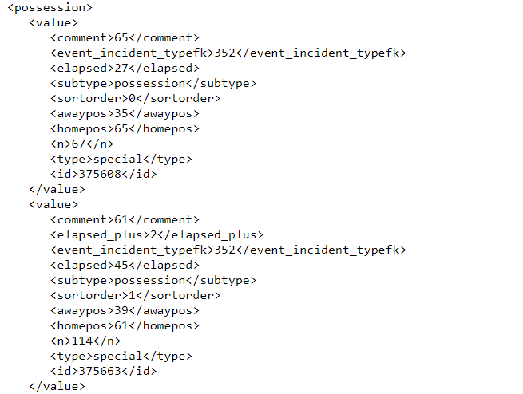
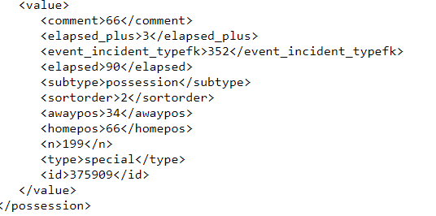

Here we can see the xml document for the first cell in the column possession. We can track the possession of each team during the match. In blue we have the time when a new value is updated. In yellow we have the possession of each team. Thus, to have the final statistic for each cell I had to take the last value of the xml document and extract the home possession and away possession. Moreover, I had to repeat not exactly the same process in order to get the statistics of each team and for each feature.

Afterwards, I had too many columns as I had the statistics of both teams in these columns:

- Shoton (Shot on Target)
- Shotoff (Shot off Target)
- Corner
- Cross
- Possession
- Red Cards

I had to find a solution to reduce the features of my data frame, because it was difficult to work with that many. However later when I have more experience, I would enjoy giving more attention to all the features that I have but since it is my first project, I wanted it to be more affordable.

Analysis

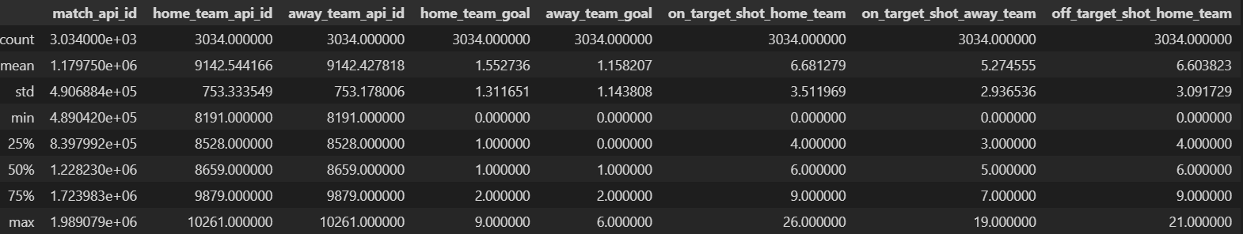
At this point, there were only 6 rows with a NaN value in possession, thus I deleted them and as you can see bellow the data frame contain much more columns that I wanted to:
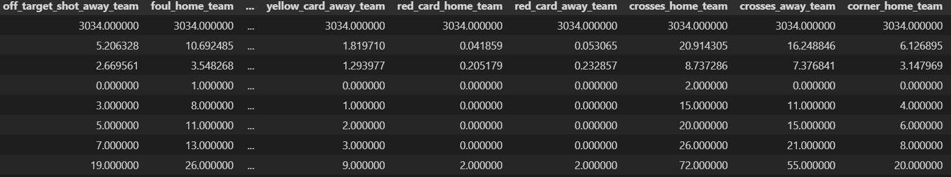

That’s not all but I'll spare you the rest. Thus, I had to find a solution to reduce the number of columns while still using this information.

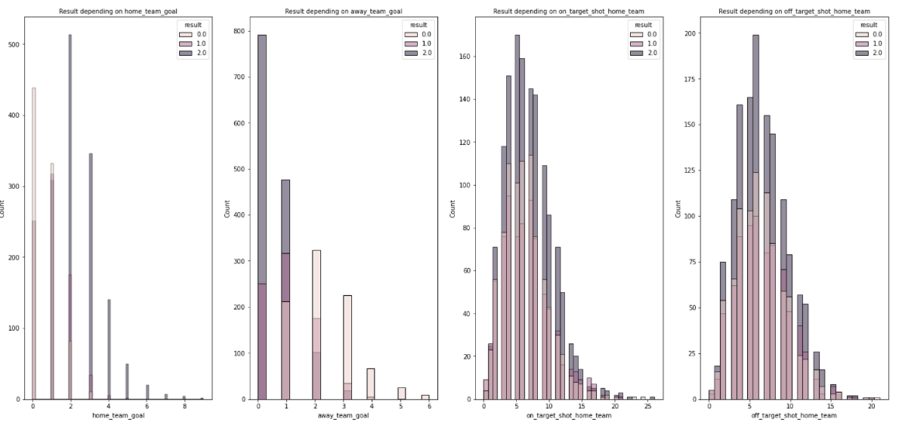

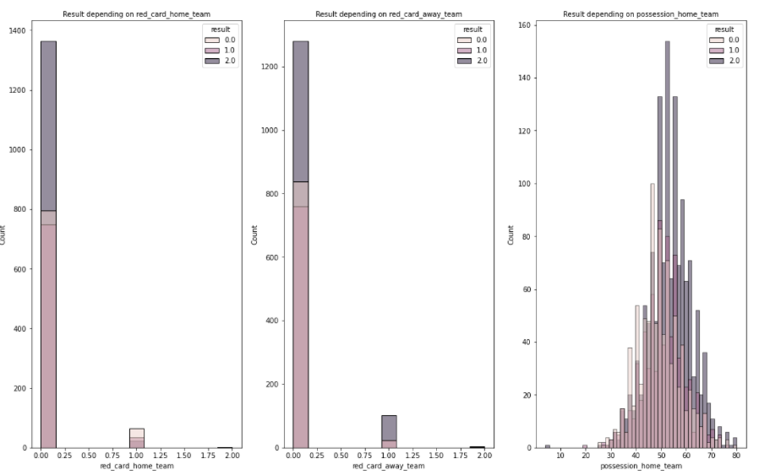

Here we can notice the importance of the feature red card as it is really predictable to find the result if there is a red card in a match. We can also see that the more the home have the possession the more they are going to win.

Difference Vectors

Since I had the statistics of the two opposing teams, in order to compare them, the easiest method was to calculate a vector of the differences between each team’s attributes.

Moreover, our task is to predict the result of the home team thus the difference vector fit perfectly, for instance:

- Vh: vector of the home team attribute
- Va: vector of the away team attribute
- R: Result of the difference vector from home team perspective

R= Vh – Va

For example:

 | VH | VA | R = VH - VA
Shoton | 10 | 5 | 5
Shotoff | 2 | 7 | -5
Corner | 2 | 3 | -1
Cross | 1 | 1 | 0
Red Card | 0 | 1 | -1
Thanks to this method, it has reduced a lot the shape of the data frame and helped me a lot to easily manipulate the data frame. Finally, I could focus more on finding the best features to get better results.

Defining models

Our task is a classification, in order to try which features combination gives the best result. First, I defined every classifier that I will use with some parameters. Secondly, I will try every classifier for each combination of features that I have chosen. Here are the classifiers with the following parameters:

- Logistic Regression:

  - {"C":0.01}
  - {"C":0.1}
  - {"C":1}
  - {"C":5}
  - {"C":10}

- Decision Tree:

  - {"criterion": "gini"}
  - {"criterion": "entropy"}

- Random Forest:

  - {"criterion": "gini"}
  - {"criterion": "entropy"}

- K-nearest neighbors:

  - {"n_neighbors":3}
  - {"n_neighbors":5}

- Naive Bayes

- Support Vector Classification:

  - {“C”:0.01}

  - {"C":0.1}

  - {"C":1}

  - {"C":10}

First Try

To begin, I wanted to calculate the accuracy without using the difference vectors to see if the difference vectors give better results.

The features that I have chosen are:

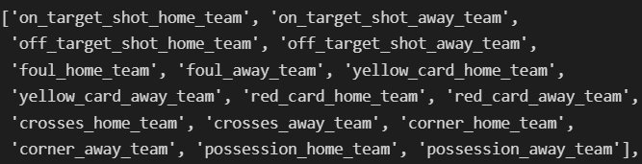

The best accuracy obtained is with the SVM {‘C’: 1}

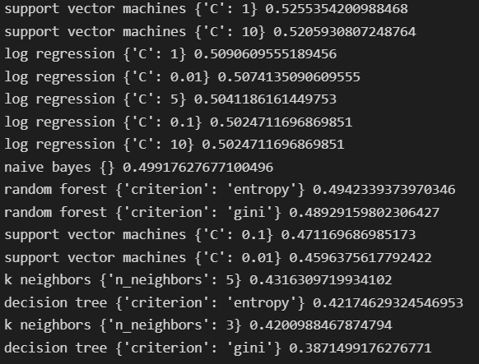

SVC:

Accuracy score for train set: 0.5162752369180058 (51.63%)
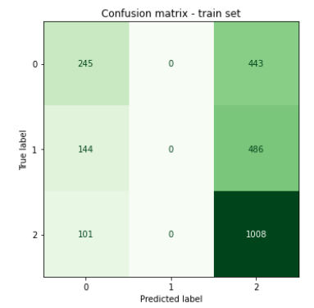
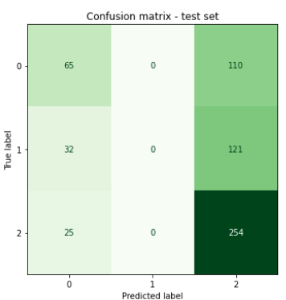
Accuracy score for test set: 0.5255354200988468 (52.55%)

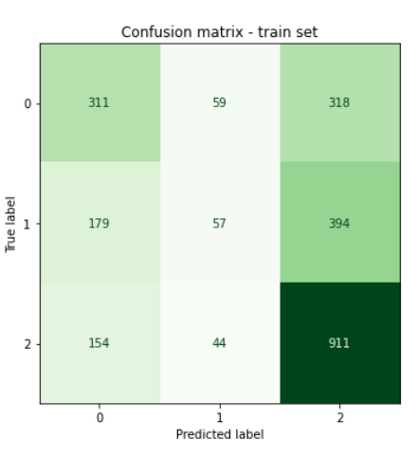
Logistic Regression
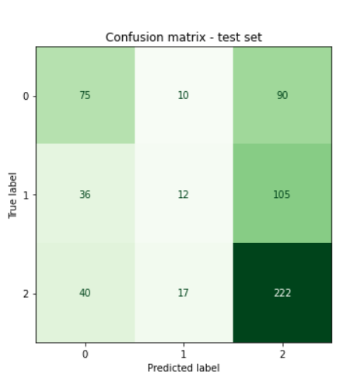

The results are interesting, we can see that the SVM doesn’t predict any draw but still have 52%. It isn’t enough; thus, I will try to add the difference vector in the next try.

Second Try

Features:

Here Card represents the difference between both teams red cards and all the features are difference vectors except possession which is just the possession of the home team, on and off target shots.

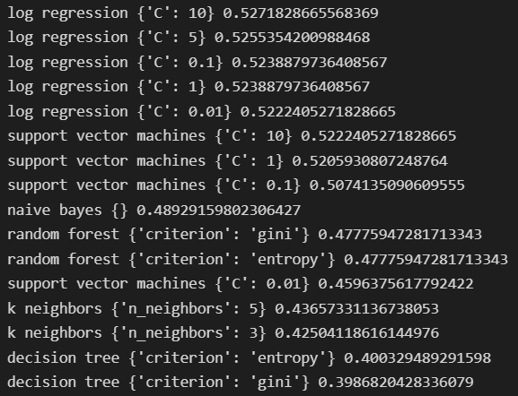

There is almost no improvement when using difference vectors.

Logistic Regression

Accuracy score for train set: 0.526988051091883 (52.7%)
Accuracy score for test set: 0.5271828665568369 (52.72%)
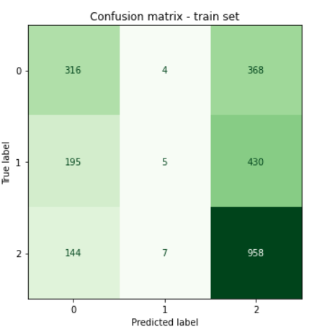
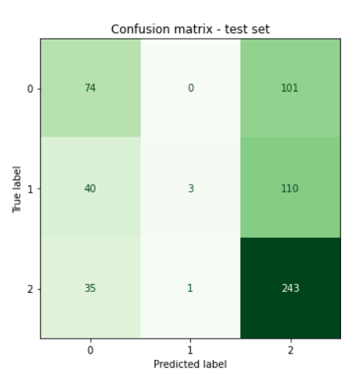

Third Try

In this part, I added a new function that calculate the win rate and the possession average of the home team against the opponent.

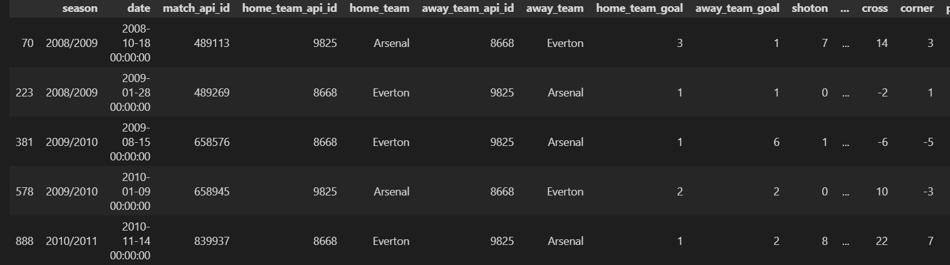
For instance, if a match faces the home team: Arsenal and the away team:
Everton.

I extract every game where Arsenal and Everton are facing each other. I calculate the win rate of Arsenal and the average possession of Arsenal.

Features:

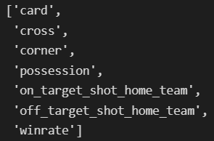
The possession is now the average possession of home team.

The results are better now.
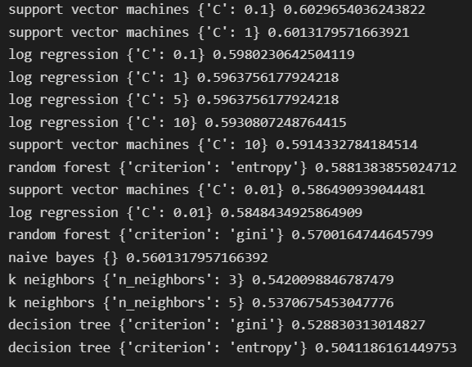

SVC

Accuracy score for train set: 0.5850844664194479 (58.51%)
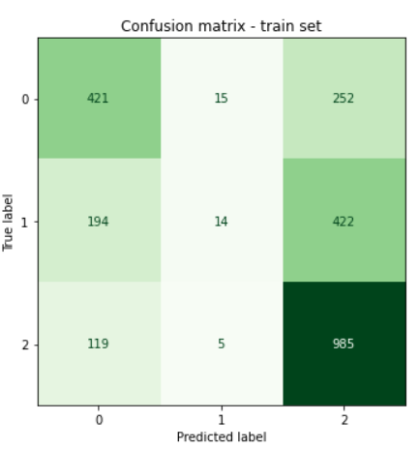
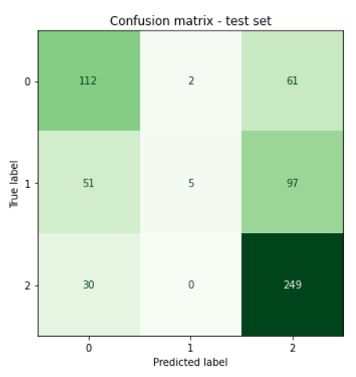
Accuracy score for test set: 0.6029654036243822 (60.3%)

We can see that the results improved significantly by adding two features. It is the best result that I ever obtain by using the whole dataset. On the next part I try to see if there is an improvement by using a certain number of games.

Finding the best number of matches

In this part I created a function, given a dataframe of games, a model and a number of previous games, find the number that gives the best accuracy.

In this part I noticed some improvement, but I also realized that each model doesn’t have the same amount of data to have the best accuracy.

Logistic Regression

When I was using the whole dataset, the SVC was the best model with an accuracy around 60% after using the function the Logistic Regression has the best accuracy: 64.7 % while using 1800 games into consideration.
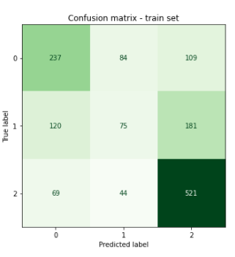
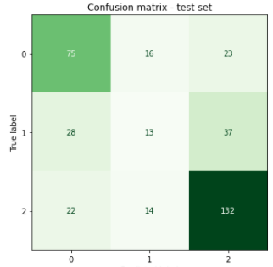

Conclusion

Report Data Science 09/06/2022

It is my first project in Data Science and at the beginning I didn’t know anything about Machine Learning and Data Science even though I was really interested in those subjects. It helped me to understand how to use Machine Learning algorithms to resolve a problem. Moreover, I discovered how to manipulate and make more understandable a bigger dataset. Furthermore, I realized how important is the preparation of the data. During the project, I had the opportunities to try and discover new classification algorithms. If I would continue the project, I would like to improve my features and maybe try to predict the result of games in the future. Thanks to this project I realized that I would like to continue my studies in Data Science and Artificial Intelligence. As I’m still at my second year of my Master, this project gave me a lot of experience.

