**Online Exam Application**

**Developed by:**

1. **Abdullah Al Osman Sajid  
   Roll: 201614049**

**Online Exam Application**

**Introduction:**An automated exam tool built using Java to conduct the examination process in digital way.

**Objectives:**

The Online Exam Application is built with the target to make the examination system digital. Using this application students can appear for the exam online without using papers and pens. Moreover here the answers will be checked automatically and mark sheet will be generated in pdf format which will give the teachers an ease in total examination system. More than one teachers can access this application, create their own account and make individual questions for the students. The students can appear for the exam seating from their respective computers. Thus making the whole examination process digital and easier.

**Used Tools/API/Library:  
import com.itextpdf.text.Document;**

**import com.itextpdf.text.DocumentException;**

**import com.itextpdf.text.Paragraph;**

**import com.itextpdf.text.pdf.PdfWriter;**

**import java.awt.event.ActionEvent;**

**import java.awt.event.ActionListener;**

**import java.io.FileNotFoundException;**

**import java.io.FileOutputStream;**

**import java.sql.*;**

**import java.sql.DriverManager;**

**import java.sql.ResultSet;**

**import java.sql.SQLException;**

**import java.util.ArrayList;**

**import java.util.concurrent.TimeUnit;**

**import java.util.logging.Level;**

**import java.util.logging.Logger;**

**import javax.swing.JOptionPane;**

**import javax.swing.Timer;**

**import net.proteanit.sql.DbUtils;**

**Features:**

* Any number of teachers can set their questions logging from their personal account.
* The teacher can set their own instructions, time for exam, marks and number of questions for the exam.
* A teacher can have only one account which provides security of the application.
* Student can appear for the exam writing their roll, name and unique code of the exam.
* As a result a student can’t appear for the same exam more than one time.
* The exam will stop after the fixed time of the exam as a result timing can be strictly maintained in the exam process.
* At the end of the exam, the student can generate the answer script as pdf which will help the student to learn from his/her errors.
* The teacher can know about the marks of all the students logging from his/her account.

**Challenges while implementing project:**

* The main challenge of this project was to work with database.
* Ensuring the proper management of marks and timing of exam.
* Ensuring that no student can appear for the same exam more than one time.

**Overcoming challenges:**

* Here the main task to deal with database was inserting data, fetching data and searching data from database. We have used mySQL. Since the basic concept of database was required so it could be solved.
* To maintain the time of the exam properly, swing timer was used.
* To ensure that no student can appear for the exam more than once, the student roll number was searched every time in the database before exam.

**Description of Implementation:**

* The total work process was initially designed using diagram and flowchart.
* The required library/API/tool were added.
* The UI design was created as per the design of the software.
* The functions were implemented along with the UI.
* The application was developed in NetBeans along with help of localhost server to connect mySQL database.
* Finally through several steps of coding, testing the whole application came into a form.

**Flowchart:**

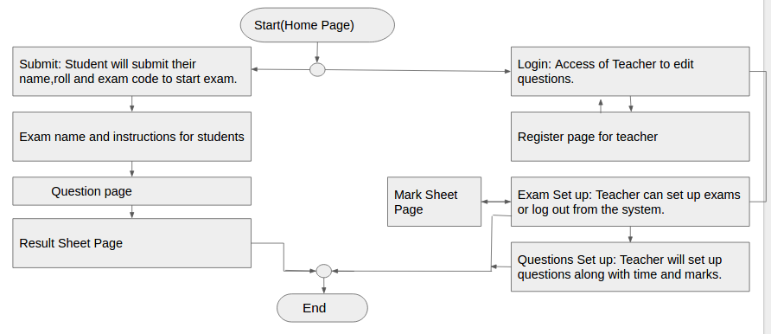

**UI Design:**

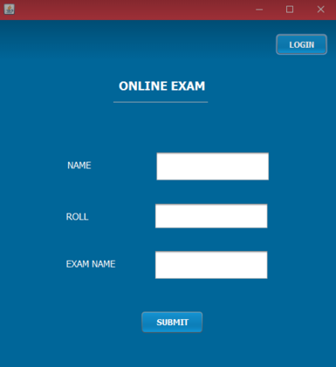

Fig: Exam starting page

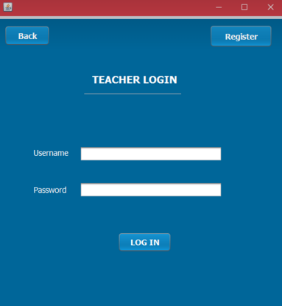

Fig: Teacher Login page

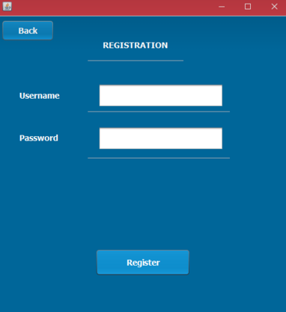

Fig: Teacher Registration Page

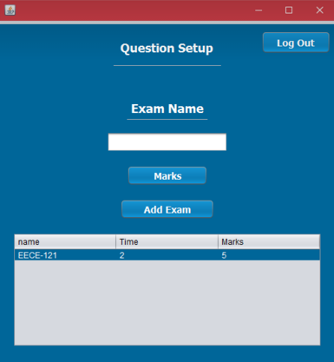

Fig: Exam setting and marks checking page

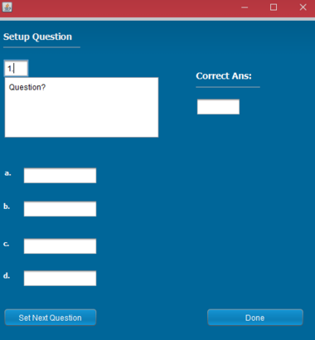

Fig: Exam questions setting page

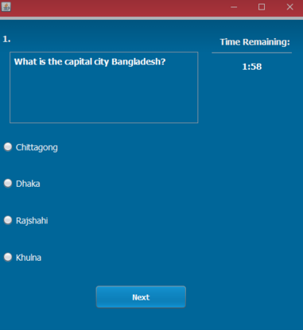

Fig: Question page for students along with timer

**Conclusion:**

The project was mainly developed to make the examination system digital and easier. The application will help to give the teachers ease regarding the examination system. Moreover it will be helpful for the students to appear for the exam. However in coming days more features can be added to the application to make it more user friendly.