Quickstart
Make an OSM account
Pick a task in the Tasking Manager
Map everything asked and save (often!)
Close your mapping window and mark your task as done!

Get started
- Create an OSM account: go to www.openstreetmap.org
- Click on sign-up and fill in the form
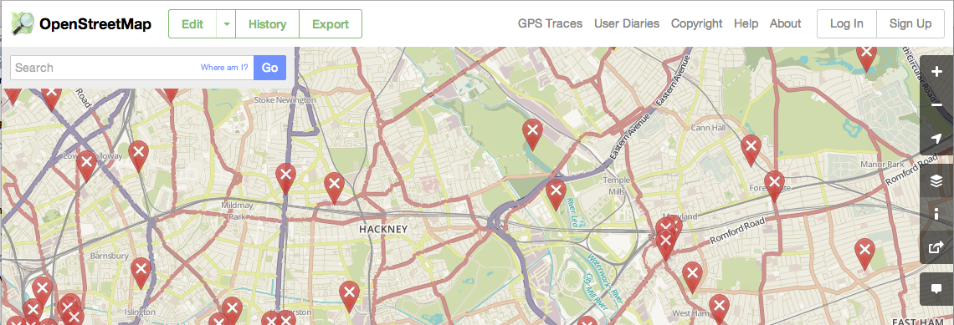
- Open your e-mail account and open the Welcome message to confirm your account. You will be taken to the OpenStreetMap welcome page.
- You’ll then be able to ‘start mapping’.
You’ll be asked to go through a walk-through and we really recommend you do this first and become initiated OSM mappers.
You can also access the walk-through by clicking on the ‘Help’ button on the right hand side, then on ‘Start the Walkthrough’.
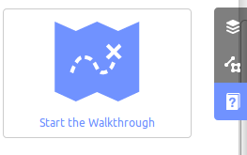
How about zooming to your home and adding the building where you live?

Start mapping with HOT/Missing Maps
- HOT coordinates all work from the Tasking Manager: tasks.hotosm.org .
- Sign in to OSM if not already logged on.
- Click on start mapping
- Navigate to today’s task: use the search button
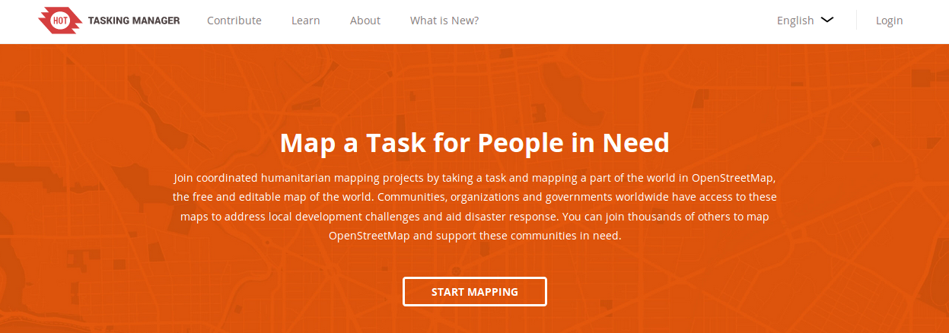
Tasking manager: Task Instructions tab:
- Contains the details on how to complete the task, including the priorities for mapping (e.g. feature type such as buildings, roads).

- Two key instructions:
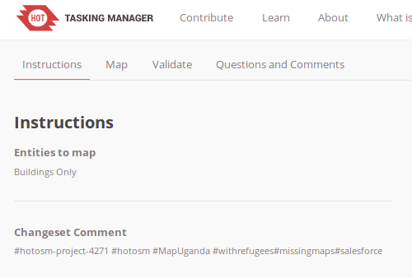
  - Changeset Comment: This is a comment made at the end of a period of editing (changeset) that tags the data with the task. This helps future interpretation of the data you created
  - Imagery details: Bing is the default satellite imagery HOT-OSM uses; however for certain responses, other satellite imagery providers will provide imagery.
Tasking manager help: What do the squares mean?
- Each task is broken down into squares.
- You select a square and this is the area you will be responsible for mapping.
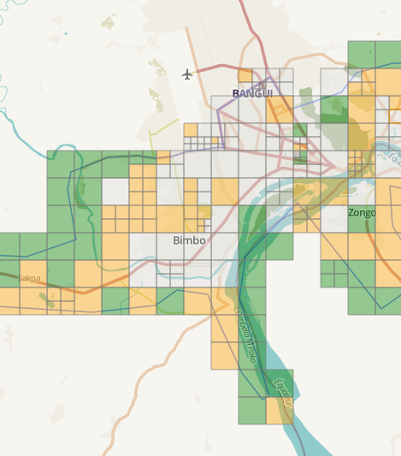
- Each square is colour-coded, so you know whether it needs to be mapped or not.

- Ready: you can pick this task!
- Mapped: The mapping of this square is complete, but it is waiting to be validated (checked) by another user.
- Bad imagery: The satellite imagery is not good enough to map.
- Validated: This square has been mapped and validated by another user.
- Invalidated: This square has been mapped but needs fixing
- Locked: This square is currently being mapped by another user
- Locked by you: This square is being mapped by you
- Priority area: This square is to be mapped first

Start contributing:
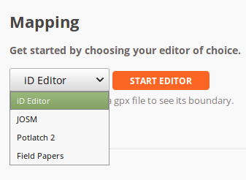
- Click a transparent square and select ‘start mapping’. This is your square now!

- You can now click Edit. For your first square, we recommend using iD editor.

(if you’re unable to see the dropdown menu, you may need to use a different internet browser)

Task too big? Split it up!
- It’s better to map a lot of little tiles than get stuck on a large one. It’s easy to split a task into four smaller tiles.
- To do this, first pick the area you would like to map. Then click the “Split” link as seen below.


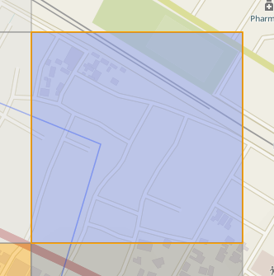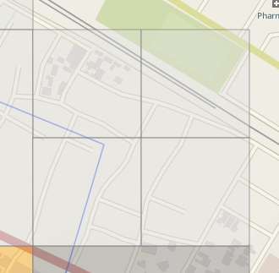

- When you are ready to start mapping, click on “Start editor”.
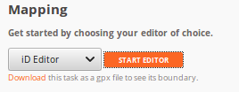

Your first mapping session
- iD Editor allows you to edit OpenStreetMap within an internet browser.
- Easy and simple to use for general OSM purposes or for HOT co-ordinated mapping.
- Follow the ‘Walkthrough’ - best introduction to the iD Editor and editing process, and/or click on the help button!
Read more: http://learnosm.org/en/beginner/id-editor/
iD wants you to choose what to map first

Technical note: iD makes a distinction between three basic datatypes that don’t really exist in OpenStreetMap. This is under the assumption that this is easier to understand for most people. In reality, Openstreetmap has these three data types:

Nodes: a point feature with an id. These nodes can have tags, for example to make a Point of Interest (POI). The same node might also be used as a part of a way
Way: an ordered collection of nodes, often a line. A closed line may or may not be an area. If a closed line is e.g. a forest, it will be assumed to be an area. If a closed line is e.g. a wall, it will still be assumed to be a line. A pedestrian road forming a closed line might be either an area (a pedestrian square) or a line (a pedestrian road going around a field). In this case, clarification will be added by using area=yes/no
Relation: a collection of nodes or ways (or even other relations). Used for boundaries, multipolygons, routes, etc.


Points of Interest


Roads
Paths
Tracks
Waterways


Buildings
Car Parks
Green Areas

Setting imagery
You can choose a number of sat pics here, change brightness of imagery, activate GPS tracks.
The tasking manager will tell your browser which imagery to show.

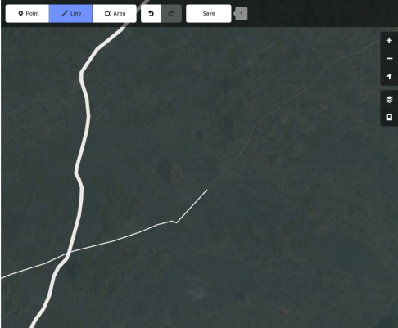
First steps, roads example

- To start digitising, click on the type of data you’ll be creating.
- Then click over the path or outline of the feature you want to map.
- Here we’ve started to digitise a road using the line tool.

End drawing
- You can complete the feature by either double-clicking when making your final point or click again over your final point (a light red circle should appear when you hover over the point).
- When adding roads, make sure your new road shares points with the roads it crosses or joins. One of the main uses of mapping roads is to allow routing, this will not work if you don’t share points between roads. While you’re mapping your road, simply click on the road you need to join.

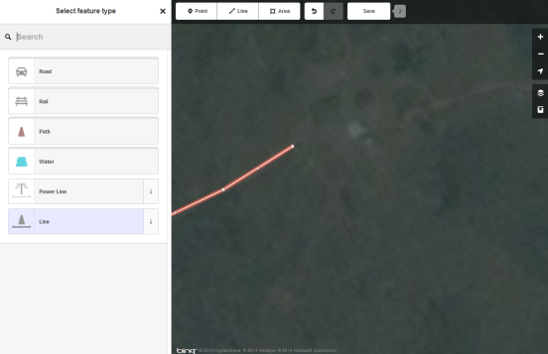
Adding tags
- You’ll then be asked to ‘tag’ the feature by selecting its type.

- You may then be asked to specify the type of feature in more detail.

Click the information button for a description of the feature if you’re unsure.

Add more tags!
- You then can add further detail about the feature, such as a road name, but this of course is only if you know it.
- Once you’ve finished editing the selected feature, close down the ‘edit feature’ window and find a new feature to digitise.
Why do we need to tag?
Tags are used to add properties to the data you created.
These properties can then be used to render or analyse the data according to established tagging practices.
You can learn more about tags here: .

- Save regularly!
If you have digitised a feature that enters another task square (e.g. a road), please save this straight away to avoid duplicates with other users.

Completing and saving a square: within iD
- Once you’ve finished mapping (either you’ve completed the square or run out of time), you’ll need to save your changes to OpenStreetMap and your work to the Tasking Manager.
- To save your changes in OSM, click on the ‘Save’ button at the top of the map.
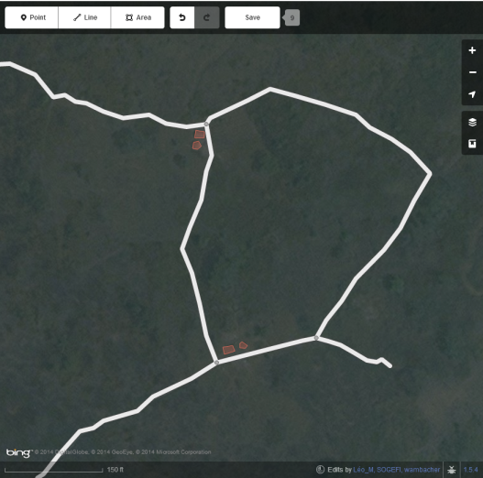
- You’ll then be shown your changes in a list and notified of any features that have not been tagged.
- Add the Changeset Comment (found back in the Task Instructions on the Tasking Manager). Include some info about what you mapped, e.g.: “added houses and roads”
- Click ‘Save’ to upload your changes to OSM.
Completing and saving a square: in the Tasking Manager
- You also need to save your work in the Tasking Manager, so other HOT contributors know what you’ve done!
- Navigate back to the Tasking Manager window open on your browser and add a comment about what you could or couldn’t do.
- Either just unlock the square, or mark it as done. If the satellite imagery is not good enough to map, mark it as bad imagery.
Mapping residential areas
Residential areas are bits of land which are largely used for housing. In OpenStreetMap, we generally start with a rough outline: one big polygon marking an entire village. Then later on, maybe someone will split that up, often along main roads. They may then exclude the business part of town, or the parks. But it is entirely acceptable to draw things on top of the residential area too.
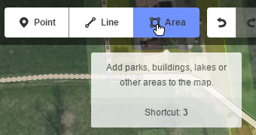
There are no hard rules as to what exactly is the extent of a residential area. In this task, don’t draw them for just one house. Don’t draw the outline on top of houses, but around them.
- Choose the Area button
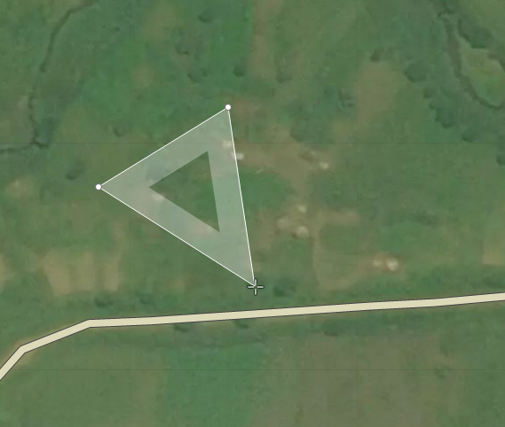
- Click on the place where you want to start the outline, and make an outline
- Finish your polygon by double clicking where you want to add the last point. (You can also finish by clicking on the first point you added).
- Click on one of the points to improve its location if needed
- Click on the little triangle between two points to add more points if needed

Add tags to tell the world what this thing is
- Click on the outline of the polygon to be able to mark it as a residential area (=tagging). If it’s flashing red, you’re ready to tag.
- You have to add at least one meaningful tag before moving on
- With your polygon still selected, you can search for “residential” or select the Residential category within the Landuse type.

The next area you draw, the editor will already suggest residential area as a tag.

Mapping buildings

- Choose the Area button
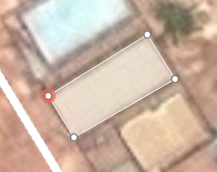
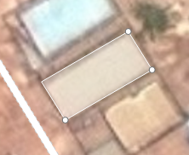
- Click on the corner of the building you want to map.
- Finish your polygon by double clicking on the last corner. (You can also finish the building by clicking on the first corner you added).
- Click on one of the corners to improve its location.
- Select the polygon, and click on the middle of one of the lines to add an extra point to the building



- Now click on the outline of the polygon to mark it as a building
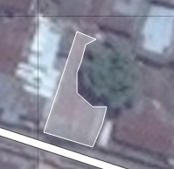
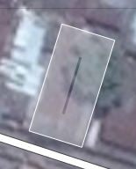
We are trying to map the building footprint. So don’t leave gaps for trees growing over houses. Roofs and high buildings might make it a bit harder to guess the footprint.

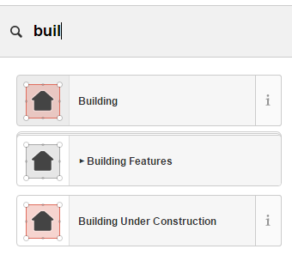
Add tags to tell the world what this thing is
- You have to add at least one meaningful tag before moving on
- With your polygon still selected, you can search for “building” or select the general building type within the building category. Don’t be tempted to add a specific building category, as this is very hard to make out based on the satellite picture.

Quicker mapping
- It’s possible to copy-paste buildings once they are ready. Simply select a nice building and use ctrl+c and ctrl+v.
- Use this if there are many identical buildings. Or you could make a simple building and move the corners into the right place. Do not use this to make many buildings that are only half correct! This will cause a lot of wasted time later on.
Classifying roads
OpenStreetMap classifies roads according to their local importance. A main road in Africa might not look like a main road does in Belgium, but it serves the same function. So it has the same classification. It is hard to determine the importance of a road from satellite pictures alone. In case of doubt, the fall-back option is to use ‘unclassified’ for connecting roads, and ‘residential road’ for roads within towns and villages.
Definition of roads in general: http://wiki.openstreetmap.org/wiki/Key:highway
Proposal for African road tagging: http://wiki.openstreetmap.org/wiki/Highway_Tag_Africa
- West African roads: https://wiki.openstreetmap.org/wiki/User:Bgirardot/West_African_HOT_Mapping_Tips
- East African roads: West African roadshttps://wiki.openstreetmap.org/wiki/East_Africa_Tagging_Guidelines
Tag | Description
Motorway | A motorway just like in Belgium, dual carriageway with separation, no roundabouts and red lights etc.
Trunk road | A main road with separated lanes but with traffic lights and the like.
Primary road | Main roads connecting large cities. In Belgium they generally have an N number. In Africa these can be large paved roads, but often they are dirt roads.  Big avenues in cities.
Secondary road | Main roads connecting smaller towns and cities, and/or roads with less traffic.  Large roads in cities.
Tertiary road | Main roads connecting smaller towns or villages to a larger city.  Important neighbourhood roads in cities.
Residential road | Smaller roads within cities, towns and villages, generally surrounded by houses.
Unclassified road | Small public road outside the cities. Generally the connection between hamlets or individual houses to a larger road or place.
Track | Agricultural or forestry road. In Belgium generally only unpaved roads get this classification. In Africa, only used for access roads to fields and the like.
Path | A path generally accessible for cyclists or pedestrians only. In Africa, only used if the road can’t reasonably be used by a good 4x4 car.
Steps | Use steps for parts of paths that consist of steps.
Options when selecting lines
Button | Function
 | Change the direction of a line  (use it to make sure water goes downhill or the one-way of a road is correct)
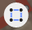 | Make straight angles where possible
 | Move the entire object
 | Make the line into a circle
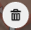 | Delete the object from the database

Options when selecting a Point
Button | Function
You can move any point by selecting it and keeping the left mouse button activated.
 | Cut the line into two parts at this point.
 | Separate two lines or polygons that share this point  (for example two buildings that are joined but shouldn’t be)
 | Continue this line  (if you want to enlarge an existing road)
 | Delete the object from the database

Options when you select an Area
Button | Function
 | Turn the area around
 | Make straight corners
 | Move the entire area
 | Make the area circular
 | Delete from the database

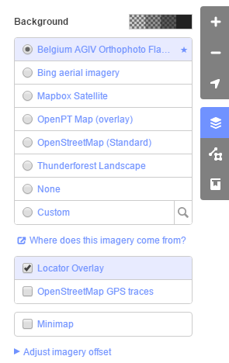
More options

Background layers
You can often choose between several background layers. To see what’s available, click on the Map Layer icon on the right-hand side of the screen.
iD will select the best available satellite pictures itself. Sometimes, the Tasking Manager will provide you with “Custom” imagery. Click on the magnifying glass to see where it gets the images from.
It makes sense to look through all the available imagery. Sometimes one is more recent than the other, or you might find a less cloudy image.
An extra layer are the “OpenStreetMap GPS traces”. These are GPS tracks made by OSM volunteers. Though GPS have a margin of error, they can help you find paths underneath trees, or analyse if the satellite picture is correct. Unfortunately, there are few GPS traces available in our areas of interest.
When the imagery is badly aligned to reality, you can adjust it with the last button. You’ll see this has happened when all the roads are next to their picture. But call for help before experimenting with this!

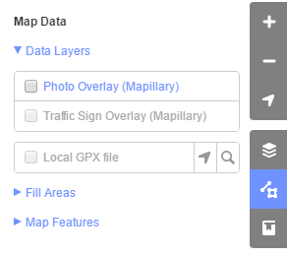
Map Data
Here you can activate Mapillary street view pictures. Contrary to Google Street View, you are allowed to use these for mapping. Use mapillary.com to check if there is any imagery available in your area of interest.
You can add your own GPX files here. Though this can be very handy, please share your tracks with the wider community too!
Then there are some settings which change how the data is rendered in your screen. You will normally not have to change this, and be careful when hiding things.

